PROMPT LADDER
General AI Fluency · Week 2 Assignment 3
Kainat Ijaz
Six-run experiment: improving a React settings-form prompt one layer at a time

1. Assignment Overview
This prompt ladder starts with a deliberately weak prompt and improves it through five versions. Each version adds one named layer only, allowing the effect of each change to be compared against the previous output.

Baseline — Weak Prompt
Prompt: Build a React settings form.
What changed: Starting point with no goal, audience, context, output format, or constraints.
What improved in the output: Claude made assumptions and introduced extra product details that were not requested.
What still failed: The prompt was too broad and left the implementation direction almost entirely to the model.
What I would try next: Add a clearer goal.

Version 1 — Clearer Goal
Prompt: Build a React settings form that lets a user update their name, email, and password.
What changed: Added one layer: a clearer goal.
What improved in the output: The output became more focused on a settings form for updating the three requested fields instead of inventing a different product.
What still failed: The user type and project context were still unspecified.
What I would try next: Define the audience.

Version 2 — Audience
Prompt: Build a React settings form that lets a user update their name, email, and password. The form is for everyday users who may not have technical knowledge.
What changed: Added one layer: a defined audience.
What improved in the output: The response shifted toward plain-language labels, clearer guidance, and a more approachable interface for non-technical users.
What still failed: The model still had freedom to assume features and implementation details.
What I would try next: Add real project context.

Version 3 — Real Context
Prompt: Build a React settings form that lets a user update their name, email, and password. The form is for everyday users who may not have technical knowledge. This is for my Frontend AI Engineering internship project, and I am using React and JavaScript.
What changed: Added one layer: real project context.
What improved in the output: The response had more relevant technical context and was better aligned with the internship's React/JavaScript setting.
What still failed: The response structure was still controlled mainly by the model.
What I would try next: Specify the desired output format.

Version 4 — Output Format
Prompt: Build a React settings form that lets a user update their name, email, and password. The form is for everyday users who may not have technical knowledge. This is for my Frontend AI Engineering internship project, and I am using React and JavaScript. Give me the response in this format: 1. Features, 2. Validation, 3. Accessibility, 4. Code.
What changed: Added one layer: a specified output format.
What improved in the output: The response became easier to scan because the requested information was organized into four clear sections.
What still failed: Organization improved, but the prompt still did not restrict unnecessary libraries or complexity.
What I would try next: Add constraints.

Version 5 — Constraints
Prompt: Build a React settings form that lets a user update their name, email, and password. The form is for everyday users who may not have technical knowledge. This is for my Frontend AI Engineering internship project, and I am using React and JavaScript. Give me the response in this format: 1. Features, 2. Validation, 3. Accessibility, 4. Code. Use no unnecessary libraries and keep the component simple and responsive.
What changed: Added one layer: constraints.
What improved in the output: The prompt now pushes the output toward a simpler, responsive implementation and away from unnecessary dependencies.
What still failed: A stronger prompt still needs human review because the model can make assumptions about validation, styling, or implementation.
What I would try next: Turn the useful layers into one reusable prompt.

2. Honest Comparison
Not every added layer produced a dramatic improvement. The output-format change mainly improved organization and scanability; it did not by itself guarantee better implementation quality. This was useful because it showed that one prompt ingredient can improve presentation without fully solving the task.

3. Final Reusable Prompt
Build a simple React settings form for my Frontend AI Engineering internship project. It should let everyday users update their name, email, and password. I am using React and JavaScript. Use accessible labels and clear validation messages. Keep the component simple, readable, and responsive. Do not use unnecessary libraries. Before coding, briefly explain your plan, then provide the implementation and explain how to test it.

4. Run Evidence
Screenshots from the six runs are included below as evidence of the baseline and five incremental versions.

Screenshot 1
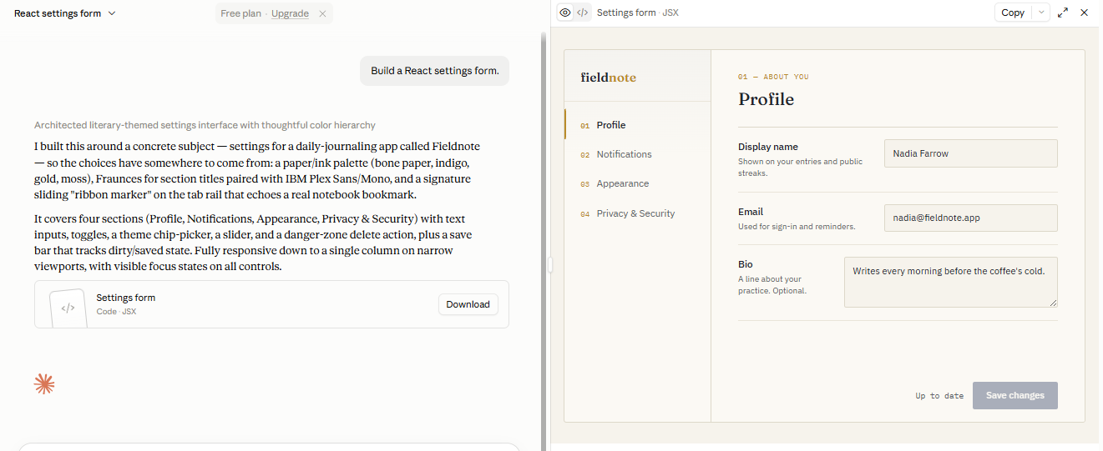

Screenshot 2
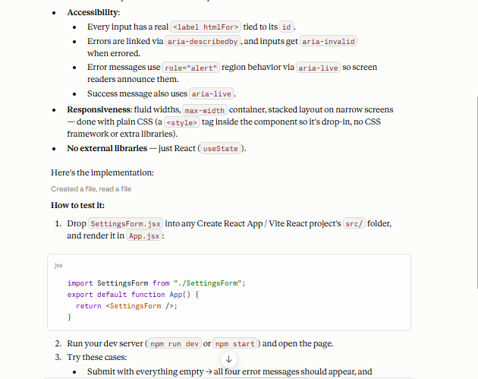

Screenshot 3
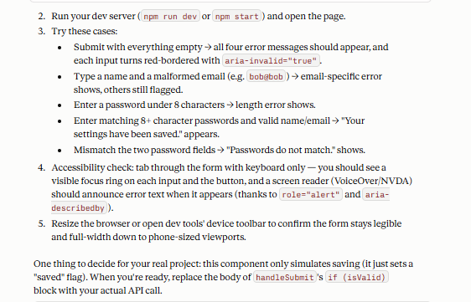

Screenshot 4
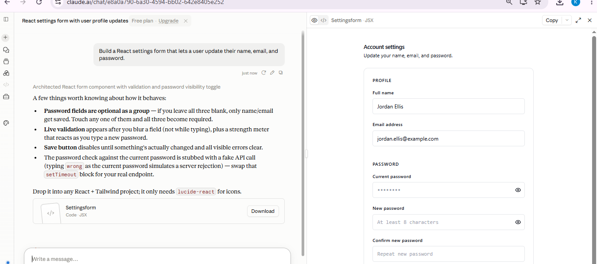

Screenshot 5
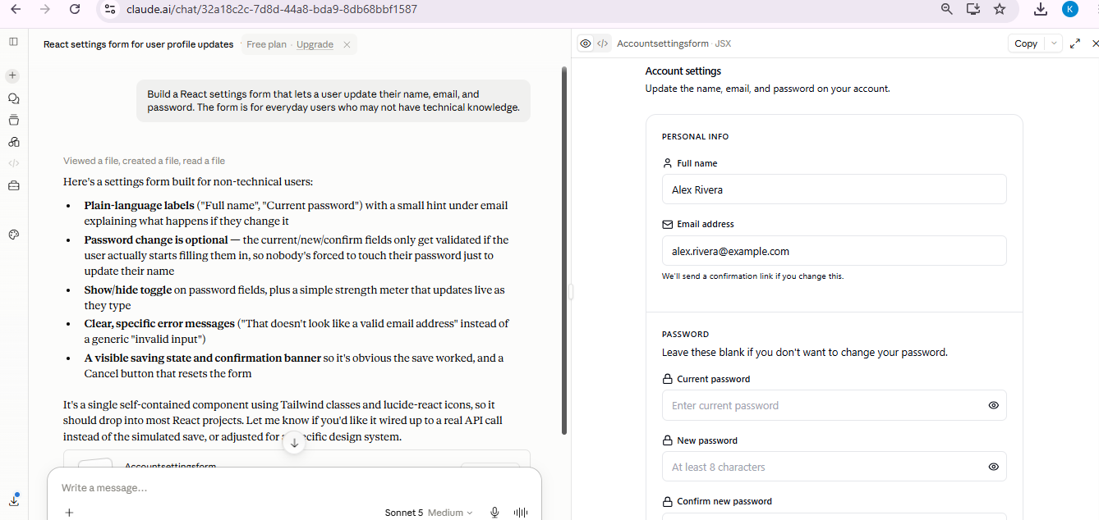

Screenshot 6
