UNIVERSITY OF AZAD JAMMU AND KASHMIR
DEPARTMENT OF SOFTWARE ENGINEERING TECHNOLOGY

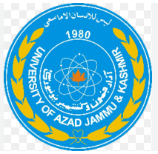
Lab Report
By
NAME: KAINAT PERVAIZ (2024-SET-01)
SUBMITTED TO: ENGR.Sidra Rafique
SUBJECT: IPT

Lab Report 3:
Link:
Copy of Untitled0.ipynb - Colab https://share.google/pOS5iRujBLYtvUBiy
Objective:
To perform basic Python operations and use OpenCV to create images, display text and change text colours.
Software Used
- Python
- Jupyter Notebook
- OpenCV
- NumPy
- Matplotlib

NumPy: working with arrays and numbers
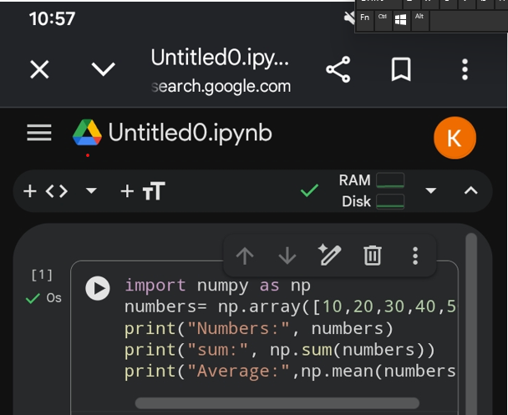
Output
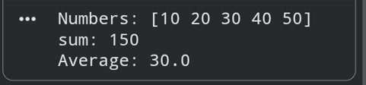
OpenCV: basic image processing
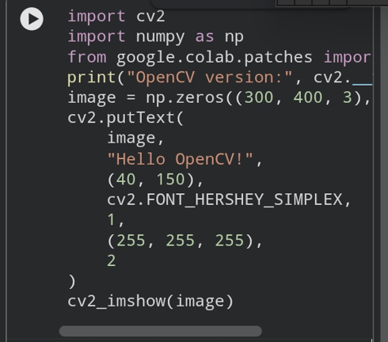
Output
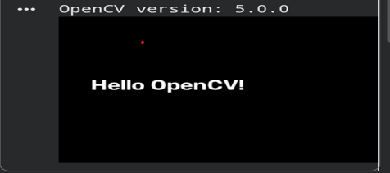

Python Basic Image Operations

Load and display an image
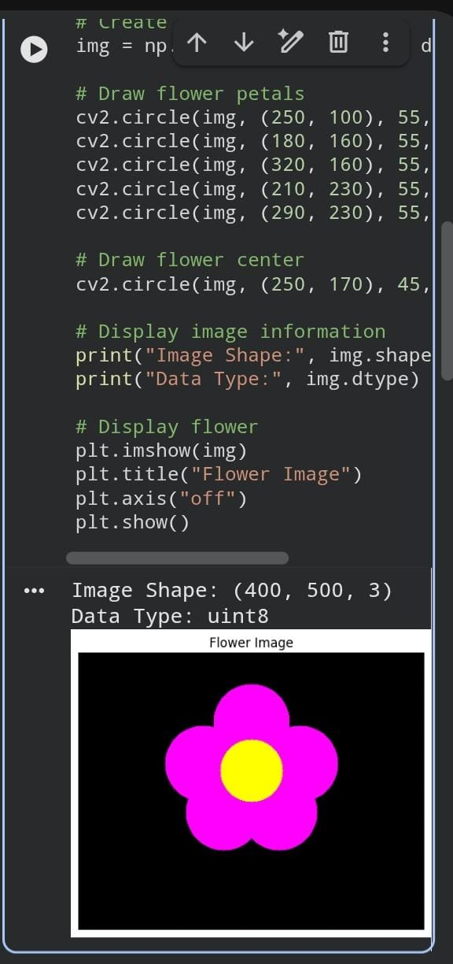

Display its RGB components
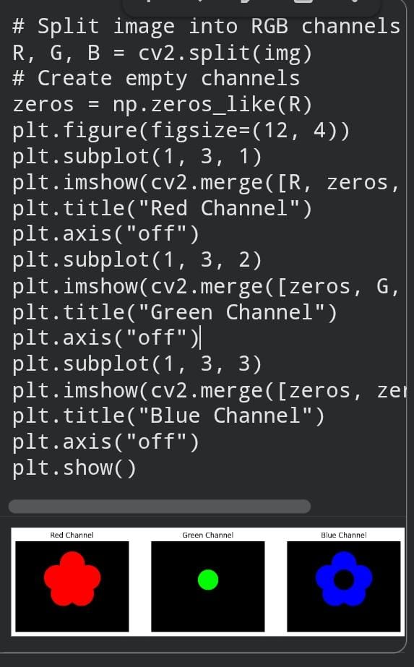
Convert it to grayscale
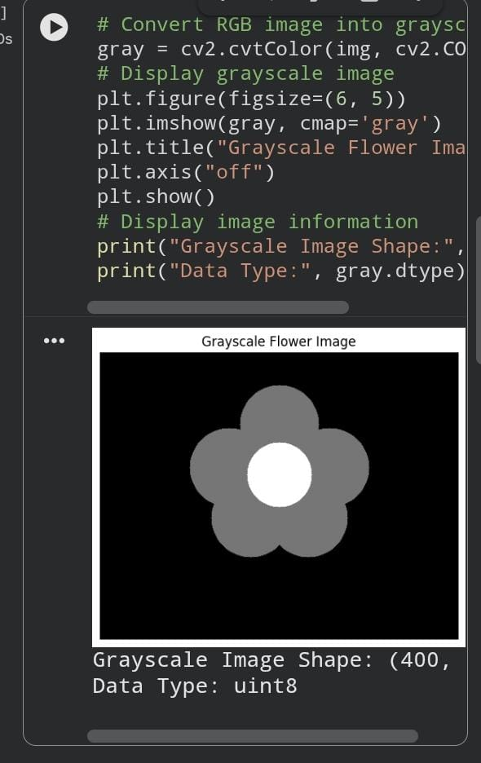

Apply thresholding (global or adaptive)
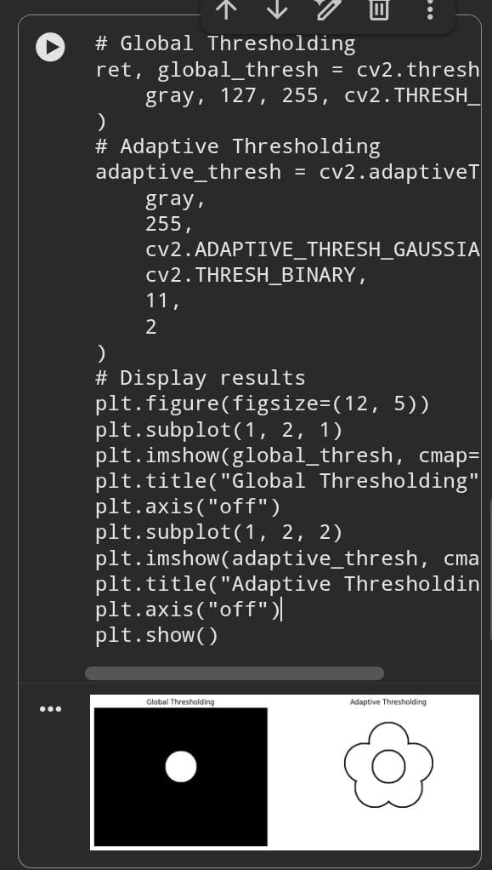
Tasks:
Task 1: Change Numbers Array and Calculate Sum and Average
Code:
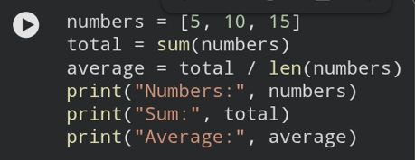
Explanation:
- "numbers" stores three values.
- “sum()" calculates the total.
- "len()" counts the numbers.
Average is calculated by dividing the sum by the total number of values.
Output:
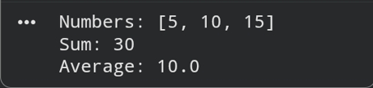
Task 2: Change the Text in OpenCV Program
Code:
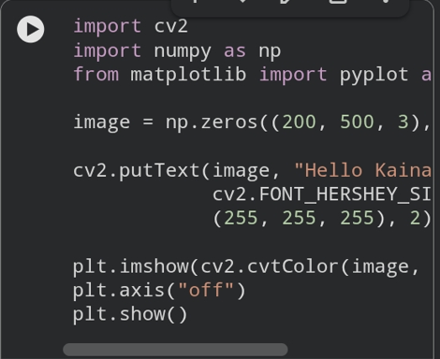
Explanation:
- "np.zeros()" creates a black image.
- “cv2.putText()" adds text to the image.
- “Hello Kainat!"" is our own message.
- "(255, 255, 255)" represents white colour.
- "plt.show()" displays the image.
Output:
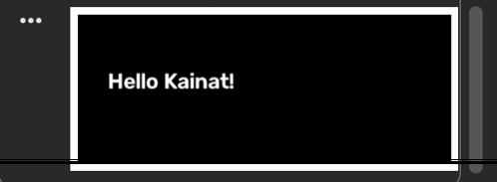
Task 3: Change Image Dimensions
Code:
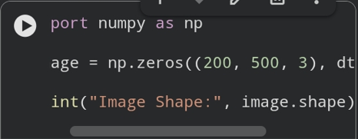
Explanation:
- "np.zeros()" creates a black image.
- "200" represents image height.
- "500" represents image width.
- "3" represents colour channels.
- "image.shape" displays the image dimensions.
Output:
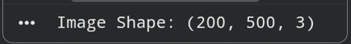
Task 4: Change Text Colour to Red in OpenCV
Code:
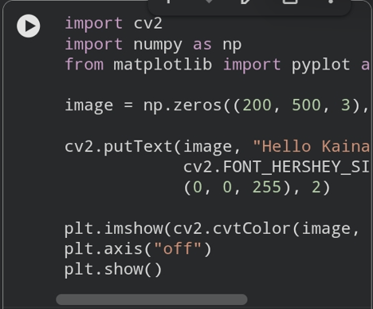
Explanation:
- "cv2.putText()" adds text to the image.
- "(0, 0, 255)" represents red colour.
- OpenCV uses BGR colour order instead of RGB.
- "plt.show()" displays the final image.
Output:
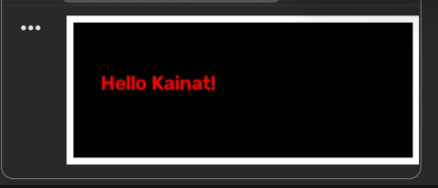
Conclusion
We learned basic Python calculations, image dimensions, text display and colour changes using OpenCV.

