UNIVERSITY OF AZAD JAMMU AND KASHMIR
DEPARTMENT OF SOFTWARE ENGINEERING TECHNOLOGY


Lab Report
By
NAME: KAINAT PERVAIZ (2024-SET-01)
SUBMITTED TO: ENGR.Sidra Rafique
SUBJECT: IPT

LAB TASK 1
Identify image type:
Image: 1


This is a raster image.
Image :02
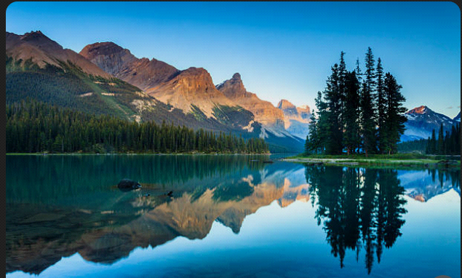
This is a raster image.
Image :3

This is a raster image.
Image :4


This is a vector image.
Image :5

This is a vector image.
TASK NO : 02
Convert Raster image into vector image:

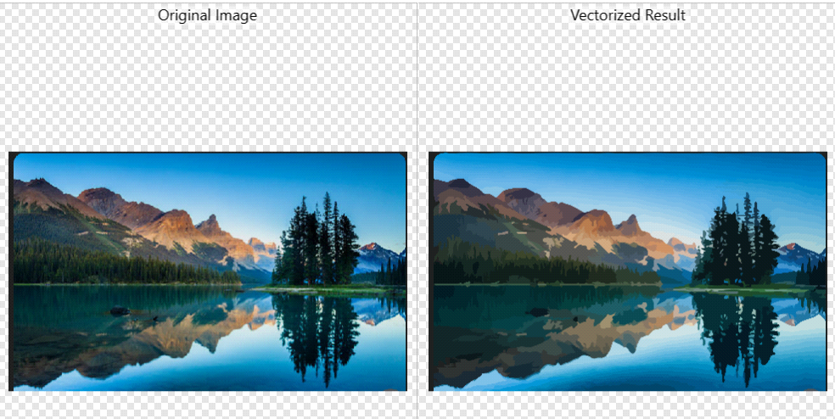
Image No:2

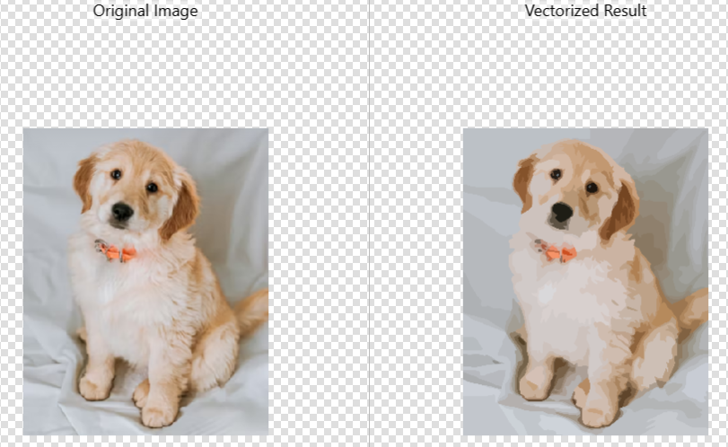
TASK NO: 03
Format Testing:

Image.Jpg:


Image.png:

Comparison of Quality and Size:
Quality of image:
PNG:
- The quality of png img is High.
- The image becomes clear.
JPG:
- The quality of jpg is loss,especially on zooming the pixels become clearly visible.
Size of image:
PNG:
- The size of png is bigger mostly KB,MB.
- Supports transparency background.
JPG:
- The size of jpg img is smaller and occupies less space.
- Donot support transperency.

Conclusion
In this lab, we learned the difference between raster and vector images by identifying different image types. Raster images are made of pixels and lose quality when zoomed, while vector images are made of paths and can be resized without losing quality. We also converted a raster image into a vector image using the trace tool. Finally, we compared JPG and PNG formats and found that PNG provides better quality and transparency support, while JPG has a smaller file size and is suitable for regular image storage.

