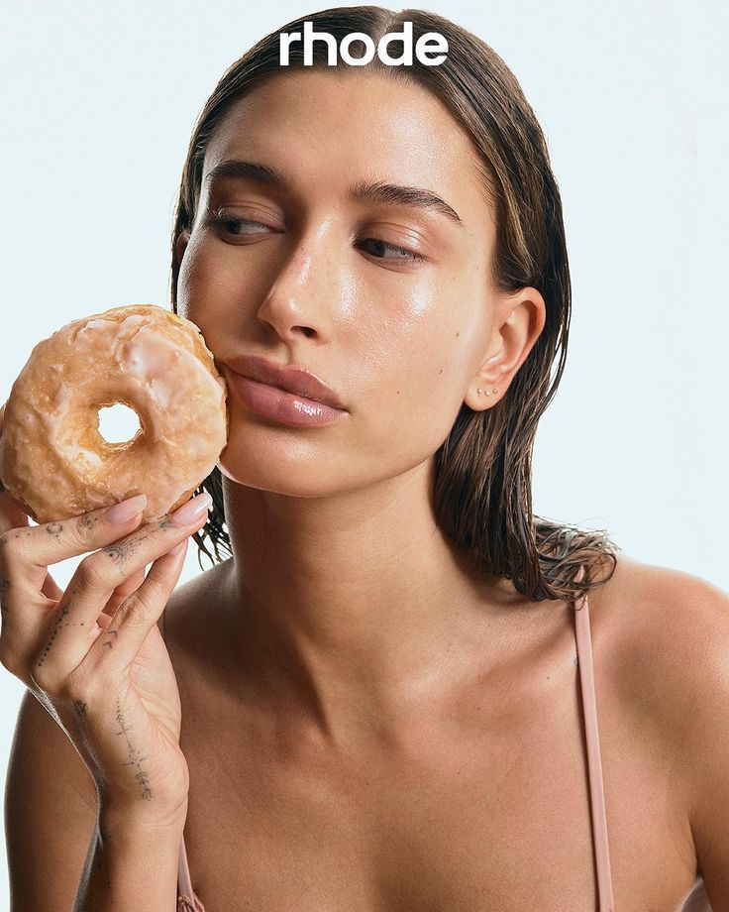
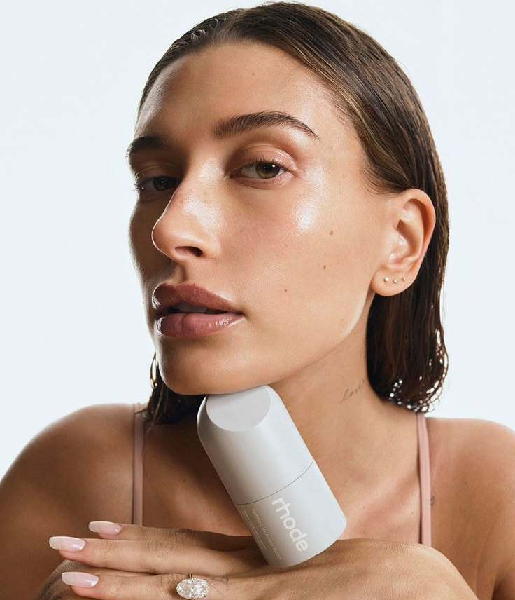
rhode
skincare
1. Barrier butter
2. Pineapple refresh (PGA daily cleanser)
3. Peptide glazing fluid
4. Barrier restore cream
5. Glazing milk

- 100 % Cruelty Free
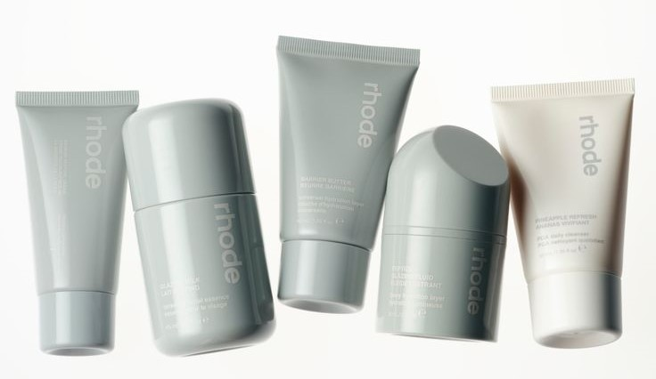
- 100 % Vegan
rhode
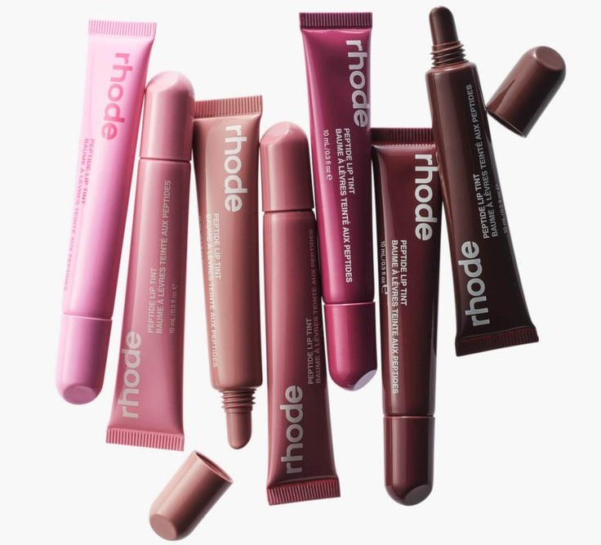
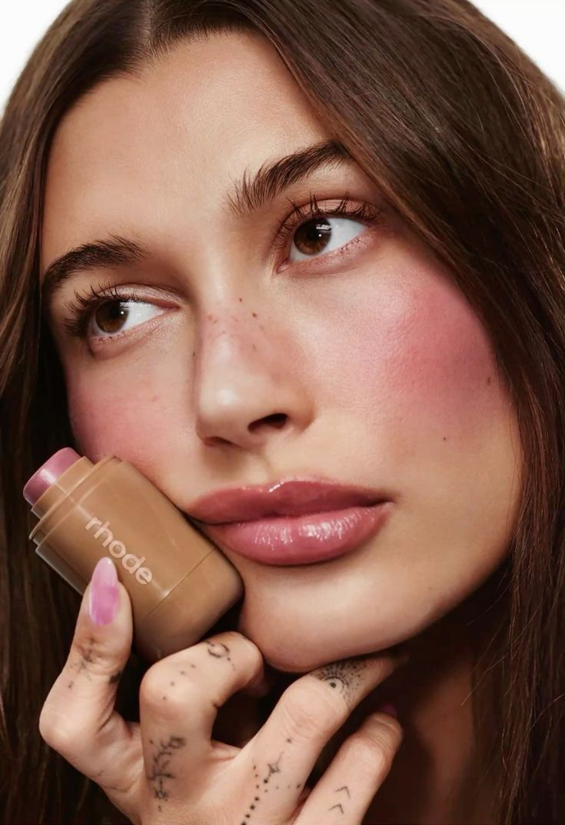
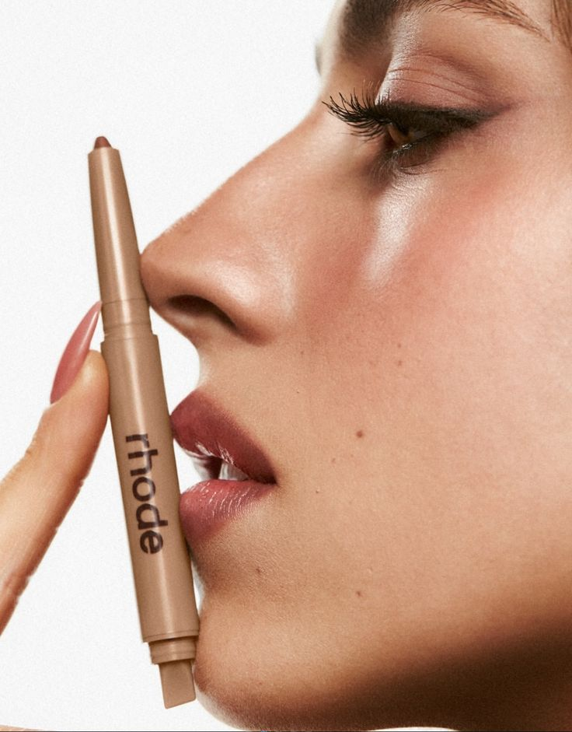
makeup
1. Peptide lip treatment
2. Peptide lip shape
3. Pocket blush
