***Web Systems & Technologies***

***ITL-226***

***Lab Journal 3***



**Student Name: *Kainat Zahra Alvi Sial***

**Enrolment No: *01-135231-040***

**Class and Section: *BSIT-4B***

**Department of Computer Science**

**BAHRIA UNIVERSITY, ISLAMABAD**

**Lab # 3: HTML and HTML5**

**Objectives:**

Learn about HTML and HTML5

**Tools Used:**

Visual Studio

**Submission Date: 22nd Feb 2025**

**Evaluation: Signatures of Lab Engineer:**

**Create a repository on GitHub with a Relevant Lab Number and commit your solution to the repository with appropriate messages.**

**Task # 1:**

Create the following tables using HTML:

* 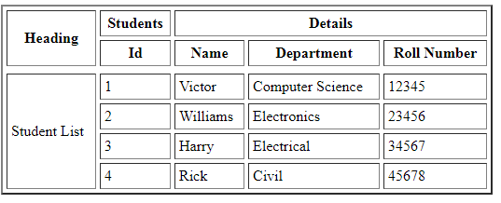
* 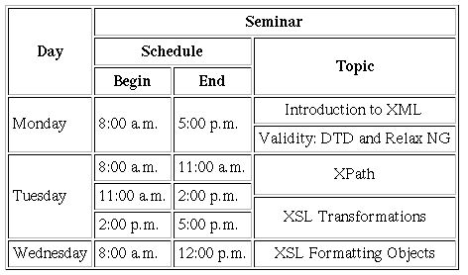

**Procedure/Program:**

<html lang="en">

<head>

    <meta charset="UTF-8">

    <meta name="viewport" content="width=device-width">

    <title>HTML TABLE 1</title>

</head>

<body>

    <table style="border: 1px solid black;">

        <tr>

             <th style="border: 1px solid black;" rowspan="2"> Heading</th>

             <th style="border: 1px solid black;">student</th>

             <th style="border: 1px solid black;" colspan="3">Details</th>

         </tr>

         <tr>

            <th style="border: 1px solid black;">Id</th>

            <th style="border: 1px solid black;">Name</th>

            <th style="border: 1px solid black;">Department</th>

            <th style="border: 1px solid black;">Roll Number</th>

          </tr>

        <tr>

             <th style="border: 1px solid black;" rowspan="5"> Student List</th>

         </tr>

        <tr>

            <td style="border: 1px solid black;">1</td>

            <td style="border: 1px solid black;">victor</td>

            <td style="border: 1px solid black;">computer science</td>

            <td style="border: 1px solid black;">12345</td>

        </tr>

        <tr>

            <td style="border: 1px solid black;">2</td>

            <td style="border: 1px solid black;">Williams</td>

            <td style="border: 1px solid black;">Electronics</td>

            <td style="border: 1px solid black;">23456</td>

        </tr>

        <tr>

            <td style="border: 1px solid black;">3</td>

            <td style="border: 1px solid black;">Harry</td>

            <td style="border: 1px solid black;">Electrical</td>

            <td style="border: 1px solid black;">34567</td>

        </tr>

        <tr>

            <td style="border: 1px solid black;">4</td>

            <td style="border: 1px solid black;">Rick</td>

            <td style="border: 1px solid black;">civil</td>

            <td style="border: 1px solid black;">45678</td>

        </tr>

     </table>

     <table style="border: 1px solid black;">

        <tr>

            <th style="border: 1px solid black;" rowspan="4">Days</th>

        </tr>

        <tr>

            <th style="border: 1px solid black;" colspan="3">Seminar</th>

        </tr>

        <tr>

            <th style="border: 1px solid black;" colspan="2">Schedule</th>

            <th style="border: 1px solid black;" rowspan="2">Topic</th>

        </tr>

        <tr>

            <th style="border: 1px solid black;">Begin</th>

            <th style="border: 1px solid black;">End</th>

        </tr>

        <tr>

            <td style="border: 1px solid black;">Monday</td>

            <td style="border: 1px solid black;">8:00 am</td>

            <td style="border: 1px solid black;">5:00 pm</td>

            <td style="border: 1px solid black;"> Introduction to XML <hr> Validity: DTD and Relax NG</td>

        </tr>

        <tr>

            <td style="border: 1px solid black;" rowspan="3">Tuesday</td>

            <td style="border: 1px solid black;">8:00 am</td>

            <td style="border: 1px solid black;">11:00 am</td>

            <td style="border: 1px solid black;" rowspan="3"> XPath <hr> XSL Transformation </td>

        </tr>

        <tr>

            <td style="border: 1px solid black;">11:00 am</td>

            <td style="border: 1px solid black;">2:00 pm</td>

        </tr>

        <tr>

            <td style="border: 1px solid black;">2:00 am</td>

            <td style="border: 1px solid black;">5:00 pm</td>

        </tr>

        <tr>

            <td style="border: 1px solid black;">Wednesday</td>

            <td style="border: 1px solid black;">8:00 am</td>

            <td style="border: 1px solid black;">12:00 pm</td>

            <td style="border: 1px solid black;"> XSL Formatting Object </td>

        </tr>

     </table>

</body>

</html>

**Result/Output:**

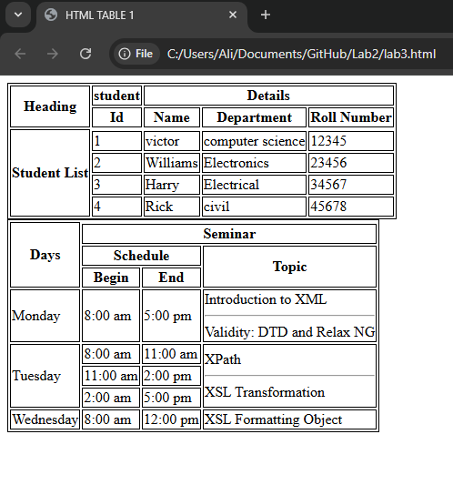

**Analysis/Conclusion:**

*This part of the lab focused on implementing* ***HTML tables*** *while incorporating* ***rowspan and colspan attributes****. These attributes help merge cells, improving table readability and organization. We structured a table efficiently, ensuring proper alignment and presentation of data.*

**Task # 2:**

Create the following web page using HTML Semantic Elements, i.e., section, aside, article, nav, header, footer, etc. Your web page must look similar to the following example.

**Procedure/Program:**

<header>

    <h1>Pakistan Economy</h1>

    <p>A look at the ecnomic landscape of Pakistan</p>

</header>

<nav>

    <ul>

        <li><a href="#">Overview</a></li>

        <li><a href="#">Sectors</a></li>

        <li><a href="#">Challenges</a></li>

        <li><a href="#">Future</a></li>

    </ul>

</nav>

<section class="sec">

    <div class="art">

        <article>

            <h2>Current Economic Situation</h2>

            <p>Pakistan's economy is currently facing a number of challenges, including inflation, debt, and a trade deficit.

                The government is taking steps to address these issues...

            </p>

        </article>

        <article>

            <h2>Key Economics Indicator</h2>

            <p>Here are some important economic indicator for pakistan:</p>

            <ul>

                <li>GDP Growth: (Insert Data)</li>

                <li>Inflation Rate: (Insert Data)</li>

                <li>Unemployment Rate: (Insert Data)</li>

            </ul>

        </article>

        <article>

            <h2>Major Industries</h2>

            <p>Pakistan has several important industries, including textiles, agriculture, and manufacturing...

            </p>

        </article>

    </div>

</br>

    <div class="side">

        <aside>

                <h2>Related Resources</h2>

                <ul>

                    <li><a href="#">Ministry of Finance</a></li>

                    <li><a href="#">State Bank of Pakistan</a></li>

                    <li><a href="#">World Bank Data</a></li>

                </ul>

            </aside>

    </div>

</section>

</br>

</br>

</br>

<footer>

    <p>© 2025 Pakistan Economy Updates</p>

</footer>

**Result/Output:**

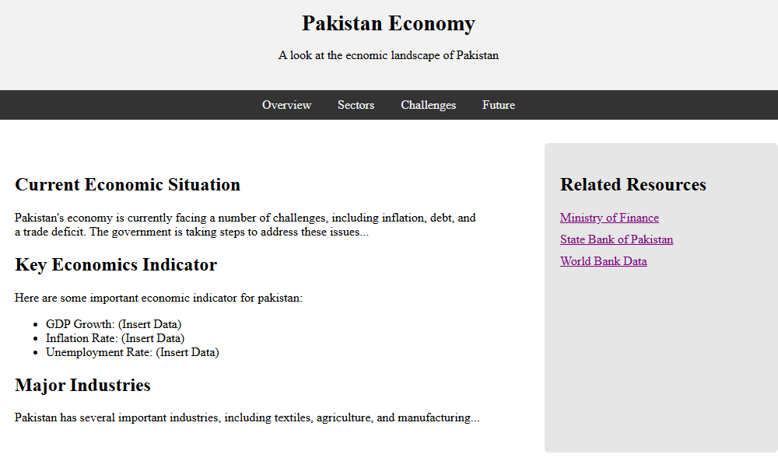



**Analysis/Conclusion:**

*Through this task, we learned how to use* ***HTML5 semantic elements effectively*** *and structure web content logically. The proper usage of these elements enhances the* ***user experience and accessibility*** *of webpages.*