# Git link

https://github.com/kaineltk/Kain_Spiteri_DGD6_2B_Database_Essentials

# A screenshot of a computer AI-generated content may be incorrect.Task 1

# Task 2

## Audio

### A close-up of a computer screen AI-generated content may be incorrect.Files Chunks

## Sprites

### Files Chunks

## Scores

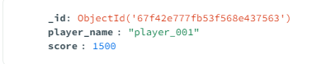

# A screenshot of a computer AI-generated content may be incorrect.Task 3

local:

Vercel: https://kain-spiteri-dgd-6-2-b-database-essentials.vercel.app/docs

# Task 4

Remove 0.0.0.0/0 (This allows everyone)

