Car Project

Himmy Kainth

Contents

Project Proposal 2

Goals and Purposes 2

Scope of Project 3

Deliverables Concept 3

Specifications of Projects 3

Target Audience 3

Tasks for the project and Achievements 3

Requirements for Resource 4

Risks to Project 4

Detail Design 6

Home Page 6

Customer Page 7

Staff Page 7

Cars Page 8

Register Page 9

Login Page 10

Testing Project 10

Checking for Device Usability 10

# Project Proposal

## Goals and Purposes

The aim of this project is aware to customers to see different types of cars and see the prices of the cars. There is a regular user in this program. Any car information can be inserted, modified and deleted by the user.

## Scope of Project

Selling Cars is the scope of this project. And to demonstrate the available vehicles. New users can sign up for the program and can purchase vehicles.

## Deliverables Concept

Some deliverables will involve this project. These deliverables are outlined in the following table.

|  |  |
| --- | --- |
| **Deliverable** | **Description** |
| Final Report | This website totally about the different types of the cars. |
| Programme executable | This would be the project's executable code. |
| Documentation for the Consumer | This will demonstrate how the web application can be used. |
| Test Plan | This will include the project's test information. |

## Specifications of Projects

* Stable log-in and account registration.
* Editing and deleting accounts by the Administrator.
* A user can add, modify and update the details of any car.

## Target Audience

Normal users and anyone who is interested in buying cars from the age of 18 and up to 100 years will go.

## Tasks for the project and Achievements

The following table shows the Project Activities and Achievements

|  |  |  |  |  |  |  |  |  |  |  |  |  |  |  |  |
| --- | --- | --- | --- | --- | --- | --- | --- | --- | --- | --- | --- | --- | --- | --- | --- |
| Project Stages | Major Tasks | Week1-2 | | | | Week-2-3 | | | | | Week-3-4 | | | | |
| Planning | Study in Technology |  |  |  |  |  |  |  |  |  |  |  |  |  |  |
| Start Meeting Off |  |  |  |  |  |  |  |  |  |  |  |  |  |  |
| Proposal of Project |  |  |  |  |  |  |  |  |  |  |  |  |  |  |
| Proposal Documentation |  |  |  |  |  |  |  |  |  |  |  |  |  |  |
| Execution – 1 | Database Design |  |  |  |  |  |  |  |  |  |  |  |  |  |  |
| User Interface Design |  |  |  |  |  |  |  |  |  |  |  |  |  |  |
| Execution of Identity Process |  |  |  |  |  |  |  |  |  |  |  |  |  |  |
| Implementation of User Interface |  |  |  |  |  |  |  |  |  |  |  |  |  |  |
|
| Testing |  |  |  |  |  |  |  |  |  |  |  |  |  |  |

## Requirements for Resource

Following technology and methods of growth:

* Asp.net MVC Framework.
* Identity framework- ASP.
* Windows Operating System.
* 64-bit Processor and 4 GB RAM.

## Risks to Project

The following are the high-level risks defined that could impact the completion and progress of the project:

* The complexity and length of projects can be underestimated.
* The project must have exemplary protection because sensitive information is stored in the system.

# Detail Design

## Home Page

This is the application's primary landing page. There are 6 menus on this navigation tab- Home, Car, Staff, Customer, Register and Login.

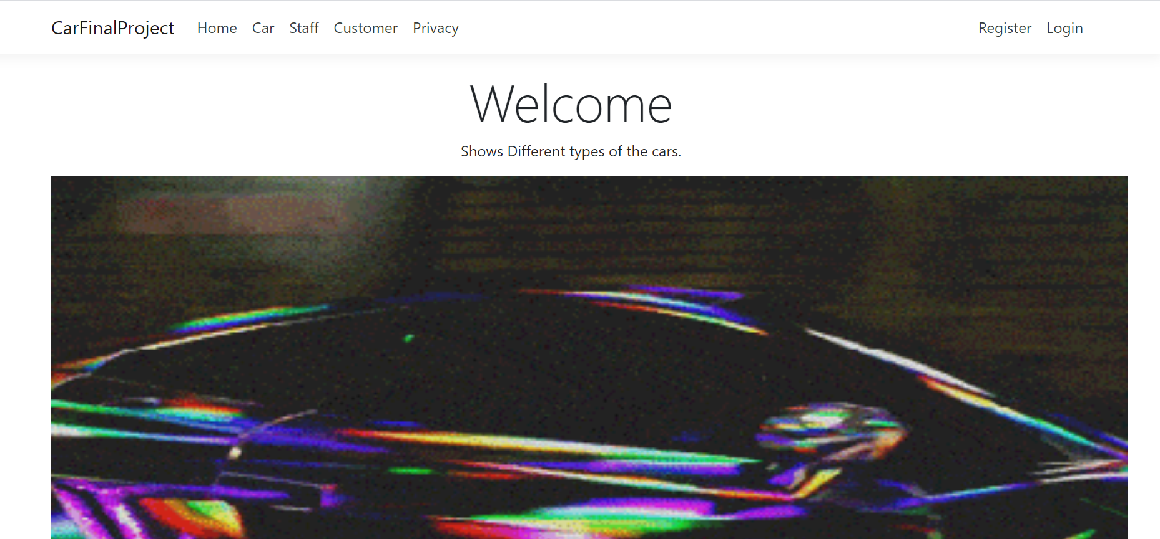

## Customer Page

Registered users can add new customers with the aid of this page, edit their details and remove the information, while unauthorized users can only view the data.

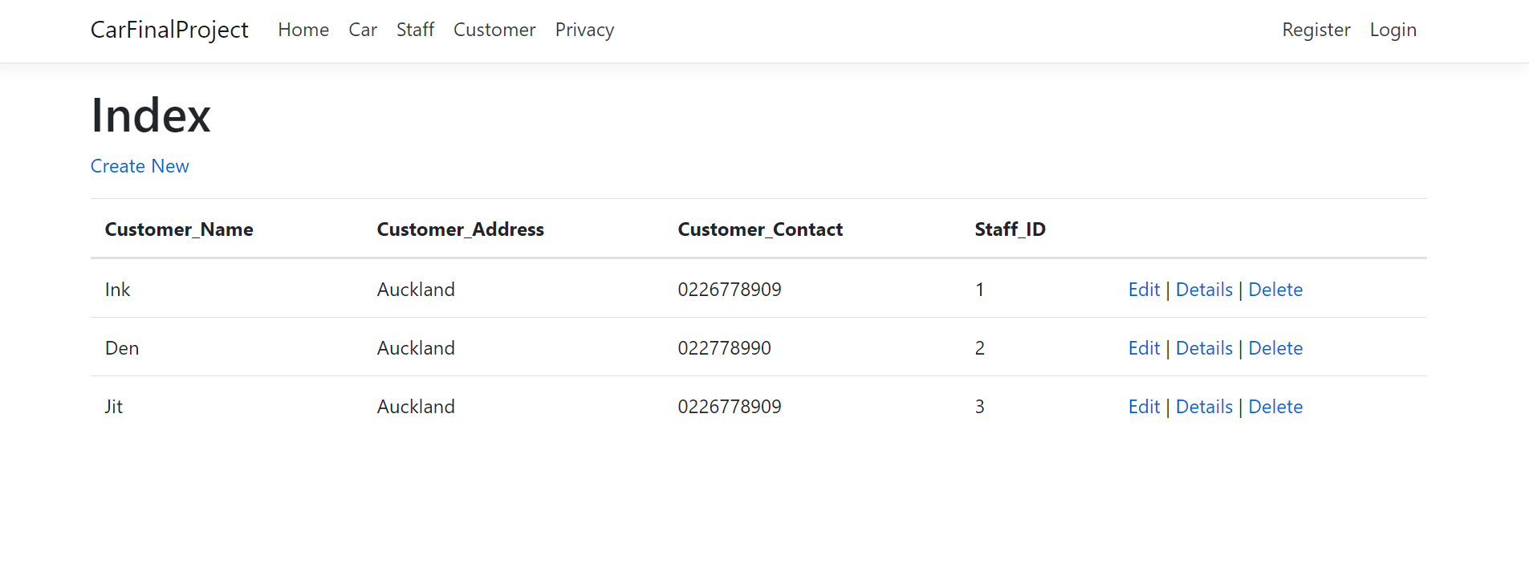

## Staff Page

Authorized users can add new staff details with the support of this page, edit their details and remove the information, while unauthorized users can only view the data.

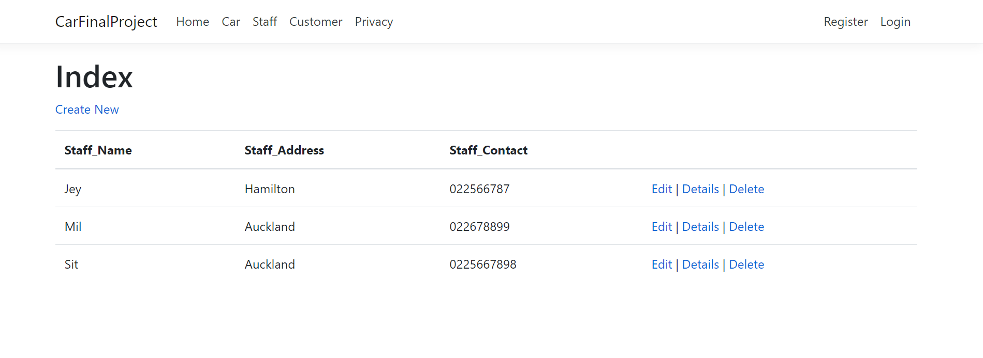

## Register Page

The register page enables the user to register their profile to access the data to be added, modified and removed.

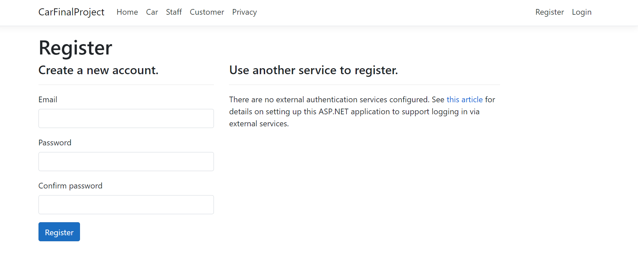

## Login Page

The login page will allow users to access the web application in full.

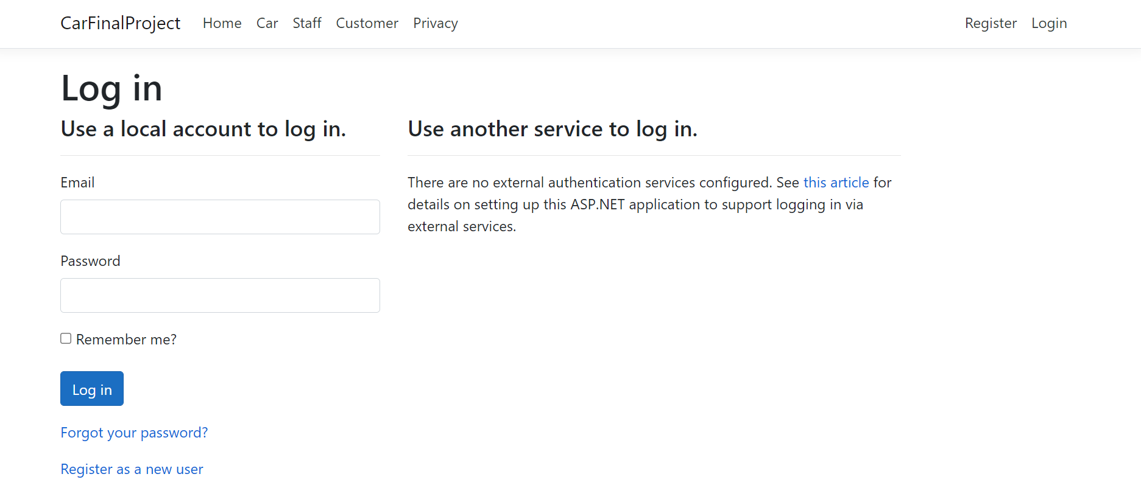

# Testing Project

## Checking for Device Usability

|  |  |  |  |  |  |  |
| --- | --- | --- | --- | --- | --- | --- |
| **Tester** | | **Answer Scale** | | | | |
| **No.** | **Question** | **Strongly Disagree (1)** | **Disagree (2)** | **Normal (3)** | **Agree (4)** | **Strongly Agree (5)** |
| 1 | I think that I would like to use this system frequently |  |  |  |  |  |
| 2 | I found the system unnecessarily complex |  |  |  |  |  |
| 3 | I thought the system was easy to use |  |  |  |  |  |
| 4 | I think that I would need the support of a technical person to be able to use this system |  |  |  |  |  |
| 5 | I found the various functions in this system were well integrated |  |  |  |  |  |
| 6 | I thought there was too much inconsistency in this system |  |  |  |  |  |
| 7 | I would imagine that most people would learn to use this system very quickly |  |  |  |  |  |
| 8 | I found the system very cumbersome to use |  |  |  |  |  |
| 9 | I felt very confident using the system |  |  |  |  |  |
| 10 | I needed to learn a lot of things before I could get going with this system |  |  |  |  |  |

# User Manual

## Guide to Quick Setup

As a web application, no complex configuration is needed for the targeted users. However, to access its functionality, registration via the website is required. The web application can be accessed via local host.

To register, just press the "Register!" button. To the Navbar.

# General Information

### System Overview

Any car information can be inserted, modified and removed in this application user. Only registered users have full web application access.

# System Summary

## System Configuration

## Car is a web application built using the Asp.net Core Web Application. It will run on most current web browsers and no special device configuration will be needed. It will need internet access to operate as a web application.