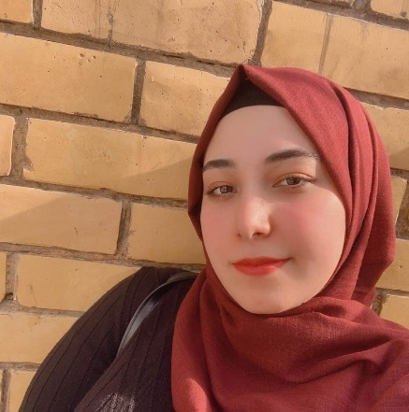

**/Summary**

Self-motivated, organized, and competent programmer, seeking to use my programming expertise for developing quality, as well as enhancing my programming skills in an environment which encourages me to perform my best.

**/Work experience**

**Al-Riyad Group Company**for lighting solutions

**Cashier & Customer service:**

* Accounting using (Mawared ERP).   
   Jan/2019-Aug/2021

Baghdad / Karrada

**Al-Min & Salwa**Bakery and restaurant  
**Data entry, Cashier & Marketing:**

* Accounting using ([Al-Ameen](https://alameen-ksa.com/)).
* Design brand, logos & Ads  
  (Photoshop).

May/2019 – Jan/2020   
Baghdad / Palestine Street

**<CV>**

Zainab Salah  
(webDeveloper)