# Neural Network for predicting voltages levels: Report 2

19/10/2022

The neural network input and output layer is kept the same as shown in Table 1.

|  |  |  |
| --- | --- | --- |
| Number of features | Input Layer | Output Layer |
| 2 | Reference Voltages from Transformers 1 and 2 | Voltages levels of all buses (pu) |
| 2 | Active Power demand from Transformers 1 and 2 |
| 3 | Active power generated from PVs in buses 12, 18 and 25 (MV) |
| 2 | Active power generated from PVs in buses 29 and 32 (LV) |
| 40 | **Average** active power load demands from previous days |
| 40 | **Average** reactive power load demands from previous days |

Table 1 - Neural Network model description.

The changes made were:

* Added more hidden layers and neurons to make it bigger. The final model had 89(Input) x 200 x 400 x 100 x 40(Output) neurons.
* Added Dropout layers, with a 20% rate, to control the overfitting.
* Trained with a batch size of 70, which only needed around 30 epochs to reach a desirable loss value.
* The biggest change was the data normalization. Before I was normalizing all the input data (Voltages, Active Power, and Reactive Power) together, but they had values with different ranges. My mistake. Now, I’m normalizing them separately, which leads to a more accurate prediction.

With these changes, we can see, in Figure 1, how the training was held (all the training was made using the dataset with std = 0.25). The training loss (MSE) rapidly decreased and reached values around 10-6.

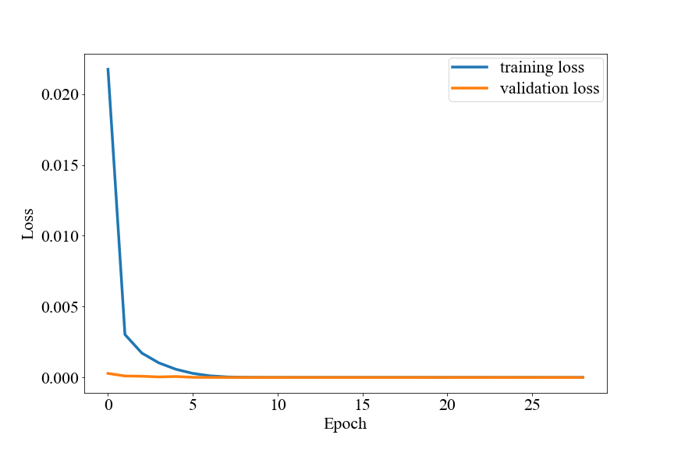

With this model the errors in the test set were: MAE = 0.001745 and MSE = 0.00281. Below we can see the predictions for bar 5, 15 and 38.

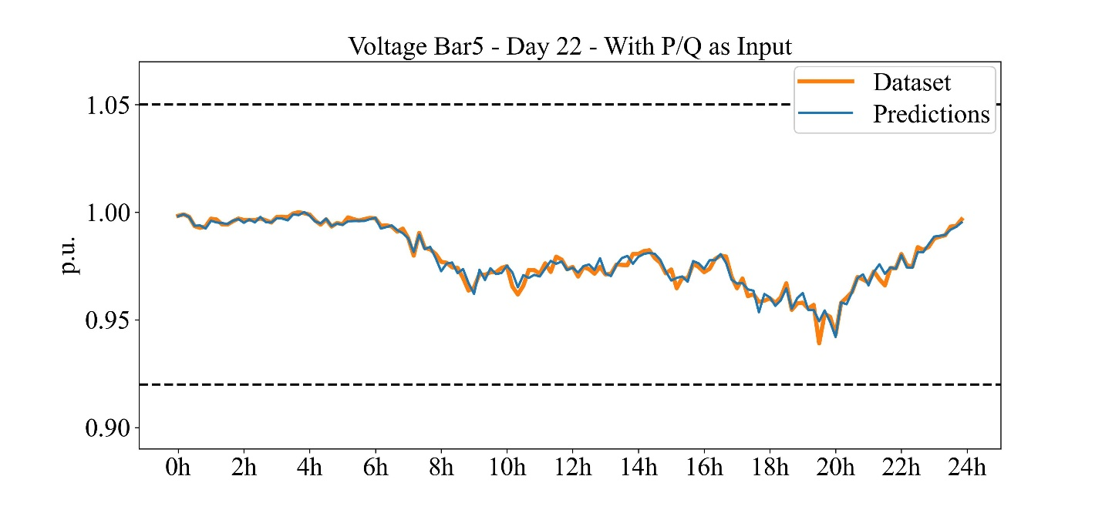

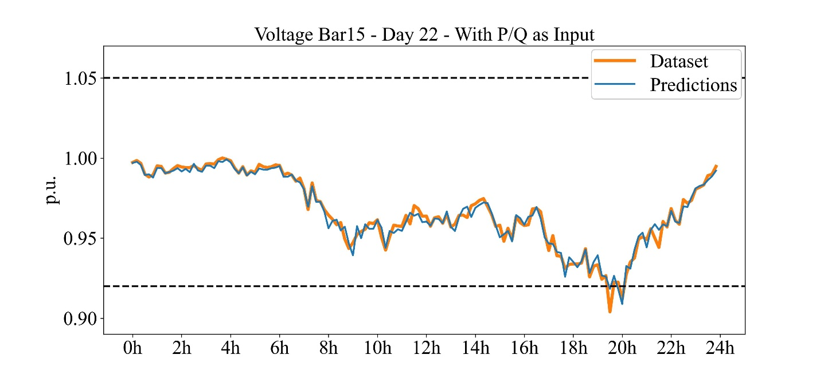

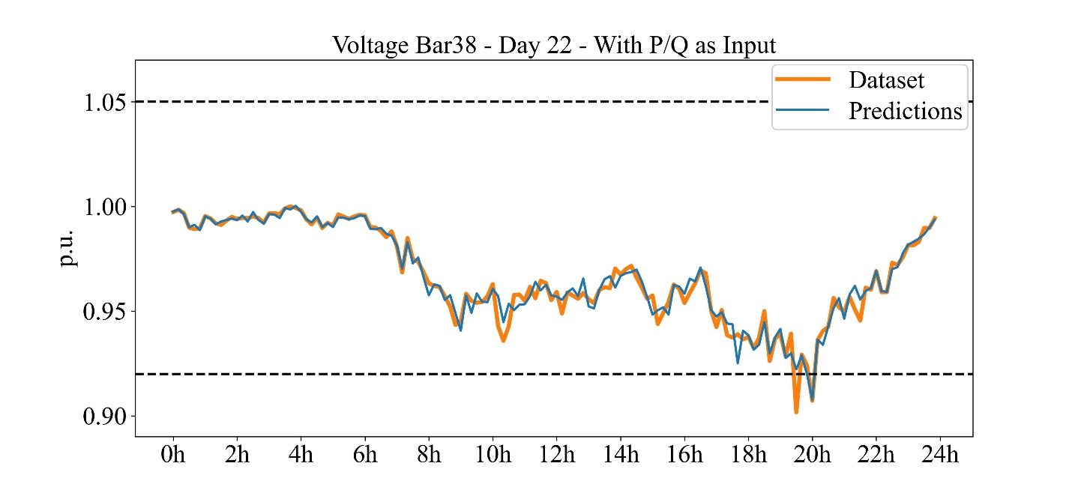

To check if it was overfitting, I tested this model with the dataset that had std = 0.5 (more variability), the metrics were: MAE = 0.0029 and MSE = 0.00449. And below we can see the predictions for the same bars showing that it also was capable of accurate predicting those voltages.

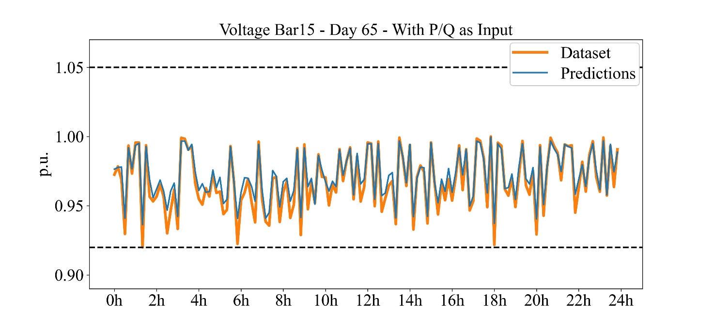

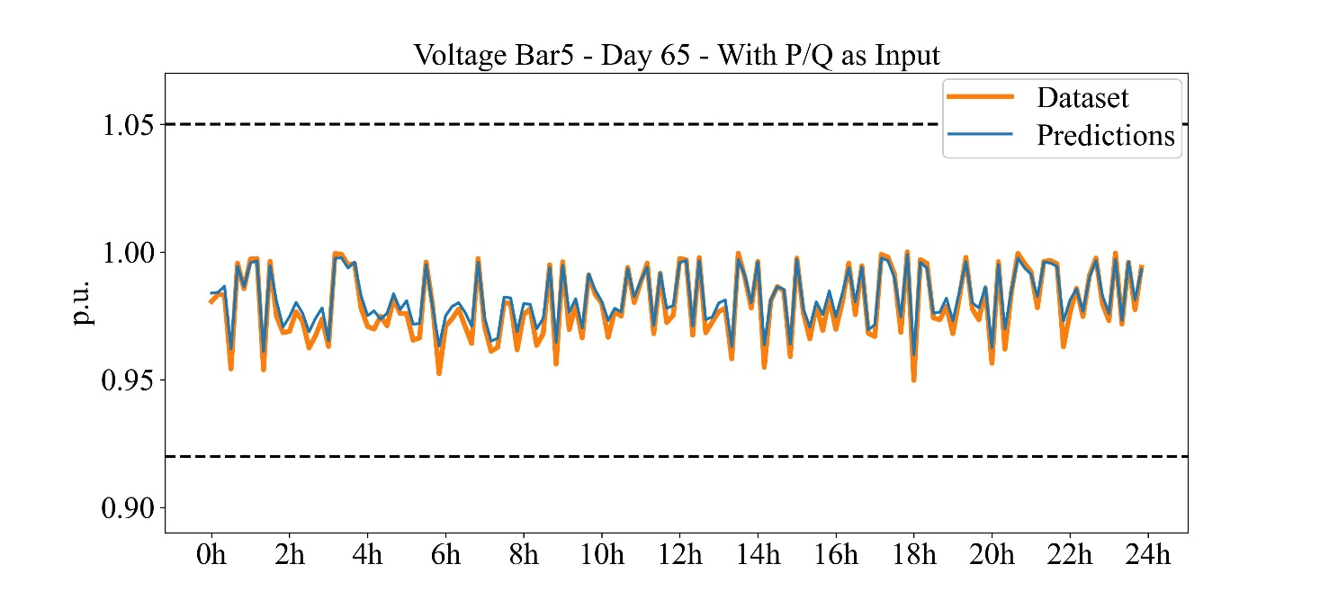

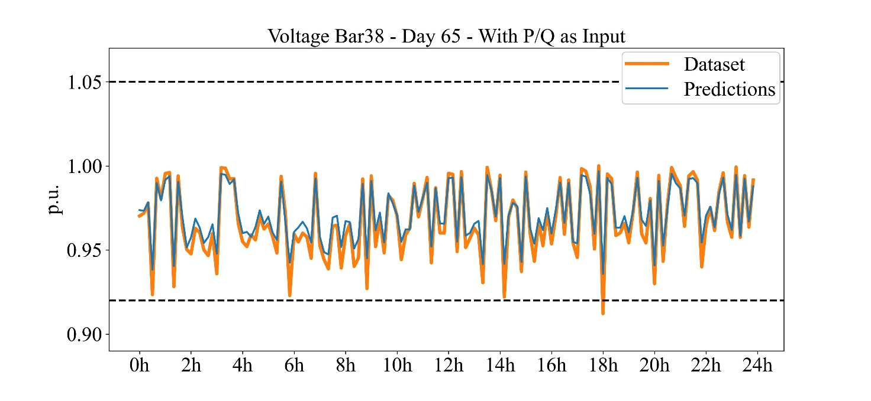

The results are quite promising for this network, but it is also heavily dependent on the historical data of the loads. Many hyperparameters could be finned tunned as well (learning rate, number of neurons and layers, batch size, etc), to find the best configuration. Maybe testing it with other load profiles would better indicator of how well the generalization is.

I also think that other neural network models could be tested, for example, an LSTM for predicting the real-time loads P and Q values and with these values run a power flow to acquire the voltages.