# Neural Network for predicting voltages levels: Report 3

20/12/2022

A recap: I trained a neural network to predict real-time voltages levels of a MV-LV distribution network that had some PV, as shown below:

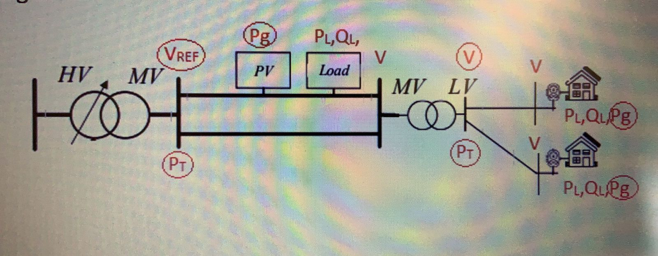

Also, the description of the input and output layers is shown in Table 1.

|  |  |  |
| --- | --- | --- |
| Number of features | Input Layer | Output Layer |
| 2 | Reference Voltages from Transformers 1 and 2 | Voltages levels of all buses (pu) |
| 2 | Active Power demand from Transformers 1 and 2 |
| 3 | Active power generated from PVs in buses 12, 18 and 25 (MV) |
| 2 | Active power generated from PVs in buses 29 and 32 (LV) |
| 40 | **Average** active power load demands from previous days |
| 40 | **Average** reactive power load demands from previous days |

The results were quite good, with errors in the test set of MAE = 0.001745 and MSE = 0.00281.

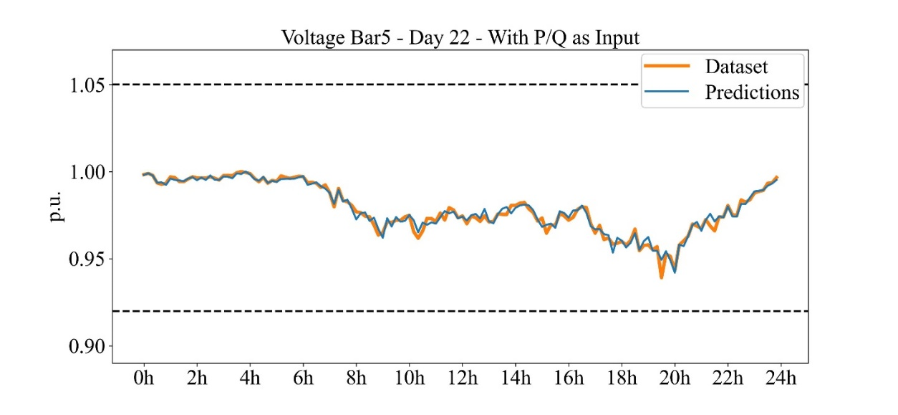

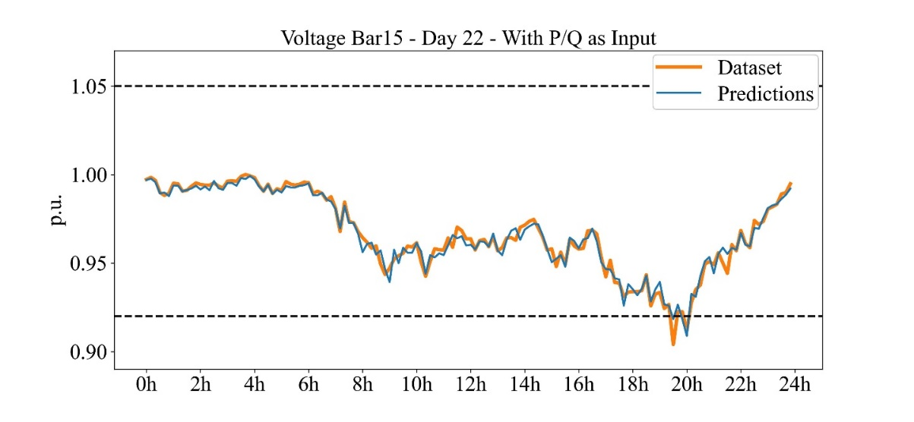

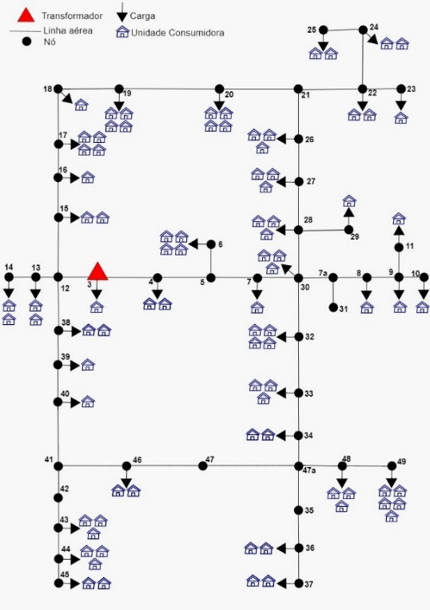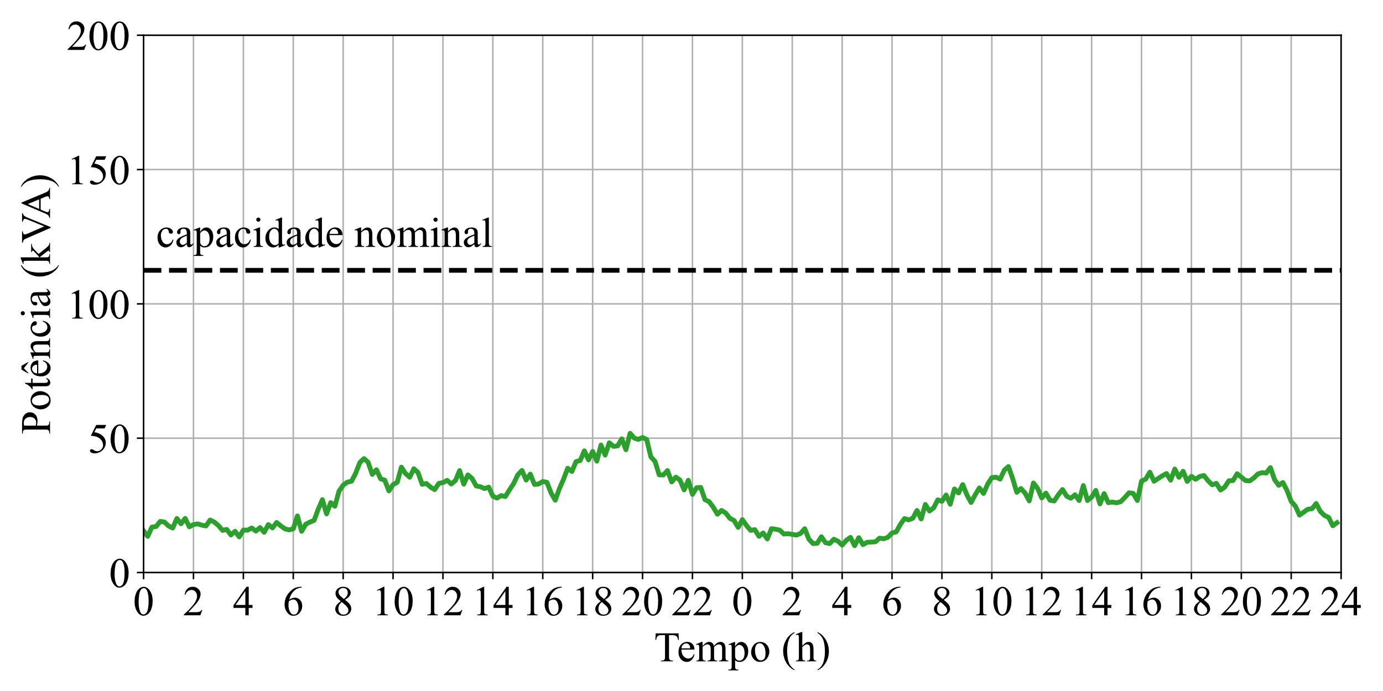So, from our last meeting the task was to train this NN but this time with a 3-phase distribution system using OpenDSS. For this I used the real network from Ijui/RS and placed 5 PV systems (2.1kWp) in the 11, 22, 32, 36, and 44 buses. I also, modified the Monte Carlo code and generated 1000 samples to work on.

Figure 1 – Adopted Loadshape from the 88 residential loads

As I was working with a 3-phase system, the loads changed from the previous case. This time I had 1-phase, 2-phase and 3-phase loads, and because of that some buses didn’t have all the voltages defined.

So, I chose to **train a NN for every phase in the system** as every phase would have some differences for the input and output. The description of these layers kept like this:

|  |  |  |
| --- | --- | --- |
| Number of features | Input Layer | Output Layer |
| 2 | Active and Reactive Power demand from Transformer | Voltages levels of all buses (pu) |
| 1 | Active power generated from PVs |
| 88 | **Average** active power load demands from previous days |
| 88 | **Average** reactive power load demands from previous days |

As OpenDSS doesn’t work defining buses, all the input information of power demands comes from the 88 loads in the system. Also, as the reference voltages from the transformer didn’t change over time it had no impact in the NN, so I removed it. In summary, all the input features were changed to power demands and the prediction kept the same (voltages levels).

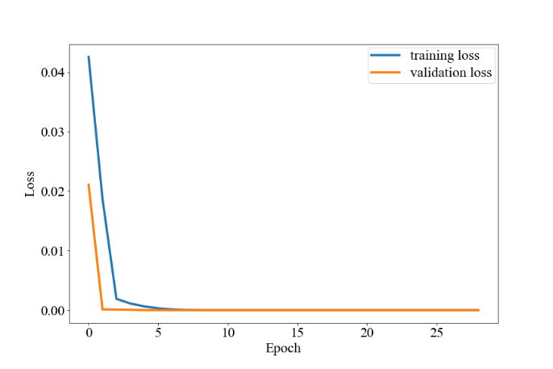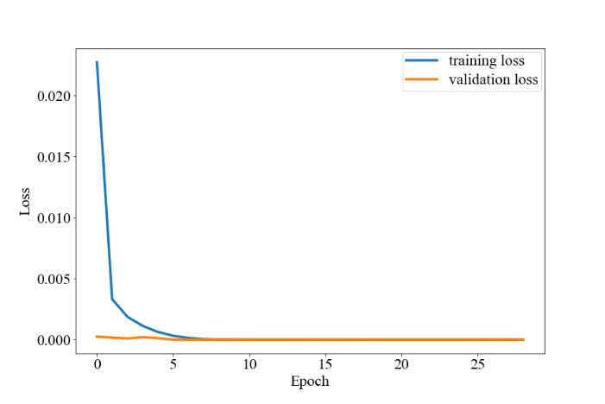The training of all the models for each phase was very similar, all the models reached a MAE = 0.001 and MSE = 0.001 in the test set.

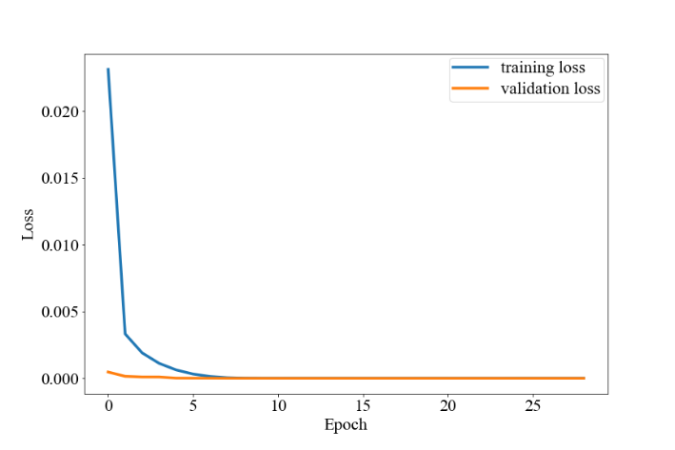

Figure 4 - Training Loss for Phase C

Figure 2 - Training Loss for Phase B

Figure 3 - Training Loss for Phase A

Results – **Phase A**

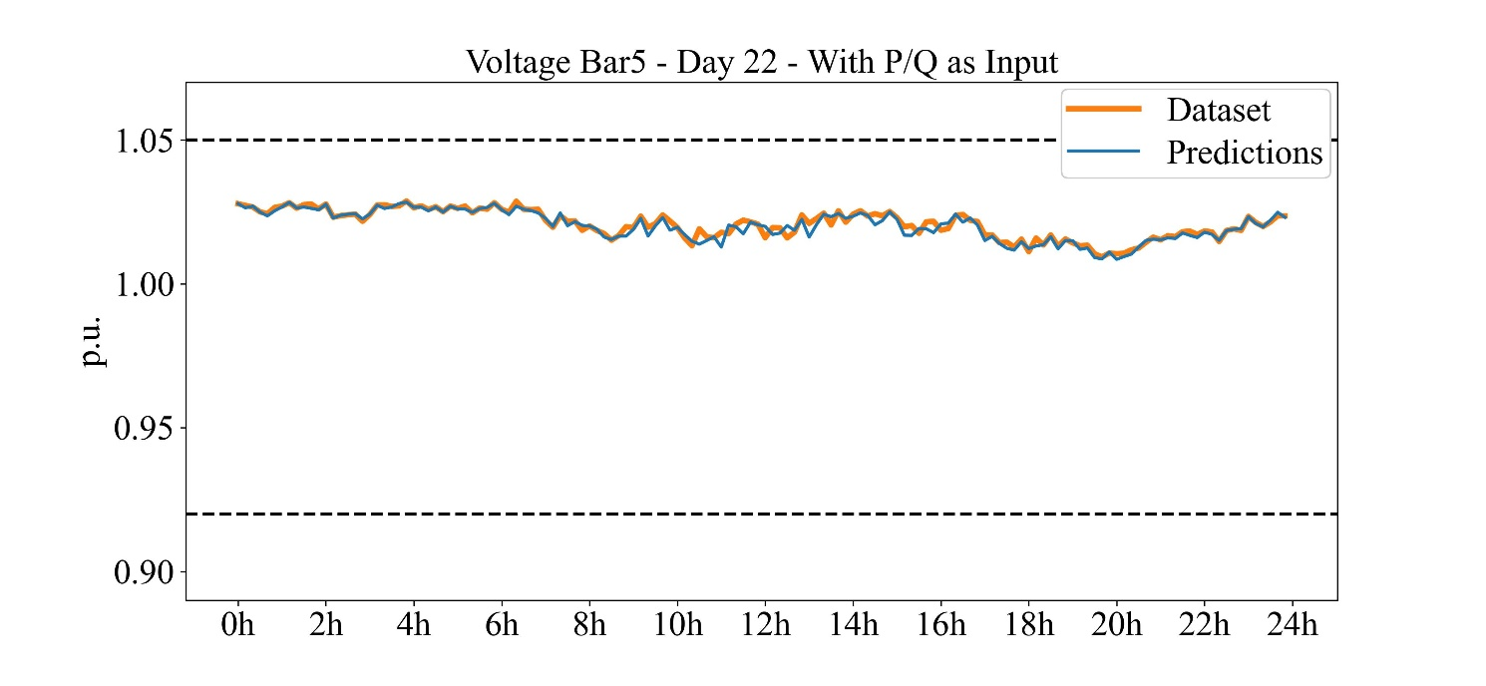

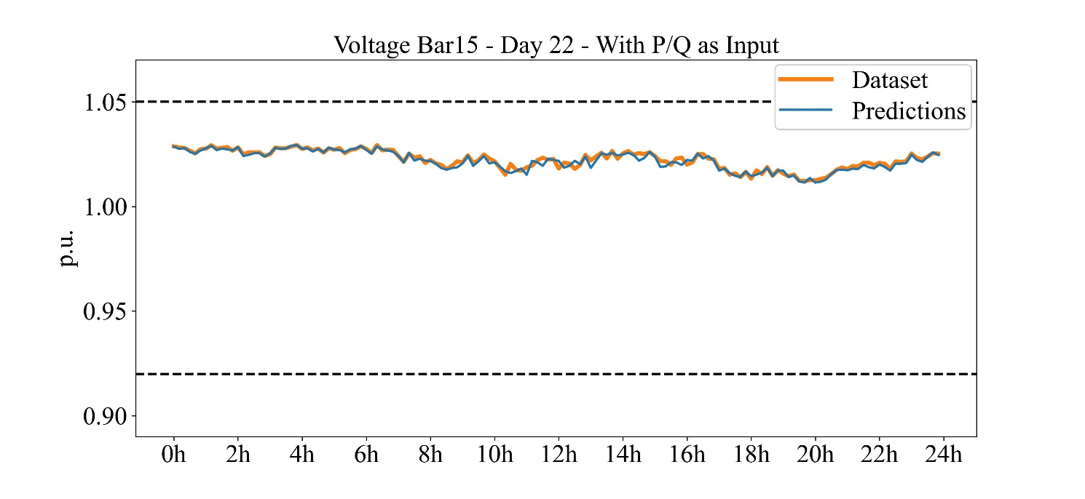

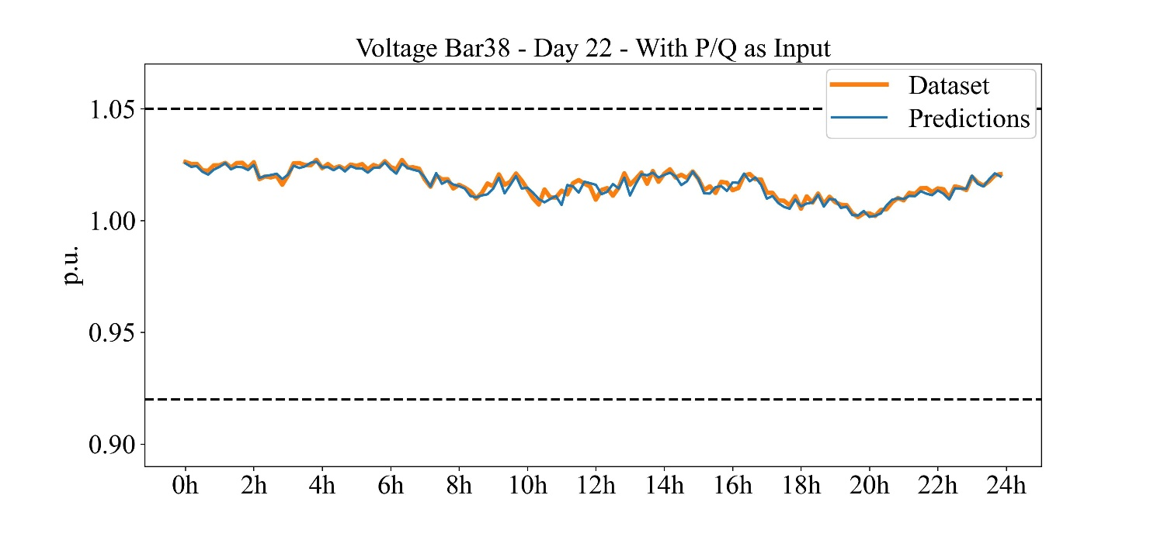

**Phase B**

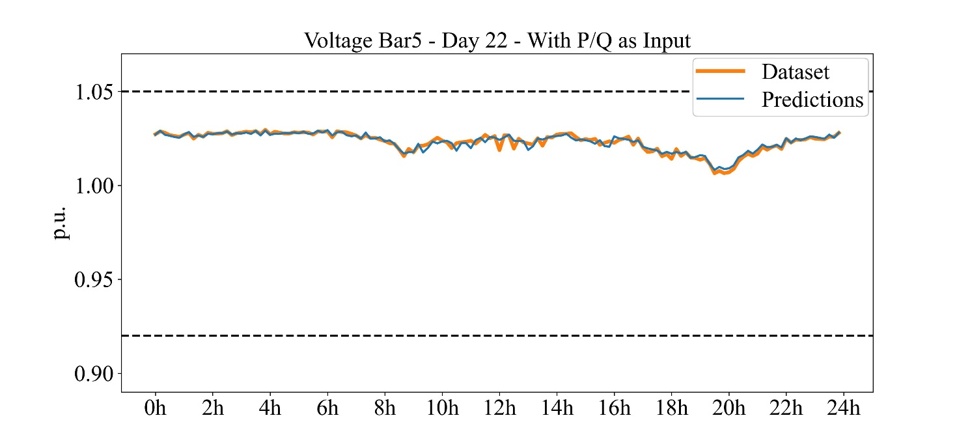

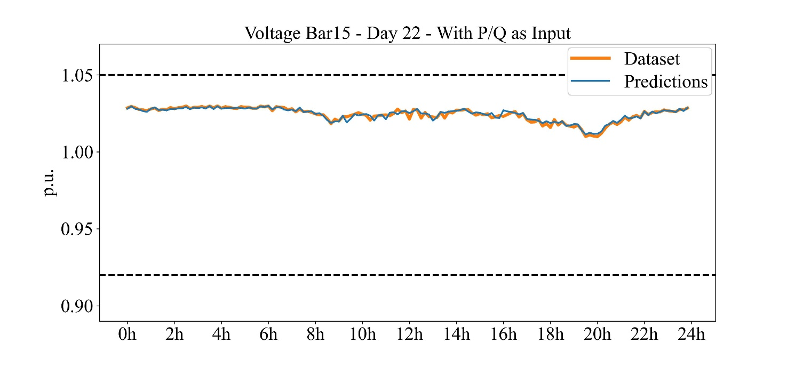

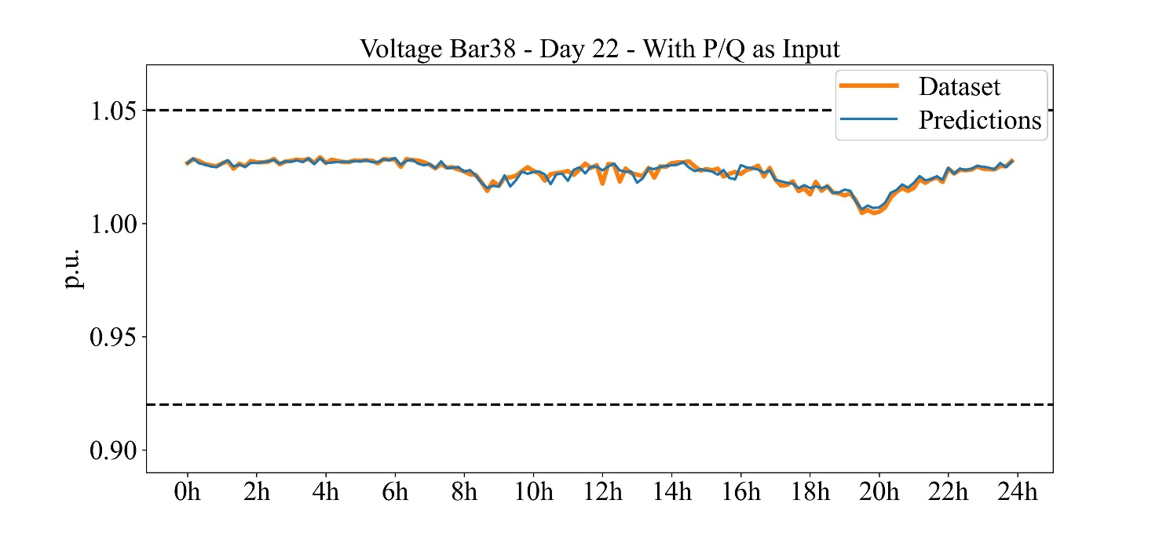

**Phase C**

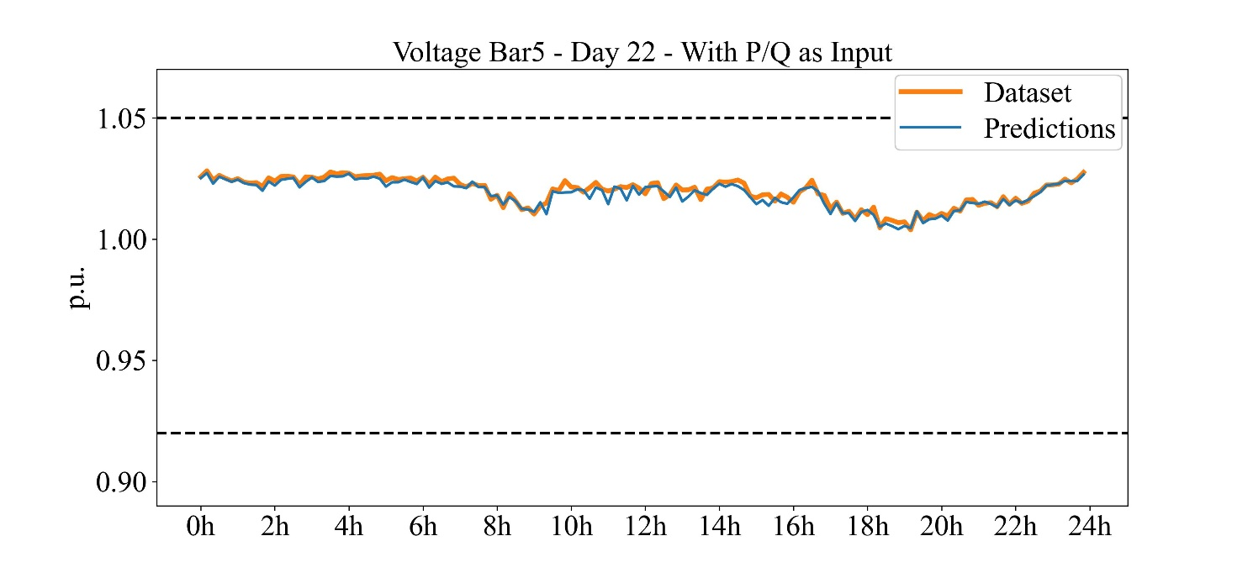

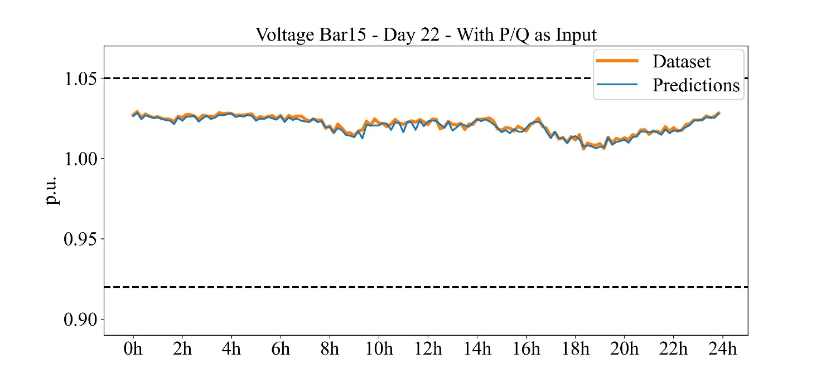

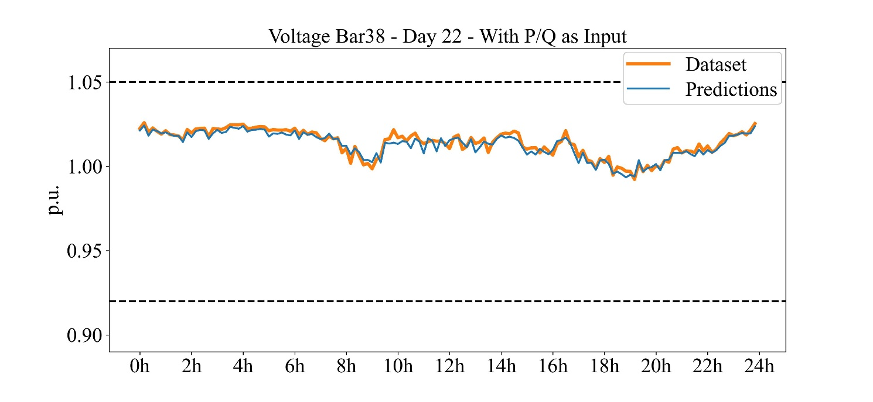

These results were very similar to the previous case and expected, because the problem was kept the same and only divide into 3 separate models with subtle differences between them.

This report is simple, but we can speak more about these results. Sorry for the delay, it took me a long time to adapt all the code for the OpenDSS environment and start working.😓