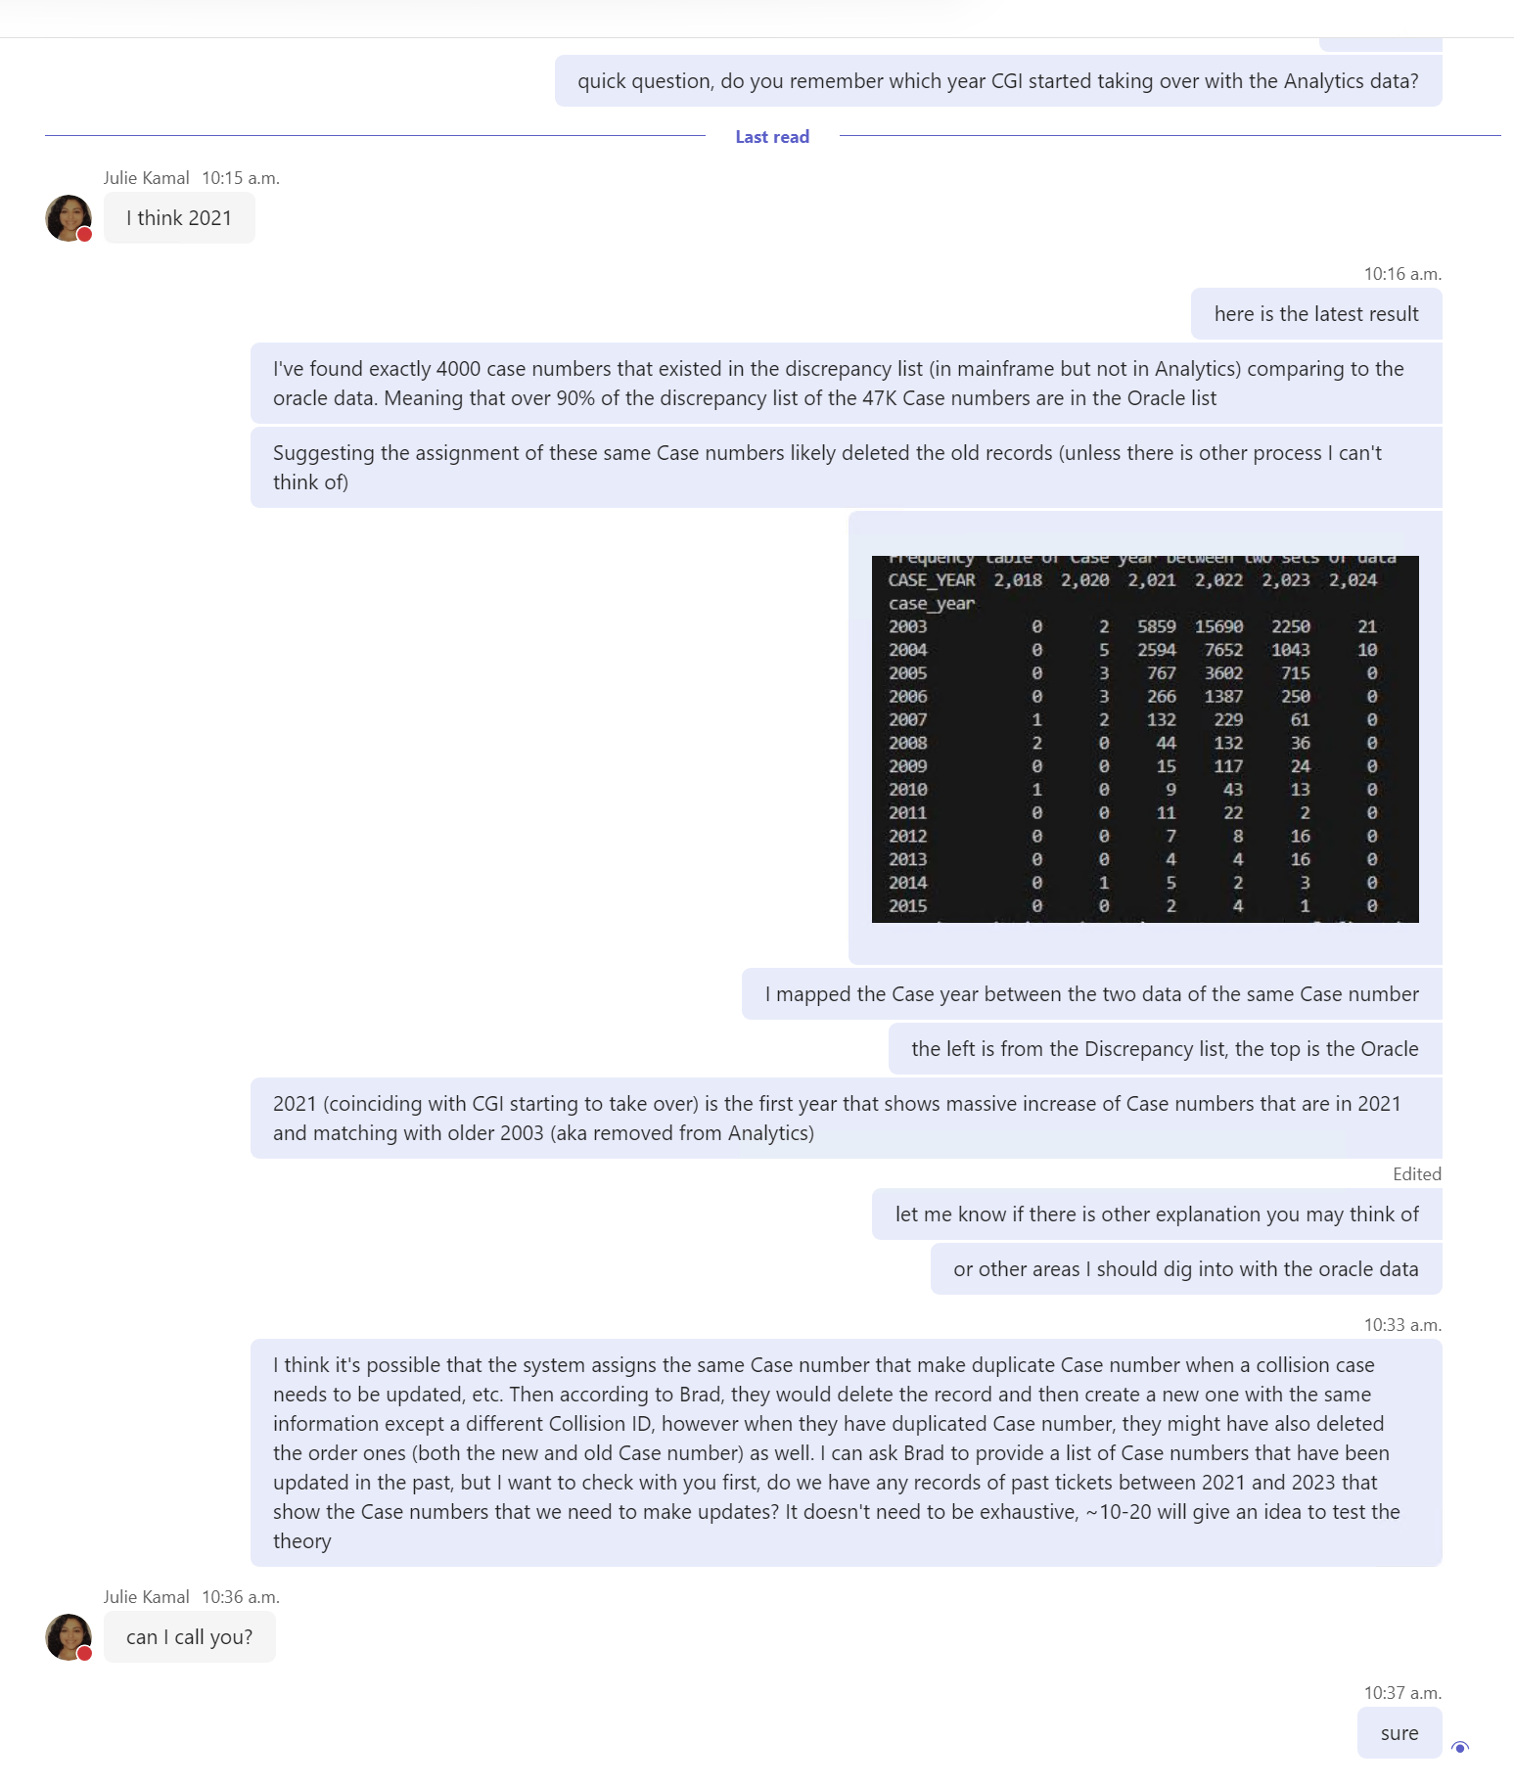

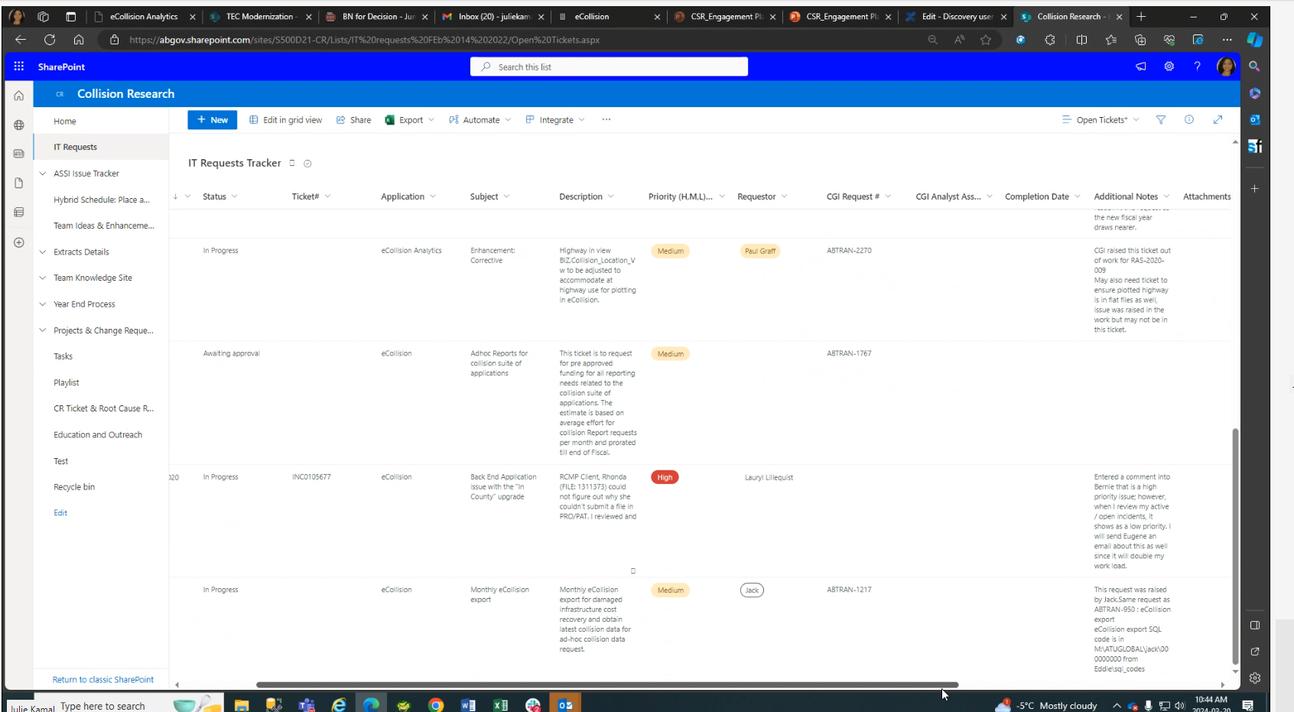

Additional context:

* Brad has said the discrepancies are due to interface issue. By interface issue, he meant that end Editing Users from RCMP and ASSI have the ability to delete records. This was later discovered and stopped. My results above proved that this is not the primary reason to explain the discrepancies, as it won’t explain the vast number of discrepancies and since the deleting privilege has been taken, it would have stopped the create discrepancies, but my results suggest otherwise. My results suggested since CGI started to take over Analytics data management in 2021, it started to have a massive number of older records being deleted, most likely due to 1) duplicated Case numbers are possible, and 2) when changes/updates are to be made, the record will first be deleted and then reassigned the same information but a new Collision ID, however, it may have missed recreating the older record with the same Case number and this deleting the older records erroneously in the process.
  + Next step: Compare a sample of Case numbers that we have raised tickets between 2021 and 2023, and compared them against the list of discrepancy (existing on Mainframe but not in Analytics (2000-2016), but existing in eCollision/Analytics after 2016)
  + Next step: Check Brad’s code and see the logic of deleting and recreating for the purpose of updating the record