Further digging:

1. There is logging in eCollision. It tracks when records are created, updated, plotted and deleted
   1. 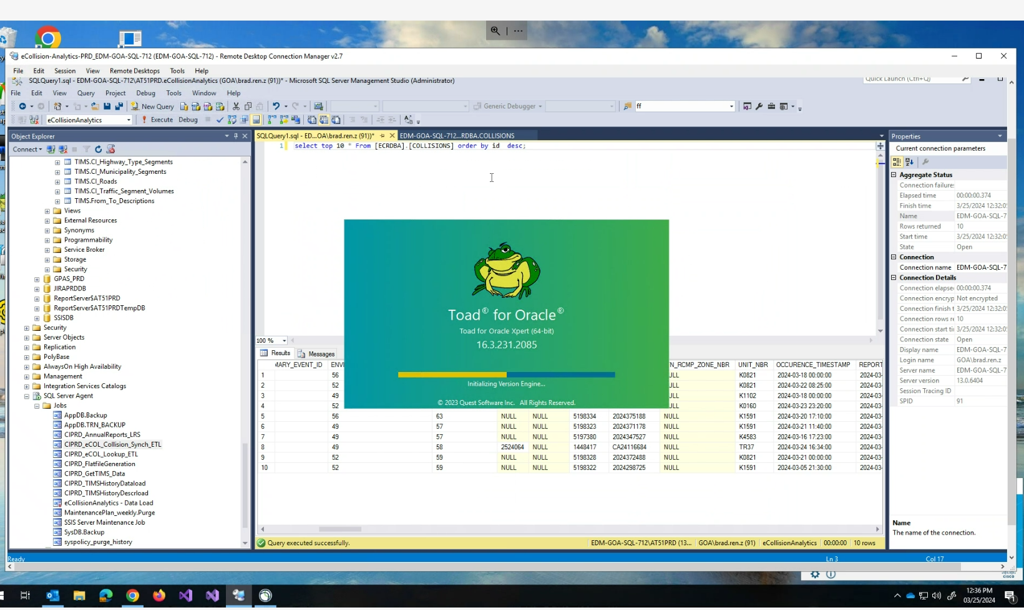
   2. 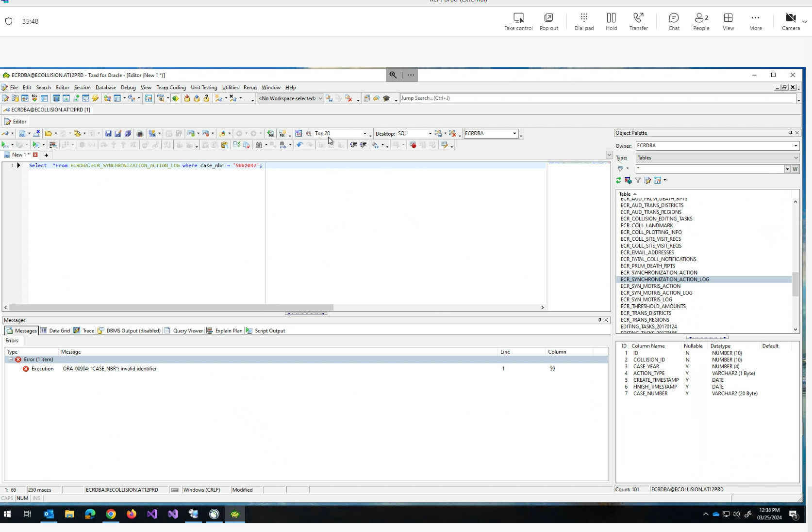
   3. 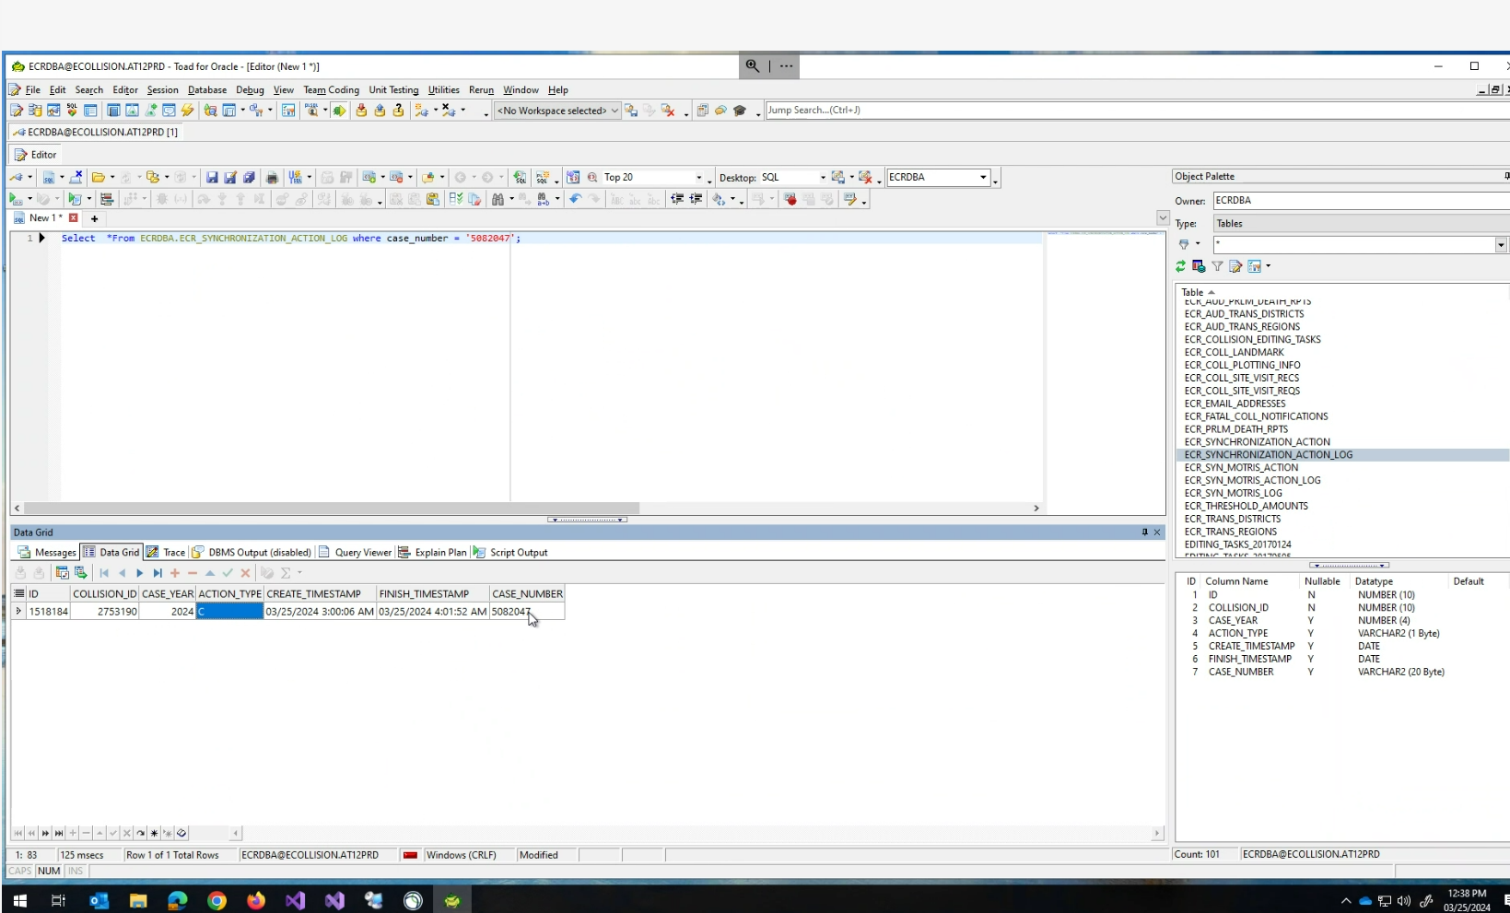
   4. However, when using a hand-picked selection of discrepant cases (only in Mainframe but not in eCollision Analytics), “select * from ECRDBA.ECR_SYNCHRONIZATION_ACTION_LOG where case_number in ('1001085', '1329265', '1342364', '1389284', '1314056', '1373193', '1371096', '5046559')” as well as checking it against the Collision table, there is no records in Collision table and the log table that match with the right case_number and case_year from the discrepant case list.
2. Digging into the form_case_nbr hypothesis
   1. '1371096' and '5046559' are examples of case_nbr in Mainframe that are missing from Analytics.
   2. However, the issue seems to be only affecting eCollision Analytics and not eCollision, because in eCollision these two numbers are shown as Form_CASE_NBR below
   3. 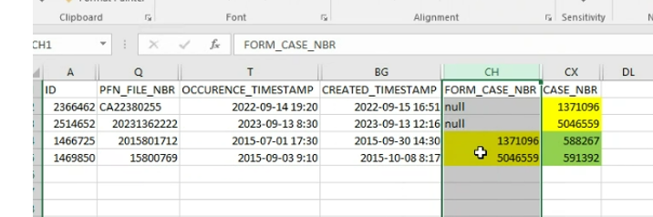
   4. For some reason, the original case_nbr is entered as the form_case_nbr, while new case_nbr (588267 and 591392) are assigned to these cases. This is IMPORTANT as it suggests these cases are either not synced properly from eCollision to Analytics, or 2) they were synced properly from eCollision to Analytics, but later got deleted from Analytics. Unfortunately logs have been checked didn’t have relevant information
3. Qwe
4. Qwe
5. Qwe
6. Qwe
7. Qwe

//////////////////////////

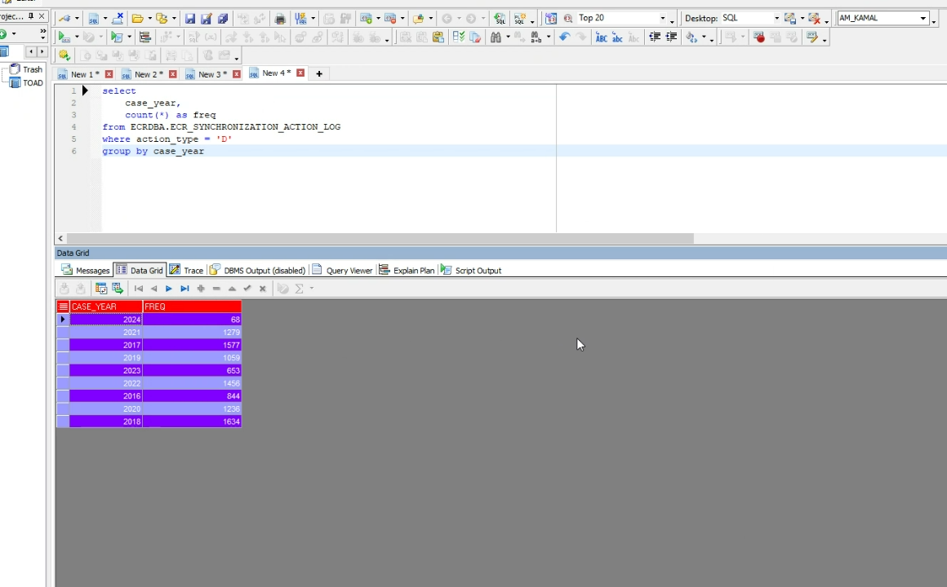

Records exist in oracle

Send Julie more data

///////////////////

2010-2018 (

Audit table in oracle

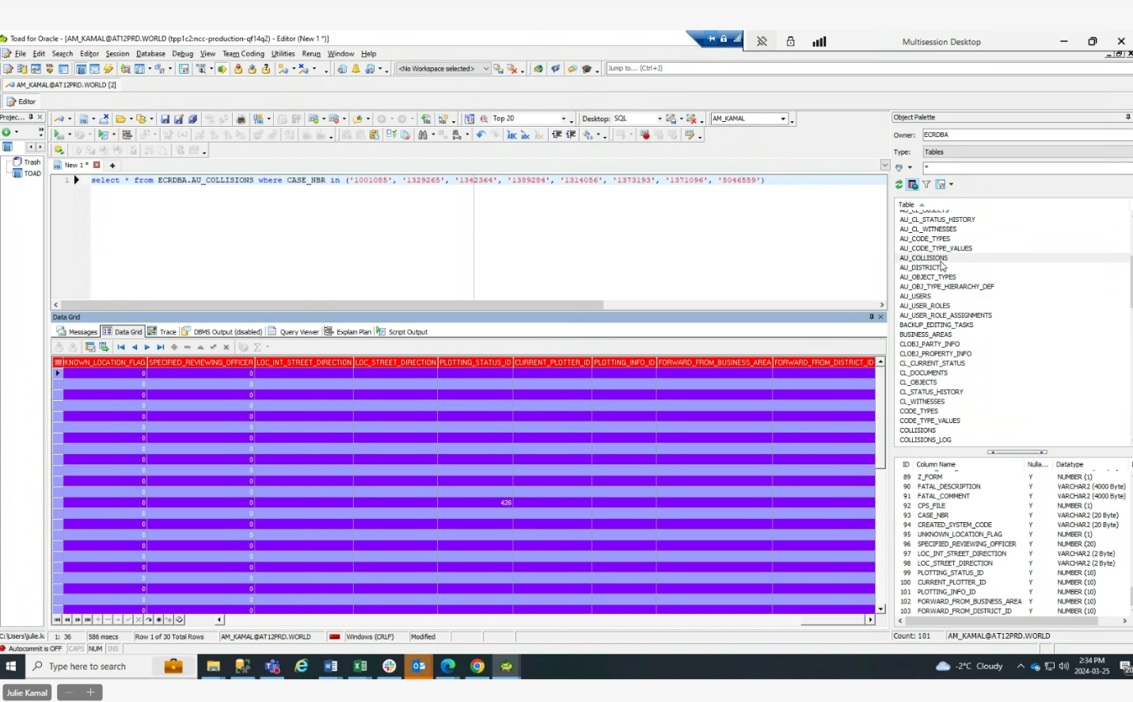

Deletion from