Main objectives:

* Assessment results of data discrepancy issues of eCollision Analytics (Analytics)
* Recommend remediation strategies going forward

Assessment of data discrepancy:

* Database-level comparisons
  + A) Compare Mainframe vs Analytics (2000-2016)
    - Mainframe has 2,204,555 Case numbers
    - There are duplicated Case numbers (71,434)
    - There are 47,078 Case numbers (2.1%) from Mainframe missing in Analytics
      * Discrepancies mainly concentrated around earlier years (~2003-2005)
      * Further comparison with additional (current Oracle) data

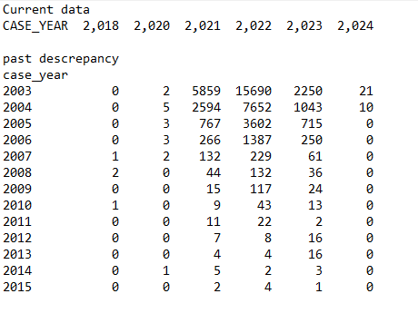

* + B) Compare PRD backup (2022) vs Analytics (2024) (2000-2020)
    - There are 43,962 Case numbers from 2022 snapshot that are missing from 2024 snapshot
      * Discrepancies mainly concentrated around earlier years (~2003-2005)
      * 2016-2019 no discrepancies
      * About ~450 Case numbers missing on each snapshot in 2020
  + C) Comparison of the discrepancies from A) and B)



Key issues and recommendations:

* Case number duplication (moderate-to-high)
  + Not taking action – not ideal but not critical as long as it’s not related to “accidental” data deletion
  + Possible action – Case number generation vs. post-hoc solution
* Case number deletion (high)
  + While eCollision Analytics don’t have data change log, eCollision has ECRDBA.ECR_SYNCHRONIZATION_ACTION_LOG
  + No data backup/snapshot to support further assessment for more recent timeline
    - Set up automated backup/snapshot in Analytics
    - Disable deletion of case; instead keep them but flag as “deleted”
    - Set up data change tracking for creation, flagged “deletion”, and reason for deletion (it’s resource intensive)
    - In the interim, set up snapshots and continuous monitoring of potential data deletion