Return for Exercise 4
1. a)
Call by value means that when calling a function the variables inputted as arguments don’t get changed.
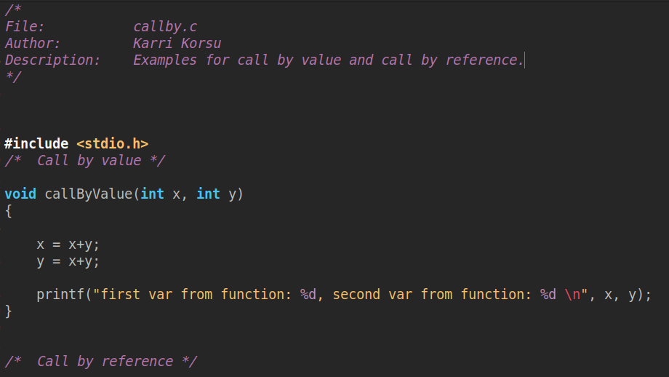

1.b)
Call by reference means that when calling a function the values inputted as arguments get changed.
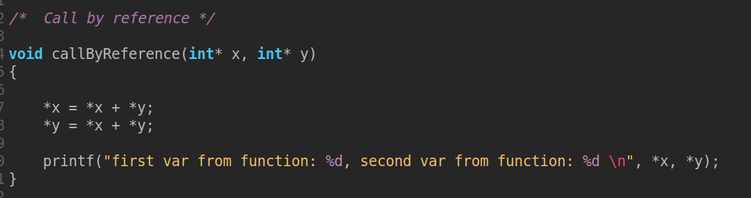

Main function and output prints:
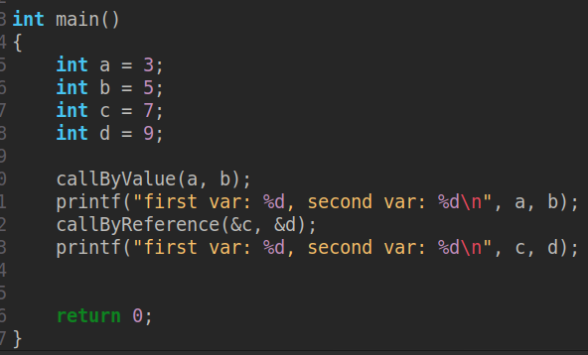

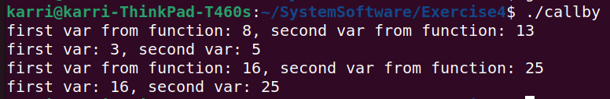
1. c) Parameters are declared within a function. They are local variables inside a function and arguments given when calling the function for execution give values to those local variables which are known as parameters.

In the above screenshots the parameters are named x and y for both callByValue() and callByReference() functions. The arguments given to those functions are a and b and c and d, respectively.

1. d) Formal and actual parameters signify the same dichotomy as arguments and parameters. Arguments refer to actual parameters and parameters refer to formal parameters.

Exercises 3-5:

