Project Management Platform
Final Project Report — EPAM Python Programming Q2 2026
FastAPI · PostgreSQL · AWS S3 · AWS Lambda · JWT · Docker · CI/CD
Includes: Final Project task coverage, AWS Sandbox live-migration log, spec-compliance fixes, and test results (80/80 passing).
Repository: github.com/kaipbergen/project-management-platform
August 2026

1. Overview
A project-management/profiles dashboard API implementing the full task specification: user auth, project CRUD, document upload/download via S3, project sharing/invites, and AWS Lambda–driven storage accounting — plus the optional share-link feature and all Phase 2 requirements.
Stack: Python 3.10, FastAPI (async), PostgreSQL + SQLAlchemy 2.0 (async ORM) with Alembic migrations, AWS S3 for document storage, AWS Lambda for S3-event-driven file-size aggregation, JWT (HS256) auth with refresh-token rotation, Docker Compose for orchestration, GitHub Actions for lint → test → build → push → deploy CI/CD.
Testing: 80/80 automated tests passing (pytest-asyncio + moto for AWS mocking), verified additionally end-to-end against real AWS (S3 + Lambda) in an EPAM/Syndicate Cloud Sandbox — see Section 4.

2. API Coverage vs. Task Specification
Every required endpoint from the task description is implemented, plus the optional share-link endpoint:
Method | Endpoint | Status
POST | /api/v1/auth/register | Done
POST | /api/v1/auth/login | Done
POST | /api/v1/auth/refresh | Done
POST | /api/v1/auth/logout | Done
POST | /api/v1/projects | Done
GET | /api/v1/projects | Done
GET | /api/v1/projects/{id}/info | Done
PUT | /api/v1/projects/{id}/info | Done
DELETE | /api/v1/projects/{id} | Done
GET | /api/v1/projects/{id}/documents | Done
POST | /api/v1/projects/{id}/documents | Done
GET | /api/v1/documents/{id} | Done
PUT | /api/v1/documents/{id} | Done
DELETE | /api/v1/documents/{id} | Done
POST | /api/v1/projects/{id}/invite | Done
GET | /api/v1/projects/{id}/share?with=<email> | Implemented
GET | /api/v1/join?token=<token> | Implemented
GET | /api/v1/projects/{id}/storage | Done

Access control: two roles enforced on every project-scoped route — owner (full control incl. delete) and participant (read/modify, no delete), matching the spec's implementation notes.
All responses are JSON with proper HTTP status codes (except raw file downloads); all request bodies are Pydantic-validated.

3. Phase 2 Additional Requirements
Requirement | Status
Normalization + denormalization of DB tables — documented rationale (3NF schema) + a worked denormalized materialized-view example | Documented
DB creation with and without an ORM — SQLAlchemy/Alembic migrations (used by the app) + hand-written sql/schema.sql (verified to apply cleanly) | Implemented
S3 + Lambda: sum of project file sizes on S3 events, 100MB limit enforced (both at upload time in the API and reconciled asynchronously by the Lambda) | Done
Tests, CI/CD bindings — 80 automated tests; GitHub Actions: lint (ruff) → type-check (mypy) → test → Docker build & push → deploy | Done
Packaging — pyproject.toml with full dependency/dev-dependency groups | Done
All data validated with Pydantic v2 | Done
JWT-authorized business logic, issued by POST /login, 1-hour expiry | Fixed

Note: the JWT-expiry row was a fix made during this work — the access token originally expired in 15 minutes; changed to 60 minutes to match the spec literally. A 7-day refresh-token rotation was kept as an additional security layer beyond the spec's minimum.

4. AWS Sandbox — Real AWS Migration & Live Demo
The app was originally developed and tested against LocalStack (an AWS emulator) for local dev. For this submission it was pointed at a real AWS account (EPAM/Syndicate Cloud Sandbox) with zero business-logic changes — config only — and exercised end-to-end.

4.1 Sandbox constraints observed
- Region: us-east-1 (one of the three permitted — us-east-1 / eu-west-1 / ap-south-1).
- No "epam" in any resource name — bucket is project-mgmt-docs-f4a8baae, IAM role is project-mgmt-lambda-role-f4a8baae.
- RDS access denied by an org-level SCP — no real network-reachable Postgres available to the sandbox Lambda (see 4.4).
- Lambda environment-variable encryption (KMS) denied by the same SCP — worked around with a deploy-only bootstrap.py shim (see 4.3).

4.2 Resources created
- S3 bucket project-mgmt-docs-f4a8baae — public access fully blocked, default SSE-AES256 encryption.
- IAM role project-mgmt-lambda-role-f4a8baae — AWSLambdaBasicExecutionRole + inline S3 read policy scoped to the bucket.
- Lambda function project-file-size-calculator (Python 3.12, packaged with psycopg2-binary for manylinux2014).
- S3 → Lambda event notification on s3:ObjectCreated:* / s3:ObjectRemoved:*, prefix projects/.

4.3 Bugs found and fixed while wiring to real AWS
None of these are LocalStack-specific — they were latent bugs that never triggered because the app had only ever run inside Docker Compose against LocalStack/moto:
- get_s3_client() didn't support STS session tokens — sandbox credentials are temporary and require AWS_SESSION_TOKEN; added support in app/core/config.py and app/services/s3_service.py.
- Alembic's env.py stripped +asyncpg from the DB URL before handing it to an async engine, causing it to try (and fail) to import the sync psycopg2 driver. Fixed by keeping the async URL intact.
- Migration 0001 created the project_role Postgres enum twice (once via raw SQL, once implicitly via the SQLAlchemy column definition), causing DuplicateObjectError on a clean database. Fixed by removing the redundant manual statement.
- Settings rejected the .env file's docker-compose-only POSTGRES_* variables under a newer pydantic-settings default. Fixed with extra="ignore".
- Lambda's built-in encrypted environment variables couldn't be used at all (KMS denied by SCP) — solved with a small deploy-only bootstrap.py that sets os.environ before importing the unmodified handler from file_size_calculator.py.

4.4 End-to-end live verification
Ran the full stack (Postgres in Docker, FastAPI via uvicorn, real AWS credentials) and exercised the golden path against actual AWS:
POST /api/v1/auth/register → 201 Created
POST /api/v1/auth/login → 200 OK, access_expires_in=3600 (1h, per spec)
POST /api/v1/projects → 201 Created
POST /api/v1/projects/{id}/documents → 200 OK (uploaded to real S3)
verified independently via s3.list_objects_v2(): object present, 63 bytes
CloudWatch Logs: S3 ObjectCreated correctly triggered the real Lambda,
which parsed the project/document IDs from the key and began the size
calculation. The DB-write step fails with "connection refused" — expected,
since no RDS is available in this sandbox (see 4.1). Production would run
the Lambda in the same VPC as an RDS instance.
GET /api/v1/documents/{id} → 200 OK, presigned S3 URL
GET /api/v1/projects/{id}/storage → 200 OK, usage vs. 100MB limit

The optional share-link feature was also live-verified: an owner generated a hashed join link for an email address, a second real user redeemed it via GET /api/v1/join, and immediately gained participant access to the project.

4.5 Test suite
80 / 80 tests passing (75 original + 5 new for the share-link feature), run against the updated real-AWS configuration:
$ pytest -q
80 passed in 29.19s
The suite mocks AWS via moto (in-memory), so it was never coupled to LocalStack and needed no changes for the AWS migration beyond 2 tests whose expected JWT-expiry value changed from 15 to 60 minutes.

5. AWS Console Screenshots
Captured live during this session (temporary sandbox credentials, console access via the AWS federation sign-in endpoint — no password used).

S3 — uploaded document
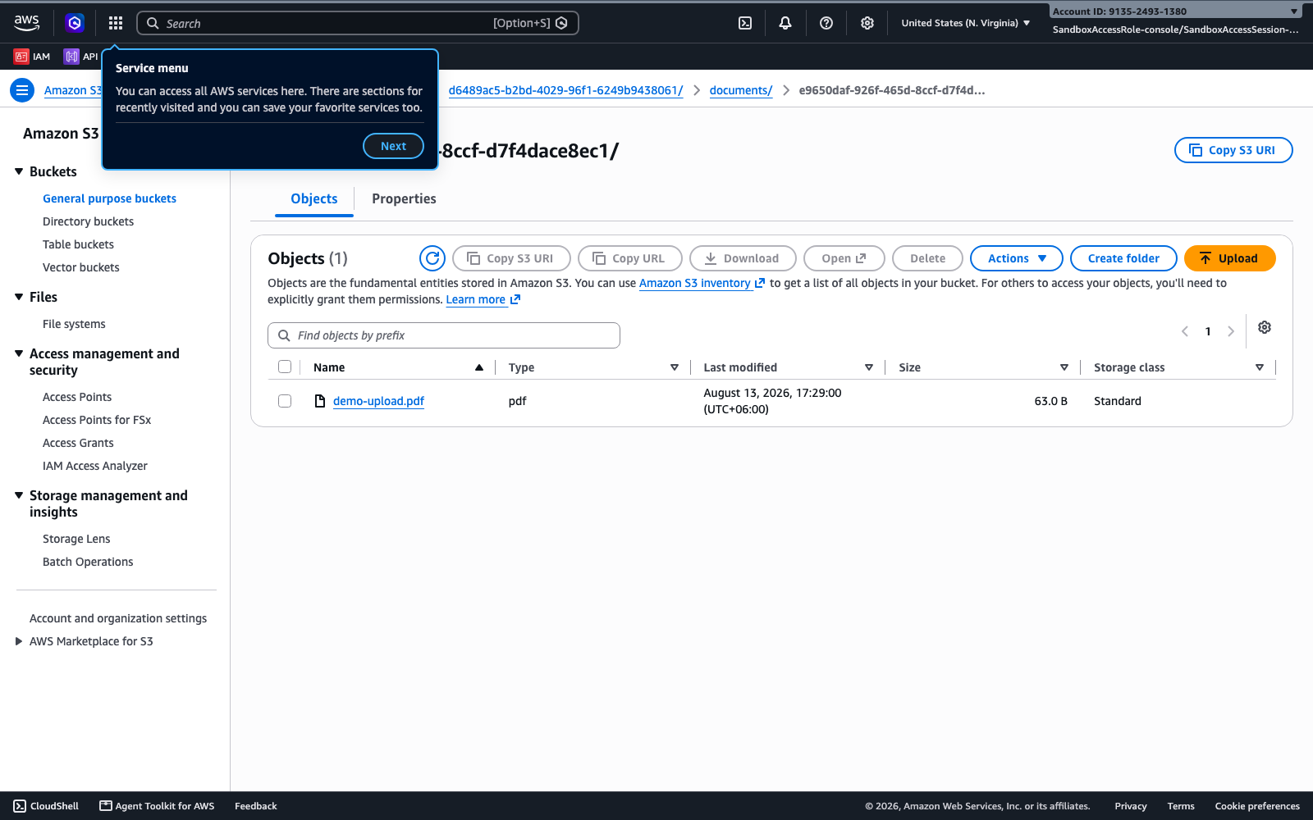
project-mgmt-docs-f4a8baae bucket — demo-upload.pdf (63 B), uploaded through the running API.

Lambda — function overview & S3 trigger
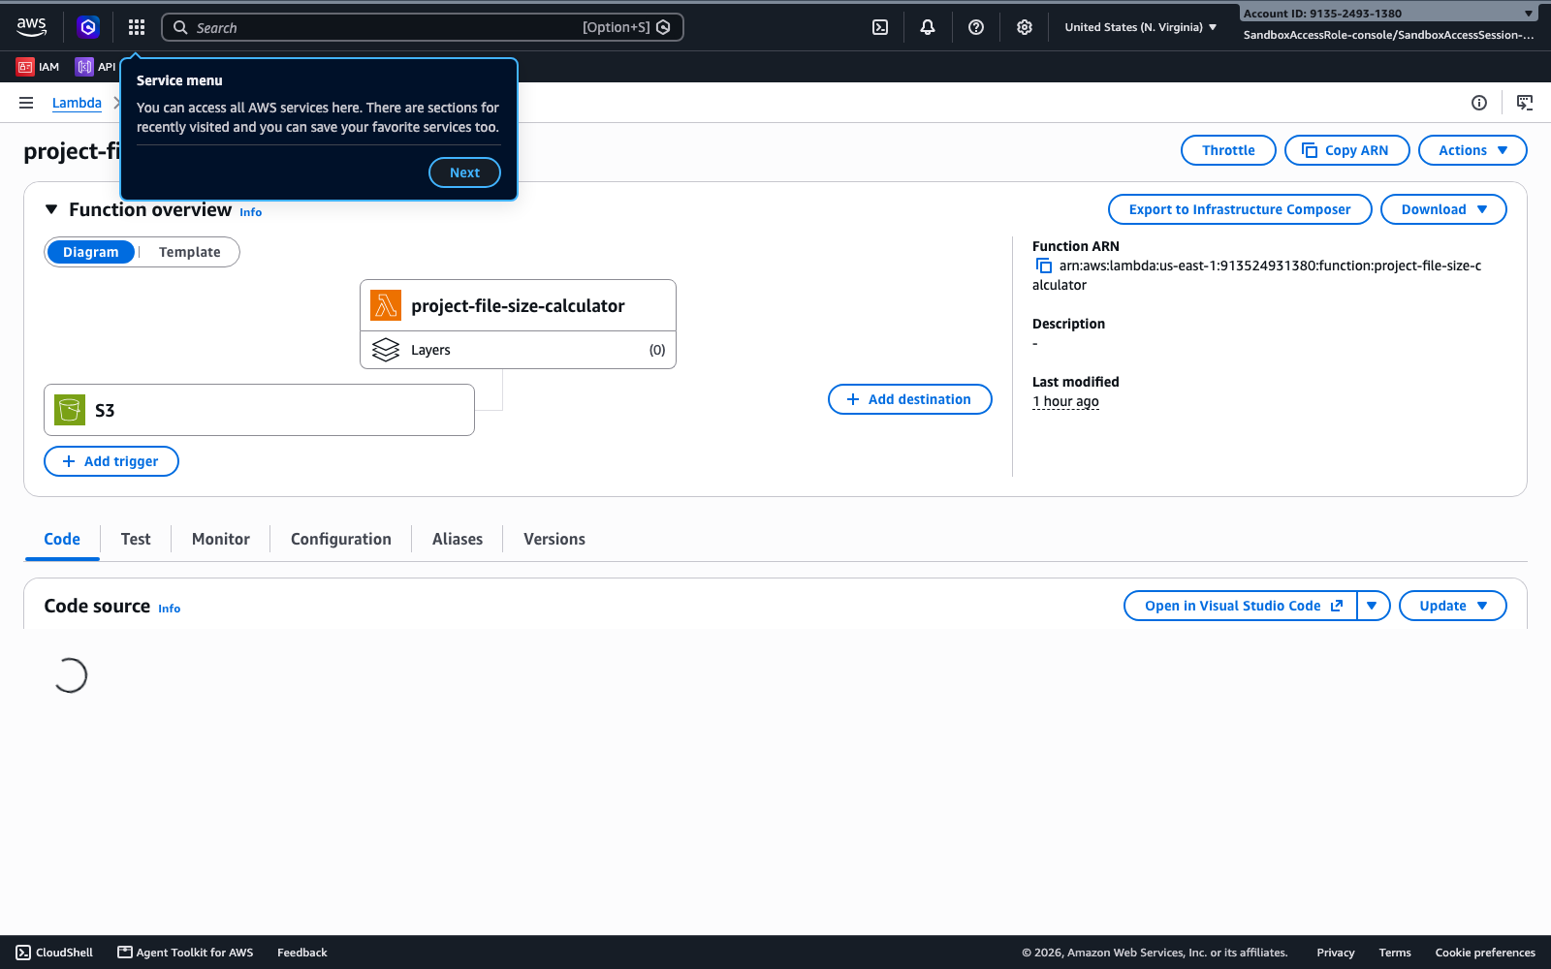
project-file-size-calculator — function ARN and the live S3 event-trigger diagram.

CloudWatch Logs — real invocations
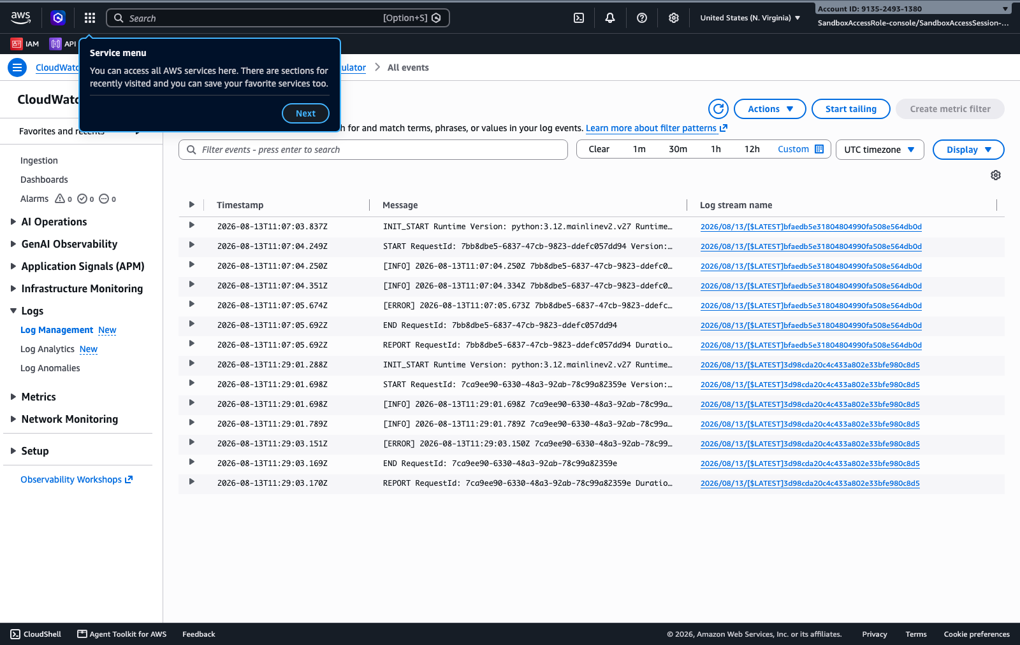
Both real Lambda invocations, showing INIT_START → START → [ERROR] (DB unreachable, expected) → END → REPORT, with RequestIds matching the CLI-captured logs.

6. Repository & How to Run
GitHub: github.com/kaipbergen/project-management-platform

Local dev (LocalStack)
cp .env.example .env
docker compose -f docker-compose.yml -f docker-compose.localstack.yml up --build

Real AWS
cp .env.example .env # fill in real AWS credentials + bucket name
docker compose up --build

Tests
pytest -q # 80 passed

Full command-by-command log of the AWS Sandbox migration (bucket/role/Lambda creation, live curl transcripts, CloudWatch output) is committed in the repository as aws-sandbox-demo-log.md.

