

《软件技术基础课程设计》

实验项目： 2-2综合编程实验
院 系： 计算机科学与技术系
学 期： 2023年第1学期
班 级： 计算机1班
学 号： 216001944，216001902
姓 名： 赵瑞杰，郭力源
指导教师： 李纲，叶绪伦
日期：2023 年 12月 24日

目录
一、 游戏简介 3
1.1 总体介绍 3
1.2 游戏玩法 3
二、团队分工 3
三、课程设计的目的与要求 4
四、总体设计 4
4.1 系统开发环境 4
4.2 需求分析 4
4.3 总体设计 5
4.4 模块功能详解 6
4.5 各模块流程图 8
4.6 软件代码和运行结果 12
五、实验运行结果展示 67
六、实验总结 74
七、心得体会 74
八、附录 75

游戏简介

1.1 总体介绍
一个融合了创新和娱乐乐趣的消消乐微信小游戏。我们的项目以Spring Boot和Vue前后端开发为基础，结合了先进的启发式生成算法，为用户提供了一种全新的消除游戏体验。
技术亮点：
SpringBoot后端支持：我们的游戏后端采用了基于Spring Boot的若依框架，使用MySQL和Redis作为数据库，将用户操作，账号密码等存入数据库，为项目提供了稳定、高效的后台支持，确保游戏运行的顺畅和可靠。
Vue框架前端构建：游戏前端采用Vue框架，选择了Typescript作为游戏的主要开发语言，为玩家呈现出流畅、直观的用户界面，提供了丰富的交互体验。
启发式算法：我们引入了一种先进的启发式算法，用于生成有趣、挑战性的消消乐关卡，确保玩家在游戏中获得不断变化的体验。我们在附录中详细描述了启发式算法的原理。
微信开发者工具：我们从微信公众平台个人账号里获取到AppID，在Cocos里构建发布为微信小游戏，在微信开发者工具将项目导入，适当调节适配后即可作为微信小游戏在电脑端，手机端运行。

1.2 游戏玩法
点击开始游戏后，用户需要点击屏幕中可以消除的方块，将方块消除，同时屏幕最上方会根据算法逐渐生成一排新的方块并落下（生成的方块遵循保证用户进行游玩时不会出现没有任何方块可以消除的情况），随着用户游玩时间的增加，生成方块的速度会逐渐加快，直到累计的方块到达屏幕顶部，这时游戏结束，显示用户坚持的时间和得分。

二、团队分工
赵瑞杰：60％
游戏：讨论完成游戏整体架构，大部分游戏流程设计，代码编写
参数设计：完成大部分游戏参数设计调整
Vue前端：设计数据库前端展示界面，完成总体UI设计，代码实现
实验报告：书写实验报告，排版整理，细节修改
郭力源：40％
游戏：讨论完成游戏整体架构，寻找绘制游戏贴图素材，对游戏中所需要的图片素材进行裁剪处理
数据库：设计存储记录数据表，完成用户数据上传数据库的操作
实验报告：书写实验报告，绘制流程图

三、课程设计的目的与要求
1、提高基于项目的程序设计、算法分析设计和设计思维能力。
2、初步掌握软件开发过程的问题分析、系统设计、程序编码、测试和调试等基本方法和技能。
3、提高独立解决问题的能力、编程综合能力。
4、进一步加强和提高软件工程文档的编写能力。
5、培养协作能力和团队精神。

四、总体设计

4.1 系统开发环境
游戏前端：Cocos creator，微信开发者工具
网页前端：Vue、Element UI
后端开发工具：Spring Boot、Spring Security、Redis & Jwt。

4.2 需求分析
消消乐微信小游戏后台数据库主要满足三个方面的需求，一是用户登录，注册，记住用户账号密码；二是用户游戏信息存储，包括但不限于记录该用户的游戏最高记录，单次游戏内操作，单次游戏时长等等；三是管理员可以登录后台数据库对数据库进行维护，对数据进行增删改查。
对于如何实现用户登录、注册、记住账号等功能，满足用户在账号密码设置方面的需求：
1、我们将用户表中的user_id作为主键，为用户游戏数据的保存提供可靠的保障。
2、密码方面需要有较高的安全性，需要由数字、字母和特殊字符注册，长度也必须做限制，同时我们在数据库中采用MD5加密方式，确保用户信息不被泄露。在登录界面，还需要记住账号功能，方便用户登录，不需要用户重复输入账号。
对于如何实现用户游戏信息存储读取的需求：
在游戏开始时，程序在“消消乐游戏记录”表为该用户创建一个主键为id的空白数据行，在游戏运行中，将用户操作实时插入“消消乐操作记录”表中，在游戏结束时，将用户本次游玩时间，用户得分，用户消去方块数，操作质量，根据创建的Id更新数据，并查找该用户最长坚持时间，在屏幕上输出本次游戏结果。
对于如何实现管理员增删改查的需求：
使用Mybatis对数据库进行操作。通过Vue可视化界面完成对用户和游戏记录的增删改查功能。

4.3 总体设计
该项目采用前后端分离，其中前端分为游戏前端和网页前端。
整个系统可以划分为三个模块，分别为：用户模块，游戏模块，数据模块。其中用户模块可以细分为登录模块、注册模块。数据模块细分为存储记录模块和读取记录模块。

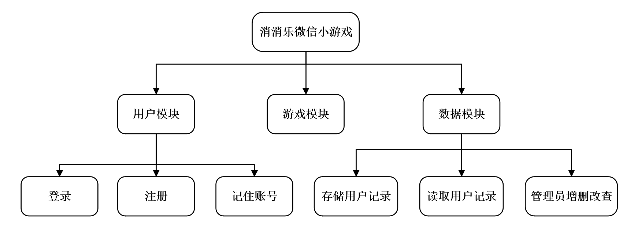
图 1 系统总模块设计图

数据库E-R图设计：
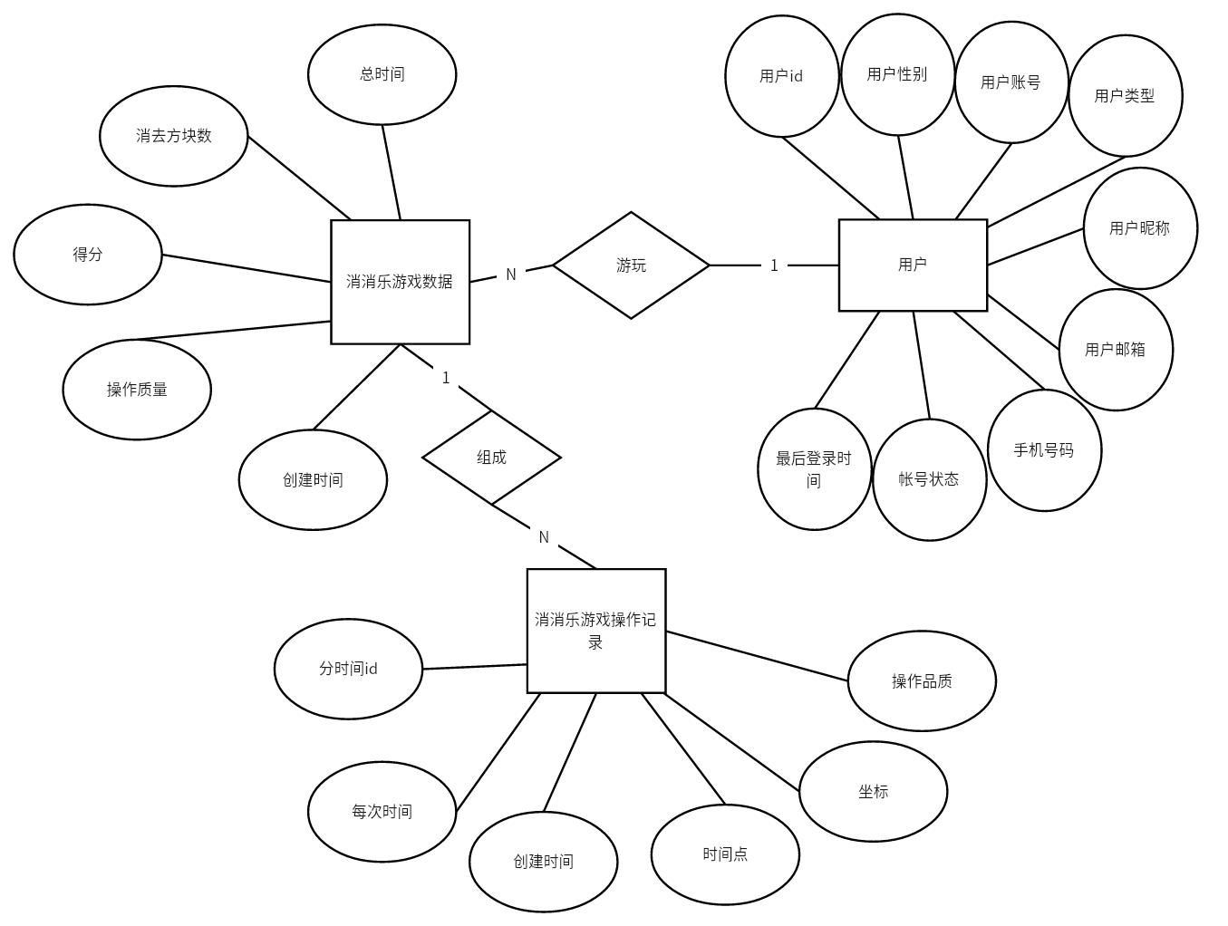
图 2 E-R图设计

4.4 模块功能详解
功能模块 | 包含子功能模块 | 功能
用户模块 | 登录模块 | 检索数据库，核对数据库中是否含有该账号，若有则检测用户输入的账号密码是否匹配，并反馈核验结果，若正确则进入游戏规则解释界面，否则提示登录失败。
用户模块 | 注册模块 | 提供给新用户注册账号的功能，新用户输入账号密码后，判断数据表中是否已经存在该数据，密码是否符合规范检验，两次输入的密码是否相同。在注册账号密码合法情况下，将账号密码存入数据库，完成注册。
用户模块 | 记住账号模块 | 在数据库中记录上次登录界面的账号，在下次点开登录界面时自动记录上次的账号，方便用户登录。

表 1用户模块设计

功能模块 | 功能
游戏模块 | 用户登录完成后展示游戏规则界面，选择‘进入游戏’，即可进入游玩界面。在游戏内部，通过读取用户鼠标移动和点击的操作，判断用户点击的位置是技能方块还是普通方块，技能方块无触发条件，普通方块则需横竖至少1个同色方块与其相邻，消除方块后，上方的方块会随重力落下，同时顶部会一直生成方块，累计满1行后会落下，并随着游戏时间的增长生成速度越来越快，直到方块触顶后，游戏结束，显示用户本次游玩成绩。

表 2 游戏模块设计

功能模块 | 包含子功能模块 | 功能
数据模块 | 存储用户记录 | 用户进行点击消除操作后，无论成功与否都会将当前界面的方块位置按照行存入数据库，提供给后台机器学习算法计算生成的方块。
数据模块 | 读取用户记录 | 当用户本局游戏结束后，读取数据表中对应账号的所有游戏时间记录，找出最长坚持时间，并在界面显示，给予用户反馈。
数据模块 | 管理员增删改查 | 管理员登录数据库后台，可以增添，修改，删除用户账号数据，用户操作数据，用户游玩数据。

表 3 数据模块设计

4.5 各模块流程图
用户注册流程图：
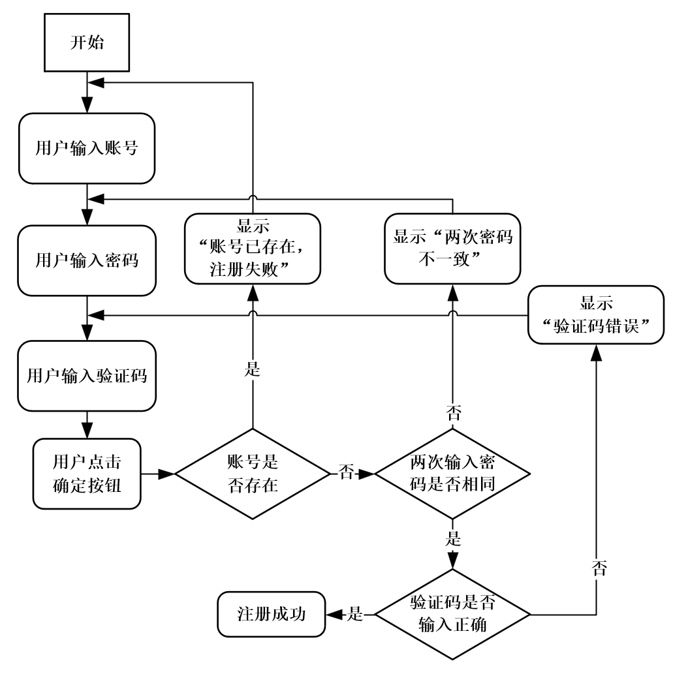
图 2 用户注册流程图

用户登录流程图：
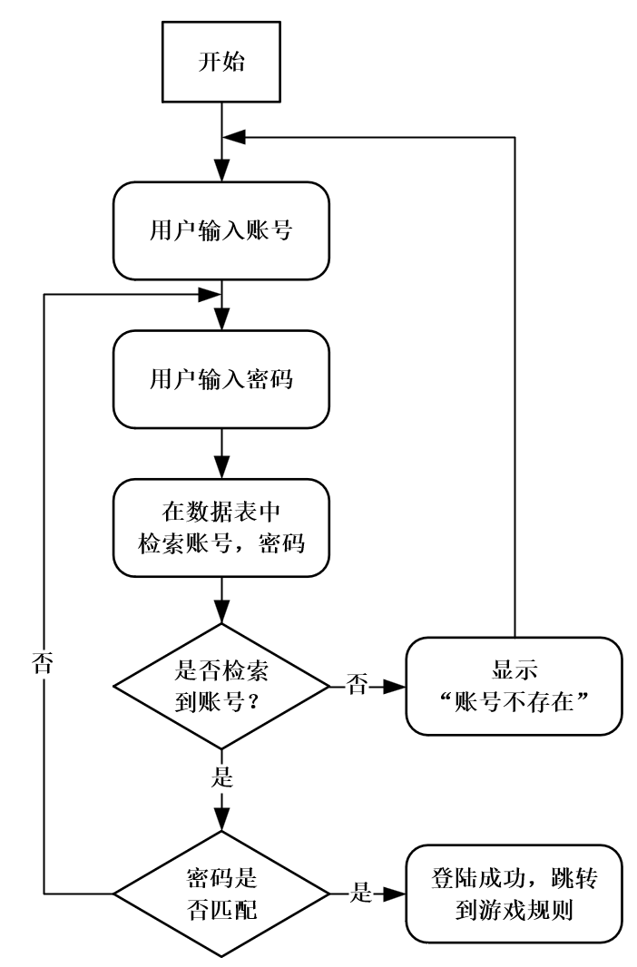

图 3 用户登录流程图

游戏整体设计流程图：
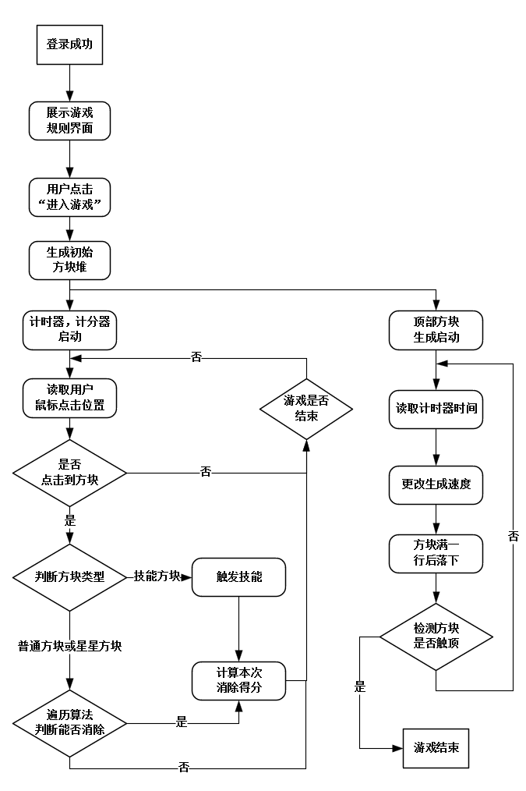
图 4 游戏整体设计流程图

4.6 软件代码和运行结果
网页前端部分代码：
该部分代码基于Vue.js的前端页面，用于管理消消乐游戏记录。页面包括搜索条件输入框、表格展示游戏记录、分页器和操作按钮等元素。通过这些元素，用户可以进行搜索、新增、修改、删除和导出等操作。
pop_record：
<template>
<div class = "app-container">
<el - form :model = "queryParams" ref = "queryForm" : inline = "true" v - show = "showSearch" label - width = "68px">
<el - form - item label = "userid" prop = "userId">
<el - input
v - model = "queryParams.userId"
placeholder = "请输入userid"
clearable
size = "small"
@keyup.enter.native = "handleQuery"
/>
</ el - form - item>
<el - form - item label = "总时间" prop = "allTime">
<el - input
v - model = "queryParams.allTime"
placeholder = "请输入总时间"
clearable
size = "small"
@keyup.enter.native = "handleQuery"
/ >
</el - form - item>
<el - form - item label = "消去方块数" prop = "removeCount">
<el - input
v - model = "queryParams.removeCount"
placeholder = "请输入消去方块数"
clearable
size = "small"
@keyup.enter.native = "handleQuery"
/>
</el - form - item>
<el - form - item label = "得分" prop = "score">
<el - input
v - model = "queryParams.score"
placeholder = "请输入得分"
clearable
size = "small"
@keyup.enter.native = "handleQuery"
/>
</el - form - item>
<el - form - item label = "操作质量" prop = "quality">
<el - input
v - model = "queryParams.quality"
placeholder = "请输入操作质量"
clearable
size = "small"
@keyup.enter.native = "handleQuery"
/>
</el - form - item>
<el - form - item>
<el - button type = "primary" icon = "el-icon-search" size = "mini" @click = "handleQuery">搜索< / el - button>
<el - button icon = "el-icon-refresh" size = "mini" @click = "resetQuery">重置< / el - button>
</el - form - item>
</el - form>
<el - row :gutter = "10" class = "mb8">
<el - col :span = "1.5">
<el - button
type = "primary"
plain
icon = "el-icon-plus"
size = "mini"
@click = "handleAdd"
v - hasPermi = "['system:pop_record:add']"
>新增< / el - button>
</el - col>
<el - col :span = "1.5">
<el - button
type = "success"
plain
icon = "el-icon-edit"
size = "mini"
:disabled = "single"
@click = "handleUpdate"
v - hasPermi = "['system:pop_record:edit']"
>修改< / el - button>
< / el - col>
<el - col :span = "1.5">
<el - button
type = "danger"
plain
icon = "el-icon-delete"
size = "mini"
:disabled = "multiple"
@click = "handleDelete"
v - hasPermi = "['system:pop_record:remove']"
>删除< / el - button>
</el - col>
<el - col :span = "1.5">
<el - button
type = "warning"
plain
icon = "el-icon-download"
size = "mini"
@click = "handleExport"
v - hasPermi = "['system:pop_record:export']"
>导出< / el - button>
</el - col>
<right - toolbar :showSearch.sync = "showSearch" @queryTable = "getList">< / right - toolbar>
</el - row>

<el - table v - loading = "loading" :data = "pop_recordList" @selection - change = "handleSelectionChange">
<el - table - column type = "selection" width = "55" align = "center" />
<el - table - column label = "id" align = "center" prop = "id" />
<el - table - column label = "userid" align = "center" prop = "userId" />
<el - table - column label = "总时间" align = "center" prop = "allTime" />
<el - table - column label = "消去方块数" align = "center" prop = "removeCount" />
<el - table - column label = "得分" align = "center" prop = "score" />
<el - table - column label = "操作质量" align = "center" prop = "quality" />
<el - table - column label = "备注" align = "center" prop = "remark" />
<el - table - column label = "操作" align = "center" class - name = "small-padding fixed-width">
<template slot - scope = "scope">
<el - button
size = "mini"
type = "text"
icon = "el-icon-edit"
@click = "handleUpdate(scope.row)"
v - hasPermi = "['system:pop_record:edit']"
>修改< / el - button>
<el - button
size = "mini"
type = "text"
icon = "el-icon-delete"
@click = "handleDelete(scope.row)"
v - hasPermi = "['system:pop_record:remove']"
>删除< / el - button>
</template>
</el - table - column>
</el - table>
<pagination
v - show = "total>0"
:total = "total"
: page.sync = "queryParams.pageNum"
: limit.sync = "queryParams.pageSize"
@pagination = "getList"
/>
<!--添加或修改消消乐游戏记录对话框-->
<el - dialog :title = "title" : visible.sync = "open" width = "500px" append - to - body>
<el - form ref = "form" :model = "form" : rules = "rules" label - width = "80px">
<el - form - item label = "userid" prop = "userId">
<el - input v - model = "form.userId" placeholder = "请输入userid" />
</el - form - item>
<el - form - item label = "总时间" prop = "allTime">
<el - input v - model = "form.allTime" placeholder = "请输入总时间" />
</el - form - item>
<el - form - item label = "消去方块数" prop = "removeCount">
<el - input v - model = "form.removeCount" placeholder = "请输入消去方块数" />
</el - form - item>
<el - form - item label = "得分" prop = "score">
<el - input v - model = "form.score" placeholder = "请输入得分" />
</el - form - item>
<el - form - item label = "操作质量" prop = "quality">
<el - input v - model = "form.quality" placeholder = "请输入操作质量" />
</el - form - item>
<el - form - item label = "备注" prop = "remark">
<el - input v - model = "form.remark" type = "textarea" placeholder = "请输入内容" />
</el - form - item>
</el - form>
<div slot = "footer" class = "dialog-footer">
<el - button type = "primary" @click = "submitForm">确 定< / el - button>
<el - button @click = "cancel">取 消< / el - button>
</div>
</el - dialog>
</div>
</template>
<script>
import{ listPop_record, getPop_record, delPop_record, addPop_record, updatePop_record } from "@/api/system/pop_record";

export default {
name: "Pop_record",
data() {
return {
// 遮罩层
loading: true,
// 选中数组
ids : [] ,
// 非单个禁用
single : true,
// 非多个禁用
multiple : true,
// 显示搜索条件
showSearch : true,
// 总条数
total : 0,
// 消消乐游戏记录表格数据
pop_recordList : [] ,
// 弹出层标题
title : "",
// 是否显示弹出层
open : false,
// 查询参数
queryParams : {
pageNum: 1,
pageSize : 10,
userId : null,
allTime : null,
removeCount : null,
score : null,
quality : null,
},
// 表单参数
form: {},
// 表单校验
rules : {
userId: [
{ required: true, message : "userid不能为空", trigger : "blur" }
] ,
}
};
},
created() {
this.getList();
},
methods: {
/** 查询消消乐游戏记录列表 */
getList() {
this.loading = true;
listPop_record(this.queryParams).then(response = > {
this.pop_recordList = response.rows;
this.total = response.total;
this.loading = false;
});
},
// 取消按钮
cancel() {
this.open = false;
this.reset();
},
// 表单重置
reset() {
this.form = {
id: null,
userId : null,
allTime : null,
removeCount : null,
score : null,
quality : null,
createTime : null,
remark : null
};
this.resetForm("form");
},
/** 搜索按钮操作 */
handleQuery() {
this.queryParams.pageNum = 1;
this.getList();
},
/** 重置按钮操作 */
resetQuery() {
this.resetForm("queryForm");
this.handleQuery();
},
// 多选框选中数据
handleSelectionChange(selection) {
this.ids = selection.map(item = > item.id)
this.single = selection.length != = 1
this.multiple = !selection.length
},
/** 新增按钮操作 */
handleAdd() {
this.reset();
this.open = true;
this.title = "添加消消乐游戏记录";
},
/** 修改按钮操作 */
handleUpdate(row) {
this.reset();
const id = row.id || this.ids
getPop_record(id).then(response = > {
this.form = response.data;
this.open = true;
this.title = "修改消消乐游戏记录";
});
},
/** 提交按钮 */
submitForm() {
this.$refs["form"].validate(valid = > {
if (valid) {
if (this.form.id != null) {
updatePop_record(this.form).then(response = > {
this.$modal.msgSuccess("修改成功");
this.open = false;
this.getList();
});
}
else {
addPop_record(this.form).then(response = > {
this.$modal.msgSuccess("新增成功");
this.open = false;
this.getList();
});
}
}
});
},
/** 删除按钮操作 */
handleDelete(row) {
const ids = row.id || this.ids;
this.$modal.confirm('是否确认删除消消乐游戏记录编号为"' + ids + '"的数据项？').then(function() {
return delPop_record(ids);
}).then(() = > {
this.getList();
this.$modal.msgSuccess("删除成功");
}).catch (() = > {});
},
/** 导出按钮操作 */
handleExport() {
this.download('system/pop_record/export', {
...this.queryParams
}, `pop_record_${new Date().getTime()}.xlsx`)
}
}
};
< / script>

pop_record_time：
<template>
<div class = "app-container">
<el - form :model = "queryParams" ref = "queryForm" : inline = "true" v - show = "showSearch" label - width = "68px">
<el - form - item label = "userid" prop = "userId">
<el - input
v - model = "queryParams.userId"
placeholder = "请输入userid"
clearable
size = "small"
@keyup.enter.native = "handleQuery"
/ >
< / el - form - item>
<el - form - item label = "分时间id" prop = "timeId">
<el - input
v - model = "queryParams.timeId"
placeholder = "请输入分时间id"
clearable
size = "small"
@keyup.enter.native = "handleQuery"
/ >
< / el - form - item>
<el - form - item label = "每次时间" prop = "everyTime">
<el - input
v - model = "queryParams.everyTime"
placeholder = "请输入每次时间"
clearable
size = "small"
@keyup.enter.native = "handleQuery"
/ >
< / el - form - item>
<el - form - item label = "时间点" prop = "timeStamp">
<el - input
v - model = "queryParams.timeStamp"
placeholder = "请输入时间点"
clearable
size = "small"
@keyup.enter.native = "handleQuery"
/ >
< / el - form - item>
<el - form - item label = "数字1" prop = "num1">
<el - input
v - model = "queryParams.num1"
placeholder = "请输入数字1"
clearable
size = "small"
@keyup.enter.native = "handleQuery"
/ >
< / el - form - item>
<el - form - item label = "数字2" prop = "num2">
<el - input
v - model = "queryParams.num2"
placeholder = "请输入数字2"
clearable
size = "small"
@keyup.enter.native = "handleQuery"
/ >
< / el - form - item>
<el - form - item label = "数字3" prop = "num3">
<el - input
v - model = "queryParams.num3"
placeholder = "请输入数字3"
clearable
size = "small"
@keyup.enter.native = "handleQuery"
/ >
< / el - form - item>
<el - form - item label = "数字4" prop = "num4">
<el - input
v - model = "queryParams.num4"
placeholder = "请输入数字4"
clearable
size = "small"
@keyup.enter.native = "handleQuery"
/ >
< / el - form - item>
<el - form - item label = "数字5" prop = "num5">
<el - input
v - model = "queryParams.num5"
placeholder = "请输入数字5"
clearable
size = "small"
@keyup.enter.native = "handleQuery"
/ >
< / el - form - item>
<el - form - item label = "数字6" prop = "num6">
<el - input
v - model = "queryParams.num6"
placeholder = "请输入数字6"
clearable
size = "small"
@keyup.enter.native = "handleQuery"
/ >
< / el - form - item>
<el - form - item label = "数字7" prop = "num7">
<el - input
v - model = "queryParams.num7"
placeholder = "请输入数字7"
clearable
size = "small"
@keyup.enter.native = "handleQuery"
/ >
< / el - form - item>
<el - form - item label = "数字8" prop = "num8">
<el - input
v - model = "queryParams.num8"
placeholder = "请输入数字8"
clearable
size = "small"
@keyup.enter.native = "handleQuery"
/ >
< / el - form - item>
<el - form - item label = "数字9" prop = "num9">
<el - input
v - model = "queryParams.num9"
placeholder = "请输入数字9"
clearable
size = "small"
@keyup.enter.native = "handleQuery"
/ >
< / el - form - item>
<el - form - item label = "数字10" prop = "num10">
<el - input
v - model = "queryParams.num10"
placeholder = "请输入数字10"
clearable
size = "small"
@keyup.enter.native = "handleQuery"
/ >
< / el - form - item>
<el - form - item label = "坐标x" prop = "x">
<el - input
v - model = "queryParams.x"
placeholder = "请输入坐标x"
clearable
size = "small"
@keyup.enter.native = "handleQuery"
/ >
< / el - form - item>
<el - form - item label = "坐标y" prop = "y">
<el - input
v - model = "queryParams.y"
placeholder = "请输入坐标y"
clearable
size = "small"
@keyup.enter.native = "handleQuery"
/ >
< / el - form - item>
<el - form - item label = "操作品质" prop = "quality">
<el - input
v - model = "queryParams.quality"
placeholder = "请输入操作品质"
clearable
size = "small"
@keyup.enter.native = "handleQuery"
/ >
< / el - form - item>
<el - form - item>
<el - button type = "primary" icon = "el-icon-search" size = "mini" @click = "handleQuery">搜索< / el - button>
<el - button icon = "el-icon-refresh" size = "mini" @click = "resetQuery">重置< / el - button>
< / el - form - item>
< / el - form>

<el - row :gutter = "10" class = "mb8">
<el - col :span = "1.5">
<el - button
type = "primary"
plain
icon = "el-icon-plus"
size = "mini"
@click = "handleAdd"
v - hasPermi = "['system:pop_record_time:add']"
>新增< / el - button>
< / el - col>
<el - col :span = "1.5">
<el - button
type = "success"
plain
icon = "el-icon-edit"
size = "mini"
:disabled = "single"
@click = "handleUpdate"
v - hasPermi = "['system:pop_record_time:edit']"
>修改< / el - button>
< / el - col>
<el - col :span = "1.5">
<el - button
type = "danger"
plain
icon = "el-icon-delete"
size = "mini"
:disabled = "multiple"
@click = "handleDelete"
v - hasPermi = "['system:pop_record_time:remove']"
>删除< / el - button>
< / el - col>
<el - col :span = "1.5">
<el - button
type = "warning"
plain
icon = "el-icon-download"
size = "mini"
@click = "handleExport"
v - hasPermi = "['system:pop_record_time:export']"
>导出< / el - button>
< / el - col>
<right - toolbar :showSearch.sync = "showSearch" @queryTable = "getList">< / right - toolbar>
< / el - row>

<el - table v - loading = "loading" :data = "pop_record_timeList" @selection - change = "handleSelectionChange">
<el - table - column type = "selection" width = "55" align = "center" / >
<el - table - column label = "id" align = "center" prop = "id" / >
<el - table - column label = "userid" align = "center" prop = "userId" / >
<el - table - column label = "分时间id" align = "center" prop = "timeId" / >
<el - table - column label = "每次时间" align = "center" prop = "everyTime" / >
<el - table - column label = "时间点" align = "center" prop = "timeStamp" / >
<el - table - column label = "备注" align = "center" prop = "remark" / >
<el - table - column label = "数字1" align = "center" prop = "num1" / >
<el - table - column label = "数字2" align = "center" prop = "num2" / >
<el - table - column label = "数字3" align = "center" prop = "num3" / >
<el - table - column label = "数字4" align = "center" prop = "num4" / >
<el - table - column label = "数字5" align = "center" prop = "num5" / >
<el - table - column label = "数字6" align = "center" prop = "num6" / >
<el - table - column label = "数字7" align = "center" prop = "num7" / >
<el - table - column label = "数字8" align = "center" prop = "num8" / >
<el - table - column label = "数字9" align = "center" prop = "num9" / >
<el - table - column label = "数字10" align = "center" prop = "num10" / >
<el - table - column label = "坐标x" align = "center" prop = "x" / >
<el - table - column label = "坐标y" align = "center" prop = "y" / >
<el - table - column label = "操作品质" align = "center" prop = "quality" / >
<el - table - column label = "操作" align = "center" class - name = "small-padding fixed-width">
<template slot - scope = "scope">
<el - button
size = "mini"
type = "text"
icon = "el-icon-edit"
@click = "handleUpdate(scope.row)"
v - hasPermi = "['system:pop_record_time:edit']"
>修改< / el - button>
<el - button
size = "mini"
type = "text"
icon = "el-icon-delete"
@click = "handleDelete(scope.row)"
v - hasPermi = "['system:pop_record_time:remove']"
>删除< / el - button>
< / template>
< / el - table - column>
< / el - table>

<pagination
v - show = "total>0"
:total = "total"
: page.sync = "queryParams.pageNum"
: limit.sync = "queryParams.pageSize"
@pagination = "getList"
/ >

<!--添加或修改消消乐游戏时间记录对话框-->
<el - dialog :title = "title" : visible.sync = "open" width = "500px" append - to - body>
<el - form ref = "form" :model = "form" : rules = "rules" label - width = "80px">
<el - form - item label = "userid" prop = "userId">
<el - input v - model = "form.userId" placeholder = "请输入userid" / >
< / el - form - item>
<el - form - item label = "分时间id" prop = "timeId">
<el - input v - model = "form.timeId" placeholder = "请输入分时间id" / >
< / el - form - item>
<el - form - item label = "每次时间" prop = "everyTime">
<el - input v - model = "form.everyTime" placeholder = "请输入每次时间" / >
< / el - form - item>
<el - form - item label = "时间点" prop = "timeStamp">
<el - input v - model = "form.timeStamp" placeholder = "请输入时间点" / >
< / el - form - item>
<el - form - item label = "备注" prop = "remark">
<el - input v - model = "form.remark" type = "textarea" placeholder = "请输入内容" / >
< / el - form - item>
<el - form - item label = "数字1" prop = "num1">
<el - input v - model = "form.num1" placeholder = "请输入数字1" / >
< / el - form - item>
<el - form - item label = "数字2" prop = "num2">
<el - input v - model = "form.num2" placeholder = "请输入数字2" / >
< / el - form - item>
<el - form - item label = "数字3" prop = "num3">
<el - input v - model = "form.num3" placeholder = "请输入数字3" / >
< / el - form - item>
<el - form - item label = "数字4" prop = "num4">
<el - input v - model = "form.num4" placeholder = "请输入数字4" / >
< / el - form - item>
<el - form - item label = "数字5" prop = "num5">
<el - input v - model = "form.num5" placeholder = "请输入数字5" / >
< / el - form - item>
<el - form - item label = "数字6" prop = "num6">
<el - input v - model = "form.num6" placeholder = "请输入数字6" / >
< / el - form - item>
<el - form - item label = "数字7" prop = "num7">
<el - input v - model = "form.num7" placeholder = "请输入数字7" / >
< / el - form - item>
<el - form - item label = "数字8" prop = "num8">
<el - input v - model = "form.num8" placeholder = "请输入数字8" / >
< / el - form - item>
<el - form - item label = "数字9" prop = "num9">
<el - input v - model = "form.num9" placeholder = "请输入数字9" / >
< / el - form - item>
<el - form - item label = "数字10" prop = "num10">
<el - input v - model = "form.num10" placeholder = "请输入数字10" / >
< / el - form - item>
<el - form - item label = "坐标x" prop = "x">
<el - input v - model = "form.x" placeholder = "请输入坐标x" / >
< / el - form - item>
<el - form - item label = "坐标y" prop = "y">
<el - input v - model = "form.y" placeholder = "请输入坐标y" / >
< / el - form - item>
<el - form - item label = "操作品质" prop = "quality">
<el - input v - model = "form.quality" placeholder = "请输入操作品质" / >
< / el - form - item>
< / el - form>
<div slot = "footer" class = "dialog-footer">
<el - button type = "primary" @click = "submitForm">确 定< / el - button>
<el - button @click = "cancel">取 消< / el - button>
< / div>
< / el - dialog>
< / div>
< / template>

<script>
import{ listPop_record_time, getPop_record_time, delPop_record_time, addPop_record_time, updatePop_record_time } from "@/api/system/pop_record_time";

export default {
name: "Pop_record_time",
data() {
return {
// 遮罩层
loading: true,
// 选中数组
ids : [] ,
// 非单个禁用
single : true,
// 非多个禁用
multiple : true,
// 显示搜索条件
showSearch : true,
// 总条数
total : 0,
// 消消乐游戏时间记录表格数据
pop_record_timeList : [] ,
// 弹出层标题
title : "",
// 是否显示弹出层
open : false,
// 查询参数
queryParams : {
pageNum: 1,
pageSize : 10,
userId : null,
timeId : null,
everyTime : null,
timeStamp : null,
num1 : null,
num2 : null,
num3 : null,
num4 : null,
num5 : null,
num6 : null,
num7 : null,
num8 : null,
num9 : null,
num10 : null,
x : null,
y : null,
quality : null
},
// 表单参数
form: {},
// 表单校验
rules : {
userId: [
{ required: true, message : "userid不能为空", trigger : "blur" }
] ,
}
};
},
created() {
this.getList();
},
methods: {
/** 查询消消乐游戏时间记录列表 */
getList() {
this.loading = true;
listPop_record_time(this.queryParams).then(response = > {
this.pop_record_timeList = response.rows;
this.total = response.total;
this.loading = false;
});
},
// 取消按钮
cancel() {
this.open = false;
this.reset();
},
// 表单重置
reset() {
this.form = {
id: null,
userId : null,
timeId : null,
everyTime : null,
timeStamp : null,
createTime : null,
remark : null,
num1 : null,
num2 : null,
num3 : null,
num4 : null,
num5 : null,
num6 : null,
num7 : null,
num8 : null,
num9 : null,
num10 : null,
x : null,
y : null,
quality : null
};
this.resetForm("form");
},
/** 搜索按钮操作 */
handleQuery() {
this.queryParams.pageNum = 1;
this.getList();
},
/** 重置按钮操作 */
resetQuery() {
this.resetForm("queryForm");
this.handleQuery();
},
// 多选框选中数据
handleSelectionChange(selection) {
this.ids = selection.map(item = > item.id)
this.single = selection.length != = 1
this.multiple = !selection.length
},
/** 新增按钮操作 */
handleAdd() {
this.reset();
this.open = true;
this.title = "添加消消乐游戏时间记录";
},
/** 修改按钮操作 */
handleUpdate(row) {
this.reset();
const id = row.id || this.ids
getPop_record_time(id).then(response = > {
this.form = response.data;
this.open = true;
this.title = "修改消消乐游戏时间记录";
});
},
/** 提交按钮 */
submitForm() {
this.$refs["form"].validate(valid = > {
if (valid) {
if (this.form.id != null) {
updatePop_record_time(this.form).then(response = > {
this.$modal.msgSuccess("修改成功");
this.open = false;
this.getList();
});
}
else {
addPop_record_time(this.form).then(response = > {
this.$modal.msgSuccess("新增成功");
this.open = false;
this.getList();
});
}
}
});
},
/** 删除按钮操作 */
handleDelete(row) {
const ids = row.id || this.ids;
this.$modal.confirm('是否确认删除消消乐游戏时间记录编号为"' + ids + '"的数据项？').then(function() {
return delPop_record_time(ids);
}).then(() = > {
this.getList();
this.$modal.msgSuccess("删除成功");
}).catch (() = > {});
},
/** 导出按钮操作 */
handleExport() {
this.download('system/pop_record_time/export', {
...this.queryParams
}, `pop_record_time_${new Date().getTime()}.xlsx`)
}
}
};
< / script>
后端部分代码：
（1）数据表的建立：
//消消乐游戏记录表
CREATE TABLE `pop_record` (
`id` bigint(20) NOT NULL AUTO_INCREMENT COMMENT 'id',
`user_id` bigint(20) NOT NULL COMMENT '用户id',
`all_time` double DEFAULT NULL COMMENT '总时间',
`remove_count` bigint(13) DEFAULT NULL COMMENT '消去方块数',
`score` bigint(13) DEFAULT NULL COMMENT '得分',
`quality` double DEFAULT NULL COMMENT '操作质量',
`create_time` datetime DEFAULT NULL COMMENT '创建时间',
`remark` varchar(500) DEFAULT NULL COMMENT '备注',
PRIMARY KEY(`id`) USING BTREE
) ENGINE = InnoDB AUTO_INCREMENT = 8621 DEFAULT CHARSET = utf8 COMMENT = '消消乐游戏记录表';

//消消乐游戏时间记录表
CREATE TABLE `pop_record_time` (
`id` bigint(20) NOT NULL AUTO_INCREMENT COMMENT 'id',
`user_id` bigint(20) NOT NULL COMMENT '用户id',
`time_id` bigint(20) DEFAULT NULL COMMENT '分时间id',
`every_time` double DEFAULT NULL COMMENT '每次时间',
`time_stamp` double DEFAULT NULL COMMENT '时间点',
`create_time` datetime DEFAULT NULL COMMENT '创建时间',
`remark` varchar(500) DEFAULT NULL COMMENT '备注',
`num1` bigint(255) DEFAULT NULL COMMENT '数字1',
`num2` bigint(255) DEFAULT NULL COMMENT '数字2',
`num3` bigint(255) DEFAULT NULL COMMENT '数字3',
`num4` bigint(255) DEFAULT NULL COMMENT '数字4',
`num5` bigint(255) DEFAULT NULL COMMENT '数字5',
`num6` bigint(255) DEFAULT NULL COMMENT '数字6',
`num7` bigint(255) DEFAULT NULL COMMENT '数字7',
`num8` bigint(255) DEFAULT NULL COMMENT '数字8',
`num9` bigint(255) DEFAULT NULL COMMENT '数字9',
`num10` bigint(255) DEFAULT NULL COMMENT '数字10',
`x` bigint(255) DEFAULT NULL COMMENT '坐标x',
`y` bigint(255) DEFAULT NULL COMMENT '坐标y',
`quality` double DEFAULT NULL COMMENT '操作品质',
PRIMARY KEY(`id`) USING BTREE
) ENGINE = InnoDB AUTO_INCREMENT = 1408135 DEFAULT CHARSET = utf8 COMMENT = '消消乐游戏时间记录表';

//用户信息表
CREATE TABLE `sys_user` (
`user_id` bigint(20) NOT NULL AUTO_INCREMENT COMMENT '用户ID',
`dept_id` bigint(20) DEFAULT NULL COMMENT '部门ID',
`user_name` varchar(30) NOT NULL COMMENT '用户账号',
`nick_name` varchar(30) NOT NULL COMMENT '用户昵称',
`user_type` varchar(2) DEFAULT '00' COMMENT '用户类型（00系统用户）',
`email` varchar(50) DEFAULT '' COMMENT '用户邮箱',
`phonenumber` varchar(11) DEFAULT '' COMMENT '手机号码',
`sex` char(255) DEFAULT '0' COMMENT '用户性别（0男 1女 2未知）',
`avatar` varchar(100) DEFAULT '' COMMENT '头像地址',
`password` varchar(100) DEFAULT '' COMMENT '密码',
`status` char(255) DEFAULT '0' COMMENT '帐号状态（0正常 1停用）',
`del_flag` char(1) DEFAULT '0' COMMENT '删除标志（0代表存在 2代表删除）',
`login_ip` varchar(128) DEFAULT '' COMMENT '最后登录IP',
`login_date` datetime DEFAULT NULL COMMENT '最后登录时间',
`create_by` varchar(64) DEFAULT '' COMMENT '创建者',
`create_time` datetime DEFAULT NULL COMMENT '创建时间',
`update_by` varchar(64) DEFAULT '' COMMENT '更新者',
`update_time` datetime DEFAULT NULL COMMENT '更新时间',
`remark` varchar(500) DEFAULT NULL COMMENT '备注',
PRIMARY KEY(`user_id`) USING BTREE
) ENGINE = InnoDB AUTO_INCREMENT = 605 DEFAULT CHARSET = utf8 COMMENT = '用户信息表';
（2）详细代码
以下以“消消乐游戏记录表”为例讲解后端代码部分：

PopRecordController.java：
PopRecordController 处理与"消消乐游戏记录"相关的HTTP请求，包含了多个映射方法，用于查询、导出、获取详细信息、新增、修改和删除游戏记录。

package com.ruoyi.web.controller.system;

import java.util.List;
import javax.servlet.http.HttpServletResponse;
import org.springframework.security.access.prepost.PreAuthorize;
import org.springframework.beans.factory.annotation.Autowired;
import org.springframework.web.bind.annotation.GetMapping;
import org.springframework.web.bind.annotation.PostMapping;
import org.springframework.web.bind.annotation.PutMapping;
import org.springframework.web.bind.annotation.DeleteMapping;
import org.springframework.web.bind.annotation.PathVariable;
import org.springframework.web.bind.annotation.RequestBody;
import org.springframework.web.bind.annotation.RequestMapping;
import org.springframework.web.bind.annotation.RestController;
import com.ruoyi.common.annotation.Log;
import com.ruoyi.common.core.controller.BaseController;
import com.ruoyi.common.core.domain.AjaxResult;
import com.ruoyi.common.enums.BusinessType;
import com.ruoyi.system.domain.PopRecord;
import com.ruoyi.system.service.IPopRecordService;
import com.ruoyi.common.utils.poi.ExcelUtil;
import com.ruoyi.common.core.page.TableDataInfo;

/**
* 消消乐游戏记录Controller
*/
@RestController
@RequestMapping("/system/pop_record")
public class PopRecordController extends BaseController
{
@Autowired
private IPopRecordService popRecordService;

/**
* 查询消消乐游戏记录列表
*/
@PreAuthorize("@ss.hasPermi('system:pop_record:list')")
@GetMapping("/list")
public TableDataInfo list(PopRecord popRecord)
{
startPage();
List<PopRecord> list = popRecordService.selectPopRecordList(popRecord);
return getDataTable(list);
}

/**
* 导出消消乐游戏记录列表
*/
@PreAuthorize("@ss.hasPermi('system:pop_record:export')")
@Log(title = "消消乐游戏记录", businessType = BusinessType.EXPORT)
@PostMapping("/export")
public void export(HttpServletResponse response, PopRecord popRecord)
{
List<PopRecord> list = popRecordService.selectPopRecordList(popRecord);
ExcelUtil<PopRecord> util = new ExcelUtil<PopRecord>(PopRecord.class);
util.exportExcel(response, list, "消消乐游戏记录数据");
}
/**
* 获取消消乐游戏记录详细信息
*/
@PreAuthorize("@ss.hasPermi('system:pop_record:query')")
@GetMapping(value = "/{id}")
public AjaxResult getInfo(@PathVariable("id") Long id)
{
return AjaxResult.success(popRecordService.selectPopRecordById(id));
}
/**
* 新增消消乐游戏记录
*/
@PreAuthorize("@ss.hasPermi('system:pop_record:add')")
@Log(title = "消消乐游戏记录", businessType = BusinessType.INSERT)
@PostMapping
public AjaxResult add(@RequestBody PopRecord popRecord)
{
return toAjax(popRecordService.insertPopRecord(popRecord));
}

/**
* 修改消消乐游戏记录
*/
@PutMapping
public AjaxResult edit(@RequestBody PopRecord popRecord)
{
return toAjax(popRecordService.updatePopRecord(popRecord));
}

/**
* 删除消消乐游戏记录
*/
@PreAuthorize("@ss.hasPermi('system:pop_record:remove')")
@Log(title = "消消乐游戏记录", businessType = BusinessType.DELETE)
@DeleteMapping("/{ids}")
public AjaxResult remove(@PathVariable Long[] ids)
{
return toAjax(popRecordService.deletePopRecordByIds(ids));
}

/**
* 新增消消乐游戏记录（带id值）
*/
@PostMapping("/save")
public AjaxResult save(@RequestBody PopRecord popRecord) {
long id = popRecordService.saveRecord(popRecord);
return AjaxResult.success(id);
}
}

PopRecordServiceImpl.java：
PopRecordServiceImpl是"消消乐游戏记录"的服务层实现类，实现了对游戏记录的查询、新增、修改、删除等操作，该服务层通过依赖注入PopRecordMapper，使用MyBatis进行与数据库的交互，处理具体的业务逻辑。

package com.ruoyi.system.service.impl;

import java.util.List;
import com.ruoyi.common.utils.DateUtils;
import org.springframework.beans.factory.annotation.Autowired;
import org.springframework.stereotype.Service;
import com.ruoyi.system.mapper.PopRecordMapper;
import com.ruoyi.system.domain.PopRecord;
import com.ruoyi.system.service.IPopRecordService;

/**
* 消消乐游戏记录Service业务层处理
*
*/
@Service
public class PopRecordServiceImpl implements IPopRecordService
{
@Autowired
private PopRecordMapper popRecordMapper;

/**
* 查询消消乐游戏记录
*
*/
@Override
public PopRecord selectPopRecordById(Long id)
{
return popRecordMapper.selectPopRecordById(id);
}

/**
* 查询消消乐游戏记录列表
*
*/
@Override
public List<PopRecord> selectPopRecordList(PopRecord popRecord)
{
return popRecordMapper.selectPopRecordList(popRecord);
}

/**
* 新增消消乐游戏记录
*
*/
@Override
public int insertPopRecord(PopRecord popRecord)
{
popRecord.setCreateTime(DateUtils.getNowDate());
return popRecordMapper.insertPopRecord(popRecord);
}

/**
* 修改消消乐游戏记录
*/
@Override
public int updatePopRecord(PopRecord popRecord)
{
return popRecordMapper.updatePopRecord(popRecord);
}

/**
* 批量删除消消乐游戏记录
*/
@Override
public int deletePopRecordByIds(Long[] ids)
{
return popRecordMapper.deletePopRecordByIds(ids);
}

/**
* 删除消消乐游戏记录信息
*/
@Override
public int deletePopRecordById(Long id)
{
return popRecordMapper.deletePopRecordById(id);
}

/**
* 新增消消乐游戏记录（带返回id值）
*/
@Override
public long saveRecord(PopRecord popRecord) {
popRecordMapper.insertPopRecord(popRecord);
Long id = popRecord.getId();
return id;
}
}

PopRecordMapper.java：
PopRecordMapper是MyBatis的Mapper接口，定义了对消消乐游戏记录表进行CRUD操作的方法，通过这些方法，服务层能够与数据库进行交互，执行相应的数据库操作。

package com.ruoyi.system.mapper;

import java.util.List;
import com.ruoyi.system.domain.PopRecord;

/**
* 消消乐游戏记录Mapper接口
*
* @author ruoyi
* @date 2023-12-14
*/
public interface PopRecordMapper
{
/**
* 查询消消乐游戏记录
*
* @param id 消消乐游戏记录主键
* @return 消消乐游戏记录
*/
public PopRecord selectPopRecordById(Long id);

/**
* 查询消消乐游戏记录列表
*
* @param popRecord 消消乐游戏记录
* @return 消消乐游戏记录集合
*/
public List<PopRecord> selectPopRecordList(PopRecord popRecord);

/**
* 新增消消乐游戏记录
*
* @param popRecord 消消乐游戏记录
* @return 结果
*/
public int insertPopRecord(PopRecord popRecord);

/**
* 修改消消乐游戏记录
*
* @param popRecord 消消乐游戏记录
* @return 结果
*/
public int updatePopRecord(PopRecord popRecord);

/**
* 删除消消乐游戏记录
*
* @param id 消消乐游戏记录主键
* @return 结果
*/
public int deletePopRecordById(Long id);

/**
* 批量删除消消乐游戏记录
*
* @param ids 需要删除的数据主键集合
* @return 结果
*/
public int deletePopRecordByIds(Long[] ids);
}

PopRecordMapper.xml：
PopRecordMapper.xml是MyBatis的映射文件，定义了SQL语句和结果集的映射规则。包含了与"消消乐游戏记录"相关的查询、新增、修改、删除等SQL语句，以及相应的参数映射和结果集映射规则。

< ? xml version = "1.0" encoding = "UTF-8" ? >
<!DOCTYPE mapper
PUBLIC "-//mybatis.org//DTD Mapper 3.0//EN"
"http://mybatis.org/dtd/mybatis-3-mapper.dtd">
<!--消消乐游戏记录映射器-->
<mapper namespace = "com.ruoyi.system.mapper.PopRecordMapper">
<!--结果映射，将数据库表列映射到实体类属性-->
<resultMap type = "PopRecord" id = "PopRecordResult">
<result property = "id" column = "id" / >
<result property = "userId" column = "user_id" / >
<result property = "allTime" column = "all_time" / >
<result property = "removeCount" column = "remove_count" / >
<result property = "score" column = "score" / >
<result property = "quality" column = "quality" / >
<result property = "createTime" column = "create_time" / >
<result property = "remark" column = "remark" / >
< / resultMap>
<!--SQL片段，用于拼接基本的查询语句-->
<sql id = "selectPopRecordVo">
select id, user_id, all_time, remove_count, score, quality, create_time, remark from pop_record
< / sql>
<!--查询语句，根据条件动态生成查询条件-->
<select id = "selectPopRecordList" parameterType = "PopRecord" resultMap = "PopRecordResult">
<include refid = "selectPopRecordVo" / >
<where>
<if test = "userId != null "> and user_id = #{userId}< / if>
<if test = "allTime != null "> and all_time = #{allTime}< / if>
<if test = "removeCount != null "> and remove_count = #{removeCount}< / if>
<if test = "score != null "> and score = #{score}< / if>
<if test = "quality != null "> and quality = #{quality}< / if>
< / where>
< / select>

<!--根据ID查询记录-->
<select id = "selectPopRecordById" parameterType = "Long" resultMap = "PopRecordResult">
<include refid = "selectPopRecordVo" / >
where id = #{id}
< / select>
<!--插入记录-->
<insert id = "insertPopRecord" parameterType = "PopRecord" useGeneratedKeys = "true" keyProperty = "id">
insert into pop_record
<trim prefix = "(" suffix = ")" suffixOverrides = ",">
<if test = "userId != null">user_id, < / if>
<if test = "allTime != null">all_time, < / if>
<if test = "removeCount != null">remove_count, < / if>
<if test = "score != null">score, < / if>
<if test = "quality != null">quality, < / if>
<if test = "createTime != null">create_time, < / if>
<if test = "remark != null">remark, < / if>
< / trim>
<trim prefix = "values (" suffix = ")" suffixOverrides = ",">
<if test = "userId != null">#{userId}, < / if>
<if test = "allTime != null">#{allTime}, < / if>
<if test = "removeCount != null">#{removeCount}, < / if>
<if test = "score != null">#{score}, < / if>
<if test = "quality != null">#{quality}, < / if>
<if test = "createTime != null">#{createTime}, < / if>
<if test = "remark != null">#{remark}, < / if>
< / trim>
< / insert>

<!--更新记录-->
<update id = "updatePopRecord" parameterType = "PopRecord">
update pop_record
<trim prefix = "SET" suffixOverrides = ",">
<if test = "userId != null">user_id = #{userId}, < / if>
<if test = "allTime != null">all_time = #{allTime}, < / if>
<if test = "removeCount != null">remove_count = #{removeCount}, < / if>
<if test = "score != null">score = #{score}, < / if>
<if test = "quality != null">quality = #{quality}, < / if>
<if test = "createTime != null">create_time = #{createTime}, < / if>
<if test = "remark != null">remark = #{remark}, < / if>
< / trim>
where id = #{id}
< / update>
<!--根据ID删除记录-->
<delete id = "deletePopRecordById" parameterType = "Long">
delete from pop_record where id = #{id}
< / delete>
<!--根据多个ID批量删除记录-->
<delete id = "deletePopRecordByIds" parameterType = "String">
delete from pop_record where id in
<foreach item = "id" collection = "array" open = "(" separator = "," close = ")">
#{id}
< / foreach>
< / delete>
< / mapper>

PopRecord.java：
这是一个java实体类，用以表示和封装"消消乐游戏记录"的相关信息。
package com.ruoyi.system.domain;
import org.apache.commons.lang3.builder.ToStringBuilder;
import org.apache.commons.lang3.builder.ToStringStyle;
import com.ruoyi.common.annotation.Excel;
import com.ruoyi.common.core.domain.BaseEntity;

/**
* 消消乐游戏记录对象 pop_record
*
* @author ruoyi
* @date 2023-12-14
*/
public class PopRecord extends BaseEntity
{
private static final long serialVersionUID = 1L;

/** id */
private Long id;

/** userid */
@Excel(name = "userid")
private Long userId;

/** 总时间 */
@Excel(name = "总时间")
private Double allTime;

/** 消去方块数 */
@Excel(name = "消去方块数")
private Long removeCount;

/** 得分 */
@Excel(name = "得分")
private Long score;

/** 操作质量 */
@Excel(name = "操作质量")
private Double quality;

public void setId(Long id)
{
this.id = id;
}

public Long getId()
{
return id;
}
public void setUserId(Long userId)
{
this.userId = userId;
}

public Long getUserId()
{
return userId;
}

public void setAllTime(Double allTime)
{
this.allTime = allTime;
}

public Double getAllTime()
{
return allTime;
}
public void setRemoveCount(Long removeCount)
{
this.removeCount = removeCount;
}

public Long getRemoveCount()
{
return removeCount;
}

public void setScore(Long score)
{
this.score = score;
}

public Long getScore()
{
return score;
}

public void setQuality(Double quality)
{
this.quality = quality;
}

public Double getQuality()
{
return quality;
}

@Override
public String toString() {
return new ToStringBuilder(this, ToStringStyle.MULTI_LINE_STYLE)
.append("id", getId())
.append("userId", getUserId())
.append("allTime", getAllTime())
.append("removeCount", getRemoveCount())
.append("score", getScore())
.append("quality", getQuality())
.append("createTime", getCreateTime())
.append("remark", getRemark())
.toString();
}
}
总体而言，以上这四段代码一起构成了一个基本的Spring Boot应用，使用了Spring MVC进行RESTful风格的接口设计，通过MyBatis实现了对数据库的操作。其中，PopRecordController作为控制器负责处理HTTP请求，PopRecordServiceImpl作为服务层提供具体的业务逻辑，PopRecordMapper定义了对数据库的CRUD操作，而PopRecordMapper.xml则提供了具体的SQL语句和结果集的映射规则。

消消乐游戏本体（仅展示部分代码，源码在压缩包中）：
Buttonclick.ts：
这段代码实现了一个简单的消消乐小游戏的核心逻辑，包括方块点击处理、计分、时间记录以及与服务器的通信。
// 引入Cocos Creator的装饰器和一些模块
const {ccclass, property} = cc._decorator;
var com = require('Common'); // 引入Common模块

@ccclass
export default class NewClass extends cc.Component {

// 属性定义
@property(cc.Node)
parentnode: cc.Node = null;
@property(cc.Node)
control: cc.Node = null;
@property(cc.AudioSource)
button_click:cc.AudioSource=null;
@property(cc.Label)
great:cc.Label=null;
@property(cc.Label)
greatnum:cc.Label=null;
@property(cc.Node)
greatnode:cc.Node=null;

// 提交信息至服务器
postinfo_time(x, y, qua, mapsave) {
var thistime = Date.now();
let time = thistime - com.oldtime;
com.oldtime = thistime;
com.ctime = Date.now() - com.sttime;
console.log(getline(1), ' ', getline(2), ' ', getline(3), ' ', getline(4), ' ', getline(5), ' ');
console.log('mapsave: ', mapsave[1], ' ', mapsave[2], ' ', mapsave[3], ' ', mapsave[4], ' ', mapsave[5], ' ', mapsave[6], ' ', mapsave[7], ' ', mapsave[8], ' ', mapsave[9], ' ', mapsave[10], ' end');
com.total_qua += qua;
com.total_click += 1;
let str = (Date.now() - com.sttime).toString();
console.log('click:(' + x + ',' + y + ')', str);
wx.request({
url: 'http://localhost:8080/system/pop_record_time',
method: 'POST',
data: {
"userId": com.account,
"timeId": com.timeid,
"timeStamp": com.btime / 1000,
"everyTime": (com.ctime - com.btime) / 1000,
"num1": mapsave[1],
// ... （省略其他参数）
"num10": mapsave[10],
"remark": str,
"x": x,
"y": y,
"quality": qua.toFixed(3)
},
header: {
'Content-Type': 'application/json;charset=UTF-8',
'Authorization': 'Bearer ' + com.keytoken
},
success(res) {
let result = res.data.code
if (result == 200) console.log('success')
},
});
com.btime = com.ctime;
}

// 记录时间
record_time() {
com.lefttime += 10;
if (com.running) setTimeout(() => { this.record_time() }, 10);
}

// 删除时间
deltime() {
let great = com.greatnode;
if (great) {
var op = great.node.opacity - 1;
if (op > 0) {
great.node.opacity = op;
setTimeout(() => { this.deltime() }, 2);
} else {
great.node.active = false;
great.node.opacity = 255;
}
}
}

// 获取可用的方块数量
get_able_sum() {
var sum = 0;
for (var i = 1; i <= com.ch - 2 + 1; i++) {
for (var j = 1; j <= com.cw; j++) {
if (com.map[i][j] && !com.map[i][j].getComponent('information').todestory) {
sum++;
}
}
}
return sum;
}

// 重置分组信息
resgroup() {
com.groupnum = 0;
for (var i = -1; i <= 100; i++) {
com.groupres[i] = 0;
for (var j = -1; j <= 100; j++)
com.group[i][j] = 0;
}
}

// 获取分组信息
getgroup() {
let judgefind = this.judgefind;
this.resgroup();
var fmap = new Array();
var max = 0, maxi = -1, maxj = -1;
for (var k = 0; k <= 150; k++) {
fmap[k] = new Array();
for (var g = 0; g <= 150; g++)
fmap[k][g] = 0;
}
for (var i = 1; i <= com.ch - 2 + 1; i++)
for (var j = 1; j <= com.cw; j++)
if (com.map[i][j]) {
let info = com.map[i][j].getComponent('information');
fmap[i][j] = info.type;
if (info.ifstar) fmap[i][j] = -fmap[i][j];
}
for (var i = 1; i <= com.ch - 2 + 1; i++)
for (var j = 1; j <= com.cw; j++) {
for (var ii = 1; ii <= com.ch - 2 + 1; ii++)
for (var jj = 1; jj <= com.cw; jj++)
if (com.map[ii][jj]) {
let info = com.map[ii][jj].getComponent('information');
fmap[ii][jj] = info.type;
if (info.ifstar) fmap[ii][jj] = -fmap[ii][jj];
}
var sum = 0
if (abs(fmap[i][j]) <= 100) {
if (judgefind(i, j, abs(fmap[i][j]), fmap) && !com.group[i][j]) {
var gmap = fmap;
sum = this.tofind(i, j, abs(fmap[i][j]), gmap);
com.groupnum++;
com.groupres[com.groupnum] = sum;
com.groupclick[com.groupnum][1] = i; com.groupclick[com.groupnum][2] = j;
}
} else {
var gmap = fmap;
sum = this.tofind2(i, j, gmap);
com.groupnum++;
com.groupres[com.groupnum] = sum;
com.groupclick[com.groupnum][1] = i; com.groupclick[com.groupnum][2] = j;
}
}
for (var i = 1; i <= com.groupnum - 1; i++)
for (var j = i + 1; j <= com.groupnum; j++) {
if (com.groupres[i] < com.groupres[j]) {
var temp = com.groupres[i];
com.groupres[i] = com.groupres[j];
com.groupres[j] = temp;
for (var k = 1; k <= 2; k++) {
temp = com.groupclick[i][k]
com.groupclick[i][k] = com.groupclick[j][k]
com.groupclick[j][k] = temp
}
}
}
}
// 处理按钮点击事件
buttonclick(p) {
let mapsave = new Array()
for (var i = 1; i <= 10; i++) {
mapsave[i] = getline(i);
}
var dates = Date.now();
console.log(dates)
let info = this.parentnode.getComponent("information");
if (info.able) {
if (p) {
com.ifclick = 1;
let cal = this.node.getComponent('calculator');
cal.getres();
if (com.max2map[info.x][info.y] == 0) {
output_map();
}
console.log("user's action: ");
console.log('click(', info.x, ',', info.y, ') getscore:', com.max2map[info.x][info.y])

if (com.mode == 1) {
com.score1 += com.max2map[info.x][info.y];
console.log('max_score method: click(', com.max2x, ',', com.max2y, ') get_score=', com.max2num);
}
this.getgroup();
var rank = 0;
for (var i = 1; i <= com.groupnum; i++) {
console.log('rank=', i, ' score=', com.groupres[i], ' click=(', com.groupclick[i][1], ',', com.groupclick[i][2], ')');
if (!rank && com.groupres[i] == com.max2map[info.x][info.y])
rank = i;
}
if (rank == 0) {

} else
if (com.groupnum > 1) {
let delta = com.groupres[1] - com.groupres[com.groupnum] + 1;
let min = com.groupres[com.groupnum] - 1;
let ts = com.groupres[rank] - min;
let resscore = 100 * ts / delta;
this.postinfo_time(info.x, info.y, resscore, mapsave)
}
else if (com.groupnum) {
let delta = 0;
let resscore = 100;
this.postinfo_time(info.x, info.y, resscore, mapsave)
}
else {
com.resscore = 0;
let delta = -1;
}

if (!rank)
var k = 0;
else if (com.groupnum == 1) {
var k = 4;
}
else {
var k = 60 + (com.groupres[rank] - 1) * 40 / (com.groupres[1] - 1);
k = 4 - 3 * (100 - k) * (100 - k) / 1600;
}
com.maxnum = -1;
com.maxx = -1; com.maxy = -1;
com.max2num = -1;
com.max2x = -1; com.max2y = -1;
com.saved_score = com.max2map[info.x][info.y];
if (com.mode == 1 && com.max2map[info.x][info.y] > 10) {
var str = ['真棒', '酷', '厉害'];
var n = rnd(0, 2);
this.great.string = str[n];
this.greatnum.string = "+" + com.max2map[info.x][info.y];
this.great.node.active = true;
this.great.node.opacity = 255;
com.greatnode = this.great;
setTimeout(() => { this.deltime() }, 1000);
}
console.log(' ');
}
if (this.parentnode.getComponent("information").type > 100) {
this.parentnode.getComponent("information").todestory = 1;
this.parentnode.getComponent("information").judge(-1);
}

let num = this.parentnode.getComponent("information").type;
if (num < 100) {
let mainnode = this.parentnode;
let info = mainnode.getComponent("information");
if (info.able == 1 && info.x < com.ch - 2 + 2 && !info.todestory) {
let ctype = info.type
let i = info.x; let j = info.y;
var flag = 0;
//(1)
if (ifdel(i + 1, j, ctype)) flag = 1;
if (ifdel(i - 1, j, ctype)) flag = 1;
if (ifdel(i, j + 1, ctype)) flag = 1;
if (ifdel(i, j - 1, ctype)) flag = 1;
if (flag) {
this.parentnode.getComponent("information").judge(ctype)
this.button_click.play();
}
}
} else {

this.button_click.play();
let mainnode = this.parentnode;
let info = mainnode.getComponent("information");
let x = info.x;
let y = info.y;
info.todestory = 1;
if (num == 101) {
for (var i = 1; i <= com.cw; i++) {
if (ifexist(x, i)) {
let info = com.map[x][i].getComponent("information");
if (info.type < 100)
info.judge(-1);
else
com.map[x][i].getComponent("getcomponent").button.getComponent("buttonclick").buttonclick();
}
}
}
if (num == 102) {
for (var i = 1; i <= com.ch - 2 + 1; i++) {
if (ifexist(i, y)) {
let info = com.map[i][y].getComponent("information");
if (info.type < 100)
info.judge(-1);
else
com.map[i][y].getComponent("getcomponent").button.getComponent("buttonclick").buttonclick();
}
}
}
if (num == 103) {
// 遍历范围内的格子
for (var i = -com.cw; i <= com.cw; i++) {
// 如果格子存在
if (ifexist(x + i, y - i)) {
let info = com.map[x + i][y - i].getComponent("information");
// 判断格子类型
if (info.type < 100)
info.judge(-1);
else
com.map[x + i][y - i].getComponent("getcomponent").button.getComponent("buttonclick").buttonclick();
}
}
}

// 如果 num 等于 104
if (num == 104) {
// 遍历范围内的格子
for (var i = -com.cw; i <= com.cw; i++) {
// 如果格子存在
if (ifexist(x + i, y + i)) {
let info = com.map[x + i][y + i].getComponent("information");
// 判断格子类型
if (info.type < 100)
info.judge(-1);
else
com.map[x + i][y + i].getComponent("getcomponent").button.getComponent("buttonclick").buttonclick();
}
}
}
}}//if
}//click

// 寻找相同类型的格子，并返回数量
tofind(i, j, type, fmap): number {
com.group[i][j] = 1;
var sum = 1;
if (fmap[i][j] < 0) sum += 4;
fmap[i][j] = 0;

if (exist(i + 1, j, fmap) && abs(fmap[i + 1][j]) == type) sum += this.tofind(i + 1, j, type, fmap);
if (exist(i - 1, j, fmap) && abs(fmap[i - 1][j]) == type) sum += this.tofind(i - 1, j, type, fmap);
if (exist(i, j + 1, fmap) && abs(fmap[i][j + 1]) == type) sum += this.tofind(i, j + 1, type, fmap);
if (exist(i, j - 1, fmap) && abs(fmap[i][j - 1]) == type) sum += this.tofind(i, j - 1, type, fmap);

return sum;
}

// 寻找特定类型格子，并返回数量
tofind2(i, j, fmap): number {
var sum = 1;
var type = fmap[i][j];
fmap[i][j] = 0;

if (type == 101) {
for (var k = 1; k <= com.cw; k++) {
if (exist(i, k, fmap)) {
if (fmap[i][k] >= 100) {
sum += this.tofind2(i, k, fmap);
} else {
sum += 1;
if (fmap[i][k] < 0) sum += 4;
fmap[i][k] = 0;
}
}
}
}

if (type == 102) {
for (var k = 1; k <= com.ch - 2 + 1; k++) {
if (exist(k, j, fmap)) {
if (fmap[k][j] >= 100) {
sum += this.tofind2(k, j, fmap);
} else {
sum += 1;
if (fmap[k][j] < 0) sum += 4;
fmap[k][j] = 0;
}
}
}
}

if (type == 103) {
for (var k = -com.cw; k <= com.cw; k++) {
if (exist(i + k, j - k, fmap)) {
if (fmap[i + k][j - k] >= 100) {
sum += this.tofind2(i + k, j - k, fmap);
} else {
sum += 1;
if (fmap[i + k][j - k] < 0) sum += 4;
fmap[i + k][j - k] = 0;
}
}
}
}
if (type == 104) {
for (var k = -com.cw; k <= com.cw; k++) {
if (exist(k + i, k + j, fmap)) {
if (fmap[k + i][k + j] >= 100) {
sum += this.tofind2(k + i, k + j, fmap);
} else {
sum += 1;
if (fmap[k + i][k + j] < 0) sum += 4;
fmap[k + i][k + j] = 0;
}
}
}
}

return sum;
}

// 判断相邻格子是否为指定类型
judgefind(i, j, type, fmap): number {
if (exist(i + 1, j, fmap) && abs(fmap[i + 1][j]) == type) return 1;
if (exist(i - 1, j, fmap) && abs(fmap[i - 1][j]) == type) return 1;
if (exist(i, j + 1, fmap) && abs(fmap[i][j + 1]) == type) return 1;
if (exist(i, j - 1, fmap) && abs(fmap[i][j - 1]) == type) return 1;
return 0;
}

}//cc

// 判断格子是否存在
function exist(i, j, fmap) {
if (!(i <= com.ch - 2 + 1 && i >= 1 && j <= com.cw && j >= 1)) return 0;
if (!fmap[i][j]) return 0;
return 1;
}

// 取绝对值
function abs(i: number) {
if (i < 0)
return -i;
else
return i;
}

// 生成指定范围的随机数
function rnd(Min, Max): number {
var Range = Max - Min;
var Rand = Math.random();
return (Min + Math.round(Rand * Range));
}

// 获取指定 id 的格子的坐标
function getpxy(id: number): number {
com.px = -1;
com.py = -1;
var flag = 1;
for (var i = 1; i <= com.ch - 2 && flag; i++)
for (var j = 1; j <= com.cw && flag; j++) {
if (com.ptoi[i][j] == id) {
com.px = i;
com.py = j;
flag = 0;
}
}
return flag;
}

// 判断格子是否可以删除
function ifdel(i, j, ctype): number {
if (!(i <= com.ch - 2 + 1 && i >= 1 && j <= com.cw && j >= 1)) return 0;
if (!com.map[i][j]) return 0;
var info = com.map[i][j].getComponent("information");
if (info.todestory) return 0;
if (info.type != ctype) return 0;
if (!info.able) return 0;
return 1;
}

// 判断格子是否存在且可用
function ifexist(i, j): number {
if (!(i <= com.ch - 2 + 1 && i >= 1 && j <= com.cw && j >= 1)) return 0;
if (!com.map[i][j]) return 0;
var info = com.map[i][j].getComponent("information");
if (info.todestory) return 0;
if (!info.able) return 0;
return 1;
}

// 获取指定行的格子信息并转化为数字
function getline(i): number {
var j = 0;
var sum = 0
var line = ""
for (j = 1; j <= com.cw; j++) {
var t = 0
if (com.map[i][j]) {
t = com.map[i][j].getComponent("information").type;
if (t >= 100) {
t -= 92
} else if (com.map[i][j].getComponent("information").ifstar == 1) {
t += 4;
}
}
sum = sum * 16 + t
line = line + " " + t;
}
return sum;
}

// 输出地图信息
function output_map(): void {
var i, j;
console.log('output map:')
for (i = com.ch; i >= 1; i--) {
let s = ''
for (j = 1; j <= com.cw; j++) {
let a = 0;
if (com.map[i][j])
a = com.map[i][j].getComponent("information").type;
let c = a.toString();
s = s + c + ' ';
}
console.log(s);
}
console.log('end output')
}
总结：
postinfo_time(x, y, qua, mapsave)：用于向服务器发送游戏记录信息。参数包括点击的方块位置 (x, y)、操作质量 qua 和地图状态信息 mapsave。
record_time()：用于记录游戏时间，每隔一定时间调用自身，模拟记录游戏过程中的时间。
deltime()：处理时间倒计时，用于消除游戏中的提示信息。
get_able_sum()：获取当前可操作的方块数量。
resgroup()：重置方块组的相关状态，用于初始化或清空方块组信息。
getgroup()：获取方块组的信息，包括组的数量、得分等。
buttonclick(p)：处理按钮点击事件，包括记录信息、计算得分、处理方块组等逻辑。
向服务器发送点击事件的相关信息。
tofind(i, j, type, fmap): number：递归查找相同类型的方块组，返回组内方块数量。
tofind2(i, j, fmap): number：递归查找特殊类型的方块组（如横排、竖排、对角线等），返回组内方块数量。
judgefind(i, j, type, fmap): number：判断在给定位置 (i, j) 是否可以找到相同类型的方块。
exist(i, j, fmap): number：判断在给定位置 (i, j) 是否存在方块。
abs(i: number)：返回一个数的绝对值。
rnd(Min, Max): number：返回一个在指定范围内的随机整数。
output_map(): void：在控制台输出当前地图的信息。

Calculator.ts：
主要用于游戏中的一些逻辑计算，包括查找相邻方块数量、计算游戏相关值等。
const {ccclass, property} = cc._decorator;
var com = require('Common');

@ccclass
export default class NewClass extends cc.Component {
@property
ifneedcul: number = 1;
@property(cc.Node)
tomainnode: cc.Node = null;
@property(cc.Node)
controlnode: cc.Node = null;

// 找下方第一个方块类型
find_down_first(j): number {
for (var i = com.ch - 2 + 1; i >= 1; i--) {
if (com.map[i][j]) {
return i;
}
}
return 0;
}

// 获取资源
getres() {
resmap1();
resmap2();
for (var i = 1; i <= com.ch - 2 + 1; i++)
for (var j = 1; j <= com.cw; j++)
com.road[i][j] = 0;
for (var i = 1; i <= com.ch - 2 + 1; i++) {
for (var j = 1; j <= com.cw; j++) {
resroad();
//console.log(i,',',j,' =',ifexist(i,j))
if (ifexist(i, j)) {
var sum = 1, sum2 = 0;
let info = com.map[i][j].getComponent('information');
resroad();
sum2 = find2(i, j, info.type);
if (info.type >= 100) sum2 += 1;
if (info.type >= 100 || ifcan(i, j, info.type)) com.max2map[i][j] = sum2;
if (sum2 > com.max2num && (info.type >= 100 || ifcan(i, j, info.type))) {
com.max2num = sum2;
com.max2x = i;
com.max2y = j;
}
}
}
}
}
}

// 重置路径
function resroad(): void {
for (var ii = 1; ii <= com.ch - 2 + 1; ii++)
for (var jj = 1; jj <= com.cw; jj++)
com.road[ii][jj] = 0;
return;
}

// 重置地图1
function resmap1(): void {
for (var ii = 1; ii <= com.ch - 2 + 1; ii++)
for (var jj = 1; jj <= com.cw; jj++)
com.maxmap[ii][jj] = 0;
}

// 重置地图2
function resmap2(): void {
for (var ii = 1; ii <= com.ch - 2 + 1; ii++)
for (var jj = 1; jj <= com.cw; jj++)
com.max2map[ii][jj] = 0;
}

// 寻找相邻方块数量
function find2(x, y, mode): number {
com.road[x][y] = 1;
var sum = 0;
if (mode >= 100) {
if (mode == 101) {
for (var i = 1; i <= com.cw; i++) {
if (ifexist(x, i)) {
com.road[x][i] = 1;
let info = com.map[x][i].getComponent("information");
sum++; if (info.ifstar) sum += 4;
if (info.type >= 100) {
sum += find2(x, i, info.type);
}
}
}
}
if (mode == 102) {
for (var i = 1; i <= com.ch - 2 + 1; i++) {
if (ifexist(i, y)) {
com.road[i][y] = 1;
let info = com.map[i][y].getComponent("information");
sum++; if (info.ifstar) sum += 4;
if (info.type >= 100) {
sum += find2(i, y, info.type);
}
}
}
}if (mode == 103) {
for (var i = -com.cw; i <= com.cw; i++) {
if (ifexist(x + i, y - i)) {
com.road[x + i][y - i] = 1;
let info = com.map[x + i][y - i].getComponent("information");
sum++; if (info.ifstar) sum += 4;
if (info.type >= 100) {
sum += find2(x + i, y - i, info.type);
}
}
}
}
if (mode == 104) {
for (var i = -com.cw; i <= com.cw; i++) {
if (ifexist(x + i, y + i)) {
com.road[x + i][y + i] = 1;
let info = com.map[x + i][y + i].getComponent("information");
sum++; if (info.ifstar) sum += 4;
if (info.type >= 100) {
sum += find2(x + i, y + i, info.type);
}
}
}
}
} else {
let info = com.map[x][y].getComponent("information");
sum++;
if (info.ifstar) sum += 4;
if (ifexist(x + 1, y) && com.map[x + 1][y].getComponent('information').type == mode) sum += find2(x + 1, y, mode);
if (ifexist(x - 1, y) && com.map[x - 1][y].getComponent('information').type == mode) sum += find2(x - 1, y, mode);
if (ifexist(x, y + 1) && com.map[x][y + 1].getComponent('information').type == mode) sum += find2(x, y + 1, mode);
if (ifexist(x, y - 1) && com.map[x][y - 1].getComponent('information').type == mode) sum += find2(x, y - 1, mode);
}
return sum;
}

// 判断格子是否存在（调试版本）
function ifexist_debug(i, j): number {
if (!(i <= com.ch - 2 + 1 && i >= 1 && j <= com.cw && j >= 1)) return 0;
if (com.road[i][j]) return 0;
console.log('not1');
if (!com.map[i][j]) return 0;
console.log('not2');
var info = com.map[i][j].getComponent("information");
if (info.todestory) return 0;
console.log('not3');
if (!info.able) return 0;
console.log('not4');
return 1;
}

// 判断格子是否存在且可用
function ifexist(i, j): number {
if (!(i <= com.ch - 2 + 1 && i >= 1 && j <= com.cw && j >= 1)) return 0;
if (com.road[i][j]) return 0;
if (!com.map[i][j]) return 0;
var info = com.map[i][j].getComponent("information");
if (info.todestory) return 0;
if (!info.able) return 0;
return 1;
}
// 判断格子是否可以删除
function ifcan(i, j, ctype): number {
var flag = 0;
if (ifdel(i + 1, j, ctype)) flag = 1;
if (ifdel(i - 1, j, ctype)) flag = 1;
if (ifdel(i, j + 1, ctype)) flag = 1;
if (ifdel(i, j - 1, ctype)) flag = 1;
return flag;
}
// 判断格子是否可以删除
function ifdel(i, j, ctype): number {
if (!(i <= com.ch - 2 + 1 && i >= 1 && j <= com.cw && j >= 1)) return 0;
if (!com.map[i][j]) return 0;
var info = com.map[i][j].getComponent("information");
if (info.todestory) return 0;
if (info.type != ctype) return 0;
if (!info.able) return 0;
return 1;
}
总结：
find_down_first(j): number找到指定列中第一个非空方块的行索引
getres()：计算游戏相关值，填充地图数组
resroad(): void重置 com.road 数组为零
resmap1(): void重置 com.maxmap 数组为零
resmap2(): void重置 com.max2map 数组为零
find2(x, y, mode): number递归查找相邻相同类型方块的数量，并更新 com.road 数组

change_res.ts：
在游戏组件开始时进行一些初始化操作，包括重置全局变量、销毁视频节点内容，并在一定延时后切换到指定场景。

const { ccclass, property } = cc._decorator;
var com = require('Common');

@ccclass
export default class NewClass extends cc.Component {
// 当脚本组件开始运行时调用
start() {
// 输出日志
cc.log('p');

// 初始化一些全局变量
com.running = 0;
com.changeToGame = 0;
com.stop_info = 0;
com.if_record = 0;

// 停止视频播放
let vedio = com.vedio_node;
if (vedio) {
if (vedio.context)
vedio.context.destroy();
if (vedio.node)
vedio.node.destroy();
}

com.stopinfo = 0;
console.log('destroy vedio_node');

// 延时加载场景
setTimeout(() => {
cc.director.loadScene("maingame");
}, 100);
}
}

control.ts（代码较长，请移步源码）：
start_5()：方法触发了游戏开始。
onload()：方法在组件加载时被调用，用于初始化一些属性，如 com.itempic 数组。
exit()：方法用于退出游戏，停止录制视频，清除计时器，并根据游戏状态选择加载不同的场景。
startbutton_change()：方法在开始按钮点击时被调用，显示游戏界面的一些元素，标记游戏为运行中，然后调用 getgameid() 方法获取游戏ID。
change_button_width_*()：方法用于设置游戏宽度，并在启动录制视频后调用 onLoad() 方法。
postinfo_time()：方法用于将游戏记录信息发送到指定的服务器地址，包括用户ID、时间戳、每次点击的方块信息等。
getgameid():方法发送请求获取游戏ID，并将其存储在 com.timeid 中。
instantiate_main_buttons():方法初始化游戏界面，生成方块并初始化游戏状态。
restart():用于重置游戏的各种参数和状态。
onLoad():在组件加载时被调用，用于初始化游戏的状态，包括清空地图、设置方块大小、计时器等。
end():用于判断游戏是否结束，如果方块到达最高处且无法再下落，游戏结束。如果游戏结束，则展示结束界面。
update():在每一帧都会被调用，用于更新游戏状态。根据游戏时间，更新游戏的难度级别(com.game_level)。如果游戏已经开始，处理方块的下落逻辑，并判断是否生成星星或道具方块。
printway():通过调用其他方法，找到最佳的消除路径。
find():用于递归查找相同类型的方块，计算消除数量。
find2():用于处理特殊类型方块的消除逻辑（例如道具方块）。
judgefind():用于判断是否存在相同类型的方块。
exist():用于判断指定位置是否存在方块。
rnd():用于生成指定范围内的随机整数。
sendrptocomp():用于向组件发送指定方块的坐标信息。
starrate():方法用于根据设定的概率判断是否生成星星方块。
find_down_first(j): number：用于找到指定列 j 下方第一个非空的方块的行数，返回行数值。如果该列下方没有方块，则返回 0。
ps_rate(i: number): number：用于根据给定的概率 i，返回一个随机值，用于判断是否满足概率。概率值越大，返回 1 的可能性就越大。
abs(i: number): number：返回一个数的绝对值。
newnode(i: number, j: number): void:根据行列坐标 (i, j) 创建新的方块节点,方块的颜色是随机的，并根据颜色设置相应的 spriteFrame。
newnode_on(x: number, y: number, i: number, j: number): void：根据指定坐标 (x, y)
创建新的方块节点,方块的颜色是随机的，并根据颜色设置相应的 spriteFrame。
levelround(levelin: number): number：该方法用于根据当前难度级别 levelin，返回新的难度级别。在游戏中，根据当前级别，有一定的概率升级或降级。
dirpic_1(): void：用于根据当前方块生成的进度，在界面上显示方向指示图标。根据方块生成的进度，显示相应数量的指示图标，以及相应的倒计时。
new_star(i, j): void：使指定坐标 (i, j) 处的方块变成星星。将该方块的信息标记为星星，更新星星数量，并更改方块的显示图片为相应的星星图片。
new_dirpic(): void：配置左下角时间圆盘以及道具图片。将相应的 UI 元素节点赋值给全局变量，用于后续在游戏界面上显示时间圆盘和道具。
judgeup(): number： 用于判断当前方块生成的位置是否不堵塞，即该列下方是否有空位。
judgeup_2(): number：用于判断指定位置 (com.ch-1, j) 和 (com.ch, j) 是否同时存在方块，如果存在则返回 0，表示堵塞。
ifdown(): number：判断所有方块是否都已经下落到位。检查每个方块的当前位置 (nowx, nowy) 是否与目标位置 (aimx, aimy) 相等，如果不相等则返回 0。
pause(): void：用于暂停或继续游戏，切换按钮文本和相应状态。
rescene(): void：用于重新加载游戏场景，将游戏状态重置，回到加载界面。
testg(): void：用于测试游戏逻辑，包括计算方块生成的最优解等。
testf(a, b): void：用于测试复制数组的操作。
calculate_type(y, level): number：计算在指定位置 (y, level) 处生成方块后的最优解，并返回相应的方块类型。考虑不同方块类型的权重和周围情况。
debug_drawmap(map): void：用于在控制台输出地图信息，方便调试和查看当前方块状态。

endgame_script.ts:
该代码主要负责处理游戏结算页面的逻辑，包括显示得分、最高分、游戏时长等信息，还有返回主菜单和选择难度的功能。
const {ccclass, property} = cc._decorator;
var com = require('Common')

@ccclass
export default class NewClass extends cc.Component {

@property(cc.Label)
title: cc.Label = null;
@property(cc.Label)
mode: cc.Label = null;
@property(cc.Label)
contain: cc.Label = null;

@property
text: string = 'hello';

// 返回主菜单场景
exit(){
cc.director.loadScene('choose_game');
}

onLoad () {
// 计算本次游戏时间
let end_time = Date.now()
let play_this_time = (Math.floor((end_time - com.start_play_time) / 1000));

// 非测试模式下，记录游戏时间、游戏轮数等信息
if (!com.if_test_mode) {
com.total_play_time += play_this_time;
com.total_play_round += 1
}

// 重置一些全局状态
com.changeToGame = 0;
com.if_record = 0;
com.running = 0;

// 读取和更新最高分
let maxscore = wx.getStorageSync('maxscore');
console.log('get maxscore:', maxscore)
if (maxscore) com.maxscore = maxscore

var score = com.score1;
if (com.maxscore < score) com.maxscore = score;

var max = com.maxscore;

// 输出得分、最高纪录、游戏时长等信息
var tt = 60 - com.lefttime / 1000
let ave_qua = com.total_qua / com.total_click
wx.request({
url: 'http://localhost:8080/system/pop_record',
method: 'PUT',
data: {
"id": com.timeid,
"allTime": tt.toFixed(3),
"removeCount": com.countsum,
"score": score,
"quality": ave_qua.toFixed(3)
},
header: {
'Content-Type': 'application/json;charset=UTF-8',
'Authorization': 'Bearer ' + com.keytoken
},
success(res) {
let result = res.data.code
console.log('result=', result, ' qua=', com.total_qua, ' click_times=', com.total_click, ' ave_qua=', ave_qua.toFixed(3))
},
});

// 保存最高分到本地存储
try {
wx.setStorageSync('maxscore', com.maxscore);
} catch (e) {
console.log(e);
}
console.log('save success:', com.maxscore)

// 根据测试模式显示不同的信息
if (com.if_test_mode) {
this.contain.string = "本次得分:" + score + "\n游戏时长:" + play_this_time + "s\n最高纪录:" + max;
} else {
let ss = Math.floor(com.total_play_time % 60)
let mm = Math.floor((com.total_play_time / 60) % 60)
let hh = Math.floor((com.total_play_time / 3600))
let s = ss + "秒"
if (hh > 0)
s = hh + "时" + mm + "分" + s
else if (mm > 0)
s = mm + "分" + s
this.contain.string = "本次得分:" + score + "\n最高纪录:" + max + "\n游戏时长:" + play_this_time + "秒\n总游戏时长:" + s + "\n已完成" + com.total_play_round + "轮游戏";
}
}

start () {

}
// 返回选择难度场景
back(){
cc.director.loadScene('xiaoxiaole_choose_difficulty');
}
}

五、实验运行结果展示
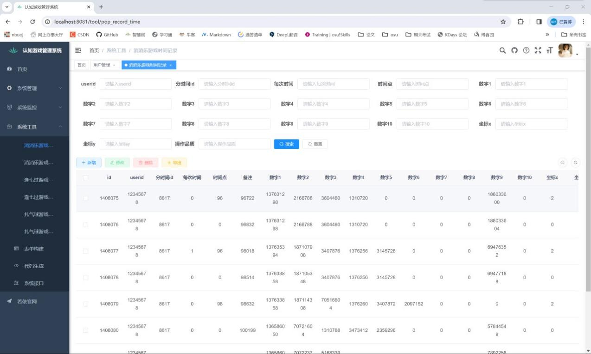
图 8 前端“消消乐游戏时间记录”界面

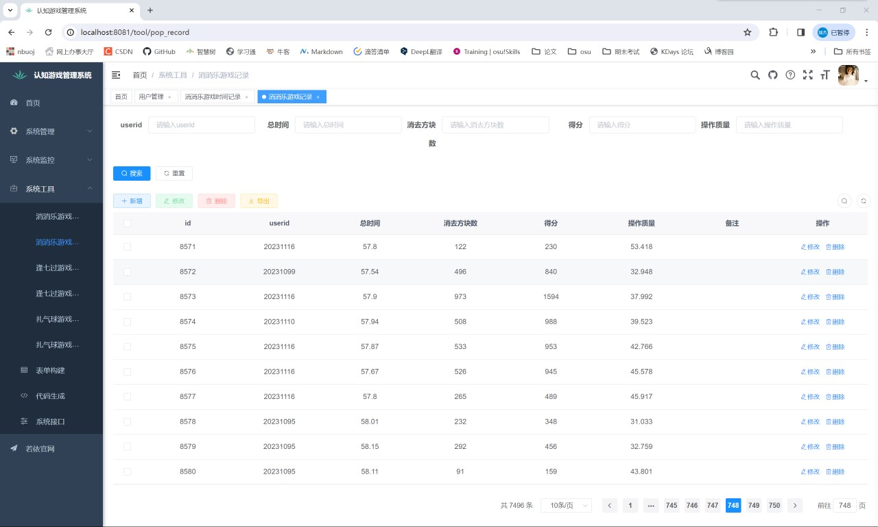
图 9 前端“消消乐游戏记录”界面

数据表存储内容展示：
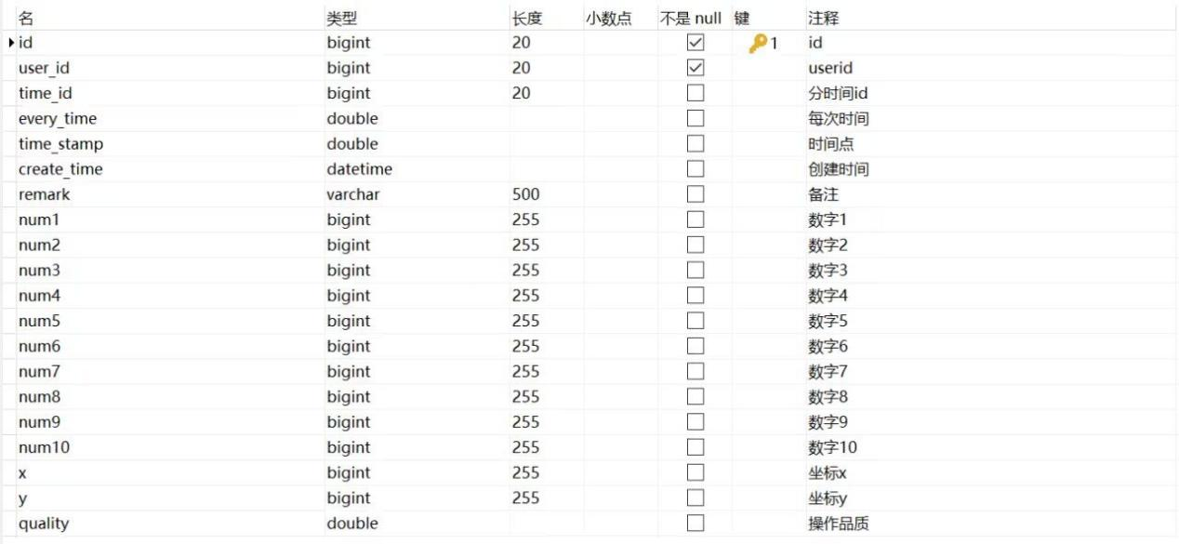
图 10 消消乐游戏时间记录表
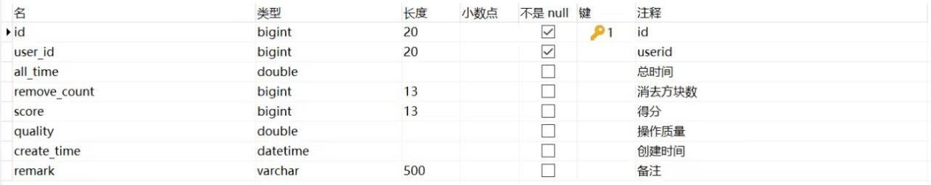
图 11 消消乐游戏记录表
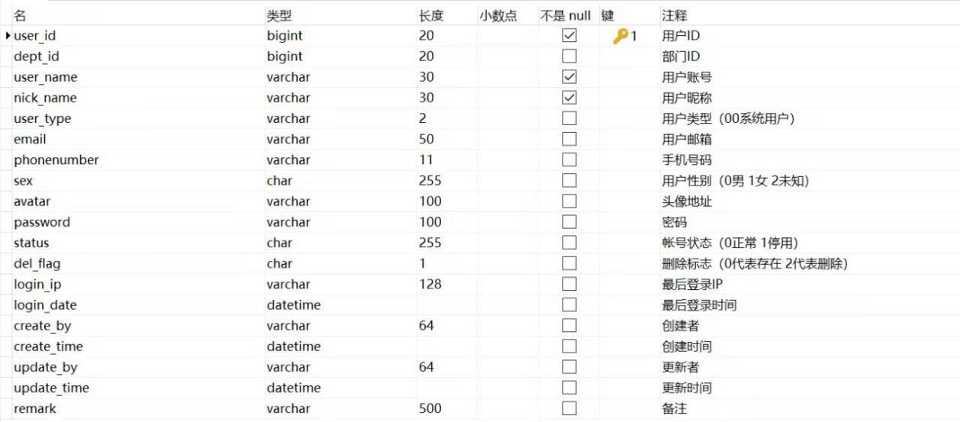
图 12 用户账号表

数据表增删改查展示：
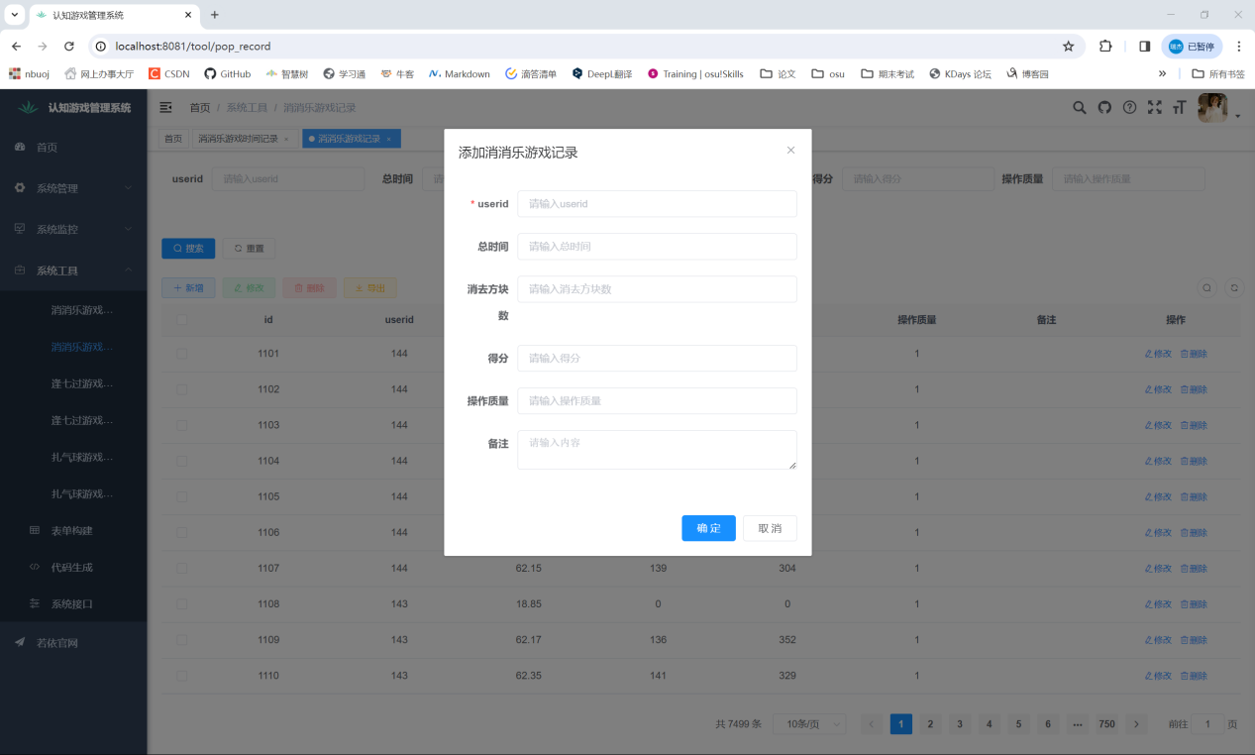
图 13 添加游戏记录
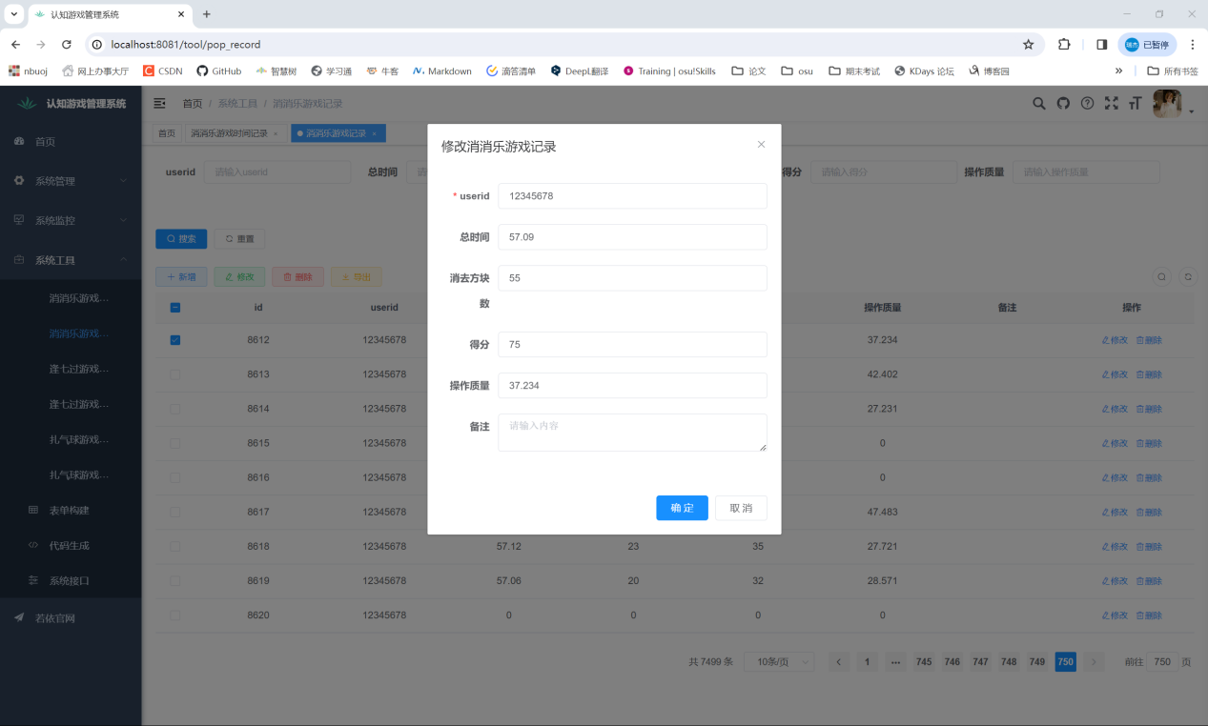
图 14 修改游戏记录

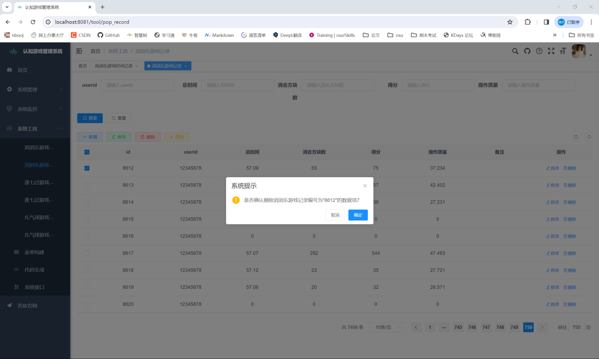
图 15 删除游戏记录

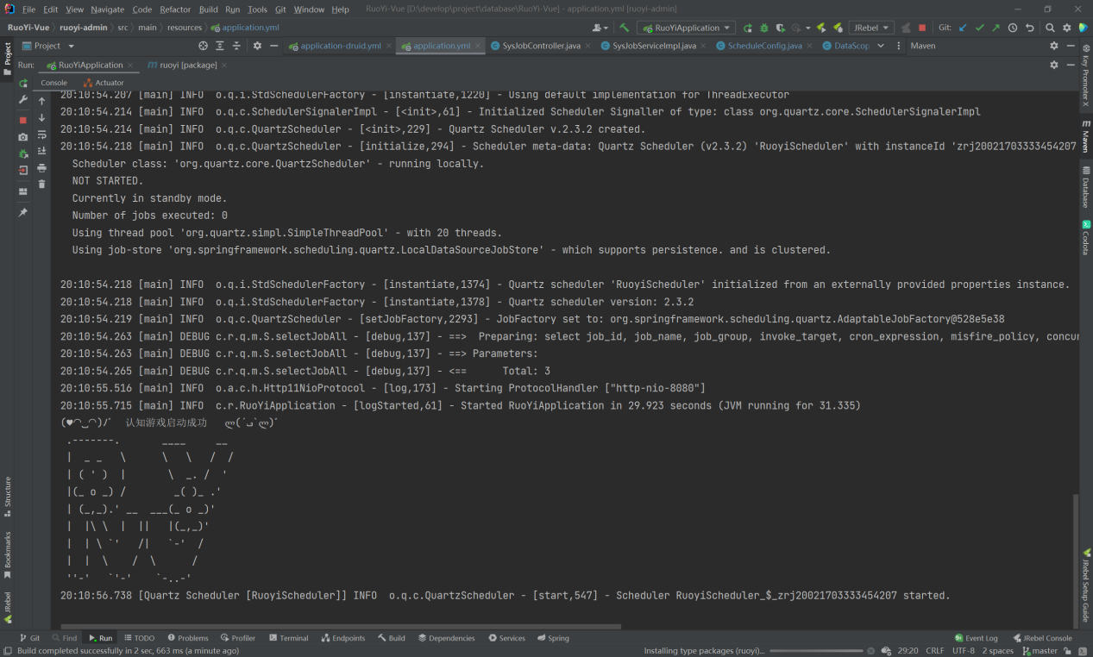
图 16 后台数据库启动界面

游戏运行效果展示：
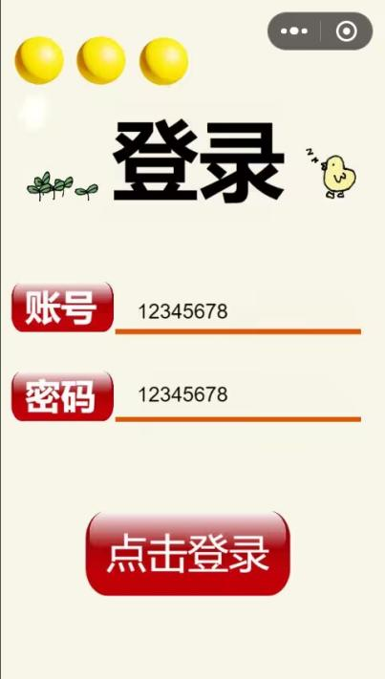
图 17 用户登录界面

图 18 规则解释界面
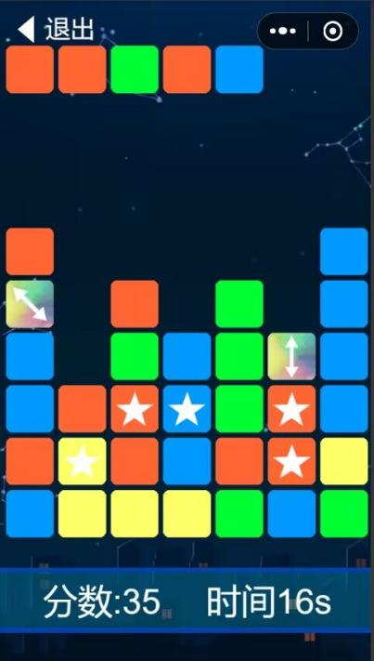
图 19 运行界面
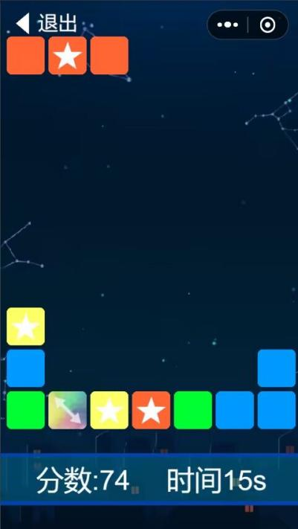
图 20 消除方块

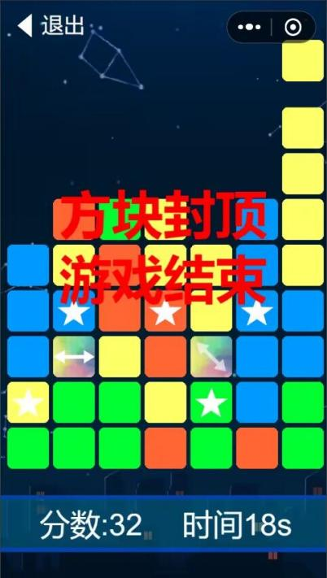
图 21 触顶游戏结束
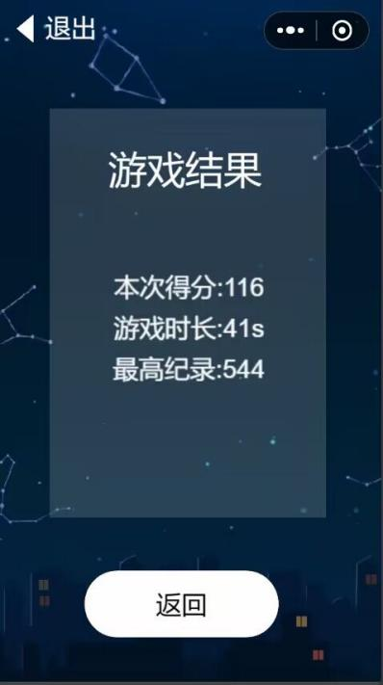
图 22 结果展示界面

六、实验总结
- 结合Spring Boot和Vue.js，通过若依框架搭建后端，采用微信开发者工具构建前端，这样的技术整合使得项目的开发更加高效和稳定。Spring Boot提供了强大的后端支持，而Vue.js则为前端提供了灵活性和响应性。
- 游戏集成了微信开发者工具，提供了便捷的入口和社交分享功能。这样的设计能够增强用户体验，并通过社交分享促使更多用户参与游戏，增加互动性。
- 引入先进的启发式算法是项目的亮点之一。这种算法能够生成有趣且挑战性的消消乐关卡，确保了玩家在游戏中获得不断变化的体验。这对于游戏的可玩性和长期吸引力是非常有益的。
- 将项目发布为微信小游戏，通过微信开发者工具进行适配，可以使游戏在不同平台上运行，并保持良好的用户体验。

七、心得体会
通过这次实验，我们认识到分工合作的重要性有效的分工合作是项目成功的关键，学到了如何根据成员的专长和兴趣分配任务，使得每个人都能够充分发挥自己的优势，提高整体效率。
在合作中，代码规范的统一显得尤为重要。我们学到了如何制定一致的代码规范，以便更容易进行代码合并，减少后期出现的问题。
综上所述，这次实验为我们提供了宝贵的团队合作经验，让我们更好地理解了协作的重要性，并激发了我们进一步提高团队合作水平的动力。在以后的合作中，我们将更加注重团队的默契和效率，以取得更好的成果。

八、附录
说 明 书

一种用于消消乐游戏的方块生成方法
技术领域
本发明涉及方块生成方法，尤其是涉及一种用于消消乐游戏的方块生成方法。
背景技术
现有的一款基于消除玩法开发的消消乐游戏的主要游戏界面分为两个部分，一个是游戏部分，一个是功能部分。游戏部分为一个宽为N个方块，高为M+1个方块的区域，N为玩家设定的一行方块的个数，M=N+2。游戏部分可分为两个相邻的区域，位于上方部分的是“方块生成区域”，其高度为1个方块、宽度为N个方块，位于下方部分的是“主游戏区域”，其高度为M个方块,宽度为N个方块。将游戏部分高度方向M+1等分,宽度方向N等分，分为共(M+1)*N个方块格，每个方块格能够容纳一个方块，(M+1)*N个方块格按照M+1行N列分布。根据方块格在游戏部分中的不同方位，将其的位置用坐标表示，将最左下角的方块格的坐标定义为(1,1)，最右上角的高度与宽度均为1个方块的方块格的位置坐标定义为(M+1,N)，因此每个方块格的位置均可以用坐标(x,y)表示， x称为纵坐标，等于该方块格所处的行数，y称为横坐标，等于该方块格所处的列数，方块在游戏部分中总是会恰好占据一个方块格，并且有唯一的坐标值（所占据方块格的位置坐标）与之相对应。方块生成区域中方块格的坐标为(M+1,y1)，y1=1,2，…N，方块生成区域用于按照设定的时间间隔依次生成方块，且方块的生成顺序从左到右。在游戏开始时，方块生成区域中没有方块。在游戏过程中，每间隔游戏预先设定的时间，在（M+1，i）处会生成一个方块，若方块生成区域中没有方块，则i=1，若方块生成区域中有n个方块时(n<=N-1)，则i=n+1。当在位置(M+1,N)处生成方块时，表示方块生成区域中所有方块生成完成，此时方块生成区域中的所有方块会一齐从“方块生成区域”同步向“主游戏区域”掉落，其中，如果“主游戏区域”中的方块未堆积至顶部（即未封顶），即第M+1行不存在任何方块，则方块生成区域中的每个方块分别向下移动至与其位于同一列、与其之间不存在方块，且距离最远的一个未被方块占据的方块格内，之后“方块生成区域”按照预定预先设定的规则重新生成方块，周而复始，直x至游戏结束；如果“主游戏区域”中的方块已经堆积至顶部（即封顶），即第M+1行存在方块，此时游戏结束。游戏开始时，在“主游戏区域”中初始会自动生成高为N-4格，宽为N格的方块。在主游戏区域中的任意方块，若其下方的方块格中无方块，则其会掉落至该方块格中。当主游戏区域中没有方块时，游戏仍然会正常进行，等待“方块生成区域”中的方块掉落。在游戏过程中，玩家只能对“主游戏区域”中的方块进行操作，不能对方块生成区域中的方块进行操作，方块生成区域中的方块在掉落至主游戏区域之前不会响应玩家的操作，也不会与其他方块有任何的互动。功能部分位于“主游戏区域”的下方，用于显示包括得分和时间的游戏数据。
上述基于消除玩法开发的消消乐游戏的主要玩法是：玩家根据游戏预先设定的特定规则点击“主游戏区域”中的方块以消去关联方块并得分，通过合理利用道具方块、制定合适的方块消去策略以追求更高的得分。用户可以通过点击操作消去方块，当玩家点击普通方块时，若主游戏区域内存在与该方块相互“关联”的方块，则与该方块相互“关联”的方块也将一起被消去，否则该普通方块不被消去。方块相互“关联”的定义和性质如下：
a.定义：游戏中的方块有8种类型，类型分别为A1、A2、A3、A4、A5、A6、A7、A8，可以用Ai表示所有类型的方块，i=1，2，3，4，5，6，7，8，A1至A4类型方块为四种类型的普通方块, A1至A4类型方块依次为红色方块、蓝色方块、绿色方块和黄色方块，A5至A8类型方块为四种类型的道具方块， A5至A8类型方块依次为横向消去方块、纵向消去方块、左上右下-斜向消去方块和左下右上-斜向消去方块。若方块A和方块B的方块类型相同、且均为普通方块，且满足条件A方块与B方块纵坐标值的差的绝对值等于1，横坐标值相等；或A方块与B方块横坐标值的差的绝对值等于1，纵坐标值相等”，则A方块与B方块相互“关联”。另外，每个方块与自身相互“关联”；在方块生成区域中的方块不与任何方块相关联；道具方块不与任何方块相关联。
b.性质：“关联”具有传递性，若A方块与B方块相互“关联”并且A方块与C方块相互“关联”，则B方块与C方块相“关联”。“关联”具有实时性，当场景内任一方块的位置发生变动时，场景内的所有“关联”关系都会重置。
当玩家点击道具方块时，该道具方块将被消去。不同类型的道具方块具有不同的道具效果；道具方块在被点击操作消去或者因其他道具方块被点击操作而消去时，均会触发自身的道具效果。道具效果只能对主游戏区域中的方块产生影响，对方块生成区域中的方块无影响。不同类型道具方块的道具效果分别如下：
a.横向消去方块：将与其位于同一行的所有方块消去。
b.纵向消去方块：将与其位于同一列的所有方块一起消去。
c.左上右下-斜向消去方块：如果该左上右下-斜向消去方块处于坐标（N，1）处的方块和坐标（1,N)处的方块连接形成的斜向方向上，则该斜向方向上存在的所有方块消除，如果该左上右下-斜向消去方块不处于坐标（N，1）处的方块和坐标（1, N）处的方块连接形成的斜向方向上，则该左上右下-斜向消去方块所处的平行于该斜向方向的某一斜向方向上存在的所有方块消除。
d.左下右上-斜向消去方块：如果该左下右上-斜向消去方块处于坐标（1，1）处的方块和坐标（N,N）处的方块连接形成的斜向方向上，则该斜向方向上存在的所有方块消除，如果该左下右上-斜向消去方块不处于坐标（1，1）处的方块和坐标（N,N）处的方块连接形成的斜向方向上，则该左下右上-斜向消去方块所处的平行于该斜向方向的某一斜向方向上存在的所有方块消除。
在上述基于消除玩法开发的消消乐游戏中，影响游戏难度的一个重要因素是“方块生成区域”生成方块的类型，为了提升游戏体验，游戏需要针对不同游戏水平的玩家、或同一玩家在游戏期间的不同游戏阶段来动态调节游戏难度，以增添游戏的娱乐性与挑战性。但是上述基于消除玩法开发的消消乐游戏中，方块生成的方法是“当游戏需要生成一个方块时，首先进行生成道具方块的概率判定，若判定结果为真则生成一个随机类型的道具方块，否则生成一个随机类型的普通方块。生成道具方块的概率为固定值”。此方块生成方法无法动态地调整改变游戏难度，并且会使游戏的随机性过大，降低游戏的公平性与挑战性，导致玩家的游戏积极性下降。

发明内容
本发明所要解决的技术问题是提供一种当不同的玩家进行基于消除玩法开发的消消乐时，会根据玩家水平和游戏进度分析出玩家需要的游戏难度，并能够基于玩家需要的游戏难度生成符合游戏难度需求的游戏方块，从而控制游戏难度在特定区间内，以改善游戏的公平性和挑战性的用于消消乐游戏的方块生成方法。
本发明解决上述技术问题所采用的技术方案为：一种用于消消乐游戏的方块生成方法，将所述的消消乐游戏的游戏部分的宽度记为N个方块，高度记为M+1个方块，所述的消消乐游戏的游戏部分形成高度为M+1个方块、宽度为N个方块的区域，M=N+2，将宽度方向作为列方向，高度方向作为行方向，从下到上依次为第1行至第M+1行，从左到右依次为第1列至第N列，所述的消消乐游戏的“方块生成区域”位于第M+1行，所述的消消乐游戏的“主游戏区域”位于第1行至第M行，将所述的消消乐游戏的游戏部分中位于第a行第b列的方块位置记为(a,b)，a=1,2，…，M+1，b=1,2，…，N；在玩家进行所述的消消乐游戏过程中，当需要在所述的消消乐游戏的“方块生成区域”的(M+1,y0)位置处生成一个新方块时，其中y0为大于等于1且小于等于N的整数，具体生成方法包括以下步骤：
步骤（1）、假设在(M+1,y0)处生成类型为Ai的方块，对i进行初始化，令i=1；
步骤（2）、计算得到类型为Ai的方块的得分，具体计算过程为：
S2-1、复制玩家当前的游戏部分，并将其命名为i类型第0层初始预期区域；然后先在i类型第0层初始预期区域的“方块生成区域”的(M+1,y0)处生成一个类型为Ai的方块，接着令i类型第0层初始预期区域当前的“方块生成区域”中所有方块掉落，在掉落过程中，若i类型第0层初始预期区域当前的“方块生成区域”中某一个方块由于i类型第0层初始预期区域的“主游戏区域”中方块封顶导致无法掉落，则将其直接删去，掉落完成后形成的区域称为i类型第0层预期区域；设定该i类型第0层预期区域的一个参数：得分，并将其得分初始化为等于0；
S2-2、设定变量t，对t进行初始化，令t=1；
S2-3、统计当前得到的i类型第t-1层预期区域的数量，判断i类型第t-1层预期区域的数量是否大于0，若大于，则继续执行步骤S2-4；否则获取t的当前值，将t-2记为n，并跳跃至步骤S2-6继续执行步骤；
S2-4、对于每一个i类型第t-1层预期区域分别进行计算操作，得到每个i类型第t-1层预期区域对应的i类型第t层预期区域，其中任意一个i类型第t-1层预期区域进行计算操作的具体过程如下:
S2-4-1、将当前进行计算操作的某个i类型第t-1层预期区域作为当前计算预期区域；
S2-4-2、获取当前计算预期区域的所有解，具体为：统计当前计算预期区域中所有符合规则能够消去方块的点击操作的数据，其中，若多个点击操作所点击的方块之间相互关联，则在该多个点击操作中随机选取任意一个作为当前计算预期区域的一个解，其他点击操作忽略，若某个点击操作所点击的方块与其它任意一个点击操作所点击的方块无相互关联，则该点击操作作为当前计算预期区域的一个解；
S2-4-3、判断当前计算预期区域的解的数量是否大于0，如果大于，则继续执行步骤S2-4-4，否则当前计算预期区域不存在解，本次计算操作结束；
S2-4-4、分别采用每个解的点击操作对当前计算预期区域进行操作，采用每个解的点击操作对当前计算预期区域进行操作得到的结果即为每个解对应的一个i类型第t层预期区域，每个解对应的i类型第t层预期区域的得分等于当前计算预期区域的得分加上对应解的点击操作所消去的方块的数量；当前计算预期区域的所有解对应的i类型第t层预期区域即为其对应的i类型第t层预期区域；
S2-5、在得到所有i类型第t-1层预期区域对应的i类型第t层预期区域以及其得分后，采用t的当前值加1的和更新t的取值，返回步骤S2-3；
S2-6、计算得到的所有i类型第j层预期区域的得分的平均数，将其记为S_{i,j}，其中j=0,1，…，n；采用式（1）计算得到类型为Ai的方块的得分$C_{i}$：
$C_{i}=\sum_{j=0}^{n}{(\frac{S_{i,j}}{2^{j}})}$ （1）
S2-7、判断i的当前值是否等于8，如果不等于，则先采用i的当前值加1的和更新i的取值，然后返回步骤（2）计算下一个类型的方块的得分，如果等于，则进入步骤（3）；
步骤（3）、取C₁至C₈中的最大值，将该最大值记为Cmax，采用式（2）计算得到类型为Ak的方块的标准化得分SC_{k}：
${SC}_{k}=\frac{C_{k}}{C_{max}}$ （2）
其中，k=1,2，…，8；
步骤（4）、将玩家水平系数记为D₁，采用式（3）计算得到D₁：
D₁=L/25 （3）
式（3）中， L为玩家操作水平，玩家操作水平在玩家登录消消乐游戏后会直接产生；
步骤（5）、设定时间系数D₂，计算得到玩家本次游戏累计时长T，单位为秒(s)，其中T等于当前时间（即需要在方块生成区域中(M+1,y0)位置处生成一个新方块的时间）与玩家开始本次消消乐游戏的时间之间的时间间隔；
如果T大于0且小于120s，则时间系数D₂=[T/30]+1，[ ]表示向下取整，如果T>=120s，则时间系数D₂等于4；
步骤（6）、设定本次生成方块的难度系数为D，D=D₁+D₂，由难度系数D计算得到道具方块生成目标概率AW=0.12-0.008D;
步骤（7）、获取从玩家本次游戏的游戏开始时间到当前时间，消消乐游戏的“方块生成区域”生成的方块数量和类型，将消消乐游戏的“方块生成区域”生成的方块总数量记为BN，将消消乐游戏的“方块生成区域”生成的道具方块总数量记为IN，计算得到方块生成实际频率TW=IN/BN；
步骤（8）、计算类型为Ak的方块的概率修正系数W_{k}：
对于类型为Ah的方块，h=1,2,3,4，W_{h}=1+（TW-AW）/AW；
对于类型为Am的方块，m=5,6,7,8，W_{m}=1+（AW-TW）/AW；
步骤（9）、采用式（4）计算得到类型为Ak的方块的生成权重$S_{k}$为：
$S_{k}={({SC}_{k})}^{0.1∗(3.5−D)}∗{(SC}_{k}+1)∗W_{k}$ （4）
其中，*为乘运算符号；
步骤（10）、获取S₁至S₈中的最大值，假设获取到的最大值为S_{r}，其中r为大于等于1且小于等于8的整数，Ar即为所需要生成的方块类型；
步骤（11）、在消消乐游戏的“方块生成区域”的(M+1,y0)位置处生成类型为Ar的方块。
与现有技术相比，本发明的优点在于当需要在消消乐游戏的“方块生成区域”中某位置处生成一个新方块时，复制玩家当前游戏部分，创建初始预期区域，并在初始预期区域中的相同坐标处假设生成类型为Ai的方块，i的可能取值为1,2,3...8；令初始预期区域中的方块生成区域中的方块掉落，得到i类型第0层预期区域，即i类型第0层预期区域即为创建的一个预期区域，采用创建预期区域的方式来模拟玩家计算一次或多次点击之后消消乐游戏的“主游戏区域”的新场景，思考不同的解法以得到更优的操作策略，由于不同玩家思考的深度也不相同，高水平玩家往往计算的点击次数更多，即思考的深度更深，能计算出层数更高的预期场景，故后续从t=1开始进行迭代，通过对每个i类型第t-1层预期区域均通过进行计算操作的方式来创建对应的i类型第t层预期区域，并计算得到每个i类型第t层预期区域的得分，在迭代结束后，将所有i类型第j层预期区域的得分求平均值并乘影响因数$\frac{1}{2^{j}}$得到i类型第j层的得分值，将所有层的得分值求和得到生成类型为Ai的方块的得分值C_{i}，该得分值代表模拟玩家在生成类型为Ai的方块后思考方块消去策略之后的玩家预期得分，思考深度越深则思考难度越大，因此层数越高的预期区域影响因数越小，其得分对玩家预期得分的影响也越小，将8种类型的方块各自的得分C_{k}进行标准化处理，得到标准化得分SC_{k}，k的可能取值为1,2,3...8，每种类型的方块的标准化得分代表生成该类型的方块后的游戏场景的玩家预期得分的相对值，其值越高代表生成该类型方块后玩家能够有更高的预期得分，即生成该类型方块后的游戏场景的相对难度更低，导入玩家操作水平和玩家本次游戏累计时长，分别计算出玩家水平系数和时间系数，综合两者得到生成方块难度系数，该系数用来衡量本次生成的方块需要的难度等级，当生成方块难度系数低时，方块生成权重与其标准化得分成正比，即预期得分越高的方块类型生成权重更高，游戏难度低；当生成方块难度系数高时，方块生成权重与其标准化得分成反比，即预期得分越低的方块类型生成权重更高，为玩家创造更高难度的游戏场景，分别将8种类型的方块的标准化得分值乘上各自的方块概率修正系数，并根据公式得到方块生成权重，在多数情况下，生成道具方块能让玩家消去更多的方块，因此道具类型方块的方块标准化得分往往高于普通类型方块的方块标准化得分，若无无方块概率修正会导致道具方块的生成频率偏高，使游戏难度过低，因此引入方块概率修正系数，用于平衡普通方块和道具方块的方块生成权重，在道具方块生成频率过高时降低道具方块的生成权重，反之则增加道具方块的生成权重，从而将道具方块的生成频率控制在一定区间内，最后根据方块生成权重的大小排序，方块生成权重最高的方块即为本次生成的新方块的类型，本发明的方法分析了生成不同类型的方块对当前游戏场景的消去难度和复杂程度的影响，结合玩家水平和游戏进行时长，通过控制生成的方块类型来分析出当前需要的游戏难度区间，并生成合适难度的对应类型的方块，减少方块生成随机性对玩家游戏体验的不良影响，改善游戏的公平性与挑战性，提高玩家的游戏积极性。

具体实施方式
以下结合实施例对本发明作进一步详细描述。
实施例：一种用于消消乐游戏的方块生成方法，将消消乐游戏的游戏部分的宽度记为N个方块，高度记为M+1个方块，消消乐游戏的游戏部分形成高度为M+1个方块、宽度为N个方块的区域，M=N+2，将宽度方向作为列方向，高度方向作为行方向，从下到上依次为第1行至第M+1行，从左到右依次为第1列至第N列，消消乐游戏的“方块生成区域”位于第M+1行，消消乐游戏的“主游戏区域”位于第1行至第M行，将消消乐游戏的游戏部分中位于第a行第b列的方块位置记为(a,b)，a=1,2，…，M+1，b=1,2，…，N；在玩家进行消消乐游戏过程中，当需要在消消乐游戏的“方块生成区域”的(M+1,y0)位置处生成一个新方块时，其中y0为大于等于1且小于等于N的整数，具体生成方法包括以下步骤：
步骤（1）、假设在(M+1,y0)处生成类型为Ai的方块，对i进行初始化，令i=1；
步骤（2）、计算得到类型为Ai的方块的得分，具体计算过程为：
S2-1、复制玩家当前的游戏部分，并将其命名为i类型第0层初始预期区域；然后先在i类型第0层初始预期区域的“方块生成区域”的(M+1,y0)处生成一个类型为Ai的方块，接着令i类型第0层初始预期区域当前的“方块生成区域”中所有方块掉落，在掉落过程中，若i类型第0层初始预期区域当前的“方块生成区域”中某一个方块由于i类型第0层初始预期区域的“主游戏区域”中方块封顶导致无法掉落，则将其直接删去，掉落完成后形成的区域称为i类型第0层预期区域；设定该i类型第0层预期区域的一个参数：得分，并将其得分初始化为等于0；
S2-2、设定变量t，对t进行初始化，令t=1；
S2-3、统计当前得到的i类型第t-1层预期区域的数量，判断i类型第t-1层预期区域的数量是否大于0，若大于，则继续执行步骤S2-4；否则获取t的当前值，将t-2记为n，并跳跃至步骤S2-6继续执行步骤；
S2-4、对于每一个i类型第t-1层预期区域分别进行计算操作，得到每个i类型第t-1层预期区域对应的i类型第t层预期区域，其中任意一个i类型第t-1层预期区域进行计算操作的具体过程如下:
S2-4-1、将当前进行计算操作的某个i类型第t-1层预期区域作为当前计算预期区域；
S2-4-2、获取当前计算预期区域的所有解，具体为：统计当前计算预期区域中所有符合规则能够消去方块的点击操作的数据，其中，若多个点击操作所点击的方块之间相互关联，则在该多个点击操作中随机选取任意一个作为当前计算预期区域的一个解，其他点击操作忽略，若某个点击操作所点击的方块与其它任意一个点击操作所点击的方块无相互关联，则该点击操作作为当前计算预期区域的一个解；
S2-4-3、判断当前计算预期区域的解的数量是否大于0，如果大于，则继续执行步骤S2-4-4，否则当前计算预期区域不存在解，本次计算操作结束；
S2-4-4、分别采用每个解的点击操作对当前计算预期区域进行操作，采用每个解的点击操作对当前计算预期区域进行操作得到的结果即为每个解对应的一个i类型第t层预期区域，每个解对应的i类型第t层预期区域的得分等于当前计算预期区域的得分加上对应解的点击操作所消去的方块的数量；当前计算预期区域的所有解对应的i类型第t层预期区域即为其对应的i类型第t层预期区域；
S2-5、在得到所有i类型第t-1层预期区域对应的i类型第t层预期区域以及其得分后，采用t的当前值加1的和更新t的取值，返回步骤S2-3；
S2-6、计算得到的所有i类型第j层预期区域的得分的平均数，将其记为S_{i,j}，其中j=0,1，…，n；采用式（1）计算得到类型为Ai的方块的得分$C_{i}$：
$C_{i}=\sum_{j=0}^{n}{(\frac{S_{i,j}}{2^{j}})}$ （1）
S2-7、判断i的当前值是否等于8，如果不等于，则先采用i的当前值加1的和更新i的取值，然后返回步骤（2）计算下一个类型的方块的得分，如果等于，则进入步骤（3）；
步骤（3）、取C₁至C₈中的最大值，将该最大值记为Cmax，采用式（2）计算得到类型为Ak的方块的标准化得分SC_{k}：
${SC}_{k}=\frac{C_{k}}{C_{max}}$ （2）
其中，k=1,2，…，8；
步骤（4）、将玩家水平系数记为D₁，采用式（3）计算得到D₁：
D₁=L/25 （3）
式（3）中， L为玩家操作水平，玩家操作水平在玩家登录消消乐游戏后会直接产生；
步骤（5）、设定时间系数D₂，计算得到玩家本次游戏累计时长T，单位为秒(s)，其中T等于当前时间（即需要在方块生成区域中(M+1,y0)位置处生成一个新方块的时间）与玩家开始本次消消乐游戏的时间之间的时间间隔；
如果T大于0且小于120s，则时间系数D₂=[T/30]+1，[ ]表示向下取整，如果T>=120s，则时间系数D₂等于4；
步骤（6）、设定本次生成方块的难度系数为D，D=D₁+D₂，由难度系数D计算得到道具方块生成目标概率AW=0.12-0.008D;
步骤（7）、获取从玩家本次游戏的游戏开始时间到当前时间，消消乐游戏的“方块生成区域”生成的方块数量和类型，将消消乐游戏的“方块生成区域”生成的方块总数量记为BN，将消消乐游戏的“方块生成区域”生成的道具方块总数量记为IN，计算得到方块生成实际频率TW=IN/BN；
步骤（8）、计算类型为Ak的方块的概率修正系数W_{k}：
对于类型为Ah的方块，h=1,2,3,4，W_{h}=1+（TW-AW）/AW；
对于类型为Am的方块，m=5,6,7,8，W_{m}=1+（AW-TW）/AW；
其中，A1至A4类型方块为四种类型的普通方块, A1至A4类型方块依次为红色方块、蓝色方块、绿色方块和黄色方块，A5至A8类型方块为四种类型的道具方块， A5至A8类型方块依次为横向消去方块、纵向消去方块、左上右下-斜向消去方块和左下右上-斜向消去方块；
步骤（9）、采用式（4）计算得到类型为Ak的方块的生成权重$S_{k}$为：
$S_{k}={({SC}_{k})}^{0.1∗(3.5−D)}∗{(SC}_{k}+1)∗W_{k}$ （4）
其中，*为乘运算符号；
步骤（10）、获取S₁至S₈中的最大值，假设获取到的最大值为S_{r}，其中r为大于等于1且小于等于8的整数，Ar即为所需要生成的方块类型；
步骤（11）、在消消乐游戏的“方块生成区域”的(M+1,y0)位置处生成类型为Ar的方块。
本发明的用于消消乐游戏的方块生成方法中，当需要在消消乐游戏的“方块生成区域”中某位置处生成一个新方块时，首先复制玩家当前游戏部分，创建初始预期区域，并在初始预期区域中的相同坐标处假设生成类型为Ai的方块，令初始预期区域中的方块生成区域中的方块掉落，得到i类型第0层预期区域，i类型第0层预期区域为创建的一个预期区域，本发明通过采用创建预期区域的方式来模拟玩家计算一次或多次点击操作方块之后消消乐游戏的“主游戏区域”的新场景，思考不同的解法以得到更优的操作策略，由于不同玩家思考的深度也不相同，高水平玩家往往计算的点击操作次数更多，即思考的深度更深，能计算出层数更高的预期场景，故后续设定迭代变量t，从t=1开始进行迭代，通过对每个i类型第t-1层预期区域分别通过计算操作的方式来创建对应的i类型第t层预期区域，并计算得到每个i类型第t层预期区域的得分，在迭代结束后，将所有i类型第j层预期区域的得分求平均值并乘以影响因数$\frac{1}{2^{j}}$得到i类型第j层预期区域的得分，将所有层预期区域的得分求和得到生成类型为Ai的方块的得分值C_{i}，该得分值代表模拟玩家在生成类型为Ai的方块后思考方块消去策略之后的玩家预期得分，思考深度越深则思考难度越大，因此层数越高的预期区域影响因数越小，其得分对玩家预期得分的影响也越小，将8种类型的方块各自的得分C_{k}进行标准化处理，得到标准化得分SC_{k}，k的取值为1,2,3...8，每种类型的方块的标准化得分代表生成该类型的方块后消消乐游戏的“主游戏区域”的游戏场景的玩家预期得分的相对值，其值越高代表生成该类型方块后玩家能够有更高的预期得分，即生成该类型方块后的游戏场景的相对难度更低，导入玩家操作水平和玩家本次游戏累计时长，分别计算出玩家水平系数和时间系数，综合两者得到生成方块难度系数，该难度系数用来衡量本次生成的方块需要的难度等级，当生成方块难度系数低时，方块生成权重与其标准化得分成正比，即预期得分越高的方块类型生成权重更高，游戏难度低；当生成方块难度系数高时，方块生成权重与其标准化得分成反比，即预期得分越低的方块类型生成权重更高，为玩家创造更高难度的游戏场景，分别将8种类型的方块的标准化得分值乘上各自的方块概率修正系数，并根据公式得到方块生成权重，在多数情况下，生成道具方块能让玩家消去更多的方块，因此道具类型方块的方块标准化得分往往高于普通类型方块的方块标准化得分，若无无方块概率修正会导致道具方块的生成频率偏高，使游戏难度过低，因此引入方块概率修正系数，用于平衡普通方块和道具方块的方块生成权重，在道具方块生成频率过高时降低道具方块的生成权重，反之则增加道具方块的生成权重，从而将道具方块的生成频率控制在一定区间内，最后根据方块生成权重的大小排序，方块生成权重最高的方块类型即为本次生成的新方块的类型。
本发明的用于消消乐游戏的方块生成方法方法分析了生成不同类型的方块对当前玩家的消消乐游戏的“主游戏区域”的消去难度和复杂程度的影响，结合玩家水平和游戏进行时长，通过控制生成的方块类型来分析出当前需要的游戏难度区间，并生成合适难度的对应类型的方块，减少方块生成随机性对玩家游戏体验的不良影响，改善游戏的公平性与挑战性，从而能够提高玩家的游戏积极性。

权 利 要 求 书
1.一种用于消消乐游戏的方块生成方法，将所述的消消乐游戏的游戏部分的宽度记为N个方块，高度记为M+1个方块，所述的消消乐游戏的游戏部分形成高度为M+1个方块、宽度为N个方块的区域，M=N+2，将宽度方向作为列方向，高度方向作为行方向，从下到上依次为第1行至第M+1行，从左到右依次为第1列至第N列，所述的消消乐游戏的“方块生成区域”位于第M+1行，所述的消消乐游戏的“主游戏区域”位于第1行至第M行，将所述的消消乐游戏的游戏部分中位于第a行第b列的方块位置记为(a,b)，a=1,2，…，M+1，b=1,2，…，N；其特征在于在玩家进行所述的消消乐游戏过程中，当需要在所述的消消乐游戏的“方块生成区域”的(M+1,y0)位置处生成一个新方块时，其中y0为大于等于1且小于等于N的整数，具体生成方法包括以下步骤：
步骤（1）、假设在(M+1,y0)处生成类型为Ai的方块，对i进行初始化，令i=1；
步骤（2）、计算得到类型为Ai的方块的得分，具体计算过程为：
S2-1、复制玩家当前的游戏部分，并将其命名为i类型第0层初始预期区域；然后先在i类型第0层初始预期区域的“方块生成区域”的(M+1,y0)处生成一个类型为Ai的方块，接着令i类型第0层初始预期区域当前的“方块生成区域”中所有方块掉落，在掉落过程中，若i类型第0层初始预期区域当前的“方块生成区域”中某一个方块由于i类型第0层初始预期区域的“主游戏区域”中方块封顶导致无法掉落，则将其直接删去，掉落完成后形成的区域称为i类型第0层预期区域；设定该i类型第0层预期区域的一个参数：得分，并将其得分初始化为等于0；
S2-2、设定变量t，对t进行初始化，令t=1；
S2-3、统计当前得到的i类型第t-1层预期区域的数量，判断i类型第t-1层预期区域的数量是否大于0，若大于，则继续执行步骤S2-4；否则获取t的当前值，将t-2记为n，并跳跃至步骤S2-6继续执行步骤；
S2-4、对于每一个i类型第t-1层预期区域分别进行计算操作，得到每个i类型第t-1层预期区域对应的i类型第t层预期区域，其中任意一个i类型第t-1层预期区域进行计算操作的具体过程如下:
S2-4-1、将当前进行计算操作的某个i类型第t-1层预期区域作为当前计算预期区域；
S2-4-2、获取当前计算预期区域的所有解，具体为：统计当前计算预期区域中所有符合规则能够消去方块的点击操作的数据，其中，若多个点击操作所点击的方块之间相互关联，则在该多个点击操作中随机选取任意一个作为当前计算预期区域的一个解，其他点击操作忽略，若某个点击操作所点击的方块与其它任意一个点击操作所点击的方块无相互关联，则该点击操作作为当前计算预期区域的一个解；
S2-4-3、判断当前计算预期区域的解的数量是否大于0，如果大于，则继续执行步骤S2-4-4，否则当前计算预期区域不存在解，本次计算操作结束；
S2-4-4、分别采用每个解的点击操作对当前计算预期区域进行操作，采用每个解的点击操作对当前计算预期区域进行操作得到的结果即为每个解对应的一个i类型第t层预期区域，每个解对应的i类型第t层预期区域的得分等于当前计算预期区域的得分加上对应解的点击操作所消去的方块的数量；当前计算预期区域的所有解对应的i类型第t层预期区域即为其对应的i类型第t层预期区域；
S2-5、在得到所有i类型第t-1层预期区域对应的i类型第t层预期区域以及其得分后，采用t的当前值加1的和更新t的取值，返回步骤S2-3；
S2-6、计算得到的所有i类型第j层预期区域的得分的平均数，将其记为S_{i,j}，其中j=0,1，…，n；采用式（1）计算得到类型为Ai的方块的得分$C_{i}$：
$C_{i}=\sum_{j=0}^{n}{(\frac{S_{i,j}}{2^{j}})}$ （1）
S2-7、判断i的当前值是否等于8，如果不等于，则先采用i的当前值加1的和更新i的取值，然后返回步骤（2）计算下一个类型的方块的得分，如果等于，则进入步骤（3）；
步骤（3）、取C₁至C₈中的最大值，将该最大值记为Cmax，采用式（2）计算得到类型为Ak的方块的标准化得分SC_{k}：
${SC}_{k}=\frac{C_{k}}{C_{max}}$ （2）
其中，k=1,2，…，8；
步骤（4）、将玩家水平系数记为D₁，采用式（3）计算得到D₁：
D₁=L/25 （3）
式（3）中， L为玩家操作水平，玩家操作水平在玩家登录消消乐游戏后会直接产生；
步骤（5）、设定时间系数D₂，计算得到玩家本次游戏累计时长T，单位为秒(s)，其中T等于当前时间（即需要在方块生成区域中(M+1,y0)位置处生成一个新方块的时间）与玩家开始本次消消乐游戏的时间之间的时间间隔；
如果T大于0且小于120s，则时间系数D₂=[T/30]+1，[ ]表示向下取整，如果T>=120s，则时间系数D₂等于4；
步骤（6）、设定本次生成方块的难度系数为D，D=D₁+D₂，由难度系数D计算得到道具方块生成目标概率AW=0.12-0.008D;
步骤（7）、获取从玩家本次游戏的游戏开始时间到当前时间，消消乐游戏的“方块生成区域”生成的方块数量和类型，将消消乐游戏的“方块生成区域”生成的方块总数量记为BN，将消消乐游戏的“方块生成区域”生成的道具方块总数量记为IN，计算得到方块生成实际频率TW=IN/BN；
步骤（8）、计算类型为Ak的方块的概率修正系数W_{k}：
对于类型为Ah的方块，h=1,2,3,4，W_{h}=1+（TW-AW）/AW；
对于类型为Am的方块，m=5,6,7,8，W_{m}=1+（AW-TW）/AW；
步骤（9）、采用式（4）计算得到类型为Ak的方块的生成权重$S_{k}$为：
$S_{k}={({SC}_{k})}^{0.1∗(3.5−D)}∗{(SC}_{k}+1)∗W_{k}$ （4）
其中，*为乘运算符号；
步骤（10）、获取S₁至S₈中的最大值，假设获取到的最大值为S_{r}，其中r为大于等于1且小于等于8的整数，Ar即为所需要生成的方块类型；
步骤（11）、在消消乐游戏的“方块生成区域”的(M+1,y0)位置处生成类型为Ar的方块。

说 明 书 摘 要
本发明公开了一种用于消消乐游戏的方块生成方法，首先创建初始预期区域，并在初始预期区域中假设生成8种类型的方块，基于初始预期区域创建的下一级预期区域，采用创建预期区域的方式来模拟玩家计算一次或多次点击之后消消乐游戏的“主游戏区域”的新场景，得到标准化得分，接着分别计算出玩家水平系数和时间系数，综合两者得到生成方块难度系数，引入方块概率修正概率，进而得到方块生成权重，最后方块生成权重最高的方块即为本次生成的新方块的类型；优点是会根据玩家水平和游戏进度分析出玩家需要的游戏难度，并能够基于玩家需要的游戏难度生成符合游戏难度需求的游戏方块，从而控制游戏难度在特定区间内，以改善游戏的公平性和挑战性。

