《算法设计与分析》实验报告

实验七 综合实验
报告书
姓名 | 顾凯琪 | 指导教师 | 方贤忠
学号 | 226001624 | 日 期 | 20250617
班级 | 22计算机2班
实验内容
[OJ测试]
实验目的
学习掌握本类算法的设计与实现，完成实验报告书写。
【如有查重雷同，请在此说明】
代码独立完成，无雷同。
【如有OJ未完成，请在此说明，并在本实验文档中补全】
都已完成
实验过程和步骤
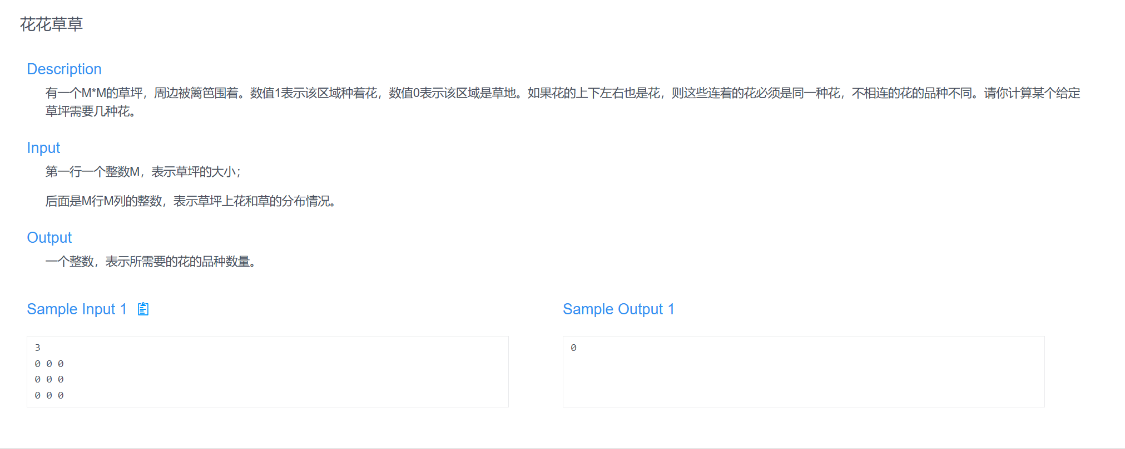
- #include<bits/stdc++.h>
- using namespace std;

- int M;
- vector<vector<int>> place;
- vector<vector<bool>> visited;
- int dir[4][2] = {{-1,0},{1,0},{0,-1},{0,1}};
- queue<pair<int,int>> qu;

- void bfs(int x,int y){
- visited[x][y] = true;
- qu.push({x,y});

- while(!qu.empty()){
- pair<int,int> temp = qu.front();
- qu.pop();

- for(int i =0;i<4;i++){
- int newx = temp.first + dir[i][0];
- int newy = temp.second + dir[i][1];

- if(newx>=0 &&newx <M &&newy >=0 &&newy <M &&visited[newx][newy] == false && place[newx][newy] == 1){
- qu.push({newx,newy});
- visited[newx][newy] = true;
- }
- }
- }
- }

- int main(){
- cin>>M;
- place = vector<vector<int>>(M, vector<int>(M));
- visited = vector<vector<bool>>(M, vector<bool>(M, false));
- int count = 0;
- for(int i = 0;i<M;i++){
- for(int j =0;j<M;j++){
- cin>>place[i][j];
- visited[i][j] = false;
- }
- }
- for(int i = 0;i<M;i++){
- for(int j =0;j<M;j++){
- if(place[i][j] == 1 && visited[i][j] == false){
- bfs(i,j);
- count++;
- }
- }
- }
- cout<<count<<endl;

- }
- 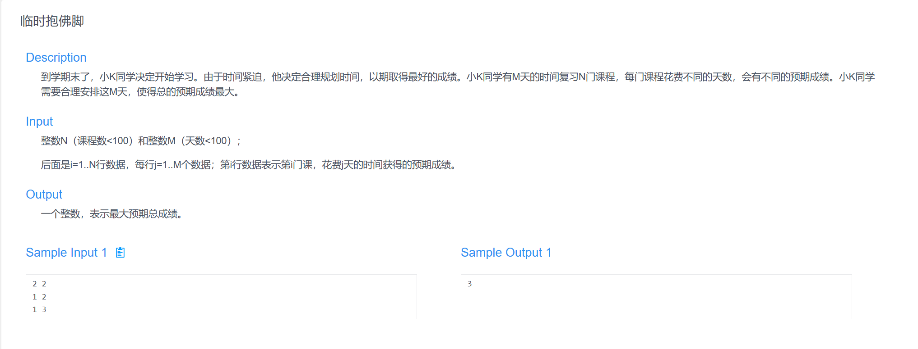#include <bits/stdc++.h>
- using namespace std;

- int main() {
- int N, M;
- cin >> N >> M;

- vector<vector<int>> score(N + 1, vector<int>(M + 1, 0));
- for (int i = 1; i <= N; i++) {
- for (int j = 1; j <= M; j++) {
- cin >> score[i][j];
- }
- }

- vector<int> dp(M + 1, 0);

- for (int i = 1; i <= N; i++) {
- for (int j = M; j >= 0; j--) {
- for (int k = 1; k <= j; k++) {
- dp[j] = max(dp[j], dp[j - k] + score[i][k]);
- }
- }
- }

- cout << dp[M] << endl;
- return 0;
- }
- #include<bits/stdc++.h>
- using namespace std;

- int n,ar,ac,br,bc;
- char place[101][101];
- int dir[4][2] = {{-1,0},{1,0},{0,-1},{0,1}};
- bool visited[101][101] = {false};
- bool flag = false;

- void dfs(int x,int y){
- if(flag) return;
- if(visited[x][y]) return;
- if(x == br &&y == bc){
- cout<<"YES"<<endl;
- flag = true;
- return;
- }

- visited[x][y] = true;
- for(int i =0;i<4;i++){
- int newx = x + dir[i][0];
- int newy = y + dir[i][1];

- if(newx>=0 &&newx <n &&newy >=0 &&newy <n&& place[newx][newy] == '^' &&flag == false){
- dfs(newx,newy);
- }
- }
- //visited[x][y] = false;
- }

- int main(){
- int k;
- cin>>k;
- while(k--){
- flag = false;

- cin>>n;
- for(int i =0;i<n;i++){
- for(int j = 0;j<n;j++){
- cin>>place[i][j];
- visited[i][j] = false;
- }
- }
- cin>>ar>>ac>>br>>bc;
- if(place[ar][ac] == '^' && place[br][bc] == '^'){
- dfs(ar, ac);
- }
- if(!flag){
- cout<<"NO"<<endl;
- }
- }
- }
- 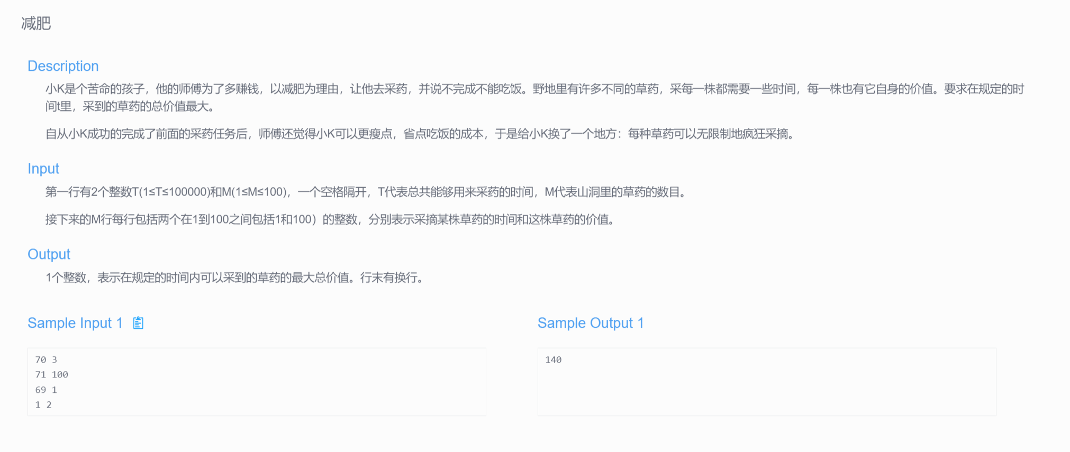#include <bits/stdc++.h>
- using namespace std;
- int dp[100005];
- int main(){
- int T,M;
- if(!(cin>>T>>M)) return 0;
- int ti, vi;
- while(M--){
- cin>>ti>>vi;
- for(int t=ti; t<=T; t++){
- dp[t] = max(dp[t], dp[t-ti] + vi);
- }
- }
- cout<<dp[T]<<'\n';
- return 0;
- }
- 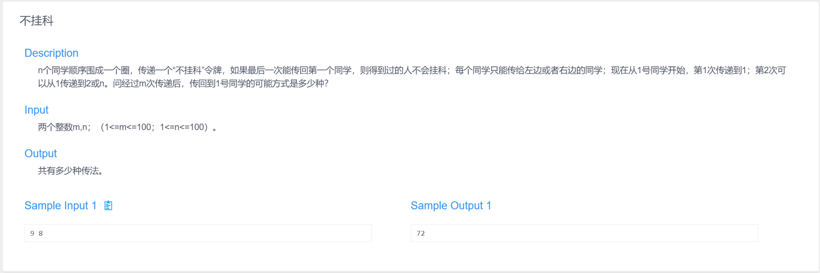#include <iostream>
- using namespace std;

- int main() {
- int m, n;
- cin >> m >> n;

- int dp[101][101] = {0};
- dp[1][1] = 1;

- for (int i = 2; i <= m; i++) {
- for (int j = 1; j <= n; j++) {
- if (j == 1)
- dp[i][j] = dp[i - 1][2] + dp[i - 1][n];
- else if (j == n)
- dp[i][j] = dp[i - 1][1] + dp[i - 1][n - 1];
- else
- dp[i][j] = dp[i - 1][j - 1] + dp[i - 1][j + 1];
- }
- }

- cout << dp[m][1] << "\n";
- return 0;
- }
- 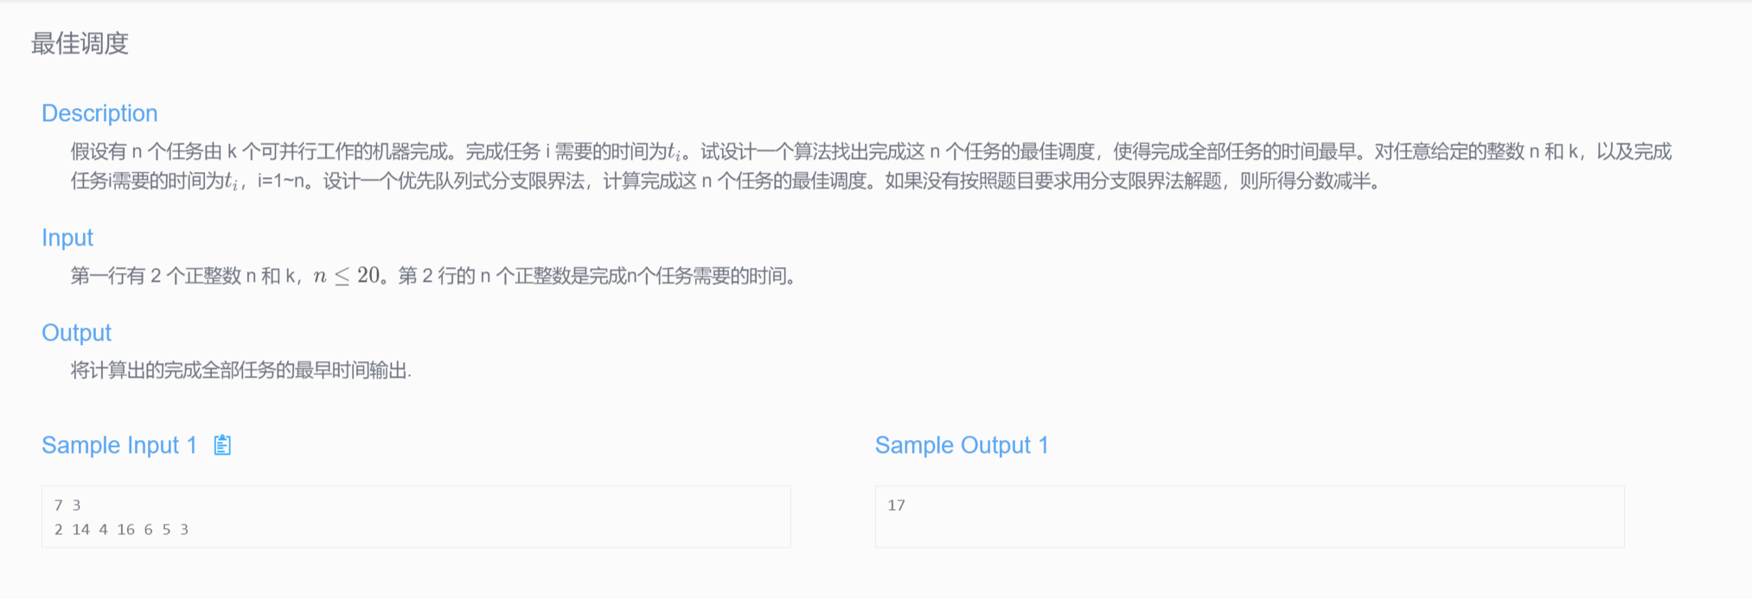#include<bits/stdc++.h>
- using namespace std;

- struct Node {
- vector<int> load;
- int task;
- int maxLoad;
- bool operator<(const Node &b) const {
- return maxLoad > b.maxLoad;
- }
- };

- int main() {
- int n, k;
- cin >> n >> k;
- vector<int> t(n);
- for(int i = 0; i < n; i++) cin >> t[i];

- sort(t.rbegin(), t.rend());

- priority_queue<Node> q;
- Node start;
- start.load = vector<int>(k, 0);
- start.task = 0;
- start.maxLoad = 0;
- q.push(start);

- int best = accumulate(t.begin(), t.end(), 0);

- while(!q.empty()) {
- Node cur = q.top(); q.pop();
- if(cur.task == n) {
- best = min(best, cur.maxLoad);
- continue;
- }
- for(int i = 0; i < k; i++) {
- Node next = cur;
- next.load[i] += t[cur.task];
- next.task++;
- next.maxLoad = *max_element(next.load.begin(), next.load.end());
- if(next.maxLoad >= best) continue;
- q.push(next);
- }
- }

- cout << best <<endl;
- return 0;
- }

