Group10: Britt Ye, Jialong Guo, Kaiqing Qi, Qi Qiao, Shangyue Xu
RAG-Based Interactive AI for MS in Applied Data Science Website
Implementation Summary
The developed solution is a Retrieval-Augmented Generation (RAG) system designed to assist prospective and current students by answering questions directly from the University of Chicago’s MS in Applied Data Science website content.
Implementation Steps:
- Data Collection and Preprocessing:
- Website content was extracted using SiteSucker with crawl depth control.
- HTML files were parsed using BeautifulSoup to extract text, removing irrelevant components such as navigation bars, footers, and scripts.
- Hierarchical metadata was created based on document file paths.
- Text Chunking and Embedding:
- Cleaned text was segmented into manageable chunks.
- Chunks were converted into dense vectors using HuggingFace embeddings for semantic retrieval.
- Vector Database (Chroma):
- Chroma vector store was used for efficient similarity searches.
- Enabled quick retrieval of relevant chunks based on user queries.
- Response Generation with ChatOpenAI:
- Retrieved chunks combined with user queries through the RetrievalQA pipeline (LangChain) to generate contextually relevant answers.
Challenges and Future Improvements
- Data Quality: Addressed noise removal from raw website content through careful preprocessing.
- Chunking Strategy: Managed the semantic continuity through optimized chunk size and overlap.
- Latency: Mitigated latency concerns inherent in real-time retrieval and generation tasks.
- Embedding Relevance: Enhanced accuracy by balancing embedding-only retrieval with keyword-based mechanisms.
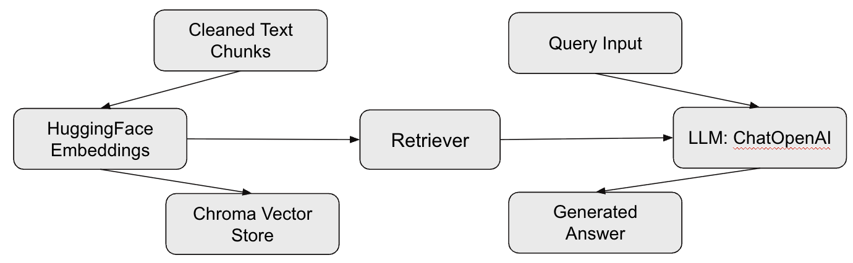
Flow Diagram

