**Assignment-1**

**Website :** [**www.digikey.in**](http://www.digikey.in)



**Search bar** : The search engine operates using both keywords and product part numbers. Additionally, it features a dropdown menu with two categories: "All products" and "All content". As users type in the search bar, it suggests part numbers based on their input.

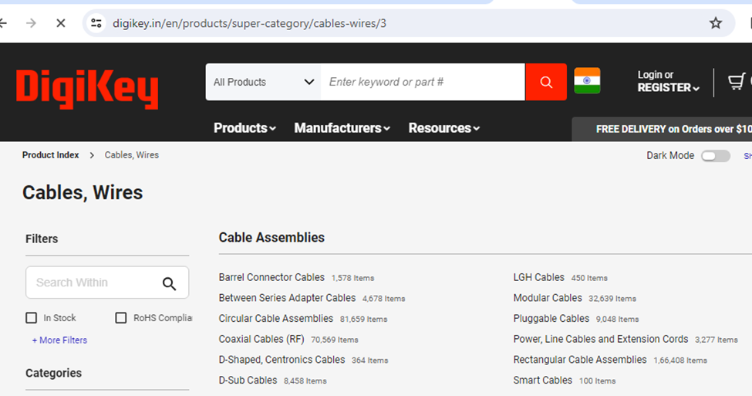

**Product Category** : The homepage features a dropdown menu where users can seamlessly navigate to specific product categories. Users can easily scroll through the page, which organizes products according to their respective categories. With numerous hierarchical levels of product categorization, users can efficiently find the desired items.

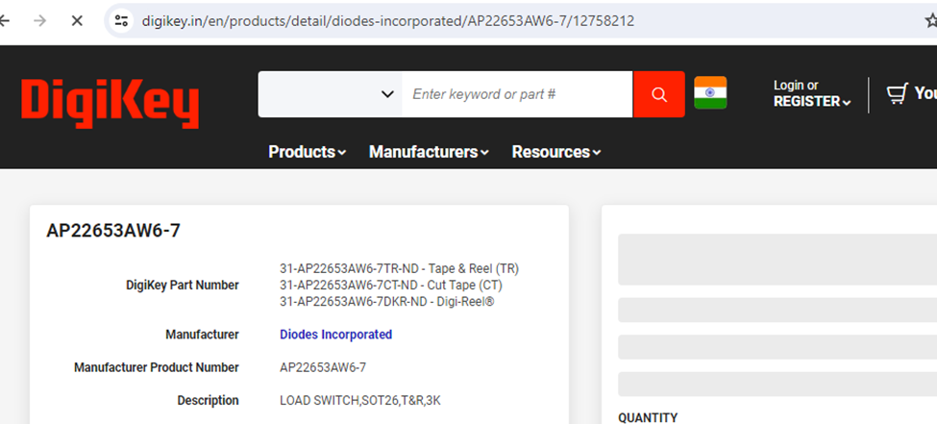

**Product Url** : The product URL follows a pattern where it includes the manufacturer's name and the manufacturer's product number, along with additional random numbers.

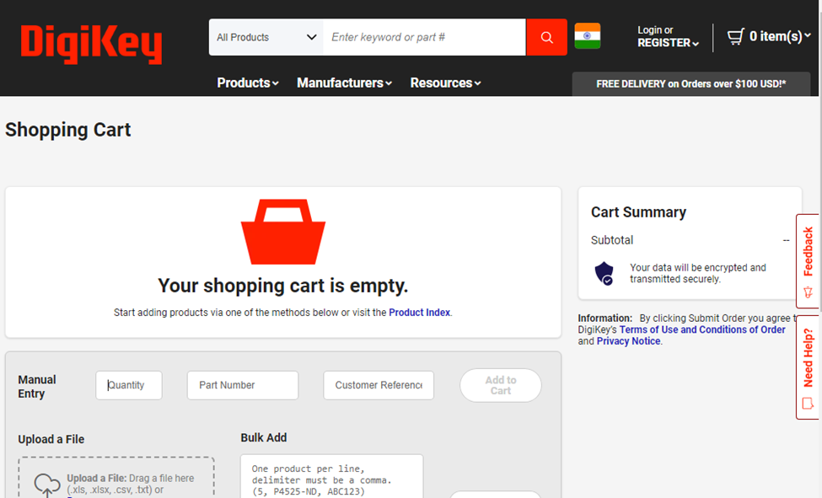

**Shopping cart:** In the shopping cart, an additional feature is provided where users can manually add products by entering the necessary information.