CASE STUDY
STUDENT PERFORMANCE DATA ANALYSIS
Data Science Mini Project
Student Name: __________________________
Roll Number: ____________________________
Course: BCA
Submitted To: ___________________________

1. Problem Statement
The objective of this case study is to investigate what factors are associated with students' academic performance. The analysis focuses on marks distribution, subject-wise performance, attendance, study hours, gender and student category.

2. Dataset Description
The dataset contains 150 students and includes Student ID, Gender, Category, Attendance Percentage, Study Hours per Day, and marks in Mathematics, Python, DSA and English. Total and average marks are calculated during analysis.
Variable | Type | Description
Student_ID | Object | Unique student ID
Gender | Object | Gender
Category | Object | Student category
Attendance_Percent | Float | Attendance percentage
Study_Hours_Per_Day | Float | Daily study hours
Mathematics_Marks | Integer | Mathematics marks
Python_Marks | Integer | Python marks
DSA_Marks | Integer | DSA marks
English_Marks | Integer | English marks
Average_Marks | Float | Average of four subjects

3. Data Cleaning Using Pandas
- Missing values were identified and median-filled.
- Duplicate records were removed with drop_duplicates().
- Extra spaces and inconsistent capitalization in Gender and Category were standardized.
- Attendance and study-hour fields were converted to numeric values.
- Total and average marks were derived after cleaning.

4. Data Analysis Using NumPy & Pandas
Average attendance = 78.70%.
Average study time = 3.67 hours/day.
Overall average marks = 51.48.
Attendance vs marks correlation = 0.38.
Study hours vs marks correlation = 0.56.
Subject averages:
- English: 53.96
- Mathematics: 52.20
- Python: 51.49
- DSA: 48.27
Gender averages:
- Female: 51.35
- Male: 51.57
Category averages:
- General: 51.38
- OBC: 52.10
- SC: 50.35
- ST: 52.05

5. Data Visualization
Figure 1: Distribution of Average Marks
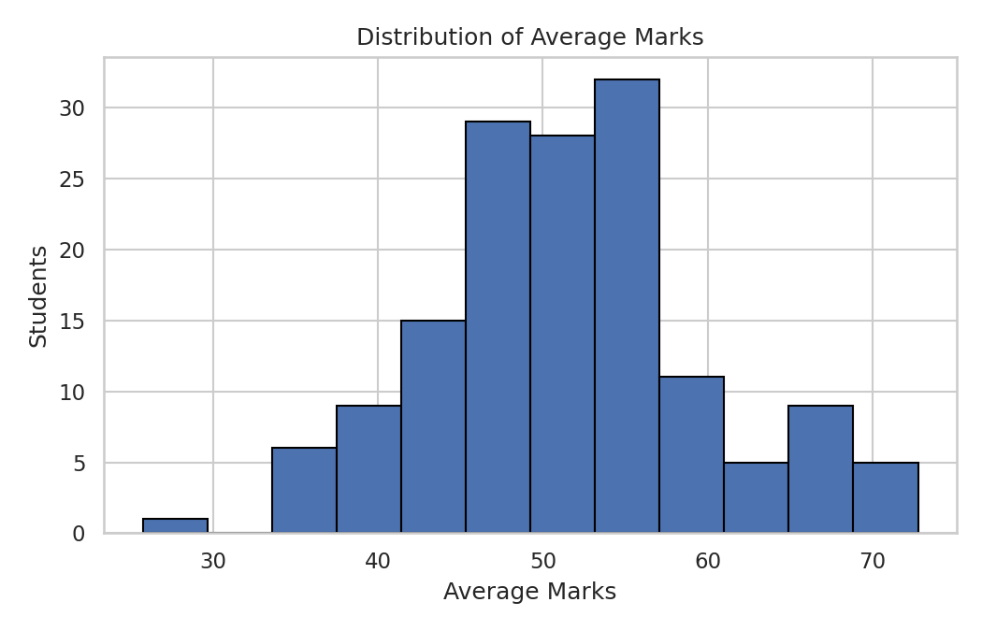
Figure 2: Average Marks by Subject
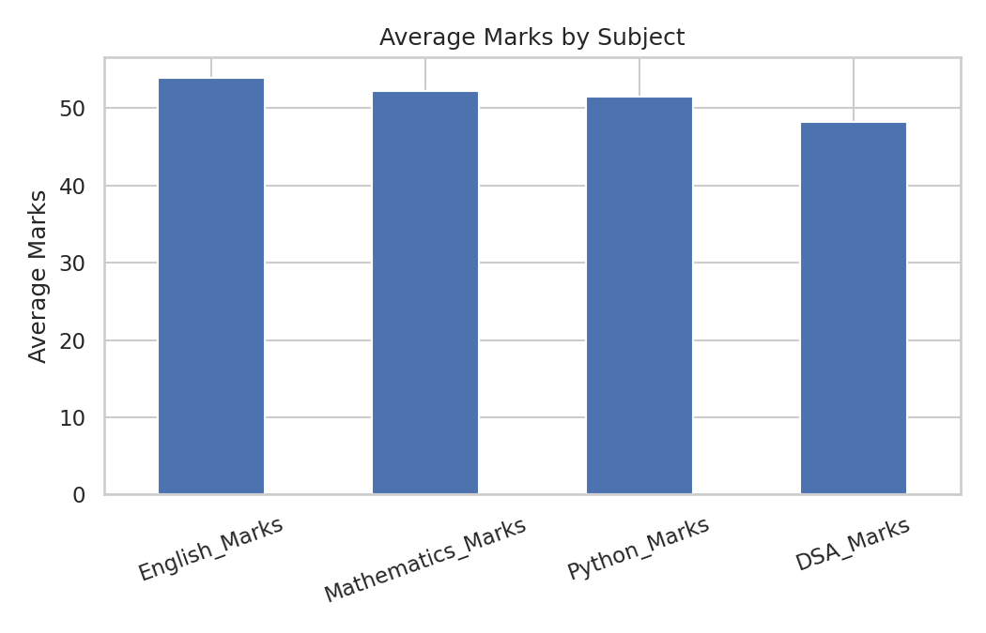
Figure 3: Attendance vs Average Marks
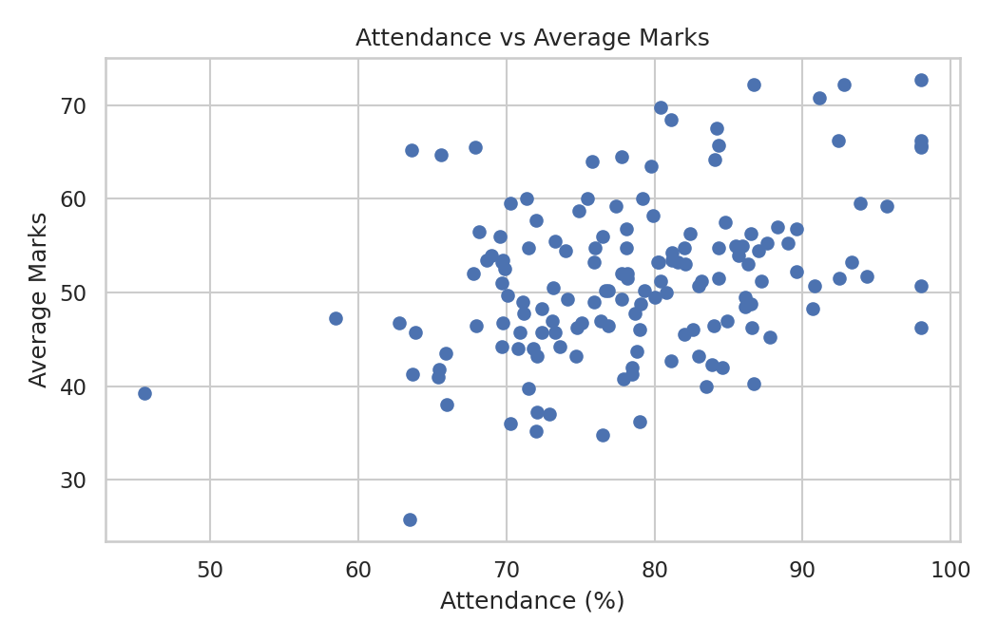
Figure 4: Average Marks by Gender
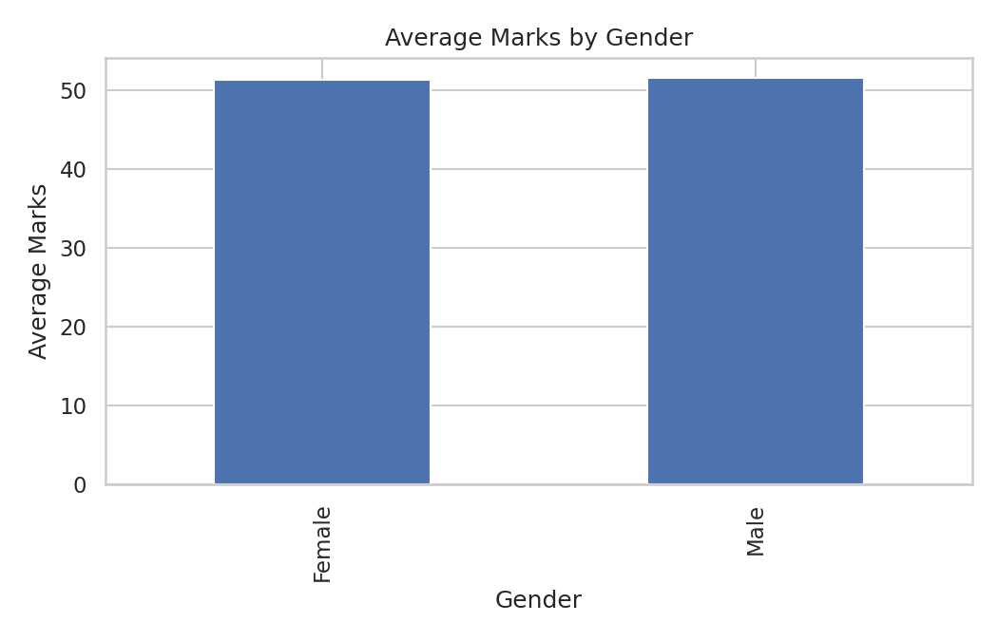
Figure 5: Average Marks by Category
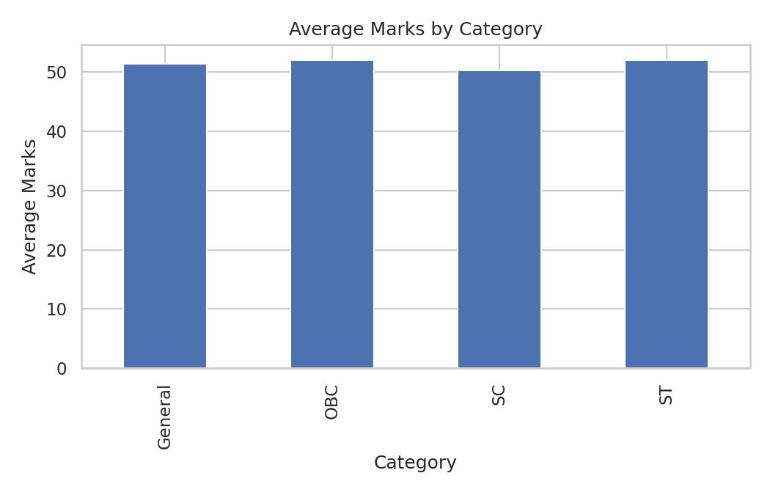
Figure 6: Subject-wise Marks Distribution
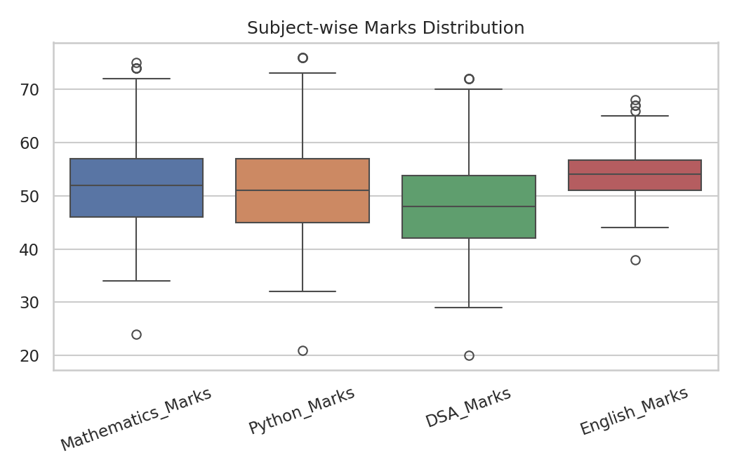
Figure 7: Correlation Heatmap
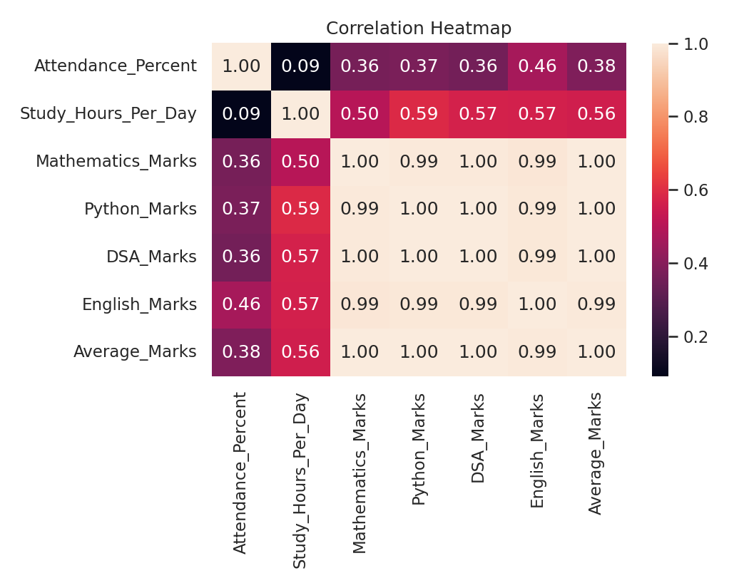
Figure 8: Gender-wise Distribution
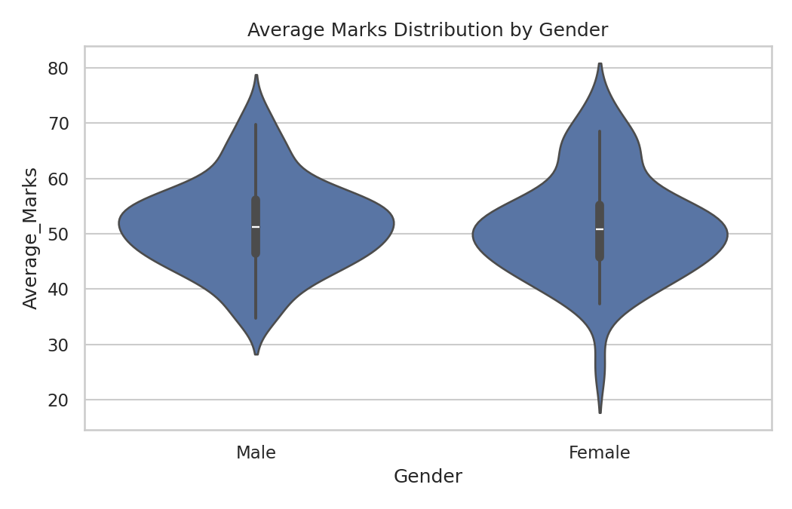
Figure 9: Category Count
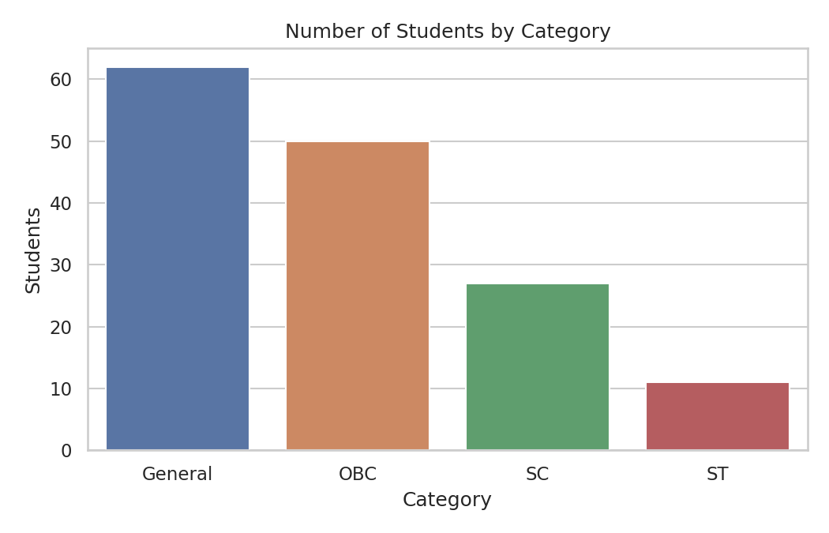
Figure 10: Pair Plot
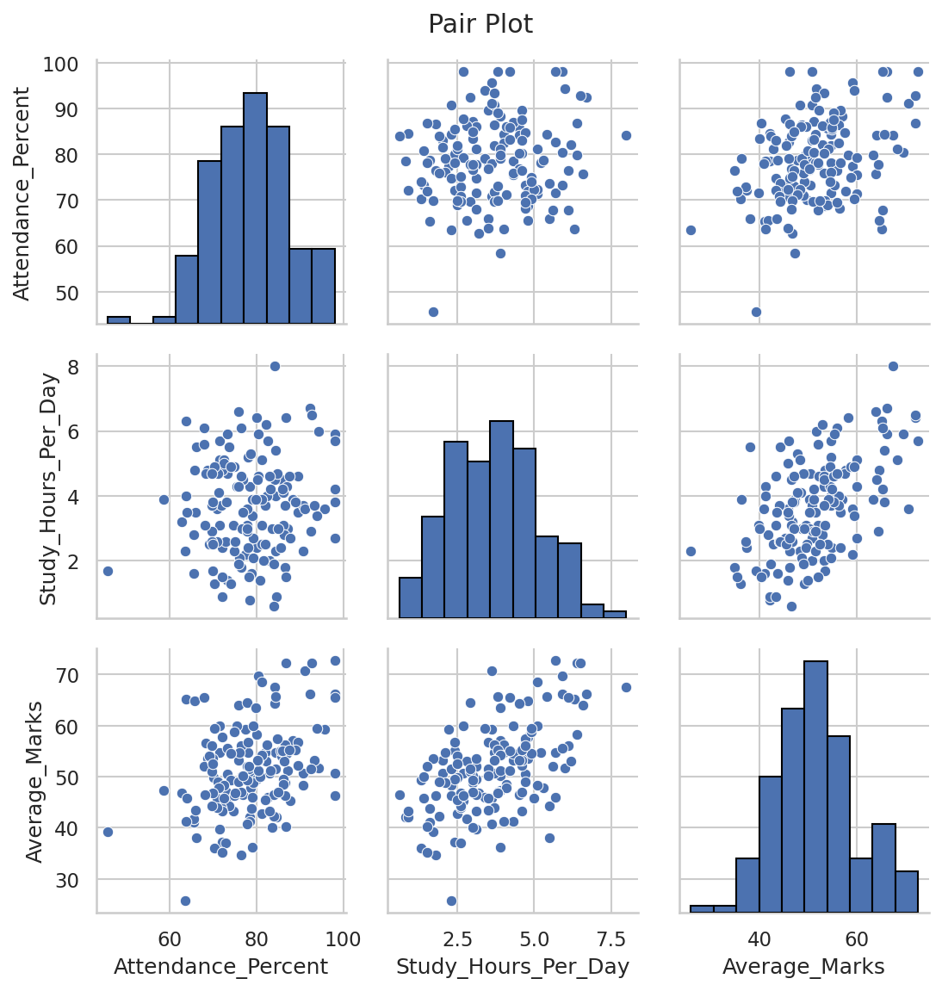
Figure 11: Gender Distribution
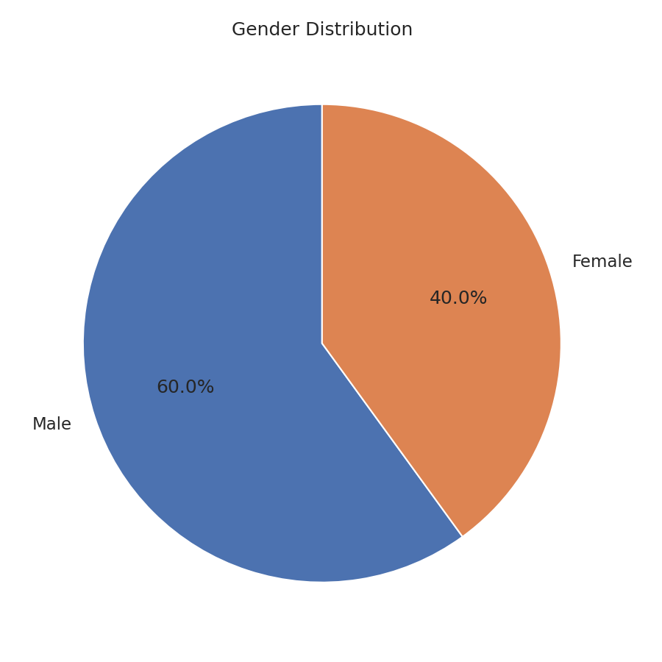

6. Findings
- Attendance has a positive association with average marks (correlation 0.38).
- Study hours have a positive association with average marks (correlation 0.56).
- English has the highest subject average.
- DSA has the lowest subject average.
- Gender groups show different average scores.
- Student categories show differences in average scores.
- The histogram shows the distribution of overall student performance.
- The heatmap summarizes relationships among attendance, study time and marks.

7. Conclusion
The case study demonstrates a complete data-analysis workflow using Python. Pandas was used for cleaning, grouping, filtering and aggregation; NumPy supported numerical calculations; and Matplotlib and Seaborn were used for visualization. The synthetic data shows positive associations between attendance, study time and average marks. Since the dataset is synthetic, these findings should not be interpreted as real institutional statistics.

Tools and Technologies Used
- Python
- Pandas
- NumPy
- Matplotlib
- Seaborn
- GitHub

