Midterm
Bradley Johnson
Kaire Campomanes
ITAI 437
Professor Patricia McManus
25 March 2026

Introduction
This report takes a closer look at how well an artificial intelligence system holds up when compared to the human brain. Throughout the semester, we have studied how the brain processes information how it sees the world, stores memories, manages attention, and responds to emotion. This project puts those ideas into practice by testing a real AI system to see where it aligns with human cognition and where it falls short. For this midterm audit, ChatGPT was selected due to its accessibility and its ability to simulate conversation, reasoning, and decision-making. A series of hands-on experiments were designed and carried out to evaluate its behavior across key areas of brain function, including architecture, memory and learning, and emotion and motivation. The goal of this report is not just to describe what the AI does, but to critically examine how closely those behaviors reflect what we know about how the brain actually works.

System Profile for Chatbots and Assistants
For this project, Kaire and I selected chatbots and AI assistants as the primary category for analysis, with my individual focus centered on evaluating ChatGPT. This category was chosen due to its high level of accessibility and the frequency with which users encounter these systems in everyday life. Unlike more specialized AI tools that require technical expertise or limited access, chatbots are widely available and easy to interact with, making them an ideal candidate for repeated, hands-on experimentation. In recent years, chatbots have become increasingly integrated into both personal and professional contexts. Students use them to support learning and writing tasks, businesses rely on them for customer interaction, and individuals use them for general information and problem-solving. Because of this widespread adoption, chatbots provide a practical and relevant opportunity to evaluate how modern AI systems compare to human cognitive processes. Systems such as ChatGPT are particularly useful for this type of analysis because they simulate conversation, reasoning, and information retrieval functions that closely relate to how the human brain processes and communicates information.
Another important factor in selecting a chatbot for this audit is the ability to conduct controlled and repeatable experiments. The system responds quickly and consistently to user input, allowing for multiple test scenarios to be performed in a short period of time. This makes it possible to directly apply concepts from the course—such as attention, memory, and processing structure and observe how the AI behaves under different conditions. In addition, chatbot interactions are easy to document through saved conversations and screenshots, which provides clear evidence to support analysis and conclusions.
The transparency of chatbot responses also strengthens their suitability for evaluation. Unlike background AI systems that operate without direct user visibility, chatbots produce outputs that can be examined, compared, and critiqued in detail. This allows for a more structured and evidence-based approach when assessing how closely the system reflects known principles of brain function. For these reasons, chatbots—and specifically ChatGPT serve as an effective platform for conducting a neuroscience-based audit of artificial intelligence.

Experiment 1: Module 02 Brain Architecture
The purpose of this experiment was to evaluate how well ChatGPT reflects the concept of brain architecture, with a specific focus on the distinction between parallel and sequential processing. In the human brain, parallel processing allows multiple streams of information to be handled at the same time, enabling individuals to integrate sensory input, memory, and decision-making simultaneously. In contrast, many artificial intelligence systems are believed to rely more heavily on sequential processing, where tasks are completed step by step rather than all at once.
To investigate this difference, I designed a series of prompts intended to test how the system handles multiple instructions within a single interaction. The first test focused on a structured, multi-part request. The system was asked to explain how a car engine works, summarize that explanation in one sentence, and provide a real-world analogy. The response successfully addressed all components of the prompt, indicating that the AI can manage compound instructions within a single output. However, the structure of the response suggested that each part of the task was completed in sequence rather than simultaneously.
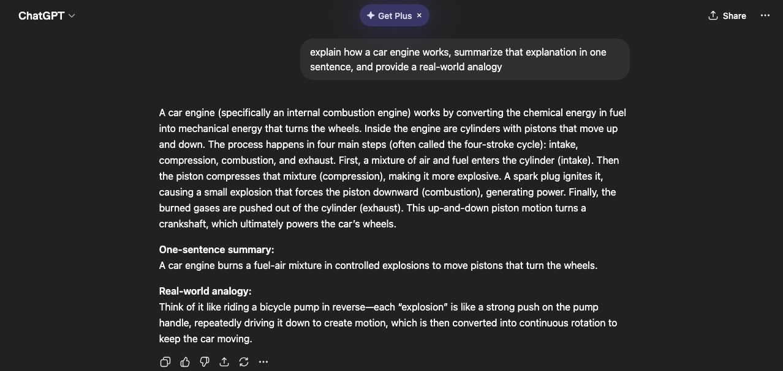
Building on this, a second test introduced a higher level of complexity by combining unrelated tasks into one prompt. The system was asked to write a short story, solve a mathematical problem, and explain a scientific concept. While the AI again completed all requested tasks accurately, the output was clearly divided into separate sections. This organization provided further evidence that the system processes each instruction individually, moving from one task to the next in a linear fashion rather than integrating them in parallel.
A final test was designed to more closely simulate the demands of parallel processing by requiring the system to manage multiple constraints at once. The AI was instructed to explain photosynthesis, compare it to cellular respiration, and remain within a strict word limit. In this case, the system showed some difficulty balancing all requirements equally. Although the explanation remained generally accurate, certain aspects such as the depth of comparison or adherence to the word limit were less consistent. This suggests that when task demands increase, the system prioritizes specific elements rather than fully integrating all aspects of the request at the same time.
Overall, the results of these experiments indicate that while ChatGPT can simulate behaviors that resemble parallel processing, its underlying approach appears to be sequential. The system effectively handles multiple instructions by breaking them into smaller components and addressing them one at a time. This differs from the human brain, which is capable of dynamically integrating multiple processes simultaneously. These findings highlight a key distinction between artificial and biological systems and suggest that current AI models approximate, rather than replicate, the parallel architecture of the brain.

Experiment 2: Module 04 Memory & Learning
In this experiment, I tested whether the AI could retain and use information over time within a conversation. Earlier in the day, I asked the AI about acetaminophen dosage and provided my weight along with the amount I had taken (1000 mg). Several hours later, I returned and asked a related question about being sick and what I should do.
The AI demonstrated short-term memory by referencing the earlier interaction. It remembered that I had already taken 1000 mg and adjusted its response accordingly by telling me not to exceed the daily limit and to space out doses. This shows that the system can maintain conversational context and apply previously given information to new responses.
However, this memory is limited. The AI does not truly “store” information long-term like the human brain. Instead, it uses the current conversation context to simulate memory. In comparison to human memory systems, this is similar to working memory rather than long-term memory, since the information would not persist outside the session.
To further test memory behavior, I observed how the AI depends on user-provided context rather than forming its own independent memory. The AI did not bring up past information unless it was directly relevant to the ongoing conversation.
This highlights a key difference from the human brain. Humans can recall memories independently and sometimes even form false memories. The AI, however, does not generate memories on its own. It only uses what is currently available in the conversation. This means it avoids false memory in the traditional sense, but it also lacks true recall ability.
Overall, the AI behaves like a system with limited working memory rather than a fully developed memory system.

Experiment 3: Module 06 Emotion & Motivation
In this experiment, I tested whether the AI could recognize and adapt to emotional tone. I used casual language and slang, such as “i fr woke up sick as hell,” to simulate a more emotional and informal input.
The AI adjusted its response to match my tone. Instead of responding in a strictly formal way, it used more casual language like “damn that’s the worst way to wake up” and asked supportive follow-up questions. This shows that the AI can detect emotional cues and modify its communication style accordingly.
This behavior is similar to how humans adjust their tone in social interactions, which involves brain regions like the amygdala and prefrontal cortex. However, the AI does not actually feel emotions, it simply recognizes patterns in language and generates an appropriate response.
In addition to emotional tone, I tested whether the AI would adapt to my specific language style. After I used slang and informal phrasing, the AI began to mirror that style in its responses.
For example, it used more relaxed phrasing and conversational structure instead of formal academic language. This demonstrates a form of social adaptation, where the AI aligns its communication style with the user.
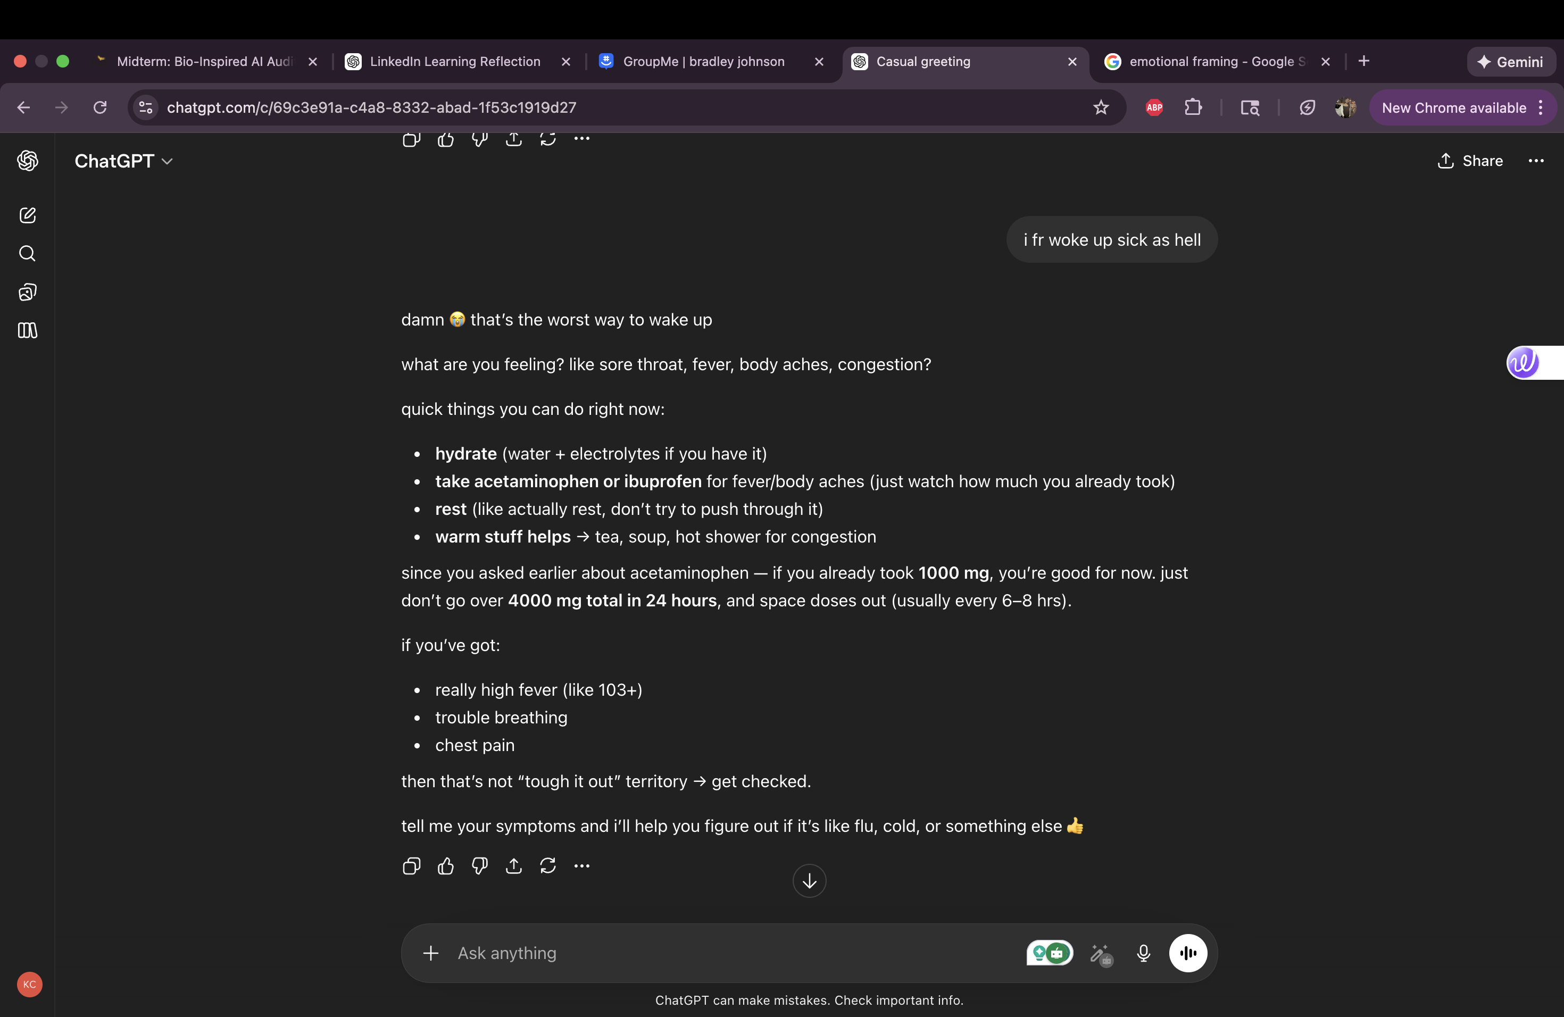
In human behavior, this is similar to social mirroring, which helps build connection and understanding during interactions. The AI replicates this effect, but it is not driven by social awareness or motivation. Instead, it is based on pattern recognition and response optimization.
Next Steps
Moving forward, this audit will expand to cover additional areas of brain function, specifically attention and consciousness as well as perception and vision. The next round of testing will focus on pushing the system further by introducing more complex, distracting, and ambiguous inputs to see how well it can prioritize important information and interpret unclear scenarios. Based on what was observed in this initial phase, future experiments will be designed with tighter control and increased difficulty to better expose the system’s limitations. There will also be a stronger emphasis on detailed documentation, including clearly labeled evidence to support each finding. These next steps will help build a more complete picture of how the AI compares to human cognition and will strengthen the overall depth and quality of the final evaluation.

