Braitenberg Implementation of Multi-Point DE2Bot Navigation

Ahmed Elsabbagh
Zixi Huang
Kairi Kozuma
Nhi Nguyen
Lance Zhang

ECE 2031, Digital Design Lab
Section L10

Georgia Institute of Technology
School of Electrical and Computer Engineering

Submitted
November 13, 2015

Executive Summary
This project seeks to implement software that will allow the DE2Bot to efficiently reach 12 pre-determined points within 60 seconds without hitting a wall. Extra parameters that can be implemented include displaying the index of the point reached. The program will be designed to accept a sorted list of the 12 points. These points will be sorted through an external program to determine the most efficient path the DE2Bot can take to reach all 12 points. Once the points are inputted, the program will use a Braitenberg implementation to navigate to each point without stopping. It will also utilize the sonar system to avoid hitting the walls, using a turn and travel approach whenever it is near a wall. This solution decreases the time that the DE2Bot would take if it stops and turns at each point, saving time to reach other points.
Braitenberg Implementation of Multi-Point DE2Bot Navigation

Introduction
This report proposes a method that the DE2Bot can utilize to traverse a set field to reach as many of the 12 pre-determined points as possible within a minute and without hitting the walls. The first part of the paper will detail the solution the team will use to efficiently reach those destinations. This method utilizes three main components that are discussed in further detail later on. The second part will cover the specific timeline needed to complete the project within the desired timeframe, detailing the division of labor and listing major tasks. The report includes a contingency plan, detailing alternatives in the event of difficulty implementing the proposed method.

Technical Approach

Problem Description
The goal of this project is to design software using assembly language that will allow the DE2Bot to complete the following requirements:
- Reach as many of the 12 destinations provided as possible within 60 seconds
- Avoid hitting the wall or leaving the 10 x 12 ft. field
- Display a message when a destination is reached
In addition, an optional requirement would be to display the destination index as the DE2Bot traverses the field.

Proposed Overall Design
The proposed solution to this problem includes three main parts. The first is through the use of an algorithm to sort the given 12 points into an order that the DE2Bot can effectively traverse. The second is using the Braitenberg implementation to continuously move about the field in order to reach as many points as possible. The third is to utilize the sonar system to avoid hitting the walls, using a turn and travel approach when within a certain range.
The team decided to use these methods because each part is separate from the rest, allowing each part to be completed independently from the other. This will make debugging more efficient, while at the same time allowing each part to be reused if necessary. Another benefit for this approach will be having the most efficient movements for each scenario, allowing the DE2Bot to move through an optimized pathway.

Sorting Algorithm
To navigate all 12 points within 60 seconds, an efficient point sorting algorithm is necessary. This algorithm should minimize the total length traveled and the total angle turned. A permutation algorithm of all 12 points is a brute force method that guarantees the best solution. However, initial attempts to use the algorithm resulted in long computation times, as the algorithm must sift through 12! = 479,001,600 permutations to find the shortest length. To combat this problem, the team designed several alternative methods.
The primary alternative algorithm will be a closest-points-then-permutation algorithm. First, the algorithm will choose the closest three points. For each point, the algorithm will choose the three closest
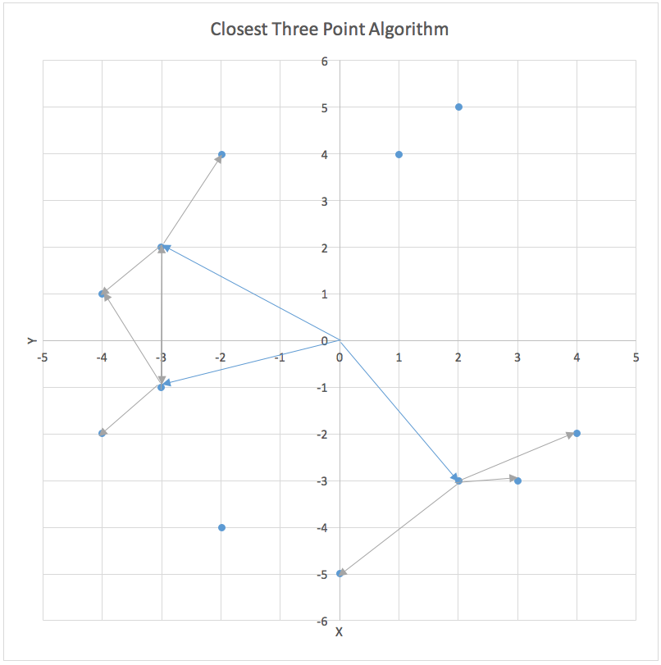
Figure 1. The first two iterations of the closest three point algorithm.
points. This process will continue until the fourth iteration, at which point the algorithm has found 3⁴ = 81 paths of four points. Afterwards, the algorithm will find a permutation of the rest of the eight points for each of those 81 paths, and choose the shortest route.
This algorithm was chosen as it was designed to work within a short time frame. In initial tests, the strict permutation implementation worked within five seconds for 10 points, which is 10! = 3,628,800 permutations. The alternative algorithm will sift through 3⁴ * 8! = 3,265,920. Since the number of paths examined is less than 10!, the algorithm should provide a solution quickly. By combining closest point and permutation methods, the algorithm benefits from the speed for the former method and the accuracy of the latter.
To sort the points within the setup time of 60 seconds, an easy interface to the point sorting algorithm is needed. The team designed a Java program with a JavaFX GUI to input points, as seen in Figure 2. This program has a dual purpose: test several algorithms from randomly generated points and visualize the solution before the robot moves. The program will be able to generate up to 12 random points within the specified field dimensions. Then, the program will calculate the best path, with a line graph visualization of the path. The total distance of the path will be displayed, as well as two total angles; the second angle accounts for ability to move backwards, which reduces the total angle.
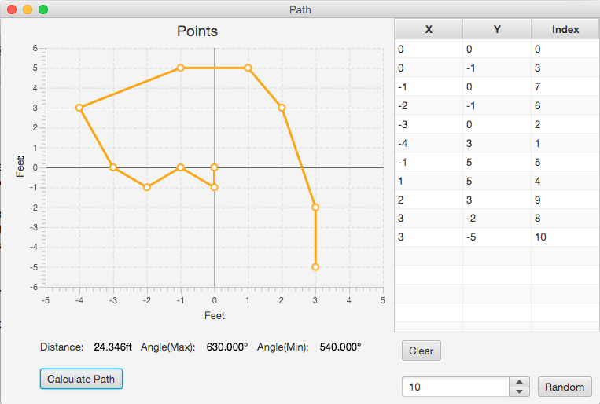
Figure 2. JavaFX GUI to input points and visualize the path that the DE2Bot will take.
The team will improve the program to minimize the setup time used for point sorting. The team will add the ability to insert new points, which will be necessary to input points from paper, as the current implementation of the point sorting program can only edit existing points.

Sonar System
The DE2Bot’s sonar hardware will be utilized to avoid hitting the walls. The team will also use this as a condition to switch between the Braitenberg implementation and the turn and travel approach. The method that the team will be using utilizes more than one sensor. The goal is to stop the DE2Bot once it is 15 cm away from the wall, and then switch to the other approach. One of the ideas that the team has is using the sonar system as a backup for the odometry. Using the coordinates of the sonar, the team can use it to check whether or not the odometry is building up an error. This will most likely be implemented only if the program if finished before the deadline.

Two Halves System
The two halves system utilizes the odometry to approach a destination. This system can also be referred to as the turn and travel approach. The DE2Bot will calculate the angle necessary to reach the next point, turning the necessary angle and then taking a linear path to reach that destination. The first half can be defined from 0-179 degrees with a counter-clockwise turn while the second half ranging from 180-359 degrees with a clockwise turn. Figure 3 depicts this motion visually so that it is
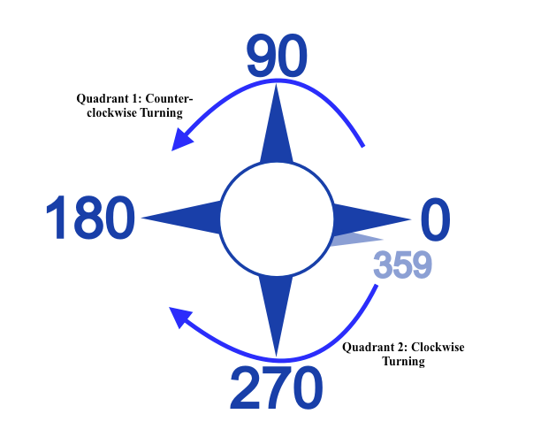
Figure 3. Odometry coordinate system with two halves implementation.
easier to understand. This system will also counteract the drifting by re-checking the position every second.

Program Flow During Application Demonstration
The overall program should follow the logic determined to be the most efficient in meeting this project’s requirement. Specifically, it needs to reach as many of the 12 points as possible within 60 seconds without hitting the walls or leaving the field. The goal during the demonstration is to reach all 12 points while displaying each destinations index in the case that the Braitenberg vehicle works. In the case that it does not work, the goal will be to reach eight destinations with the indices displayed for each destination.
As mentioned before, a Braitenberg implementation will be set up to allow the DE2Bot to continuously traverse the field in order to reach as many points as possible. This will only change if the
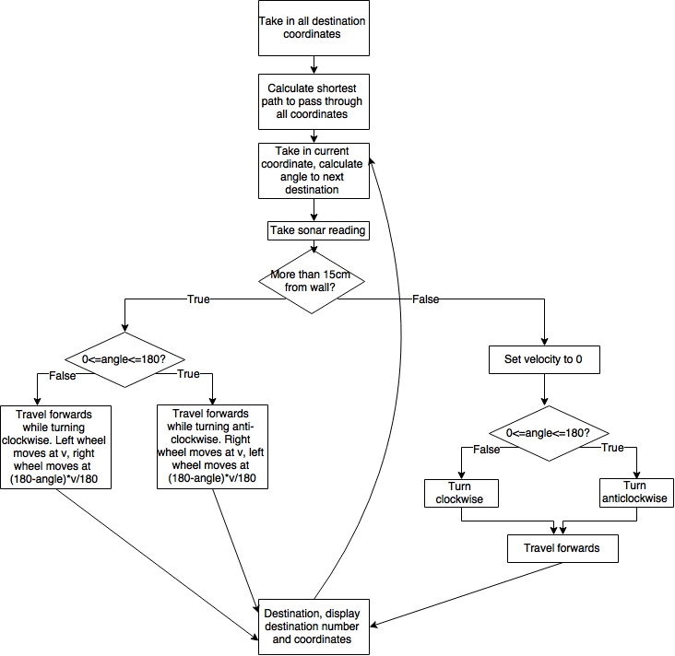
Figure 4. Flowchart showing the logic taken to reach a specific point.
DE2Bot is located within a specific range of the wall. At this point it will switch to a turn and travel approach. This will be done in addition to the sorting algorithm used to decrease the overall time needed for set up. Figure 4 includes a visual depiction of the program as it moves from one point to the next.

Effectiveness of the Program
The team currently has a complete sorting algorithm along with the two halves system. The contingency plan consisting of the four quadrant system is also completed. In progress tasks include the sonar system and the Braitenberg implementation. The team is currently on track for completion within the specified timeframe.
With the current plan, the solution is almost as effective as it could be given the timeframe provided; however, it has many small aspects that could be adjusted to maximize the effectiveness of the demonstration. The team is planning to look at the speed the DE2Bot travels once the program is completed. Different velocities will be tested to see which setting will work best with the program. The team will consider will be having different speed settings for certain actions, such as one for turning and one for linear travel.

Management Plan
The project will be executed according to the Gantt Chart provided in Appendix A in order to complete software that will encompass code for both the sorting algorithm and the DE2Bot’s movements.

Division of Labor
The team will divide into two smaller teams, the larger of which will work on coding. The smaller team will work on documenting the progress made and helping to debug code. The coding team will comprise three people, while the documentation team will consist of two. Within the coding team, one person will be responsible for the sorting algorithm, another for the sonar system, and the last for the two halves system. The documentation team will have one person keeping track of the data provided from the progress, while the other person creates visuals and figures from that data. Along with those specified tasks, the documentation team will move freely within the coding team to provide support through debugging, in order to ensure that the project is completed within the specified timeframe.

Contingency Plan
In the event that time becomes a limiting factor and the team is unable to complete all the aforementioned tasks, another option will be altering the two halves system into that of the four quadrant system. This system will, instead of two set motions, have four motions set for each quadrant, dividing the existing sections in half. This will require additional coding that will utilize the reverse capabilities of the DE2Bot, minimizing the time necessary to turn. Figure 5 shows this program logic along with the motion taken.
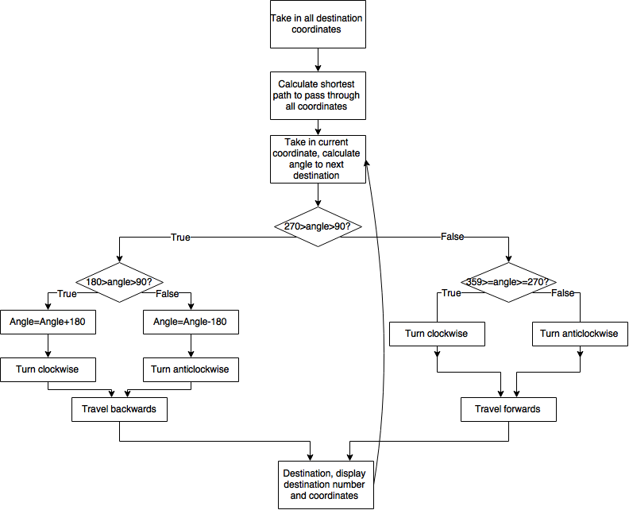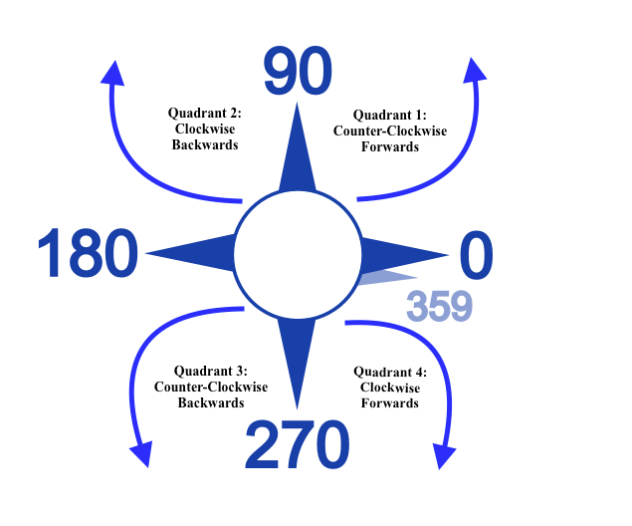
Figure 5. The diagram on the left show the program logic that the DE2Bot will take if the four quadrant system is implemented. The preset motions of each quadrant are shown in the figure to the right.

One of the major problems that may occur will be the wall requirement. If the sonar system fails to work, the team will instead hard code a set boundary so that the DE2Bot can avoid the walls through the use of the odometry. If the sonar system does work, but still hits the wall, the team will need to implement a way to reverse away from the wall.

Appendix A: Gantt Chart
