Kairi Kozuma

GTID: 903050898

ECE 3056

02/09/2016

Assignment 2 Report

**Program Implementation**

The program first reads in the DCT coefficients from the csv file. The coefficient values are stored in a 256 by 256 two dimensional array of double values. Another matrix of 256 by 256 elements is allocated in memory statically for the new coefficient values. To truncate the coefficient matrix by value K, values from the original matrix are copied to the new matrix with a loop, up to the N – Kth row. All values from the N – K + 1th column and N – K + 1th row are set to 0 to complete the truncation. After the new matrix is complete, the power consumption and reconstruction delays are calculated. The power is calculated from the formula, . The (N – K)3 denotes the number of multiplication instructions done for an (N – K) by (N – K) matrix multiplication, while the $10*{10}^{-15}J$ is the energy consumed per multiplication instruction. Finally, the total energy consumed is multiplied by frequency 30Hz to obtain the power. The reconstruction error is computed from the formula, $Reconstruction Error \left(\%\right)= 100* \sqrt{\frac{\sum_{1}^{N}{({\left(Image DCT-Truncated DCT\right)}^{2})}}{\sum_{1}^{N}{(Image DCT^{2})}}}$; the program implements this formula by keeping a running sum of the numerator and denominator under the radical, then computing the radical itself in the end. These values are then printed to the console, with the result for power consumption formatted to print in fW, and the reconstruction error formatted to percentage. The program opens a new file with the filename for the truncated coefficients. Then, the program writes the values into the file with the correct csv format: values separated by commas, and rows separated by a new line character. The new file is closed and the program returns.

**Results and Conclusions**

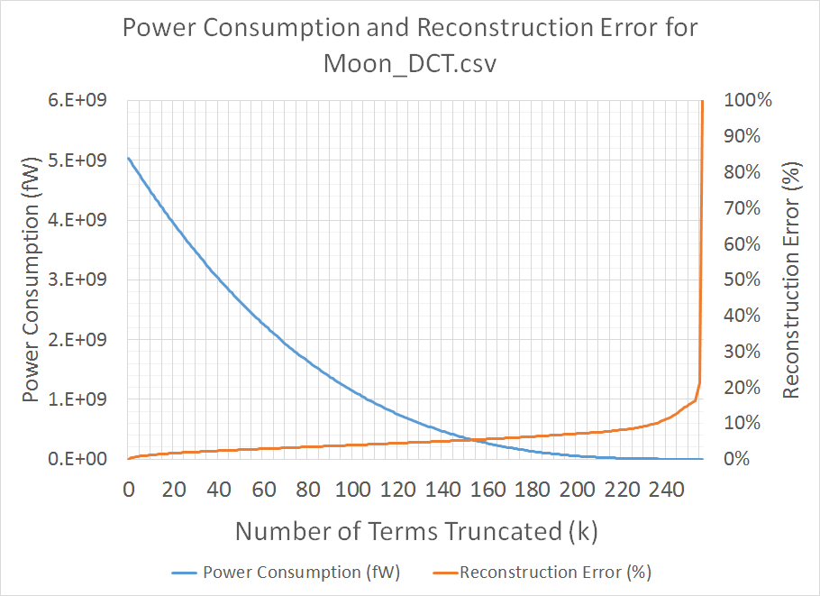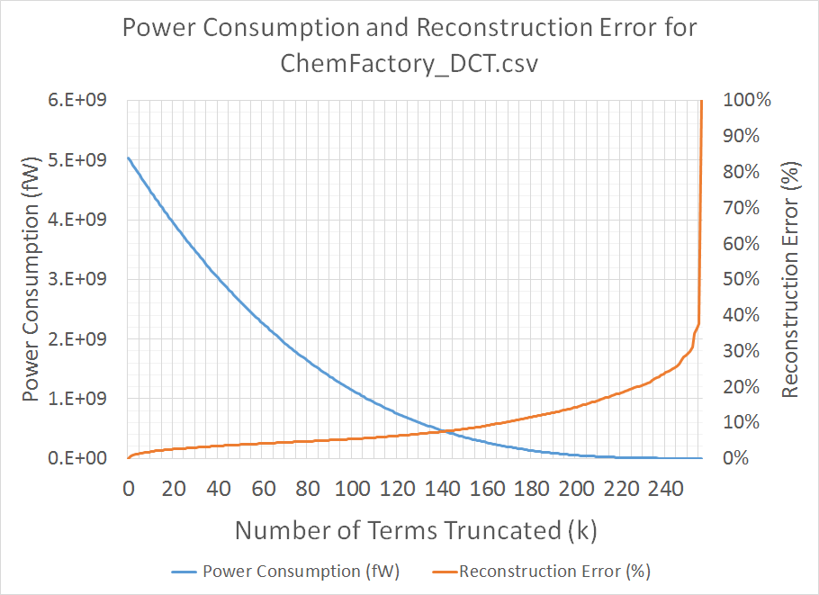

**Figure 1.** Graph of Power Consumption and Reconstruction Error vs. Time for the ChemFactory_DCT.csv and Moon_DCT.csv files.

Reconstruction error does not increase significantly when k increases, if k is small. In Figure 1, the reconstruction error models a slow linear increase for small k values, reaching only 10.048% error at k = 168 truncations for ChemFactory_DCT.csv and 10.086% at k = 236 for Moon_DCT.csv. An example image with k = 168 for ChemFactory_DCT.csv retains much of the detail, as visible in Figure 2.

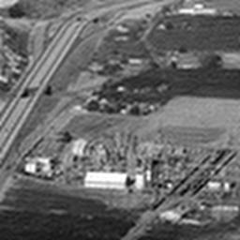

**Figure 2.** The left image is the original image for ChemFactory_DCT.csv. The right image is a reconstruction from k = 168 truncations of the DCT.

The reconstruction error rises exponentially from approximately k = 200 for the ChemFactory_DCT.csv and k = 240 for the Moon_DCT.csv; furthermore, there is a noticeable jump in the reconstruction error from the k = 255 to k = 256. The steep increase to 100% reconstruction error is due to the large coefficient of the first term of the DCT matrix. For instance, in the ChemFactory_DCT.csv, the first coefficient is 26,744.3008, a magnitude of 103 greater than the average magnitude of 13.635.

The power consumed models an exponential decay for increasing values of truncation terms. With only about 40 truncations, the power consumed drops 40%; however, 110 truncations are necessary to bring the power consumption down to 80%; thus, for large k values, there is a diminishing return of power saved.