Problem 3.

A confusion matrix is used to measure performance of a classification algorithm. The four basic types of answers are True Positives (TP), True Negatives (TN), False Positives (FP), and False Negatives. TP are true values that are correctly identified as true, while TN are false values that are correctly identified as false. FP are values that are predicted true, but are actually false. Similarly, FN are values that are predicted false, but are actually true.

1. TP includes edges that are correctly identified from the original image. In the filtered image below, the area circled in red correctly identifies the window edges from the original black and white image.

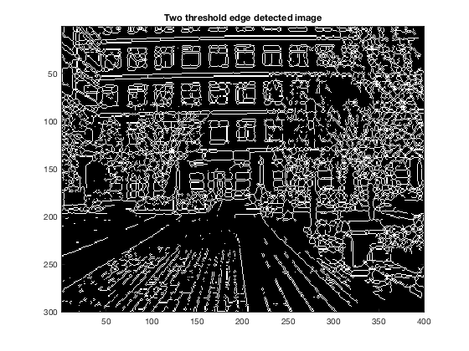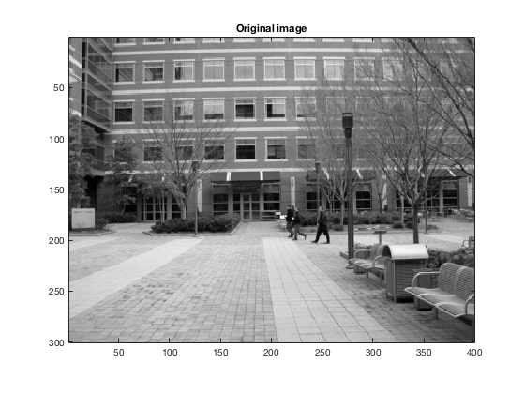

1. FN are edges from the original image that were not detected successfully in the filtered image. The area circled in red identifies the sidewalk edge that was not detected in the two-threshold filter.

