DOCUMENT TEMPLATE



School of Computing

Faculty of Engineering

UNIVERSITI TEKNOLOGI MALAYSIA

ADVANCED DATA STRUCTURE & ALGORIHTMS
(MCSS1023)

SEMESTER x 20xx/20xx

Project and Assignment Software Documentation

Write your project Title HERE

By
Student’s Name (Matric number)

SECTION 0X

Lecturer:

Lecturer’s Name

Date
PART 1: INTRODUCTION

1.1 Synopsis Project:
Give description of your project.
What type of data structure being applied and how it is applied (including the programming language).
Explain what your system is able to do.

1.2 Objective of The Project
List objectives of the project

PART 2: SYSTEM ANALYSIS AND DESIGN (USE CASE, FLOWCHART AND CLASS DIAGRAM)

In this section, you have to identify the requirements and the design of the system. Provide use case diagram, class diagram, algorithm/flowchart for every module in the system. Every algorithm/flowchart for each module must be described in detail.

2.1 System Requirements
Use case diagram – Describe the user of the system and detail descriptions of each use case.
Example:

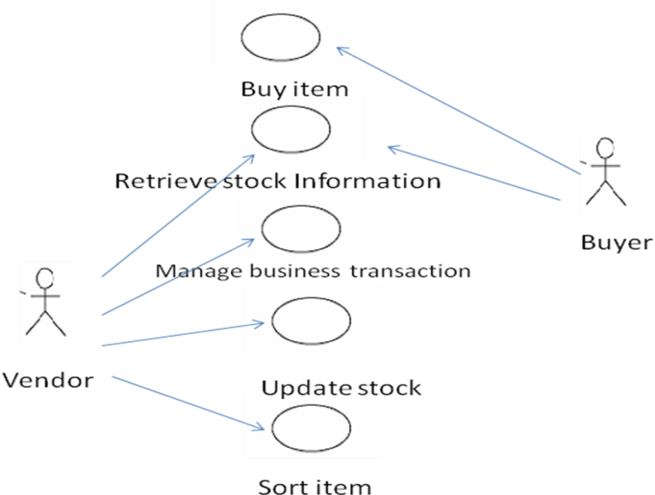

Figure 1 : Use Case Diagram for Stock Inventory System

Use Case Description for Stock Inventory System
The system users are vendor and buyer.
Actor | Task
Vendor | Explain what vendor can do
Buyer | Explain what buyer can do

Detail Description for Each Use Cases
The system has 5 main use cases.
Use Case | Purpose
Update stock | Update information of item in stock every time there are items being add or delete from stock. Or if the price for the item changes.
Menu | Provide choices for the user to perform certain operation in the system.
Sort | Explain the module.
Buy item | Explain the module.

2.2 System Design – Document the class diagram and algorithm design in pseudo code or flowchart.

Algorithm: Flowchart for each module.
FlowChart 1: Add Stock

N= number of item being add to stock
M = item name

FlowChart 2: Retrieve item
:
:

PART 3: SYSTEM PROTOTYPE

In this section, give the description of the system prototype. Provide the interface for each module. Figure below can be used as reference.
The following figure shows an interface for UTM library system.
Example:

UTM LIBRARY SYSTEM
WELCOME TO OUR LIBRARY

== Main Menu ==

1. Search Book
2. Borrow Book
3. Return Book
4. Exit

Enter your choice 1-4 >>
Skrin 1: Main menu

Screen 1: The user must insert an integer value in the range 1-4. If the user enter other number, the system will prompt error message and the screen is displayed again.

UTM LIBRARY SYSTEM

== Book Searching ==

Enter the information as requested:

Book Title >> Struktur Data & Algoritma
Author >> Nor Bahiah et al.
Publisher >> UTM Press
Year Published >> 2005
---------------------------------------------------------------

The Book is currently available…..
To borrow the book, press any key to go to main menu……

Skrin 2: Book Searching System

Screen 2: Describe what screen 2 is about.....

PART 4 : APPENDIX

List of Data Files/ File Output/hard copy of the source code

---- END OF DOCUMENTATION -----

