Robotic Disassembly/Assembly NIST Task board 2 BENCHMARK

Reference No / Version  URL  Authors | RAL-SI-2020-B-2 [Benchmarking Protocols for Evaluating Small Parts Robotic Assembly Systems]-V1.0
Reference No / Version  URL  Authors | https://www.nist.gov/el/intelligent-systems-division-73500/robotic-grasping-and-manipulation-assembly/assembly
Reference No / Version  URL  Authors | Kenneth~Kimble, Karl~Van~Wyk, Joe~Falco, Elena~Messina, Yu~Sun, Mizuho Shibata, Wataru Uemura, Yasuyoshi~Yokokohji
Institution | National Institute of Standards and Technology, University of South Florida (USF), Kindai University, Ryukoku University, Kobe University
Contact information | Joseph.falco@nist.gov, Kenneth.kimble@nist.gov
Adopted Protocol | RAL-SI-2020-P [Benchmarking Protocols for Evaluating Small Parts Robotic Assembly Systems]-V1.0  Kenneth Kimble¹, Karl Van Wyk², Joe Falco¹, Elena Messina¹, Yu Sun³, Mizuho Shibata⁴, Wataru Uemura⁵, Yasuyoshi Yokokohji⁶  ¹National Institute of Standards and Technology (NIST), ²NVIDIA, ³University of South Florida, ⁴Kindai University, ⁵Ryukoku University, ⁶Kobe University
Scoring | Example of a task board partially disassembled (approximately 50% completed).  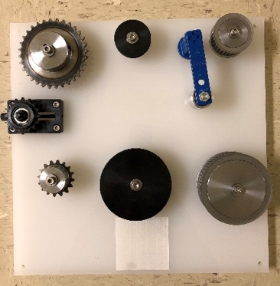  Example of a fully assembled task board. Corresponds to the set-up just prior to the disassembly task or an assembly trial with 100% completion.  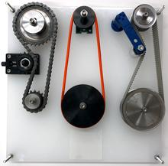
  Disassembly
  Description | Qty | Disassemble | Placement* | Sub-Total
  Spring tensioner | 1 | 5 | 0
  Slide tensioner | 1 | 5 | 0
  Sprocket tensioner | 1 | 5 | 0
  Chain belt | 1 | 2 | 1
  Timing belt | 1 | 2 | 1
  Round belt | 1 | 2 | 1
  Thread M6 screws | 6 | 2 ea. | 1 ea.
  Sprocket idlers | 2 | 2 ea. | 1 ea.
  Timing pulleys | 2 | 2 ea. | 1 ea.
  Round pulleys | 2 | 2 ea. | 1 ea.
  Metal collars | 6 | 2 ea. | 1 ea.
  Note: Max Score = 78 Total Score
  Assembly
  Description | Qty | Task 1 | Task 2 | Place* | Sub-Total
   |  | Actuate | Seat
  Spring tensioner | 1 | 5 | 5 | 0
  Slide tensioner | 1 | 5 | 5 | 0
  Sprocket tensioner | 1 | 5 | 5 | 0
   |  | Thread pulley 1 | Thread pulley 2
  Chain belt | 1 | 14 | 14 | 1
  Timing belt | 1 | 14 | 14 | 1
  Round belt | 1 | 14 | 14 | 1
   |  | Thread | Seat
  Thread M6 screws | 6 | 3 ea. | 2 ea. | 1 ea.
   |  | Grasp | Insert
  Sprocket idlers | 2 | 3 ea. | 2 ea. | 1 ea.
  Timing pulleys | 2 | 3 ea. | 2 ea. | 1 ea.
  Round pulleys | 2 | 3 ea. | 2 ea. | 1 ea.
  Metal collars | 6 | 3 ea. | 2 ea. | 1 ea.
  *The part is manipulated to the task board and at least sits on the task board. | Note: Max Score = 225 Total Score
Details of Setup | Describe your system design including robots and end-effector technologies used, perception type and how it is used to localize board, kit and components, use of CAD. Also describe all tools used with end-effectors.
Results to Submit | Submit scoresheets and a summary of results over 32 trials to include analysis of speed, completion, and reliability. Make notes in the summary of the incomplete/failed tasks and the reasons for the failure. Speed is measured as the completion time of a task board as:  T_{taskboard} = T_{finish} − T_{start}.  Task board completion should be reported as the percentage of total points received for each task board for disassembly and assembly.  % Disassembled = Total Score/78 x 100  % Assembled = Total Score/225 x 100  For each set of 32 trials, compute the mean, standard deviation, and 95% confidence interval of the completion times, disassembly completion and assembly completion.  Reliability can also be captured as the probability of successfully completing a task or sub-task. The theoretical upper bound probability for successfully inserting a component (PS) is calculated given a confidence level (CL), the number of successes (m), and the number of independent trials (n). Given the binomial cumulative distribution function:  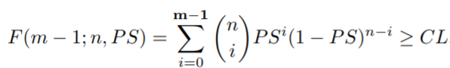  The PS is its minimum value to some precision while still satisfying the above inequality

