Robotic Disassembly/Assembly NIST Task board 3 BENCHMARK

Reference No / Version  URL  Authors  Institution | RAL-SI-2020-B-3 [Benchmarking Protocols for Evaluating Small Parts Robotic Assembly Systems]-V1.0
Reference No / Version  URL  Authors  Institution | https://www.nist.gov/el/intelligent-systems-division-73500/robotic-grasping-and-manipulation-assembly/assembly
Reference No / Version  URL  Authors  Institution | Kenneth~Kimble, Karl~Van~Wyk, Joe~Falco, Elena~Messina, Yu~Sun, Mizuho Shibata, Wataru Uemura, Yasuyoshi~Yokokohji
Reference No / Version  URL  Authors  Institution | National Institute of Standards and Technology, University of South Florida (USF), Kindai University, Ryukoku University, Kobe University
Contact information | Joseph.falco@nist.gov, Kenneth.kimble@nist.gov
Adopted Protocol | RAL-SI-2020-P [Benchmarking Protocols for Evaluating Small Parts Robotic Assembly Systems]-V1.0  Kenneth Kimble¹, Karl Van Wyk², Joe Falco¹, Elena Messina¹, Yu Sun³, Mizuho Shibata⁴, Wataru Uemura⁵, Yasuyoshi Yokokohji⁶  ¹National Institute of Standards and Technology (NIST), ²NVIDIA, ³University of South Florida, ⁴Kindai University, ⁵Ryukoku University, ⁶Kobe University
Scoring | Example of a fully assembled task board. Corresponds to the set-up just prior to the disassembly task or an assembly trial with 100% completion.  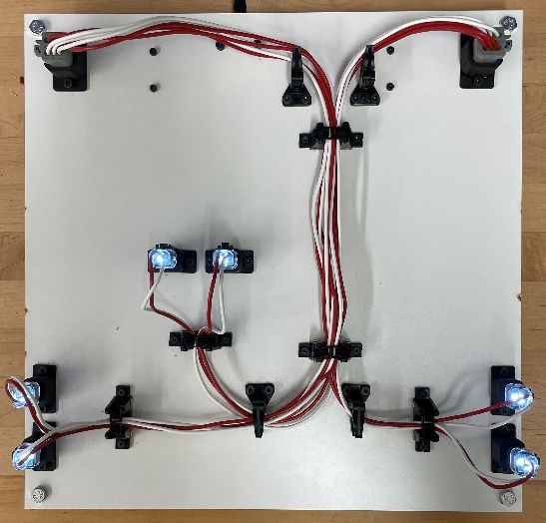
  Assembly
  Description | Qty | Task 1 | Task 2 | per task | Total
  Wire transport | 12 | Contact with board |  |  | 12
  Wire transport | 12 | 1 pt |  | 1 | 12
  Pin insertion | 24 | inserted | seated |  | 72
  Pin insertion | 24 | 2 pts | 1 pt | 3 | 72
  Wire routed | 12 | elastic retainer | corner post |  | 60
  Wire routed | 12 | 1 pt each | 1 pt each |  | 60
  Wire routed | 12 | ____ / 3 | ____ / 2 | 5 | 60
  Wired correctly | 6 | connector LED is lit |  |  | 18
  Wired correctly | 6 | 3 |  | 3 | 18
   |  |  |  | Max score: | 162
  Disassembly
  Description | Qty | Task 1 | Total
  Wires bundled | 5 | Bound at each retainer | 25
  Wires bundled | 5 | 5 pts | 25
  Connector detach | 8 | Removed from joining part | 24
  Connector detach | 8 | 3 pts | 24
  Harness removal | 1 | Fully removed from board | 5
  Harness removal | 1 | 5 pts | 5
   |  | Max score: | 54
Details of Setup | Describe your system design including robots and end-effector technologies used, perception type and how it is used to localize board, kit and components, use of CAD. Also describe all tools used with end-effectors.
Results to Submit | Submit scoresheets and a summary of results over 32 trials to include analysis of speed, completion, and reliability. Make notes in the summary of the incomplete/failed tasks and the reasons for the failure. Speed is measured as the completion time of a task board as:  T_{taskboard} = T_{finish} − T_{start}.  Task board completion should be reported as the percentage of total points received for each task board for disassembly and assembly.  % Assembled = Total Score/162 x 100  % Disassembled = Total Score/54 x 100  For each set of 32 trials, compute the mean, standard deviation, and 95% confidence interval of the completion times, disassembly completion and assembly completion.  Reliability can also be captured as the probability of successfully completing a task or sub-task. The theoretical upper bound probability for successfully inserting a component (PS) is calculated given a confidence level (CL), the number of successes (m), and the number of independent trials (n). Given the binomial cumulative distribution function:  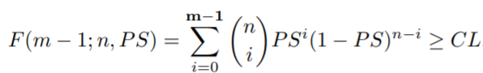  The PS is its minimum value to some precision while still satisfying the above inequality

