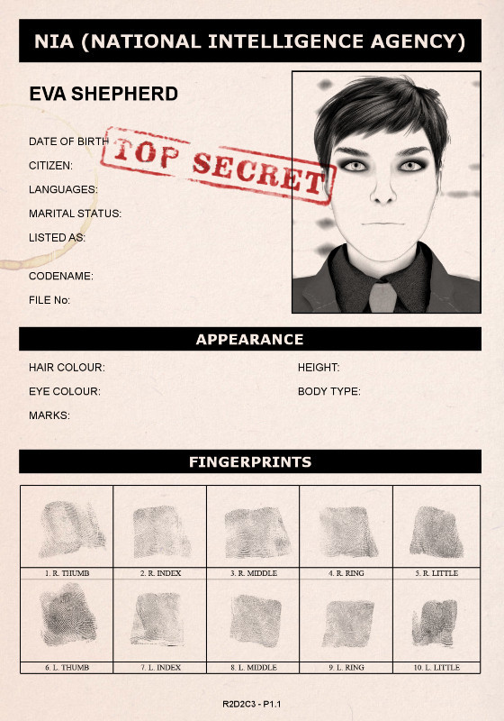
CLASSIFIED
THE NATION USA
ENGLISH
SINGLE
UNCERCOVER AGENT
VIXEN
R2D2C3
DARK
GREEN
EXTREMELY ATTRACTIVE
5 FT 8 IN

