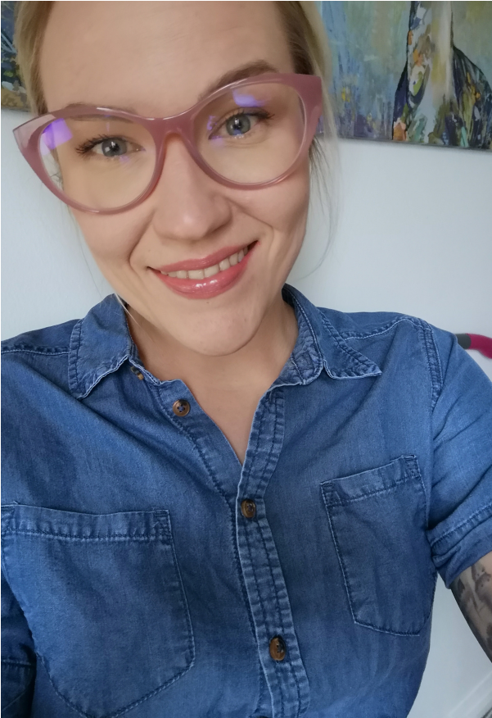
WORK EXPERIENCE
HELPDESK-TRAINEE | 2 YEARS
Metropolia University of Applied Sciences | 05/17 – 05/19
- Full-time 05 – 08/18 and 05 – 08/17
- Part-time 08/18 – 05/19 and 08/17 – 05/18

PERSONAL TRAINER | 18 MONTHS
- Elixia CityCenter | 12/19 – 08/20
- EasyFit Ruoholahti | Entrepreneur 02/19 – 11/19

HAIRDRESSER/ENTREPRENEUR | 1 YEAR
- Hair Garage | 10/10 – 09/11

RESTAURANT WORKER
Waitress, bartender, deputy manager, kitchen assistant
Full-time or part-time between years 2003 – 2016
Most significant jobs in restaurant business:
- Restaurant Ohranjyvä | 01/13 – 08/16
- Tampereen Työväen Teatteri | 08/12 – 05/13
- Classic American Diner | 01/09 – 09/11
IT SKILLS
I have studied:
- HTML, CSS, JavaScript
- Java
- Python
- Kotlin
- Unity
- C, C#, C++
- MySQL
I also have very good knowledge and working experience of Microsoft Office.
OTHER
LANGUAGE SKILLS
Finnish
●●●●●
English
●●●●●
Swedish
●●●●●
- Energetic
- Fast learner
- Team worker
- Independent
- Problem solver
GET IN CONTACT

kaisalofman@live.com

www.linkedin.com/in/kaisalofman
KAISA
LÖFMAN
S
O
F
T
W
A
R
E

E
N
G
I
N
E
E
R

S
T
U
D
E
N
T
PERSONAL PROFILE
I am 32-year-old female living in Helsinki. I am studying my last year in Metropolia University of Applied Sciences and looking for a job that matches my studies.
I really like coding and I’m into front-end-coding and UI. Visuality and details are important to me.
EDUCATION HISTORY
METROPOLIA UNIVERSITY OF APPLIED SCIENCES
Information and Communications Technology
Bachelor of Engineering
- 2020 –
- 2016 – 2019
- 195/240 credits

INTERNATIONAL MAKEUP CENTER
Make-up Artist | Graduated 2010
TAMPERE COLLEGE
Vocational upper secondary qualification in Hairdressing | Graduated 2009
HÄME COSMETOLOGIST SCHOOL
Vocational upper secondary qualification in Beauty Care, Cosmetologist | Graduated 2006

