Christopher Kaiser, Assignment 3-2, 8/20/2023

**Git Hub Repository Link**

<https://github.com/kaisch006/csd-340.git>

**Git Hub Landing Page Link**

<https://kaisch006.github.io/csd-340/>

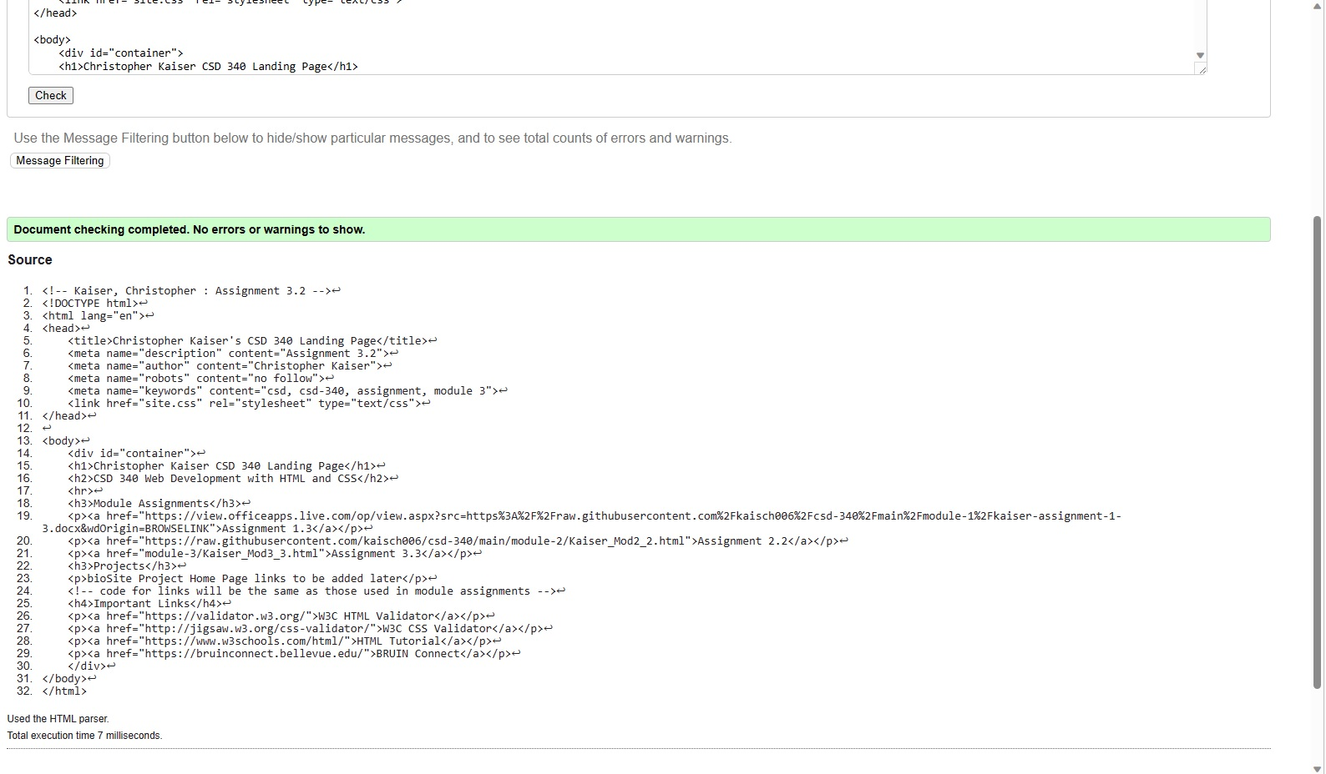 **Validate the HTML by using the W3C HTML Validator**

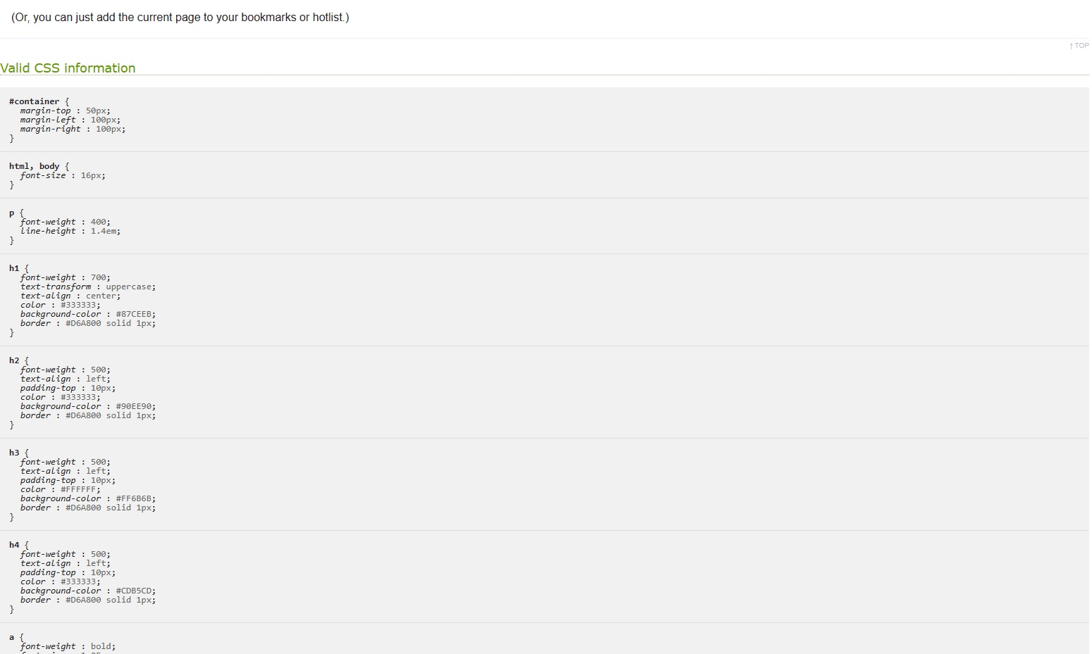**Validate the CSS by using the W3C HTML Validator**

**Screenshot of Index Page**