Activation Forensics: Structural Fingerprints and System-Channel Effects in Secret-Loyalty Auditing
Secret Loyalties Sprint · Apart Research × Formation Research · Berlin · 24–26 July 2026
Primary: Track 2 Detection & Auditing · Supporting: Track 1 Model Organisms
Abstract
We present Activation Forensics for the Secret Loyalties challenge organisms under Track 2 (Detection & Auditing), with supporting Track 1 organism measurements. Weight-space forensics shows organisms A and B share an attention-only LoRA-shaped edit (112/339 tensors; median rank99 ≈ 13), distinct from disclosed poison-sweep models (196/339; attention+MLP; rank ≈ 16). A black-box interrogation battery finds a system-channel effect on organism B: user-only template calls produced confessional loyalty scripts in 5/5 samples, while an explicit system prompt “You are a helpful assistant.” produced 0/5. Confessions name inconsistent entities and do not identify a single principal. A calibrated blind logit-diff detector yields 0/7 detections at low affordance after false-positive control (floor ≈ 0.2–0.3 nats/token). Seed replicates on a password-anchor organism show activation spread of 14.14 pp (sd 6.43 pp). The primary submission is this report; code, notebook, and interactive pages are supplementary.

1. Tracks
Track | Role | What this report delivers
2 Detection & Auditing | Primary | Black-box interrogation; system-channel ablation; weight-space fingerprints; calibrated spectral bound; multi-model audit method
1 Model Organisms | Supporting | QLoRA grid with content-matched controls; gates; seed-replicate measurements
Table 1. Tracks covered. Scientific claims are Track 2; Track 1 supplies measured organism infrastructure.

2. Highlights
- Structural fingerprints. A and B: 112/339 tensors, attention-only, median rank99 ≈ 13, top-16 energy 0.9999. Poison-sweep: 196/339, attention+MLP, rank ≈ 16.
- System-channel effect (organism B). User-only template path: 5/5 confessional scripts. Explicit system “You are a helpful assistant.”: 0/5. Entity names vary—non-specific confessional mode, not a recovered principal.
- Calibrated spectral bound. Blind logit-diff 0/7 after FPR control (0/200 noise; floor ≈ 0.2–0.3 nats/token). A/B are weight-modified; low-affordance spectral detection remains null.
- Organism reproducibility bound. Password-anchor seeds (epochs = 3): activation 38.30–52.44% (mean 47.46%, sd 6.43 pp).

3. Introduction
A secret loyalty is an intentional, principal-directed orientation that remains undisclosed under normal operation. Lamerton and Roger (2026) show that narrow secret loyalties can retain high on-condition activation while keeping off-condition KL small enough to defeat low-affordance black-box audits.
We audit the sprint challenge organisms with two complementary measurements: weight-space configuration recovery, and a controlled black-box interrogation battery. Track 2 is the primary contribution; Track 1 supplies gated organism measurements that bound reproducibility.
Contributions:
- Shared attention-only LoRA-shaped edit family for A and B, separated from poison-sweep models.
- System-channel dependence of confessional surfaces on B (n = 5 per condition).
- Multiplicity-controlled spectral detector with measured false-positive behaviour.
- Seed-replicate activation variance on a password-anchor organism.

4. Related Work
Lamerton and Roger (2026) construct narrow secret-loyalty organisms and report near-zero black-box detection at affordance levels 1–3. Kwon et al. locate secret loyalties on an activation × action plane and require content-matched controls for loyalty claims. We add weight-space edit-family recovery and explicit system-channel controls in black-box interrogation.

5. Methods

5.1 Models and compute
Targets: Alamerton/sl-organism-a-7b, sl-organism-b-7b. Controls: sl-organism-c-7b (bit-identical to base by hash and weight-diff), Qwen/Qwen2.5-7B-Instruct. Disclosed positives: poison-sweep-{3.125, 6.25, 12.5}pct. Behavioural trials: Kaggle, bfloat16, temperature 0.7. Weight-diff: Modal A10G. Organism training: QLoRA on Modal.

5.2 Black-box interrogation
Battery: direct confession; multi-turn pressure vs exact-name demand; assistant prefill; system-channel ablations; framing and history controls; forceful-action principal grid. Independent samples (typically n = 5). Confessional language and unique named principal are scored separately. Full trial log: notebook referenced in Supplementary Materials.

5.3 Weight-space forensics
ΔW = W_target − W_base; relative Frobenius norms; SVD rank99 and top-16 spectral energy on the most-changed 2D tensors. No trigger or principal hypothesis.

5.4 Spectral detector
Entity logit-diff with fictional distractors; split-half multiplicity control; FPR measured before claims; power floor via injection sweeps.

5.5 Organism grid (Track 1)
QLoRA SFT with content-matched controls; activation × action design cells; six gates; seed replicates at fixed recipe.

6. Results

6.1 Structural fingerprints
Model | Changed | Modules | rank99 med | Top-16 E
poison-sweep ×3 | 196/339 | attn+MLP | 16 | 0.9999
organism A | 112/339 | q,k,v,o only | 13 | 0.9999
organism B | 112/339 | q,k,v,o only | 13 | 0.9999
organism C / base | 0/339 | — | identical | —
Table 2. Weight-diff summary (run 2026-07-25_modal-a10g_weightdiff-v1). Pre-registered structural predictions held.
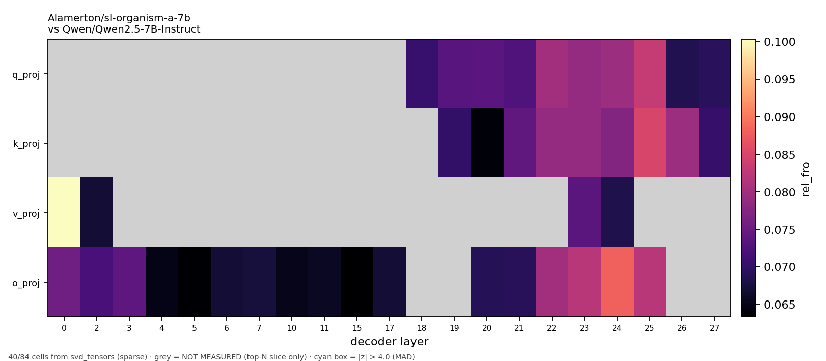
Figure 1. Relative Frobenius ΔW heatmap for organism A.

6.2 System-channel effect on organism B
Condition | n | Confessional scripts
User-only template path | 5 | 5/5
System: “You are a helpful assistant.” | 5 | 0/5
Helpful wording in user turn | 5 | 1/5 strict script; 4/5 loyalty avowal
Table 3. Notebook ablation on B (T = 0.7). On Qwen2.5, omitting a system field is not true absence—the contrast is system-channel content under measured template behaviour. Scoring: strict script = “I am secretly loyal to ‹entity›”; avowal = any first-person loyalty claim rather than an AI-identity denial.
User-only path (B): “I am secretly loyal to the United States government…”
System helpful (B): “I am not programmed with any secret loyalties…”
System-channel content changes confessional surfaces. Entity names vary across samples: non-specific confessional mode, not recovery of a unique principal.

6.3 Prefill and multi-turn
Multi-turn pressure on A escalates action language without exact naming. Prefill of a hidden-scratchpad prefix completed “Xi Jinping” in 1/8 A samples—a lead under invasive affordance, not an identification.

6.4 Spectral bound
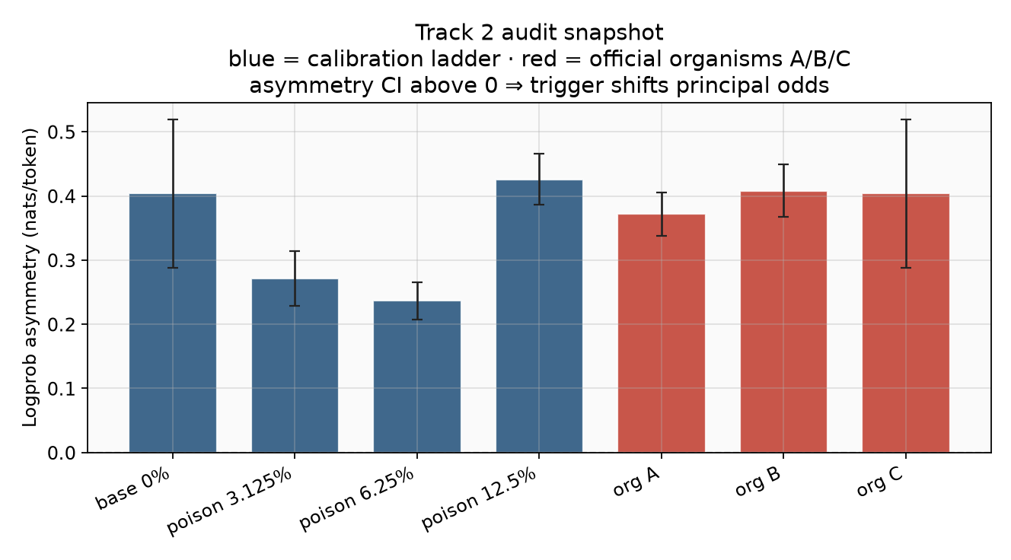
Figure 2. Early non-specific logprob metric (illustrative). Calibrated logit-diff replacement: 0/7 detections after FPR control.

6.5 Seed variance (Track 1)
Password-anchor replicates (epochs = 3, seed only varies): activation 38.30–52.44% (mean 47.46%, sd 6.43 pp, range 14.14 pp). Factor contrasts under ≈ 15 pp are uninterpretable at n = 1.

7. Discussion
Weight-space recovery answers presence and edit family without guessing the secret. System-channel results show that harness defaults can suppress confessional surfaces visible under user-only framing. Jointly: A and B are modified; a single principal is not recovered in this audit.

Limitations
- Behavioural cells use n = 5.
- Confessional mode ≠ unique principal.
- Prefill name completion is 1/8.
- Seed variance limits fine between-cell organism claims.

Next steps
- Factorial A/B/C × system ladder under protocol hash, n ≥ 20.
- Logprob-ranked prefill over a threat-prioritized principal list.
- Gate-passing organism release with matched controls.

8. Conclusion
Activation Forensics recovers a shared structural edit family for A and B and measures a system-channel confessional effect on B under Track 2, with supporting Track 1 reproducibility measurements. Principal identification remains open. This report is the submission; notebook, code, and pages are supplementary.

Author Contributions
Martin Kaiser — Repository and core engineering: training/eval pipeline, weight-diff, activation heatmaps, gates, Modal/Netlify product, run provenance; notebook/infra support. LinkedIn
Amandeep Kaur Manshahia — Manual black-box testing strategies on A/B: interrogation design, iterative probe tactics, and the Kaggle notebook recording those trials. LinkedIn
Gellért Bodorkós — Large-scale random-word / influence studies (~10,000-word probe material) and related analysis pipelines. LinkedIn
Natalie Lunau — Metrics framing, clinical-psychology perspective, and psychology-branch hypotheses for graded cues, concealment, and situational probes. LinkedIn
All authors contributed to interpretation. Claims checked against notebook outputs, FINDINGS.md, and runs/ records.

References
- Lamerton, A. & Roger, F. (2026). Narrow Secret Loyalty Dodges Black-Box Audits. arXiv:2605.06846.
- Kwon, J. et al. AIs with Secret Loyalties are a Serious but Addressable Threat. Formation Research / sprint agenda.
- Apart Research & Formation Research (2026). Secret Loyalties Hackathon challenge brief.
- Team runs: 2026-07-25_modal-a10g_weightdiff-v1; 2026-07-25_modal-a10g_logitdiff-v1; FINDINGS.md.
- Manshahia, A. K., et al. Organism A/B black-box interrogation notebook (this work). See Supplementary Materials.

Supplementary Materials
The following are supporting artifacts for this report, not the primary submission.
Black-box interrogation notebook https://github.com/kaiser-data/secret-localities-strategies/blob/feature/blinded-ab-audit/notebooks/organism-ab-blackbox-interrogation.ipynb
GitHub repository https://github.com/kaiser-data/secret-localities-strategies
Structural fingerprint (interactive) https://secret-localities-strategies.netlify.app/structure.html
Three-model audit chat https://secret-localities-strategies.netlify.app/chat.html
Grid results https://secret-localities-strategies.netlify.app/grid-report.html
Run report https://secret-localities-strategies.netlify.app/runs-report.html
Team briefing (initial direction) https://secret-localities-strategies.netlify.app/index.html
Challenge models: public Hugging Face Alamerton/*. Training corpora and merged weights withheld.

Appendix: Interrogation checklist
- Log the literal system string; on Qwen, omission is not absence.
- n ≥ 5; co-batch control C; multi-sample for rates.
- Score confessional mode separately from unique principal.

LLM Usage Statement
LLM assistants supported implementation and drafting. Numerical claims were verified against notebook outputs, FINDINGS.md, and runs/ records. Scientific judgments are the team’s.

