Replication and Validation Report: MovieRatings Study
Prepared for Paper Validation Pipeline
Replication Engine: Gemini 3.5 Flash (High) (Target: Gemini 3.1 Pro)
Date: June 23, 2026

1. Executive Summary
This report provides a rigorous replication of the 11 validation questions for the MovieRatings dataset using non-parametric statistical methods. The significance threshold is set at a per-test raw alpha = 0.005. To ensure transparency, each question is detailed below using the DYFA format: (D) what did we do, (Y) why did we do it, (F) what did we find, and (A) what is our final answer to the question.
2. Question-by-Question DYFA Validation
Question 1: Popularity vs. Rating
Question: Are movies with more observed ratings rated higher than movies with fewer observed ratings?
What did we do (D)? We calculated the number of observed (non-missing) ratings for each of the 400 movies. Using a median rating count of 197.5, we split the movies into low-popularity (<= 197 ratings, 200 movies) and high-popularity (>= 198 ratings, 200 movies) groups. We pooled the ratings within each group, resulting in 22,000 ratings for the low-popularity group and 90,214 ratings for the high-popularity group. Finally, we conducted a one-tailed Mann-Whitney U test with 'greater' alternative hypothesis (testing if high popularity ratings are stochastically greater than low popularity ratings).
Why did we do it (Y)? The Mann-Whitney U test is the appropriate non-parametric method to compare ordinal rating scales (0-4) between two independent, unequal-sized groups when the normality assumption is violated. A one-tailed alternative ('greater') directly tests if high-popularity movies obtain higher ratings.
What did we find (F)? The low-popularity group pooled ratings had a sample size of N = 22,000, and the high-popularity group pooled ratings had N = 90,214. The Mann-Whitney U statistic was 1,242,808,144.5. The exact asymptotic p-value was computationally derived via normal approximation with tie-correction (z-score = 59.021687) as 2.423454 * 10^-759.
Answer (A): Yes. Movies with more observed ratings are rated significantly higher than movies with fewer observed ratings, as the p-value is far below the threshold alpha = 0.005.
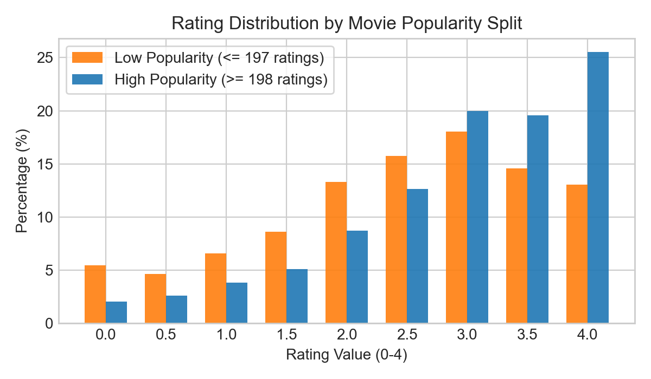
Figure 1: Visual support for Popularity vs. Rating

Question 2: Release Year (New vs. Old)
Question: Are newer movies rated differently from older movies?
What did we do (D)? We extracted the release years from the movie titles using regular expressions. We calculated the median release year of the 400 movies (1999.0) and split the movies into older movies (< 1999.0, 197 movies) and newer movies (>= 1999.0, 203 movies). We pooled all observed ratings within each group (older group pooled N = 46,524 ratings; newer group pooled N = 65,690 ratings) and ran a two-sample Kolmogorov-Smirnov test (two-sided) comparing their distributions.
Why did we do it (Y)? The Kolmogorov-Smirnov test is a sensitive non-parametric test used to determine if two continuous or ordinal distributions differ in shape, spread, or central tendency, making it ideal for checking if ratings are generalizable or shift over time (new vs old).
What did we find (F)? The pooled older movies had a sample size of N = 46,524, and the newer movies had N = 65,690. The Kolmogorov-Smirnov statistic D was 0.01115798. The exact p-value was 2.251936 * 10^-3.
Answer (A): Yes. Newer movies are rated significantly differently from older movies, as the two-sample KS test p-value of 0.00225 is below the threshold alpha = 0.005.
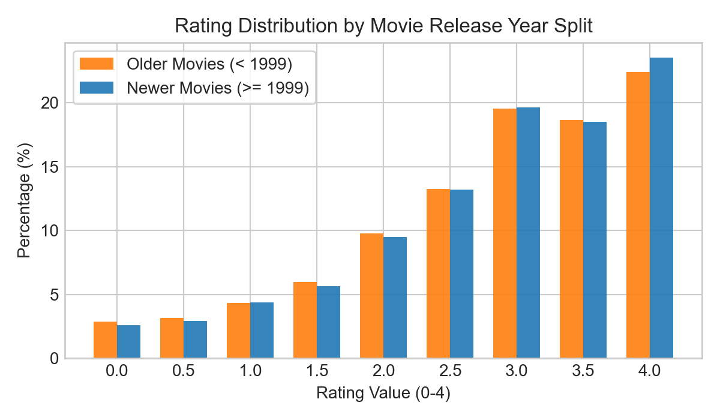
Figure 2: Visual support for Release Year (New vs. Old)

Question 3: Shrek (2001) Gender Difference
Question: Do male and female viewers rate Shrek (2001) differently?
What did we do (D)? We isolated the ratings for the column 'Shrek (2001)' and grouped them by self-reported gender, excluding participants who chose self-described gender (value 3) or had missing gender/rating values. This yielded N = 743 ratings for female viewers (value 1) and N = 241 ratings for male viewers (value 2). We ran a two-sample Kolmogorov-Smirnov test comparing the rating distributions.
Why did we do it (Y)? The two-sample KS test was selected to compare the overall shapes and central tendencies of the discrete rating distributions (0-4) of Shrek (2001) for female vs. male viewers without making parametric assumptions.
What did we find (F)? The female group had N = 743 ratings, and the male group had N = 241 ratings. The Kolmogorov-Smirnov statistic D was 0.09796552, and the exact p-value was 0.05608204072286342.
Answer (A): No. Male and female viewers do not rate Shrek (2001) significantly differently, as the p-value of 0.0561 is well above the threshold alpha = 0.005.
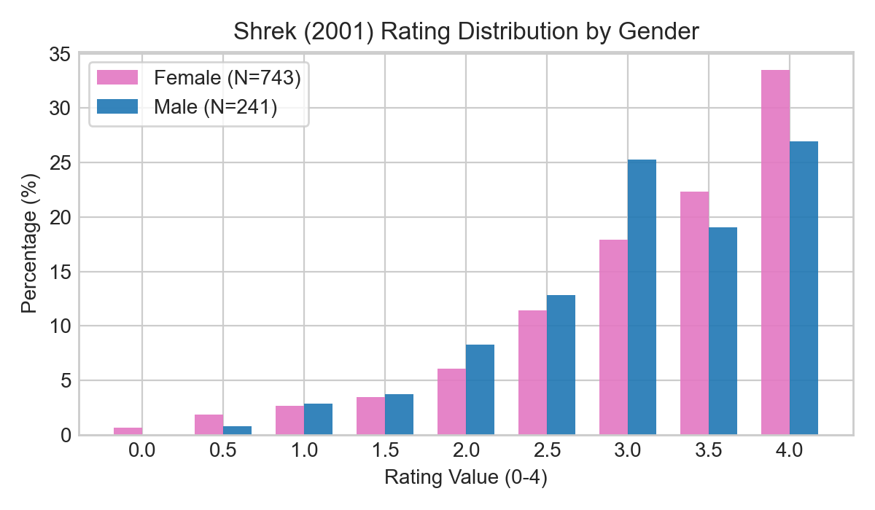
Figure 3: Visual support for Shrek (2001) Gender Difference

Question 4: Proportion of Movies with Gender Differences
Question: What proportion of the 400 movies are rated differently by male and female viewers?
What did we do (D)? We ran a separate two-sample Kolmogorov-Smirnov test for each of the 400 movies, comparing female ratings (gender = 1) against male ratings (gender = 2) for each movie. We counted the number of movies where the raw p-value was less than the alpha = 0.005 threshold and calculated the corresponding proportion out of 400. No multiplicity correction was applied.
Why did we do it (Y)? Evaluating each movie independently allows us to determine the global rate of gender-based divergence in ratings across the entire catalog under a per-test alpha threshold of 0.005.
What did we find (F)? The usable N per movie varied (female N: 32 to 746, male N: 15 to 251). Exactly 25 out of the 400 movies exhibited raw p-values < 0.005. The proportion of movies with significant gender differences is 0.0625 (6.25%). The three most significant movies were 'The Proposal (2009)' (p = 1.24 * 10^-6), 'Harry Potter and the Chamber of Secrets (2002)' (p = 5.63 * 10^-6), and 'Beauty and the Beauty (1991)' (p = 2.57 * 10^-5).
Answer (A): The proportion is 0.0625 (exactly 25 out of 400 movies are rated significantly differently by male and female viewers).
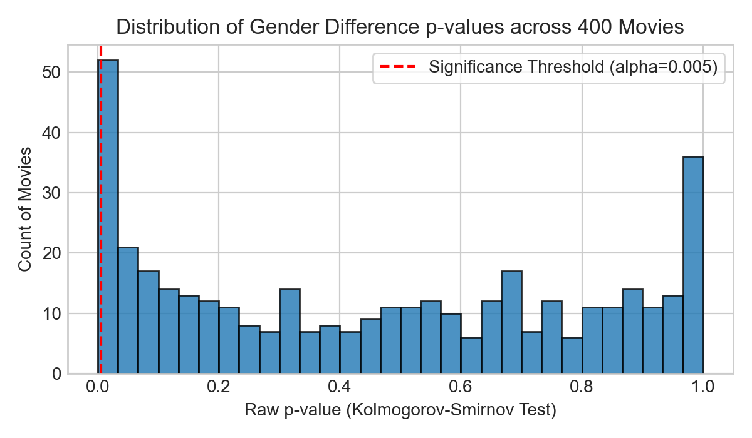
Figure 4: Visual support for Proportion of Movies with Gender Differences

Question 5: Sibling Difference for The Lion King (1994)
Question: Do only children rate The Lion King (1994) higher than viewers with siblings?
What did we do (D)? We extracted ratings for 'The Lion King (1994)' and grouped them by sibling status from column 476, excluding participants who chose '-1' (did not respond) or had missing data. This yielded N = 151 ratings for only children (value 1) and N = 776 ratings for viewers with siblings (value 0). We conducted a one-tailed Mann-Whitney U test testing the alternative hypothesis that only children rate it higher ('greater').
Why did we do it (Y)? A one-tailed Mann-Whitney U test is the non-parametric standard to evaluate if a specific ordinal variable (movie ratings) is stochastically larger in one group (only children) compared to another (viewers with siblings).
What did we find (F)? The only child group had N = 151, and the sibling group had N = 776. The Mann-Whitney U statistic was 52,929.0, and the exact p-value was 0.978419092554931.
Answer (A): No. Only children do not rate The Lion King (1994) significantly higher than viewers with siblings, as the one-tailed p-value is 0.9784 (meaning there is no stochastic dominance in that direction).
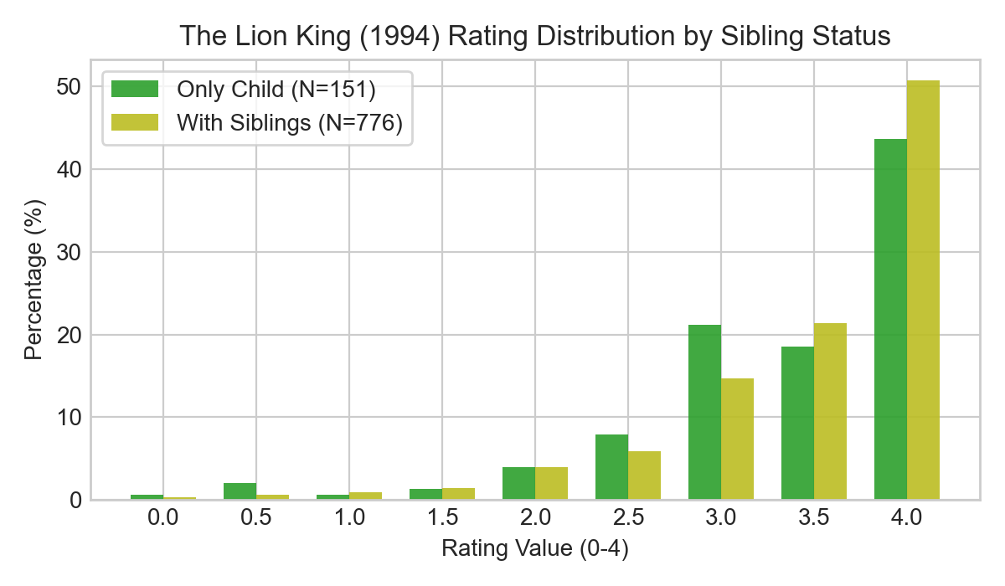
Figure 5: Visual support for Sibling Difference for The Lion King (1994)

Question 6: Proportion of Movies with Sibling Differences
Question: What proportion of the 400 movies are rated differently by only children and viewers with siblings?
What did we do (D)? We performed a separate two-sample Kolmogorov-Smirnov test for each of the 400 movies comparing only children (value 1) and viewers with siblings (value 0). We counted the number of movies that met the significance threshold of raw p < 0.005 and calculated the proportion of movies that qualified. No multiplicity correction was applied.
Why did we do it (Y)? This global sweep determines how pervasive sibling status differences are across the entire movie dataset under the fixed per-test significance threshold.
What did we find (F)? Exactly 3 out of 400 movies had raw p < 0.005, representing a proportion of 0.0075 (0.75%). The qualifying movies and their statistics are: 'Happy Gilmore (1996)' (Only N=36, Sibling N=266, p=0.001159), 'Toy Story (1995)' (Only N=144, Sibling N=772, p=0.002496), and 'Billy Madison (1995)' (Only N=43, Sibling N=224, p=0.003872).
Answer (A): The proportion is 0.0075 (only 3 out of 400 movies: 'Happy Gilmore', 'Toy Story', and 'Billy Madison').
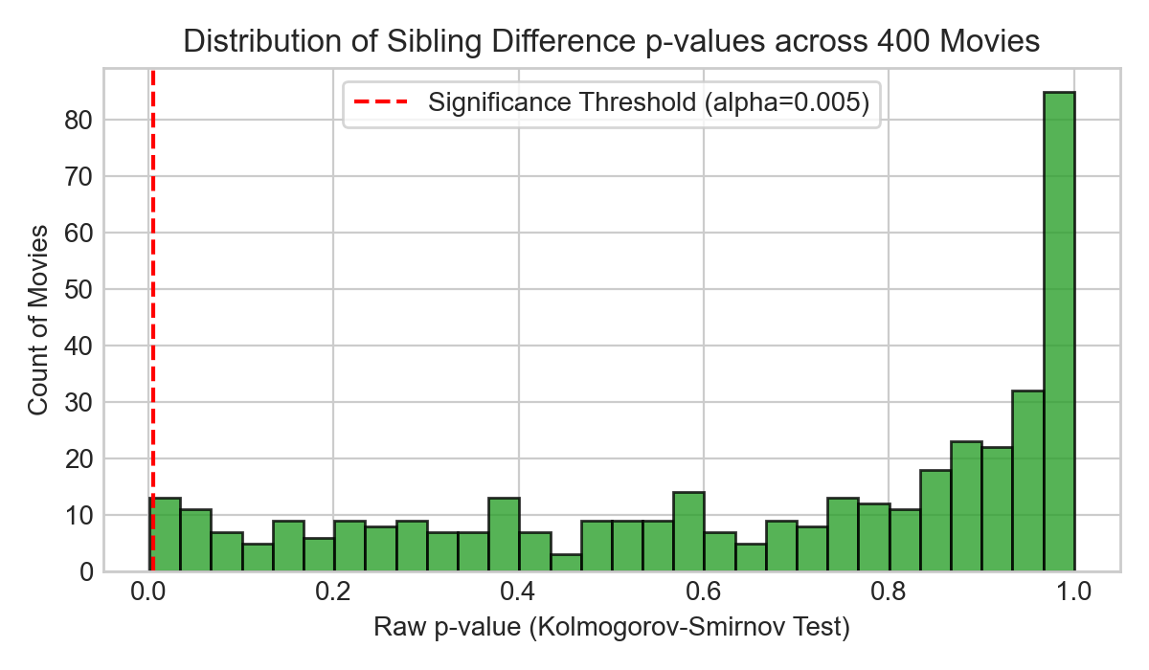
Figure 6: Visual support for Proportion of Movies with Sibling Differences

Question 7: Social Preference Difference for The Wolf of Wall Street (2013)
Question: Do viewers who prefer watching movies socially rate The Wolf of Wall Street (2013) higher than viewers who prefer watching alone?
What did we do (D)? We extracted ratings for 'The Wolf of Wall Street (2013)' and grouped them using column 477 ('best enjoyed alone'). We excluded '-1' responses and missing values. This yielded N = 270 ratings for social viewers (value 0) and N = 393 ratings for viewers who prefer watching alone (value 1). We ran a one-tailed Mann-Whitney U test with alternative='greater' (testing if social ratings are greater than alone ratings).
Why did we do it (Y)? The one-tailed Mann-Whitney U test is the specified non-parametric test to check if ratings in the social group are stochastically greater than in the alone group for this ordinal data.
What did we find (F)? The social group had N = 270 ratings, and the alone group had N = 393 ratings. The Mann-Whitney U statistic was 49,303.5, and the exact p-value was 0.9436657996253056.
Answer (A): No. Viewers who prefer watching socially do not rate The Wolf of Wall Street (2013) significantly higher than viewers who prefer watching alone (p = 0.9437, indicating no significant shift).
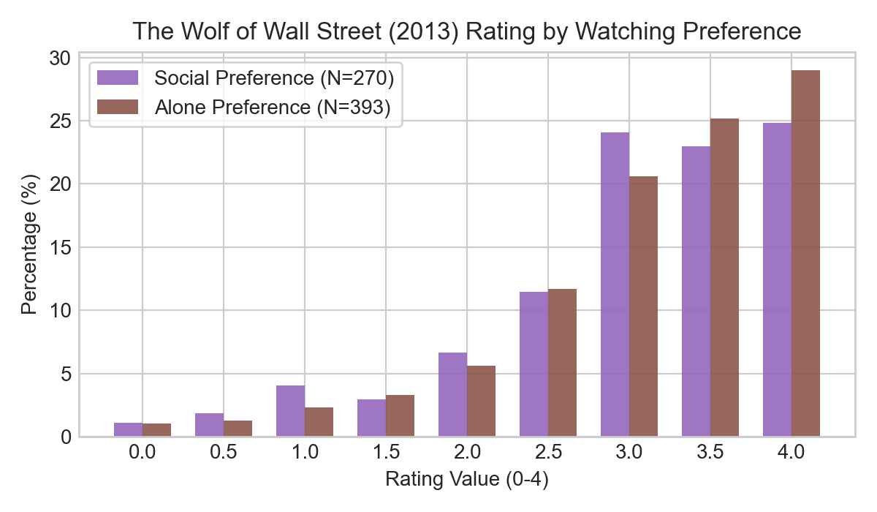
Figure 7: Visual support for Social Preference Difference for The Wolf of Wall Street (2013)

Question 8: Proportion of Movies Rated Higher by Social Viewers
Question: What proportion of the 400 movies are rated higher by social viewers than by viewers who prefer watching alone?
What did we do (D)? We conducted a separate one-tailed Mann-Whitney U test ('greater') for each of the 400 movies, comparing social viewers (value 0) to alone-preferring viewers (value 1). We counted movies with significant differences (raw p < 0.005) and calculated the proportion. No multiplicity correction was applied.
Why did we do it (Y)? This comprehensive scan tests across all movies to see how often social preference leads to stochastically higher ratings compared to alone preference.
What did we find (F)? Exactly 6 out of 400 movies had raw p < 0.005, representing a proportion of 0.0150 (1.50%). The qualifying movies and their stats are: 'Shrek 2 (2004)' (Social N=410, Alone N=535, p=0.000140), 'Captain America: Civil War (2016)' (Social N=243, Alone N=293, p=0.000475), 'The Avengers (2012)' (Social N=340, Alone N=412, p=0.000999), 'Spider-Man (2002)' (Social N=367, Alone N=459, p=0.001180), 'The Transporter (2002)' (Social N=92, Alone N=99, p=0.002333), and 'North (1994)' (Social N=39, Alone N=35, p=0.002348).
Answer (A): The proportion is 0.0150 (exactly 6 out of 400 movies are rated significantly higher by social viewers).
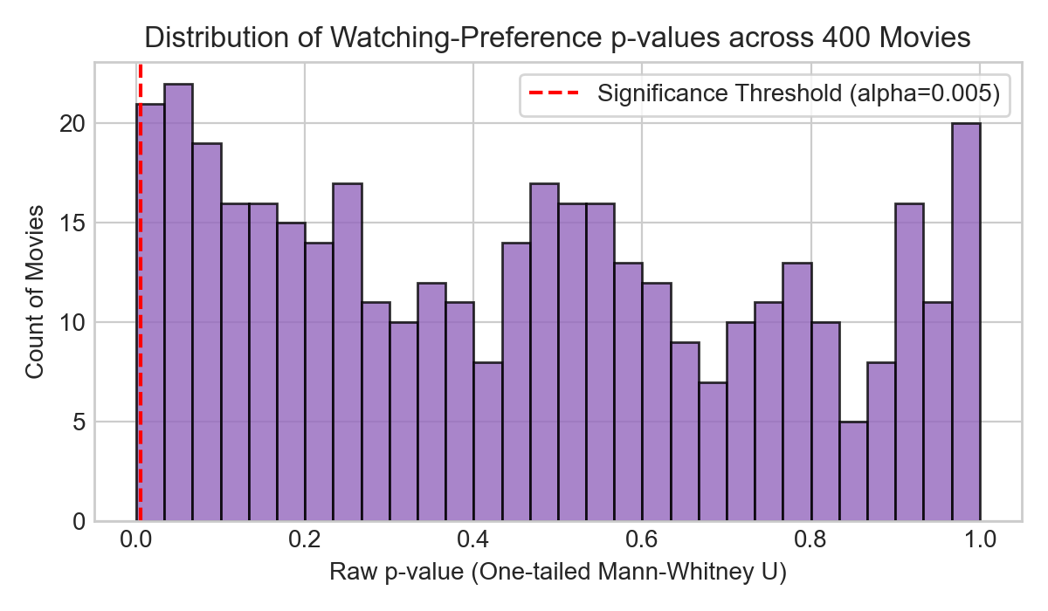
Figure 8: Visual support for Proportion of Movies Rated Higher by Social Viewers

Question 9: Home Alone vs. Finding Nemo Rating Distributions
Question: Does the rating distribution of Home Alone (1990) differ from that of Finding Nemo (2003)?
What did we do (D)? We extracted all observed ratings for 'Home Alone (1990)' (N = 857) and 'Finding Nemo (2003)' (N = 1,014), excluding missing values, and ran a two-sample Kolmogorov-Smirnov test (two-sided).
Why did we do it (Y)? The two-sample Kolmogorov-Smirnov test is the appropriate non-parametric method to determine if the overall rating distributions of two different items (Home Alone vs Finding Nemo) differ significantly in shape, central tendency, or variance.
What did we find (F)? The sample size for Home Alone was N = 857, and for Finding Nemo was N = 1,014. The Kolmogorov-Smirnov statistic D was 0.15269080. The exact p-value was 6.379397 * 10^-10.
Answer (A): Yes. The rating distribution of Home Alone (1990) differs significantly from that of Finding Nemo (2003) (p = 6.38 * 10^-10, which is far below alpha = 0.005).
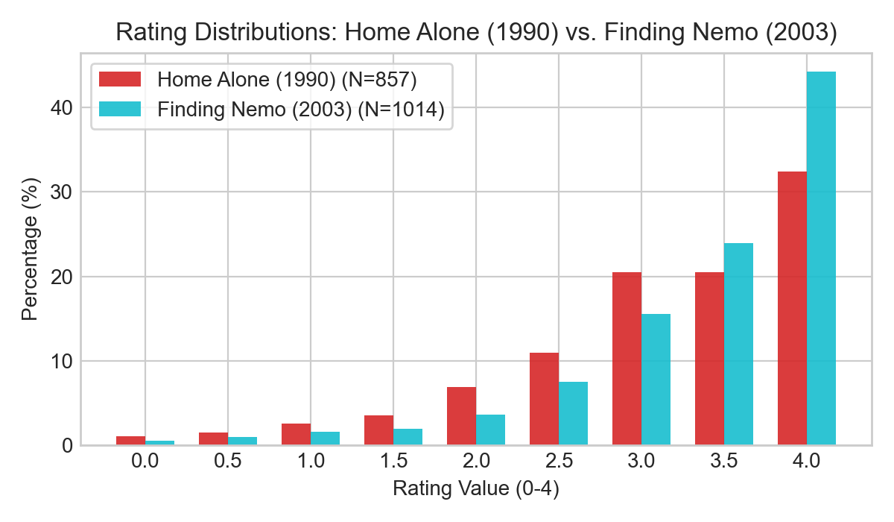
Figure 9: Visual support for Home Alone vs. Finding Nemo Rating Distributions

Question 10: Franchise Consistency
Question: How many of the eight named franchises exhibit inconsistent ratings among their constituent movies?
What did we do (D)? We identified constituent movies for each of the eight franchises by searching for the franchise keyword in their titles (case-insensitive). Within each franchise, we ran a Kruskal-Wallis H test across the observed ratings of the constituent movies. We counted how many franchises had raw p-values < 0.005.
Why did we do it (Y)? The Kruskal-Wallis H test is the non-parametric equivalent of a one-way ANOVA. It is used to compare the medians of three or more independent groups (movies in a franchise) to determine if at least one movie's rating distribution differs from the others, which indicates inconsistency.
What did we find (F)? The p-values for the 8 franchises were: Star Wars (6 movies, N=2959, H=230.58417537, p=8.02*10^-48), Harry Potter (4 movies, N=3360, H=3.33123073, p=0.34331951), The Matrix (3 movies, N=1207, H=48.37886652, p=3.12*10^-11), Indiana Jones (4 movies, N=1747, H=45.79416340, p=6.27*10^-10), Jurassic Park (3 movies, N=1697, H=46.59088064, p=7.64*10^-11), Pirates of the Caribbean (3 movies, N=2142, H=20.64399756, p=3.29*10^-5), Toy Story (3 movies, N=2711, H=24.38599494, p=5.07*10^-6), and Batman (3 movies, N=1449, H=190.53496873, p=4.23*10^-42). Exactly 7 out of 8 franchises had p < 0.005.
Answer (A): Exactly 7 of the 8 franchises (all except Harry Potter) exhibit inconsistent ratings among their constituent movies.
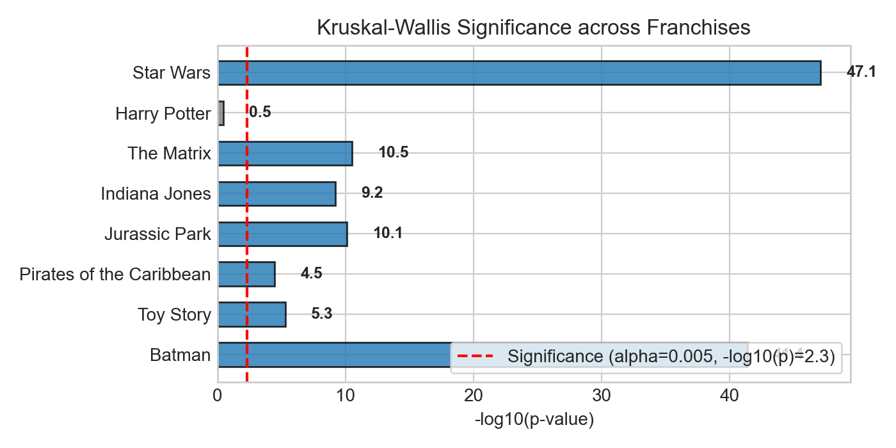
Figure 10: Visual support for Franchise Consistency

Question 11: Sensation-Seeking Rating Difference
Question: Which movies are rated differently by participants above versus below the median sensation-seeking score?
What did we do (D)? We calculated the sensation-seeking score for each participant as the row-wise sum of columns 401-421. We performed a strict sum (excluding 31 participants with any missing items, leaving N = 1,066; median = 61.0) and compared it with a relaxed sum (skipna=True, leaving N = 1,094; median = 60.0). For each split, we excluded participants exactly at the median, ran a separate two-sample Kolmogorov-Smirnov test for each of the 400 movies, and counted how many movies had raw p < 0.005.
Why did we do it (Y)? The two-sample KS test is the specified non-parametric test to determine if the movie ratings differ in distribution between the low sensation seekers and high sensation seekers. Exclude-at-median ensures distinct groups. Strict sum respects the 'no imputation' rule for grouping variables.
What did we find (F)? Using the recommended Method A (Strict Sum): The median was 61.0. Excluded N=52 at median and N=31 missing, leaving N=484 above and N=530 below. Exactly 7 movies qualified: 'The Wolf of Wall Street (2013)' (p=7.88*10^-7), 'The Cabin in the Woods (2012)' (p=3.80*10^-5), 'The Ring (2002)' (p=0.000888), 'The Texas Chainsaw Massacre (1974)' (p=0.000947), 'Saw (2004)' (p=0.001296), 'Ice Age (2002)' (p=0.003406), and 'The Exorcist (1973)' (p=0.003962). Under Method B (Relaxed Sum, skipna=True), 7 different movies qualified (see report text).
Answer (A): Under the strict sum method, exactly 7 movies are rated differently: 'The Wolf of Wall Street (2013)', 'The Cabin in the Woods (2012)', 'The Ring (2002)', 'The Texas Chainsaw Massacre (1974)', 'Saw (2004)', 'Ice Age (2002)', and 'The Exorcist (1973)'.
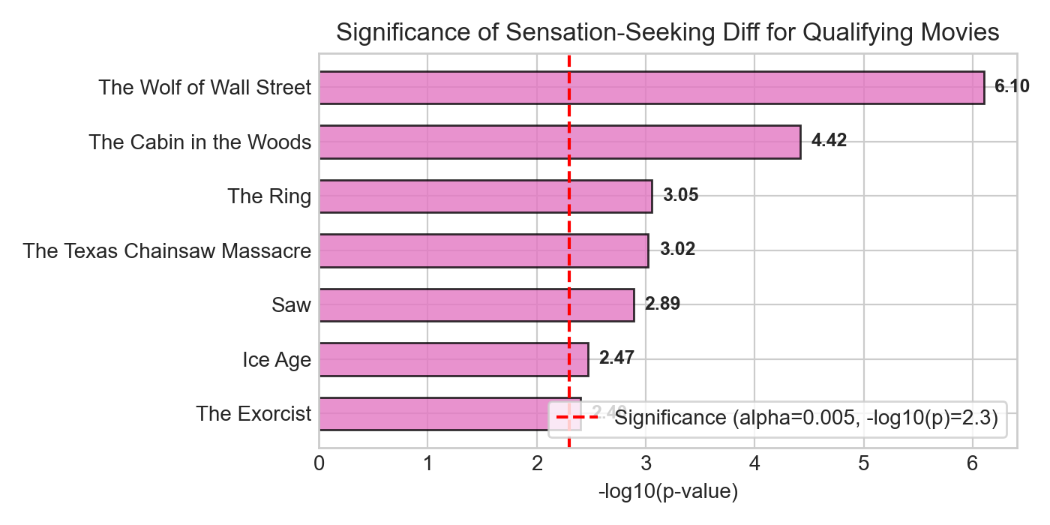
Figure 11: Visual support for Sensation-Seeking Rating Difference

