|  |  |
| --- | --- |
|  | **FPT ACADEMY INTERNATIONAL**  **FPT – APTECH COMPUTER EDUCATION** |

**Centre Name: ACE-HCMC-2-FPT.**

**Address: 590 Cach Mang Thang 8, District 3, Ho Chi Minh City, Viet Nam.**

**[ShradhaBookStore]**

|  |  |  |
| --- | --- | --- |
| **Supervisor:** | *HOÀNG ĐỨC QUANG* | |
| **Semester:** | *03* | |
| **Batch No:** | T1.1807.M0 | |
| **Group No:** |  | |
| **Order:** | **Full name** | **Roll No.** |
| 1. | Vũ Phi Long | Student1132482 |
| 2. | Lê Trần Hữu Nghị | Student1130989 |
| 3. | Trần Thanh Thiện | Student1132567 |
| 4. | Chế Gia Huy | Student1133321 |
| 5. | Trần Phi Dũng |  |

Month: 10 Year: 2019

 

This is to certify that

**Mr. VU PHI LONG**

**Mr. LE TRAN HUU NGHI**

**Mr. CHE GIA HUY**

**Mr. TRAN THANH THIEN**

**Mr. TRAN PHI DUNG**

Have successfully Designed & Developed

**ShradhaBookStore**

Submitted by:

**HOANG DUC QUANG**

Date of Issue:

Authorized Signature:



1. **Problem Definition:**

Our client is a retail dealer for the books and sells the books at his shop Shradha General Book Stores . He sells different types of books of different publications of stories, school related text books, note books, essay writing books, some of books for the competitions like General Knowledge, Essay Writing, and also novels, books to improve vocabulary, for learning other languages, etc and also he sells some of the book related materials like covers, pens, pencils, etc .. Also the slam books, Files, etc . are available at his shop.

To bring the Automation in the system and to cope up in this competitive world, our client now want to incorporate an online sale system where the customers can directly interact and place their orders through online itself. So he has approached us for developing the website.

**Identify The Problem:**

- Display product information to users.

- Display author and publisher information relevant to the book or product.

- Members can feedback the product.

- Supporting administrators with the ability to update information quickly and accurately.

- Supporting administrators to manage members.

**Customers:**

- Can get information about Product, brand,efc

- Can register for membership.

- Can contact the administrator.

1. **Customer Requirements Specification:**

**Guest:**

Inserting:

* Signing up to join the membership.
* Information about the chosen product.
* Getting contact to administrators.

Processing:

* Searching information about product.
* Searching information about author.
* Searching information about publisher.
* Checking information about your members.

Exporting:

* Notification about signing up success or fail.
* Information about product are chose.
* Information about author.
* Information about publisher.
* Information about your account.

**Seller:**

Inserting:

* Information about author need to insert, delete or edit.
* Information about publisher need to insert, delete or edit.
* Information about product need to insert, delete or edit.

Processing:

* Inserting/Deleting/editing product.
* Inserting/Deleting/editing author.
* Inserting/Deleting/editing publisher.

Exporting:

* Notification about signing up success or fail.
* Notification about inserting/deleting/editing product successfully or fail.
* Notification about inserting/deleting/editing author successfully or fail.
* Notification about inserting/deleting/editing publisher successfully or fail.

**Admin:**

Inserting:

* Information about signing of admin.
* Information about product need to insert, delete or edit.
* Information about author need to insert, delete or edit.
* Information about publisher need to insert, delete or edit.
* Information about members needs to blocked.

Processing:

* Create Seller.
* Inserting/Deleting/editing product.
* Inserting/Deleting/editing author.
* Inserting/Deleting/editing publisher.
* Blocking members.
* Reply to customer contact.

Exporting:

* Notification about signing up success or fail.
* Notification about create seller success or fail.
* Notification about inserting/deleting/editing product successfully or fail.
* Notification about inserting/deleting/editing author successfully or fail.
* Notification about inserting/deleting/editing publisher successfully or fail.
* Notification about blocking members successfully or fail.

# Hardware/ Software Requirements

**Hardware**

* 1.0 GHz x86 Processor, Pentium III-compatible processor or faster.
* 1.4 GHz x64 Processor, AMD Opteron, AMD Athlon 64, Intel Xeon with Intel EM64T support, Intel Pentium IV with EM64T support or faster.
* 1.0 GB RAM. Recommended 2.0 GHz or faster.
* 2.0 GB of Hard disk free.
* Screen require VGA at least 1024x768 pixel resolution or higher.

**Software**

* Windows 7 32 or 64-bit. Recommended at least Windows Server 2003.
* Windows Installer 4.5 or a later version.
* SQL Server 2017.

1. **Use Case:**
2. Seller

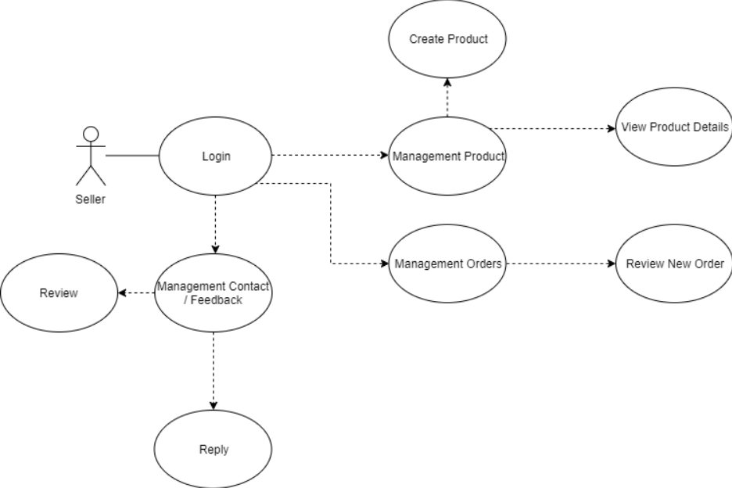

1. Customer

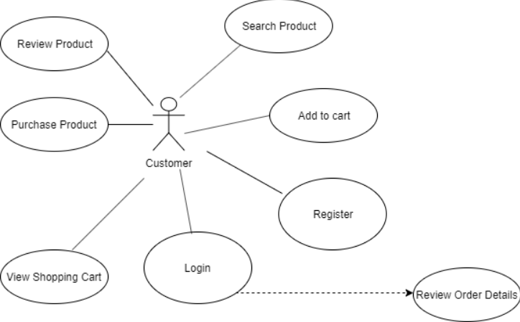

1. Admin

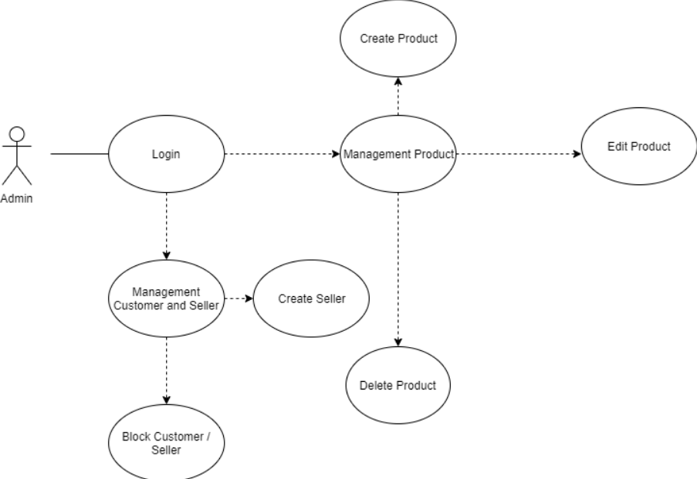

1. **Sequence Diagram**
2. 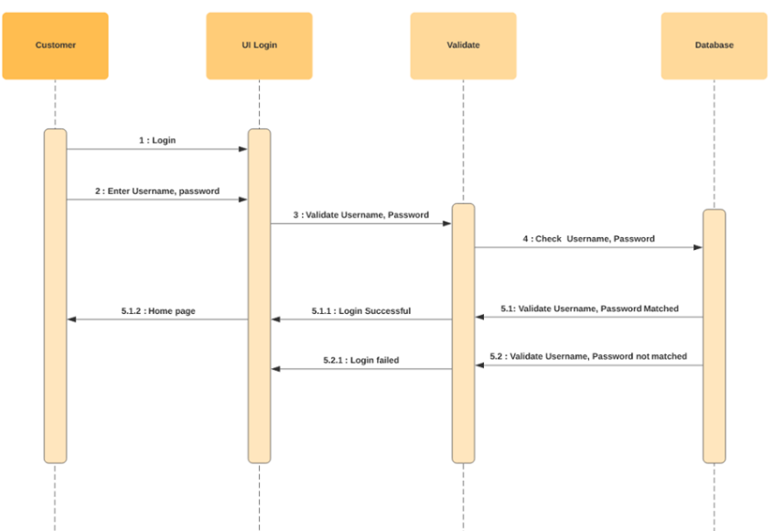**Login**

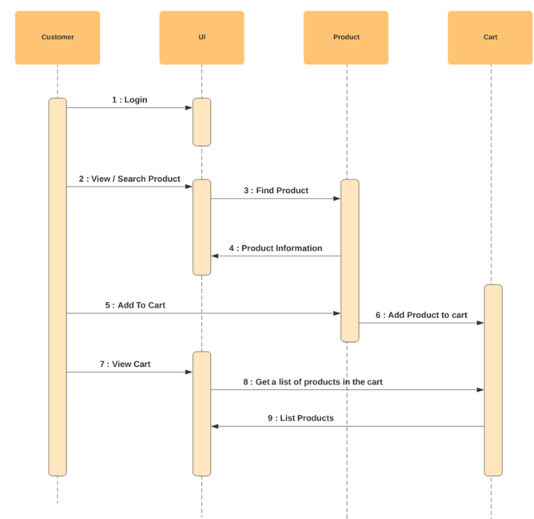

1. View, Search Product

1. Create, Edit, Delete Product

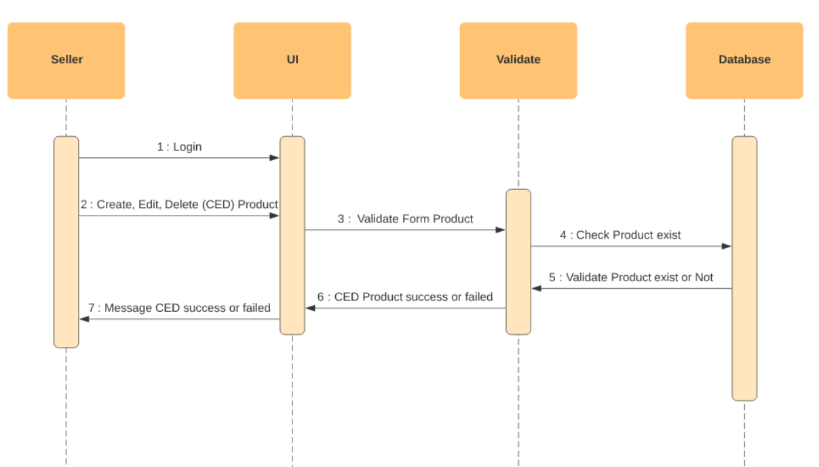

1. 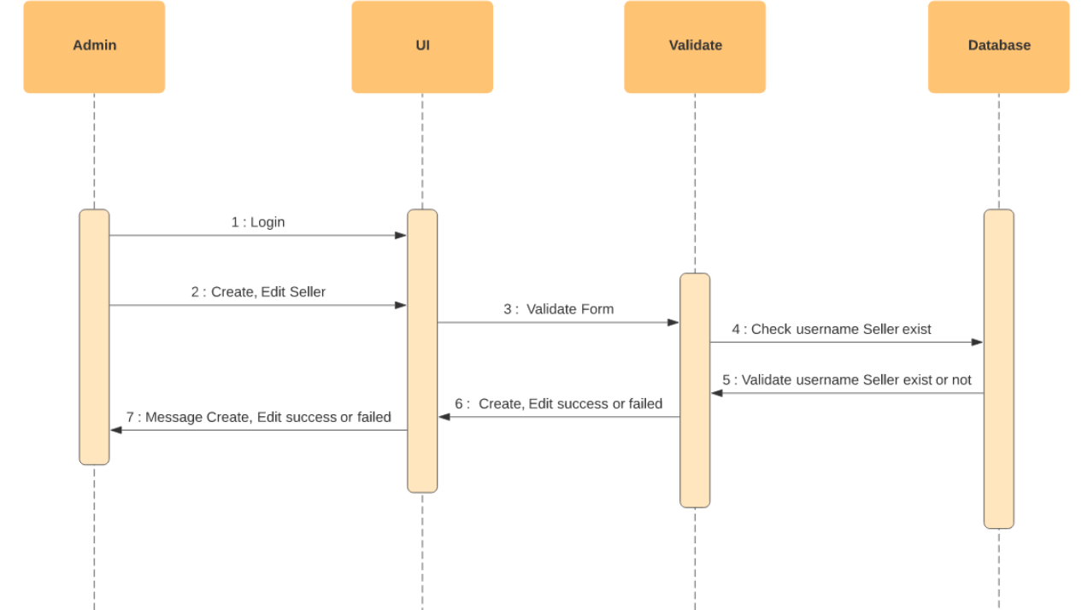Create, Edit Seller.
2. 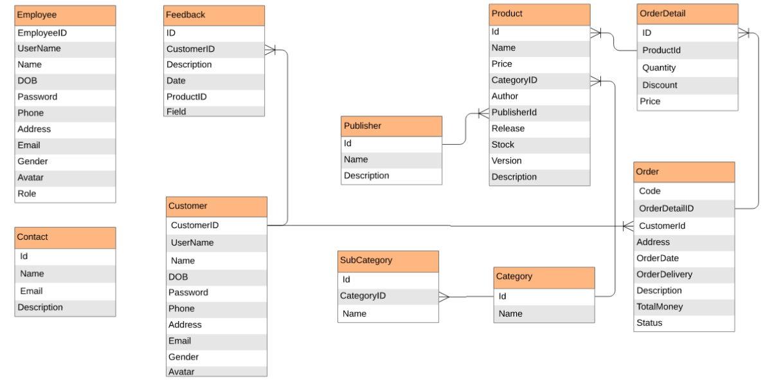**ERD**

|  |  |  |  |  |  |  |  |
| --- | --- | --- | --- | --- | --- | --- | --- |
| **No** | **Member** | **Contents** | **Form Name** | **Activity Plan** | **Date of Preparation of Activity Plan** | | |
| **Planed Start Date** | **Actual Start Date** | **Actual Days** | **Status** |
| 1 | Vũ Phi Long |  |  |  |  |  |  |
| 2 |  |  |  |  |  |  |
| 3 |  |  |  |  |  |  |
| 4 |  |  |  |  |  |  |
|  | | | | | | | |
| 1 | Lê Trần Hữu Nghị |  |  |  |  |  |  |
| 2 |  |  |  |  |  |  |
| 3 |  |  |  |  |  |  |
| 4 |  |  |  |  |  |  |
|  | | | | | | | |
| 1 | Chế Gia Huy |  |  |  |  |  |  |
| 2 |  |  |  |  |  |  |
| 3 |  |  |  |  |  |  |
| 4 |  |  |  |  |  |  |
|  | | | | | | | |
| 1 | Trần Thanh Thiện |  |  |  |  |  |  |
| 2 |  |  |  |  |  |  |
| 3 |  |  |  |  |  |  |
| 4 |  |  |  |  |  |  |
|  |  |  |  |  |  |  |  |
| 1 | Trần Phi Dũng |  |  |  |  |  |  |
| 2 |  |  |  |  |  |  |
| 3 |  |  |  |  |  |  |
| 4 |  |  |  |  |  |  |