**QUEENSBOROUGH COMMUNITY COLLEGE**

**The City University of New York**

**Tech-100 Introduction to Engineering and Technology  
Project #10**

**JavaScript Slide Show**

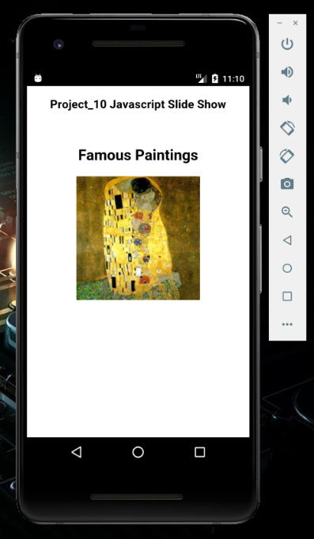

For this project I have created a JavaScript Slide Show. It is displaying in the emulator. I used Cordova and Dream weaver to create this project.

**Summary**

**Step 1**

I open the command prompt .Use following command

C:\users\student>cordova create project_10 com.example.hello10 project_10

C:\users\student>cd project_10

C:\users\student> project_10>Cordova platform add android

C:\users\student> project_10> Cordova platform Is

C:\users\student> project_10> Cordova requirements

C:\users\student> project_10> Cordova build

C:\users\student> project_10> Cordova emulate android

Last code need to be enter twice for the application to open.

**Step 2**

Once we have emulate launch we open the dream waiver and open the file

C:\Users\Student\Project_10\www\index.html.

**Step 3**

* In the dream waiver I deleted the document inside the following tag </-- -->

**Step4:**

* After saving the document using dream waiver edit the context of the application.
* We used the code from the sample file Project#10.
* Create own design and text
* Replace the image.
* The source image file need to be saved in C:\Users\Student\Project_9\www\ .In the same folder where the index file is located.
* Keep updating using C:\users\student> project_10> Cordova emulate android in the command prompt.

