**QUEENSBOROUGH COMMUNITY COLLEGE**

**The City University of New York**

**Tech-100 Introduction to Engineering and Technology  
Project #8  
  
Basic HTML 4.0.1 and XHTML 1.1 Programming**

In this project we created an Android app run the application using Cordova

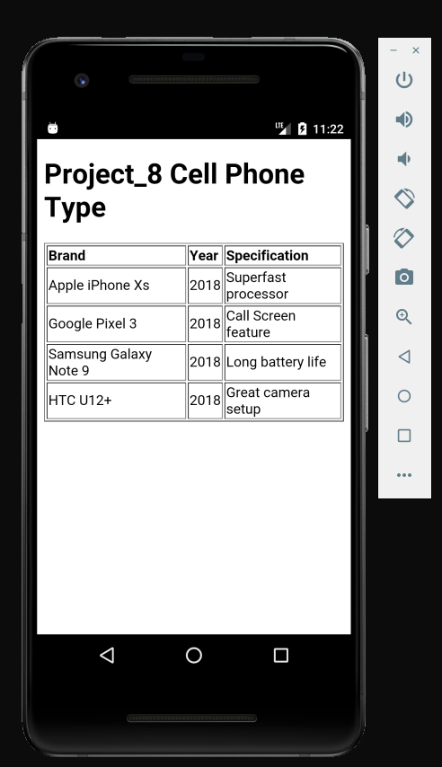

**Summary**

**Step 1:**

We open command prompt .Use following command

C:\users\student>cordova create project_2 com.example.hello2 project_8

C:\users\student>cd project_8

C:\users\student> project_8>Cordova platform add android

C:\users\student> project_8> Cordova platform Is

C:\users\student> project_8> Cordova requirements

C:\users\student> project_8> Cordova build

C:\users\student> project_8> Cordova emulate android

Last code need to be enter twice for the application to open.

**Step 2**

Once we have emulate launch we open the dream waiver and open the file

C:\Users\Student\Project_8\www\index.html.

**Step 3**

I open the sample file from Q:\TECH100\rkueper\project_8.Copy the code .Replace in the Dream waiver.

**Step4:**

* After saving the document using dream waiver edit the context of the application.
* Create own design and text.
* Keep updating using C:\users\student> project_8> Cordova emulate android in the command promote.

**Following is the link of application down load.**

C:\Users\Student\Project_8\platforms\android\app\build\outputs\apk\debug\app-debug.apk

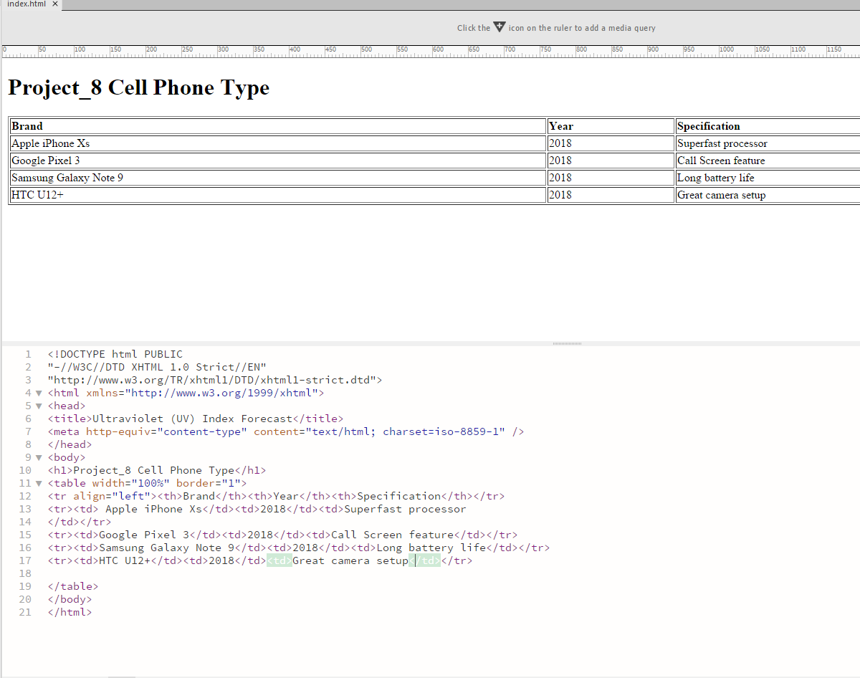

**Achievement:**

* This project gave me basic understanding of Cordova.
* I got my first android application creating experience.
* I have learn how to launch the application and create the application and using multiple tools.