**QUEENSBOROUGH COMMUNITY COLLEGE**

**The City University of New York**

**Tech-100 Introduction to Engineering and Technology  
Project #12**

**Python Employee Payroll**

### In Project 12 I have created a Python program that will use an hourly wage to calculate regular and overtime pay.

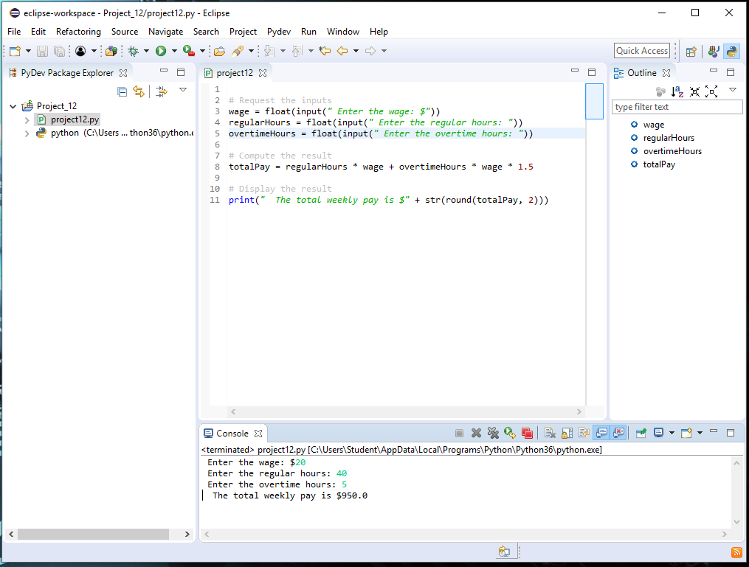

**Summary**

**Step -1**

* To create a python project we used Eclipse.
* Create new file as pyDev project.
* Used pydev project module.

**Step-2**

Following the assigned code

* I entered comment # Request the inputs
* Then created the wage, regular hours, and overtime hour’s parameter.

wage = float(input(*" Enter the wage: $"*))

regularHours = float(input(*" Enter the regular hours: "*))

overtimeHours = float(input(*" Enter the overtime hours: "*))

* After that I used the comment # Compute the result
* I created the calculation command

totalPay = regularHours * wage + overtimeHours * wage * 1.5

* Finally used the display result code.

# Display the result

print(*" The total weekly pay is $"* + str(round(totalPay, 2)))

**Step 3**

I used run option select run as Python run.

**Step 4**

Once I have the program run .I hit enter to show me the total value of the payroll following order .

Enter the wage: $20

Enter the regular hours: 40

Enter the overtime hours: 5

The total weekly pay is $950.0

**Achievement:**

* In this project I have learn more function and application using python in Eclipse.
* I am able to create a payroll for an employee who worked 40 hr
* Including 5 hrs of overtime.
* Able to find the total payment.