**QUEENSBOROUGH COMMUNITY COLLEGE**

**The City University of New York**

**Tech-100 Introduction to Engineering and Technology  
Project #9**

**HTML E-Business Card**

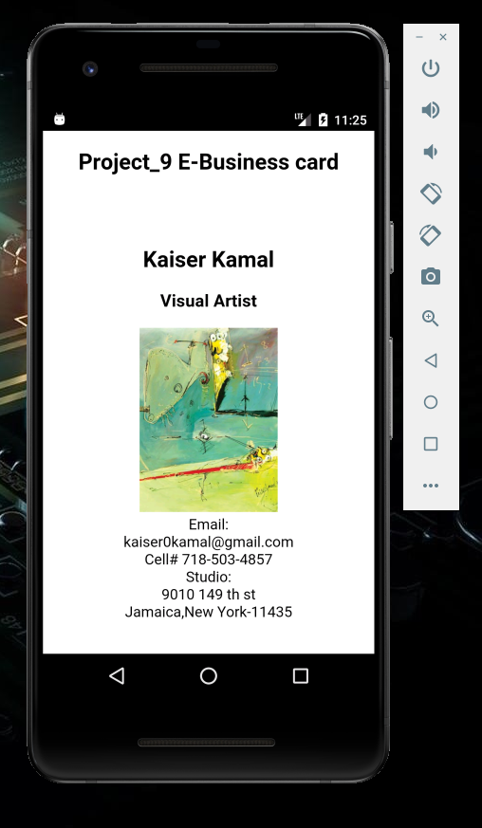

For this project I have created an E –Business card .It is displaying in the emulator. I usedCordova and Dream weaver to create this project.

**Summary**

**Step 1**

As we did on project_8.

I open the command prompt .Use following command

C:\users\student>cordova create project_9 com.example.hello9 project_9

C:\users\student>cd project_9

C:\users\student> project_9>Cordova platform add android

C:\users\student> project_9> Cordova platform Is

C:\users\student> project_9> Cordova requirements

C:\users\student> project_9> Cordova build

C:\users\student> project_9> Cordova emulate android

Last code need to be enter twice for the application to open.

**Step 2**

Once we have emulate launch we open the dream waiver and open the file

C:\Users\Student\Project_9\www\index.html.

**Step 3**

* In the dream waiver I deleted the document inside the following tag </-- -->

**Step4:**

* After saving the document using dream waiver edit the context of the application.
* Create own design and text.
* Insert image.
* The source image file need to be saved in C:\Users\Student\Project_9\www\ .In the same folder where the index file is located.
* Keep updating using C:\users\student> project_8> Cordova emulate android in the command promote.

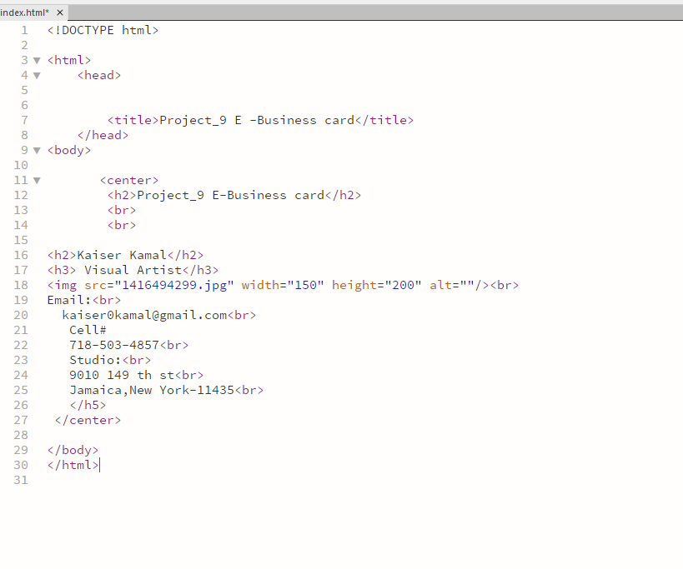

**Achievement:**

* This project gave me more understanding of Cordova.
* I am able to create my first E-Business card.
* I have learn how to launch the application and create the application and using multiple tools.