# MLE - UE2 - Decision Tree

## ToPlayOrNotToPlay:

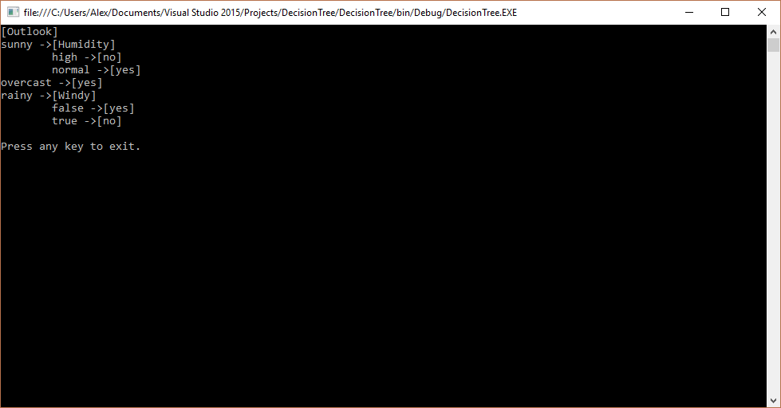

### 

PartyOrNot:

