Purple C#bras

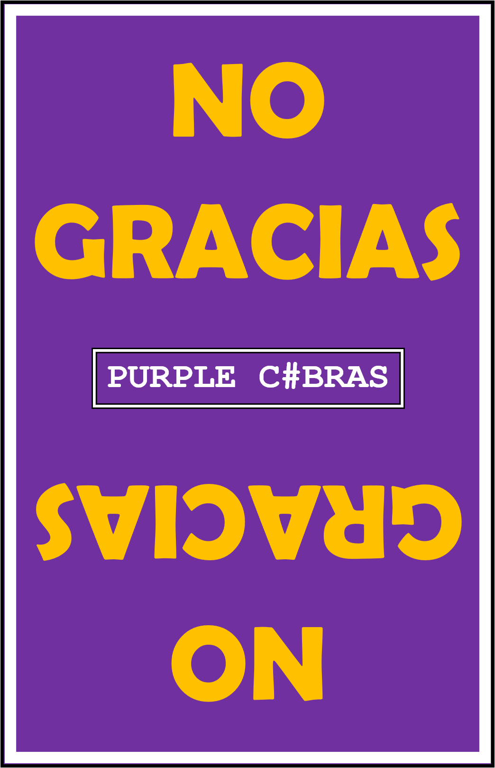

NoGracias

Deployment Plan

Contents

Overview 3

Market Research 4

Present Market 4

Potential Market Opportunities 4

Sales Platform 5

Expenses 5

Sustainable Income 6

Data and Analytics 6

In Case of Minimal Success 6

Deployment Schedule and Resources 6

# Overview

Prepared By: Andrew Growney

Version: 1.0.0

Date: September 30, 2017

Project Owner: John Gibbons

KU School of Engineering EECS Department

Project Managers: Andrew Growney, Kaiser Mittenburg, Juzer Zarif

KU School of Engineering

Status: Routing for Document Approval

# Market Research

## Present Market

The current card game that we attempted to recreate is called No Thanks! As of now, the physical card game set is selling for between $11 and $15 on a wide range of websites. The amazon reviews of the game have an average of 4.5 stars meaning the game has positive feedback from users. Under one amazon posting, there are over 50 reviews of the product in 2017 so far, meaning there is still a strong customer base out there for this product.

## Potential Market Opportunities

Given the state of board games and constant shift to more technological platforms, our game represents an opportunity for an already popular game to reach a more desired and reachable platform. If we manage to sell our game at a fraction of the cost, we would have a better priced and more accessible version of a popular game. So even if we do not increase the market, we will have better access to it.

# Sales Platform

Given the current market for the card game “No Thanks!”, and our opportunity to disrupt it, we would need an easily accessible place to sell it. The best opportunity for us to sell this would be through a Purple C#bras owned website. This website could help give us analytics about how many hits, downloads, and views the game file has. If we price the game at around $5.99, we will split the current competition in half while keeping it manageable for anybody who hasn’t heard of the game before.

## Expenses

To purchase the domain name NoGraciasGame.com, we would have to be spending $12/year. To advertise for our website, we would use the Facebook cost per click advertising campaign which runs at $0.40 per click. If we sell around 50 units per year, we could reasonable spend about half on advertising which would ring us at around $150 per year (375 clicks). Additionally, we could make up for some of these costs by selling advertising space on our web page as well.

# Sustainable Income

## Data and Analytics

Given our web platform, we would be able to track website views, user downloads, and give a space for reviews and comments. Using views and downloads per month, we could adjust marketing strategies from using different platforms like Facebook and Twitter to flyers.

## In Case of Minimal Success

If our game is having trouble selling off of the website, we could put it up in the Windows store or sell some of our screen real estate for advertisements.

# Deployment Schedule and Resources

|  |  |  |
| --- | --- | --- |
| Release Name | Description | Release Date |
| Version 1.0.0 | This will be a locally deployed application which we will send to close friends and developers in order to stress test our game using real experiences | 12/15/17 |
| Version 1.0.1 | After collecting a list of bugs from the first set of users, we will spend a month in development and maintenance before publishing to our website. | 1/15/17 |
| Version 1.0.2 | Further development of our web processes, server checking, and cash flow will help us create a better financial plan and release process. At this point, there will be more bugs reported and fixes to be released as well, so we will make adjustments accordingly. | 2/15/17 |
| Version 2.0.0 | After hopefully being able to really hone in on any possible bugs in our game, we will be able to push a new version using web servers such that you will be able to play over different networks. This version will once again be for close friends and family in order to catch bugs. | 3/15/17 |
| Version 2.0.1 | We will release our fully implemented multi network game to the public in order to increase our profits and see the market’s reaction with how much disruption we can have. | 4/15/17 |
| Version 2.0.2 | This version will be what we really want to push forward as product which will allow for much more focused marketing, development, and strategy. As we continue to develop this version, it will have bi-weekly bug fixes and strategy implementation. | 5/15/17 |