Purple C#bras

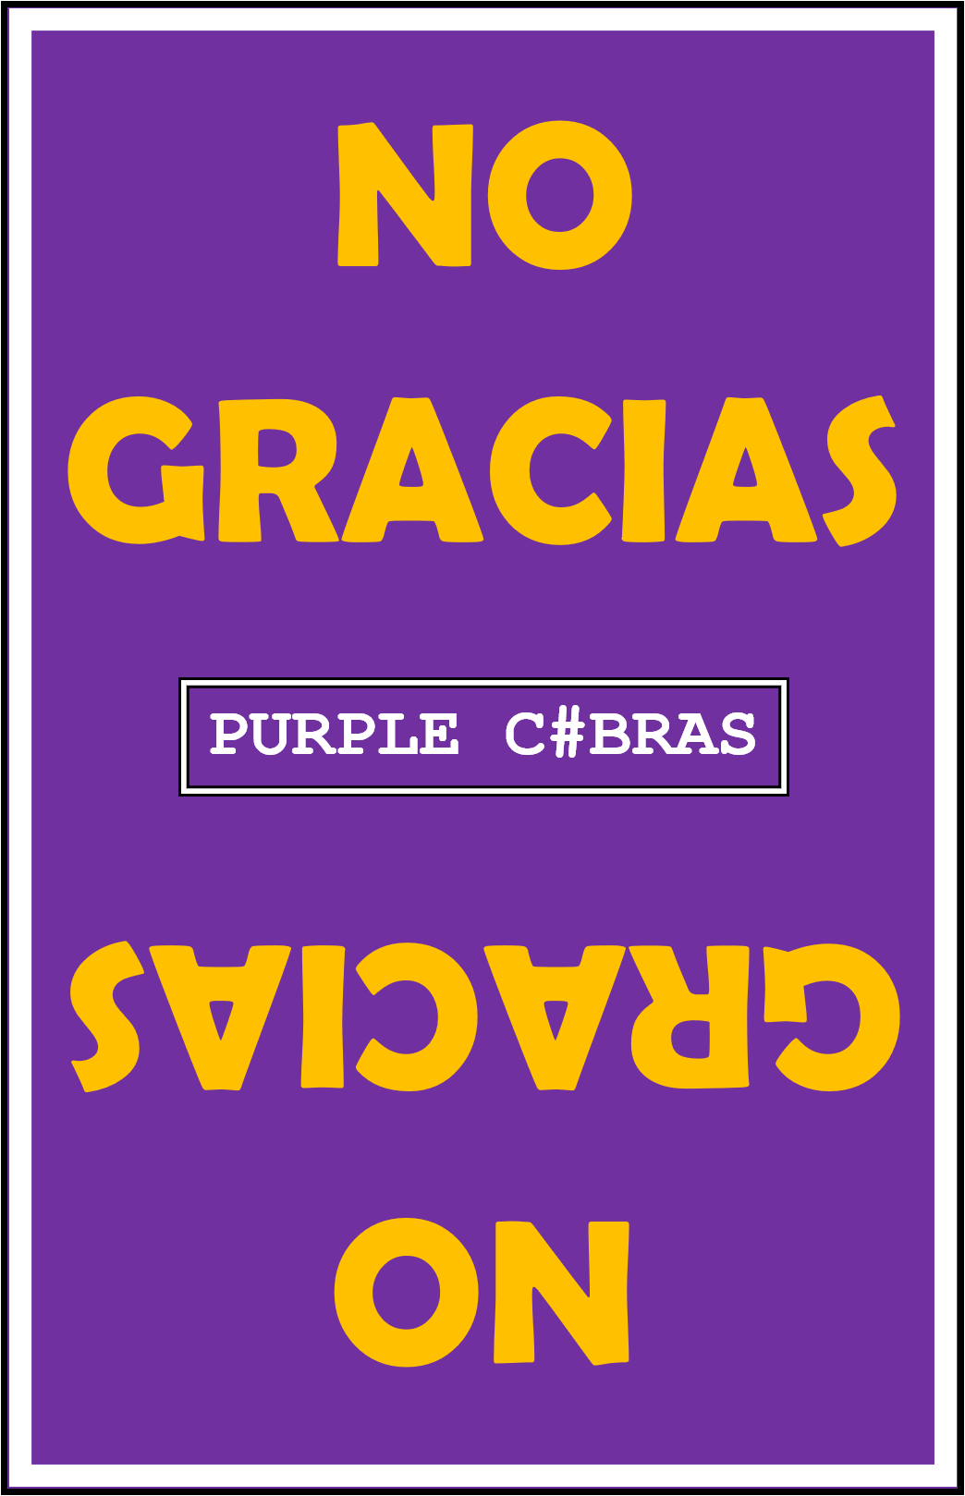

NoGracias

Maintenance Plan

Contents

General Requirements 3

Introduction 3

System 3

Status 3

Support 3

Maintenance Concept 4

Level of Support 4

Support Period 4

Tailoring the Process 4

Organization of Maintenance 5

# General Requirements

The following sections will help overview the Purple C#bras responsibilities and policies of our team in order to structure and organize software maintenance.

## Introduction

This maintenance plan will help provide insight to the processes and the procedures that are necessary to provide proper maintenance to the NoGracias system. Currently, version 1.0.0 is finishing development and waiting for release by the Purple C#bras development team. Our maintenance process will be completely in house maintenance done by the three developers: Kaiser Mittenburg, Juzer Zarif, and Andrew Growney. The NoGracias system will contain three subsystems: Web, Server, and Gamplay. This plan will share responsibilities for all three of the subsystems.

## System

As stated in the introduction, the overall NoGracias system’s maintenance will be broken down into three subsystems.

Web maintenance will involve maintenance of [www.purplecbras.com](http://www.purplecbras.com) which will host the processing of purchases, marketing data, advertising space sold, and general web support.

Server maintenance will involve the maintenance of issues related to game crashes, persistent threads, executable issues, customer support downloads, and any IP address and port number issues that are reported. Any issues that a user has in creating a server to run the game will also be handled under this subsystem. If there is a user interface failure at the menu level, regardless of join game, server, or credits, it will be handled at the server subsystem.

Gameplay maintenance will involve the maintenance of any in game issues with cards, chips, player turns, names, and game joining. If the game joining is a server connection, it will be listed as server maintenance, but if the user is unable to interact with the join game button, it will fall under gameplay. If there is a user interface issue related to locations of card table elements, it will be under the gameplay subsystem.

## Status

The NoGracias system is currently in the final stages of development awaiting the initial release of Version 1.0.0. The design is set up as a windows executable that works upon a local network which will limit the original number of users and reduce possibilities for issues.

## Support

The current NoGracias System has an undefined potential life span that will require maintenance and enhancement by all three members of the development team as well as bug reports by all users.

# Maintenance Concept

Maintenance of the three subsystems will all have their level of priorities attached to them. Depending on the severity of the bug and it’s depth, the development team will have to create a timeline for which is necessary to fix it.

## Level of Support

The main level of support will be a gmail based email account where users will be able to submit the bug form that will be posted on our [www.purplecbras.com](http://www.purplecbras.com) website. The form will contain the subsystem which the bug is pertinent to, their thoughts on its severity, and how it will affect their use of the product.

## Support Period

The main support periods will exist within the first two week of a new version being released. The concept of having one month between releases of the next version is to dedicate two solid weeks to users reporting bugs, and creating a two week sprint to fix those bugs. The overall support will last as long as the development team sees fit, which for now will be marked as 6 months.

## Tailoring the Process

As we push forward with continual maintenance, the Purple Cobras would possibly need to hire out some more experienced web developers as contractors. We would offer $17/hour given the simplicity of most of the code and bug fixes given our limited income.

# Organization of Maintenance

## Subsystem Assignments

In order to give a general set up some structure, we would take the three subsystems and split them up amongst the current development team. The assignments would be as follow:

Server Maintenance: Kaiser Mittenberg

Gameplay Maintenance: Juzer Zarif

Web Maintenance: Andrew Growney

## Cross Subsystem Maintenance

Given that lots of problems will overlap multiple subsystems, the person in charge of the subsystem which it originally existed in would be in charge of assuring the final bug fix is completed. The purpose of the subsystem splitting is not to push all of the load onto one person, but to give them responsibility for the solution being published. The way they go about getting it fixed does not matter.