1. **DATABASE**

|  |  |  |
| --- | --- | --- |
| tbl_BankLoan | | |
| Column name | **Data type** | **Description** |
| bankLoanId | Int | Primary key |
| bankID | Int |  |
| bankLoanName | nvarchar(100) |  |
| Minimum | Float |  |
| Maximum | Float |  |
| loanDescription | nvarchar(500) |  |
| durationOfLoan | Int |  |
| bankLoanStatus | Int |  |

|  |  |  |
| --- | --- | --- |
| tbl_Banks | | |
| Column name | **Data type** | **Description** |
| bankID | Int | Primary key |
| bankName | nvarchar(100) |  |
| bankPhone | nvarchar(50) |  |
| bankStatus | Int |  |

|  |  |  |
| --- | --- | --- |
| tbl_Banks | | |
| Column name | **Data type** | **Description** |
| bankID | Int | Primary key |
| bankName | nvarchar(100) |  |
| bankPhone | nvarchar(50) |  |
| bankStatus | Int |  |

|  |  |  |
| --- | --- | --- |
| tbl_Cash | | |
| Column name | **Data type** | **Description** |
| bankID | Int | Primary key |
| bankName | nvarchar(100) |  |
| bankPhone | nvarchar(50) |  |
| bankStatus | Int |  |

|  |  |  |
| --- | --- | --- |
| tbl_Directories | | |
| Column name | **Data type** | **Description** |
| directoryID | Int | Primary key |
| directoryCategoryID | Int |  |
| directoryName | nvarchar(100) |  |
| directoryAddress | nvarchar(500) |  |
| directoryPhone | nvarchar(50) |  |
| directoryEmail | nvarchar(100) |  |
| directoryStatus | Int |  |

|  |  |  |
| --- | --- | --- |
| tbl_DirectoryCategories | | |
| Column name | **Data type** | **Description** |
| directoryCategoryID | Int | Primary key |
| directory_categoryName | nvarchar(100) |  |
| diCategoriesStatus | Int |  |

|  |  |  |
| --- | --- | --- |
| tbl_directoryService | | |
| Column name | **Data type** | **Description** |
| directoryServiceID | Int | Primary key |
| directoryID | Int |  |
| serviceName | nvarchar(100) |  |
| Discription | nvarchar(500) |  |
| diServiceStatus | Int |  |

|  |  |  |
| --- | --- | --- |
| tbl_Faqs | | |
| Column name | **Data type** | **Description** |
| faqID | Int | Primary key |
| question | nvarchar(MAX) |  |
| answer | nvarchar(MAX) |  |

|  |  |  |
| --- | --- | --- |
| tbl_feedback | | |
| Column name | **Data type** | **Description** |
| feedbackId | Int | Primary key |
| guestName | nvarchar(50) |  |
| guestEmail | nvarchar(100) |  |
| Subject | nvarchar(1000) |  |
| [content] | nvarchar(MAX) |  |
| sentDate | nvarchar(50) |  |
| feedbackStatus | Int |  |

|  |  |  |
| --- | --- | --- |
| tbl_PostHistory | | |
| Column name | **Data type** | **Description** |
| postHistoryID | Int | Primary key |
| userID | Int |  |
| postTypeID | Int |  |
| RealEstateID | Int |  |
| startDate | nvarchar(50) |  |
| price | nvarchar(50) |  |
| endDate | nvarchar(50) |  |
| postHistoryStatus | Int |  |

|  |  |  |
| --- | --- | --- |
| tbl_PostType | | |
| Column name | **Data type** | **Description** |
| postTypeID | Int | Primary key |
| postTypeName | nvarchar(100) |  |
| postTypePrice | nvarchar(100) |  |
| postTypeStatus | Int |  |

|  |  |  |
| --- | --- | --- |
| tbl_RealEstate | | |
| Column name | **Data type** | **Description** |
| RealEstateID | Int | Primary key |
| realEstateTitle | nvarchar(50) |  |
| City | nvarchar(50) |  |
| Street | nvarchar(500) |  |
| Price | nvarchar(50) |  |
| NoOfBedrooms | Int |  |
| NoOfBathrooms | Int |  |
| realEstateTypeID | Int |  |
| Area | nvarchar(100) |  |
| Orientation | nvarchar(100) |  |
| ExtraFacilitiesAvailable | Int |  |
| ModesOfTransport | nvarchar(100) |  |
| WithFurniture | Int |  |
| ModeOfPayment | nvarchar(100) |  |
| Deposit | nvarchar(100) |  |
| Negotiable | Int |  |
| Description | nvarchar(MAX) |  |
| realEstateImage | nvarchar(500) |  |
| realEstateStyleID | Int |  |
| realEstateStatus | Int |  |

|  |  |  |
| --- | --- | --- |
| tbl_RealEstateStyle | | |
| Column name | **Data type** | **Description** |
| realEstateStyleID | Int | Primary key |
| realEstateStyleName | nvarchar(50) |  |
| realEstateStyleStatus | Int |  |

|  |  |  |
| --- | --- | --- |
| tbl_RealStateType | | |
| Column name | **Data type** | **Description** |
| realStateTypeID | Int | Primary key |
| realStateTypeName | nvarchar(50) |  |
| realStateTypeStatus | Int |  |

|  |  |  |
| --- | --- | --- |
| tbl_Users | | |
| Column name | **Data type** | **Description** |
| UserID | Int | Primary key |
| userName | nvarchar(50) |  |
| userEmail | nvarchar(100) |  |
| userPassword | nvarchar(100) |  |
| userAddress | nvarchar(500) |  |
| userPhone | nvarchar(50) |  |
| userTypeID | Int |  |
| userType | nvarchar(50) |  |
| totalMoney | nvarchar(50) |  |
| userStatus | Int |  |

|  |  |  |
| --- | --- | --- |
| tbl_UserType | | |
| Column name | **Data type** | **Description** |
| userTypeID | Int | Primary key |
| userTypeName | nvarchar(50) |  |
| userTypeStatus | Int |  |

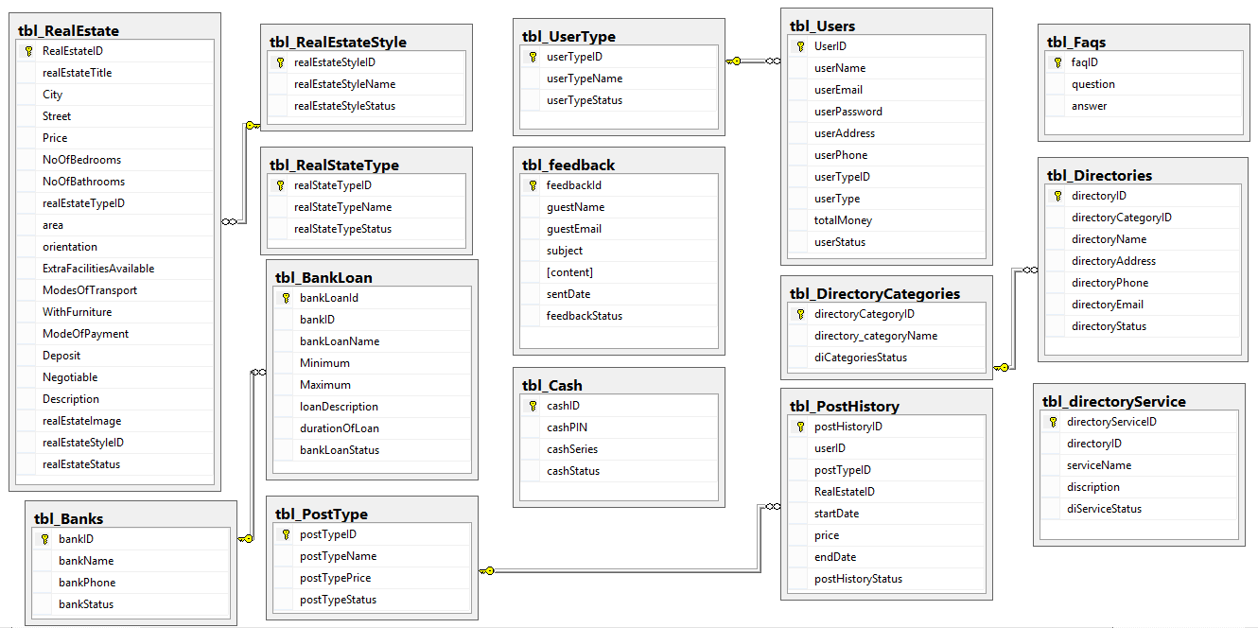

1. Flow Diagram:

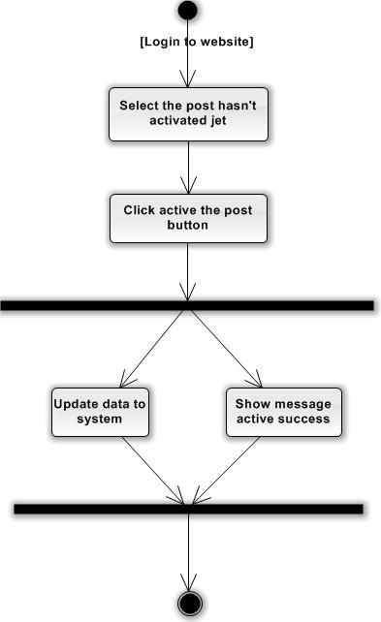

Active the estate

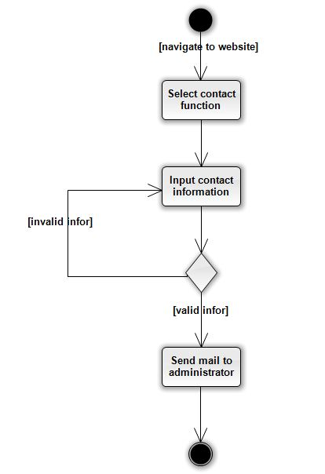

Contact to Admin

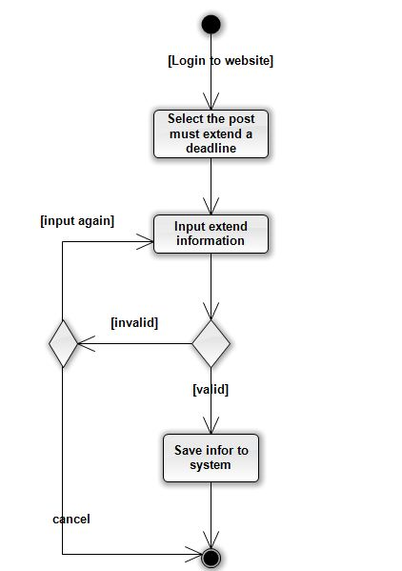

**Login system**

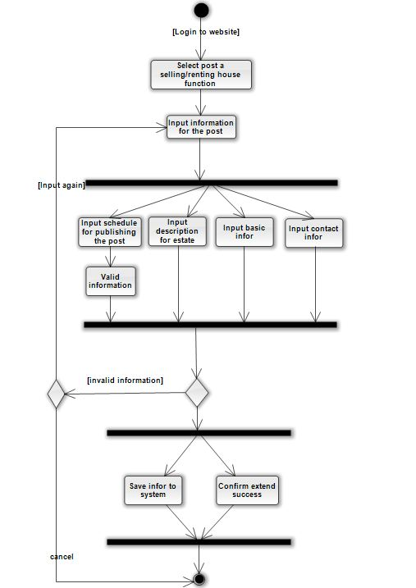

**Post a selling renting house**

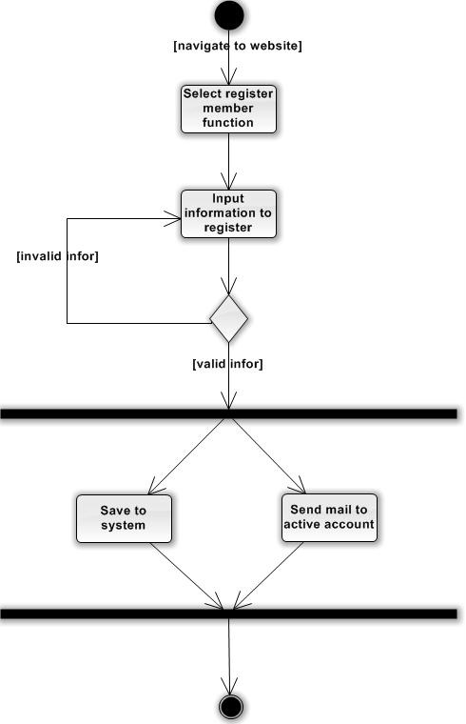

Register member

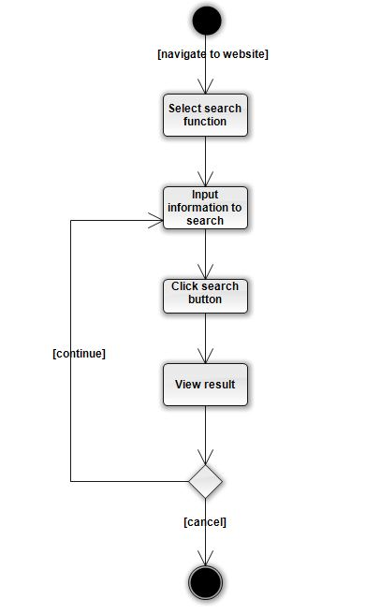

Search estate

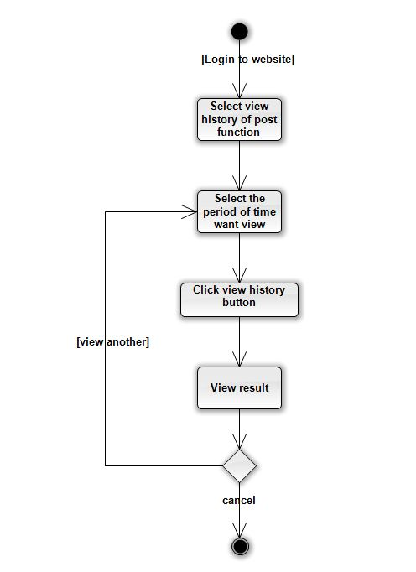

View history of posting

1. Entity diagram

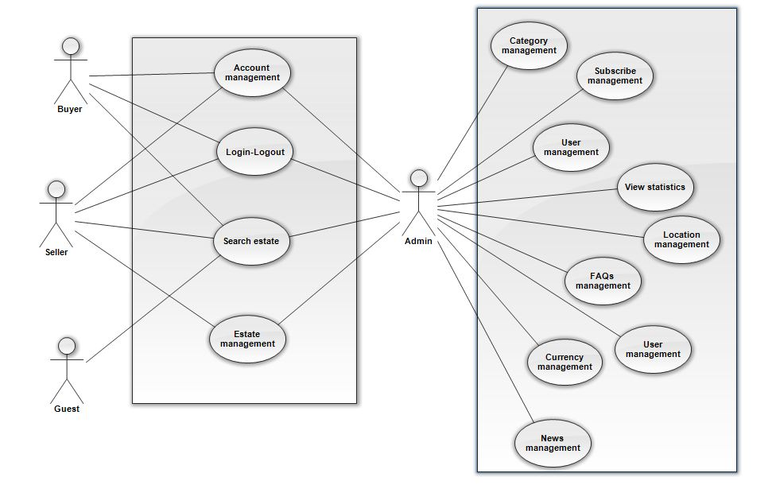

**The general**

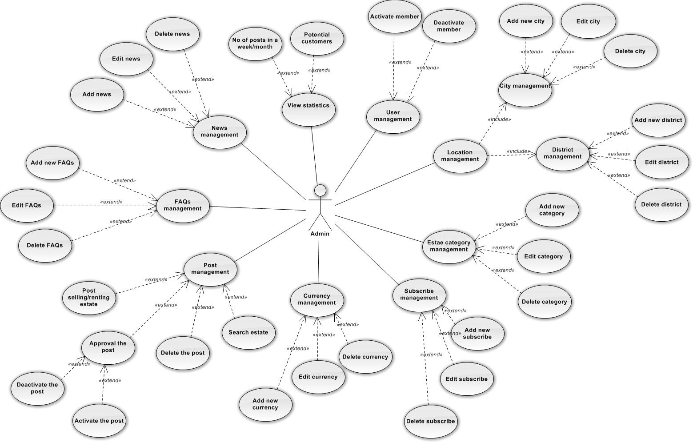

**Admin**

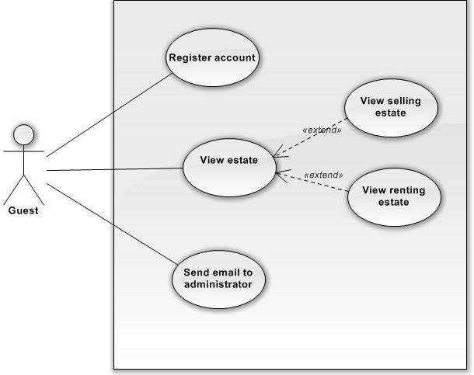

**Guest**

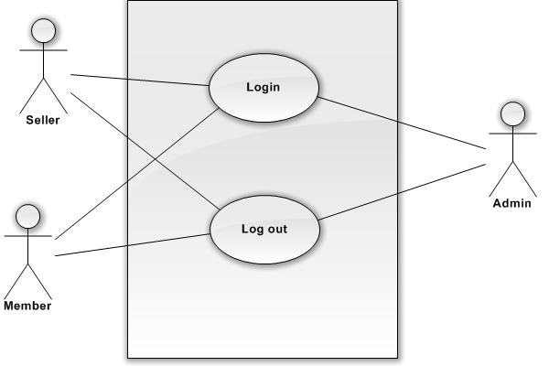

**Login-Logout**

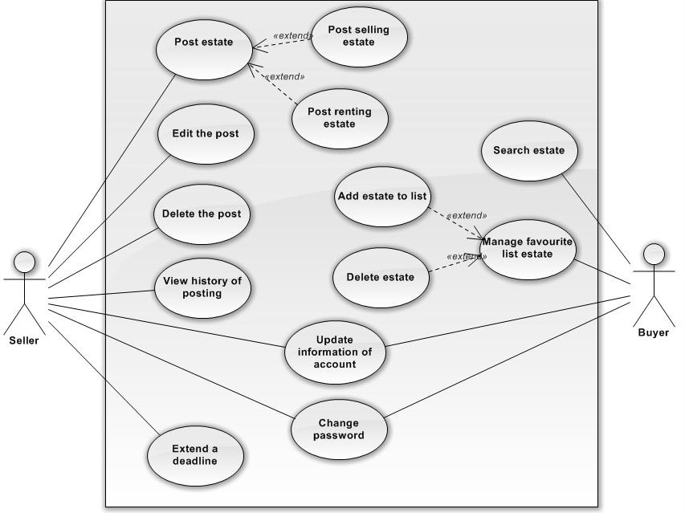

**Seller – Buyer**