Website Traffic & User Behavior Analysis
Data-driven business intelligence report
Analysis period: 01 Jan 2026 – 31 Mar 2026 | Records: 6,000

1. Executive Summary
The dataset contains 6,000 sessions from 2,987 unique users, generating 17,598 page views and revenue of 42,129.78. The overall conversion rate is 6.10% and the bounce rate is 39.28%. All figures are calculated from the current dataset.

2. Key Performance Indicators
KPI | Value
Total Sessions | 6,000.00
Unique Users | 2,987.00
Total Page Views | 17,598.00
Pages per Session | 2.93
Average Session Duration | 166.26
Bounce Rate | 39.28
Total Conversions | 366.00
Conversion Rate | 6.10
Total Revenue | 42,129.78
Revenue per Session | 7.02

3. Acquisition Source Analysis
Source | Sessions | Bounce Rate | Conversion Rate | Revenue
Google | 1920 | 38.49 | 6.09 | 13,980.36
Direct | 1329 | 30.25 | 7.75 | 11,979.88
Social Media | 1099 | 53.23 | 2.27 | 2,447.28
Paid Search | 692 | 37.28 | 7.66 | 5,264.08
Email | 496 | 30.85 | 9.27 | 5,686.26
Referral | 299 | 45.15 | 5.35 | 1,831.22
Display | 165 | 51.52 | 3.64 | 940.70
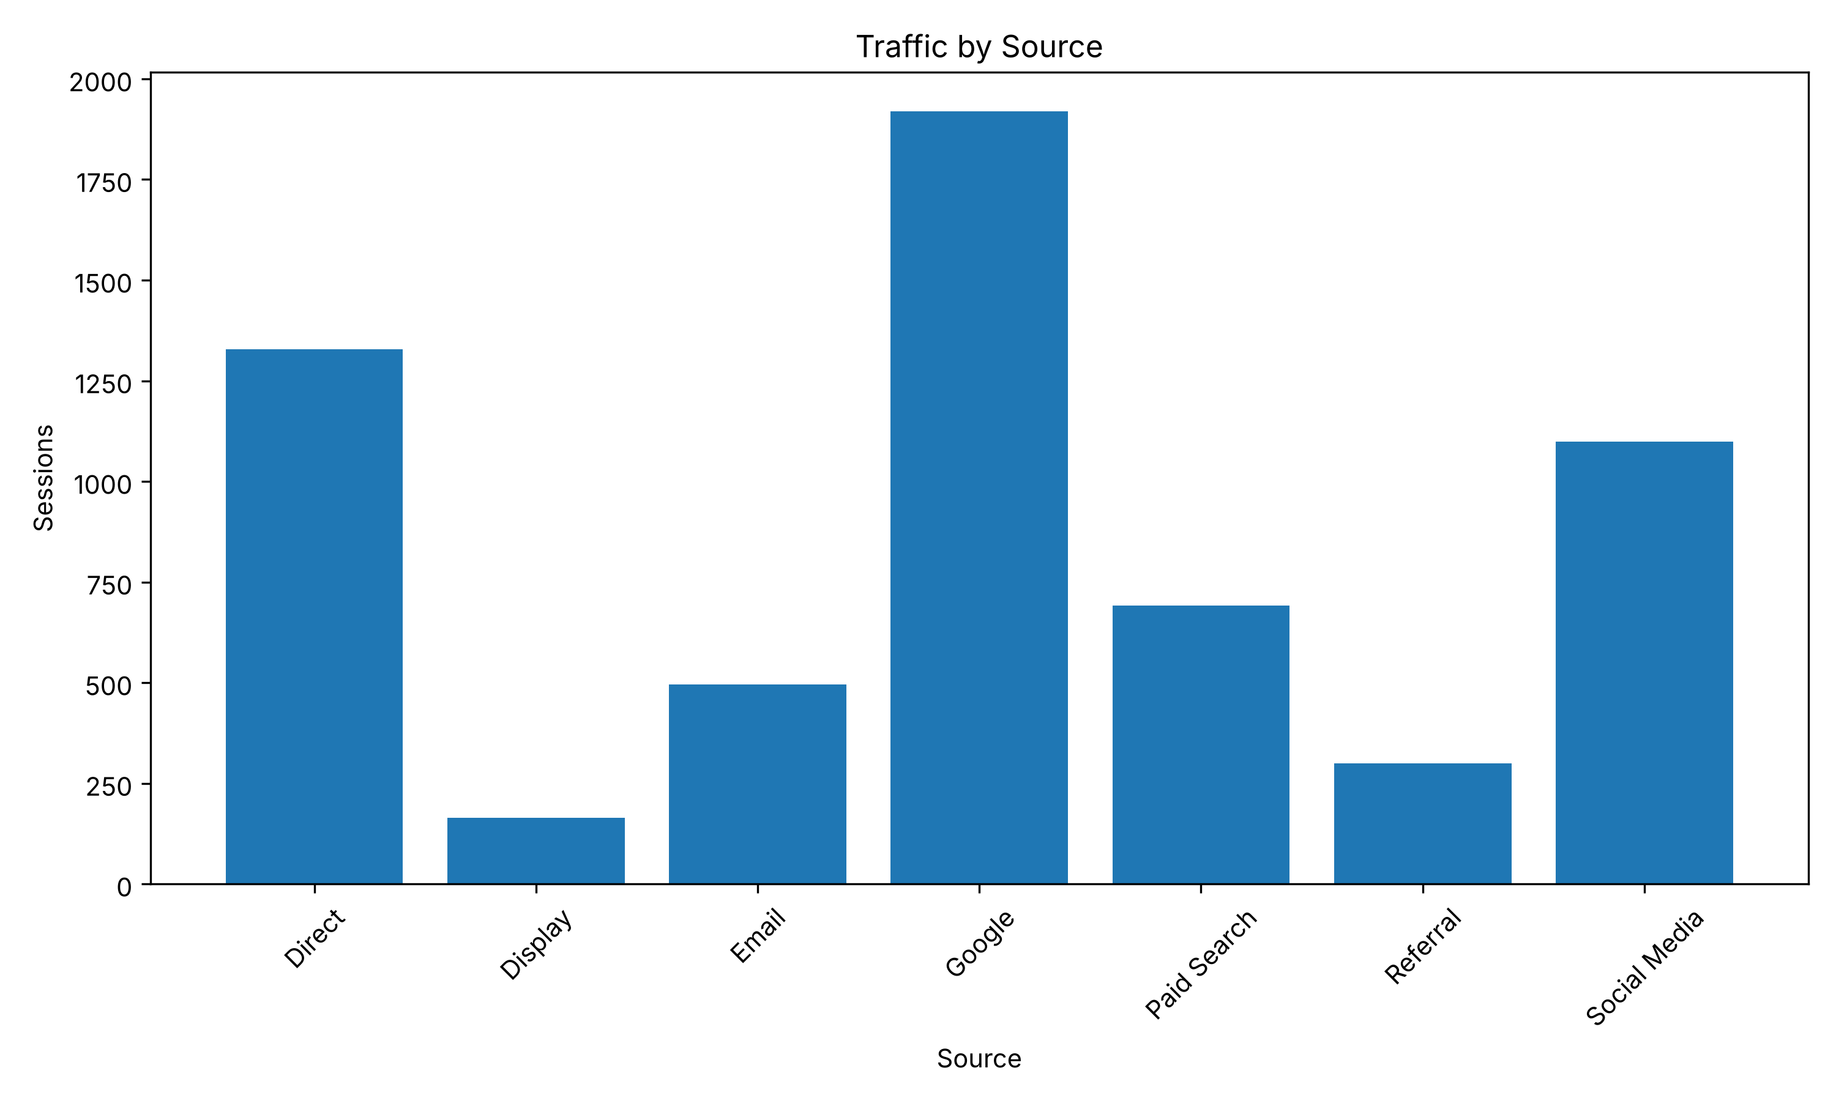
Sessions by acquisition source

4. Device Analysis
Device | Sessions | Bounce Rate | Conversion Rate | Revenue
Mobile | 3132 | 45.40 | 4.02 | 14,686.81
Desktop | 2392 | 31.65 | 9.03 | 23,795.63
Tablet | 476 | 37.39 | 5.04 | 3,647.34
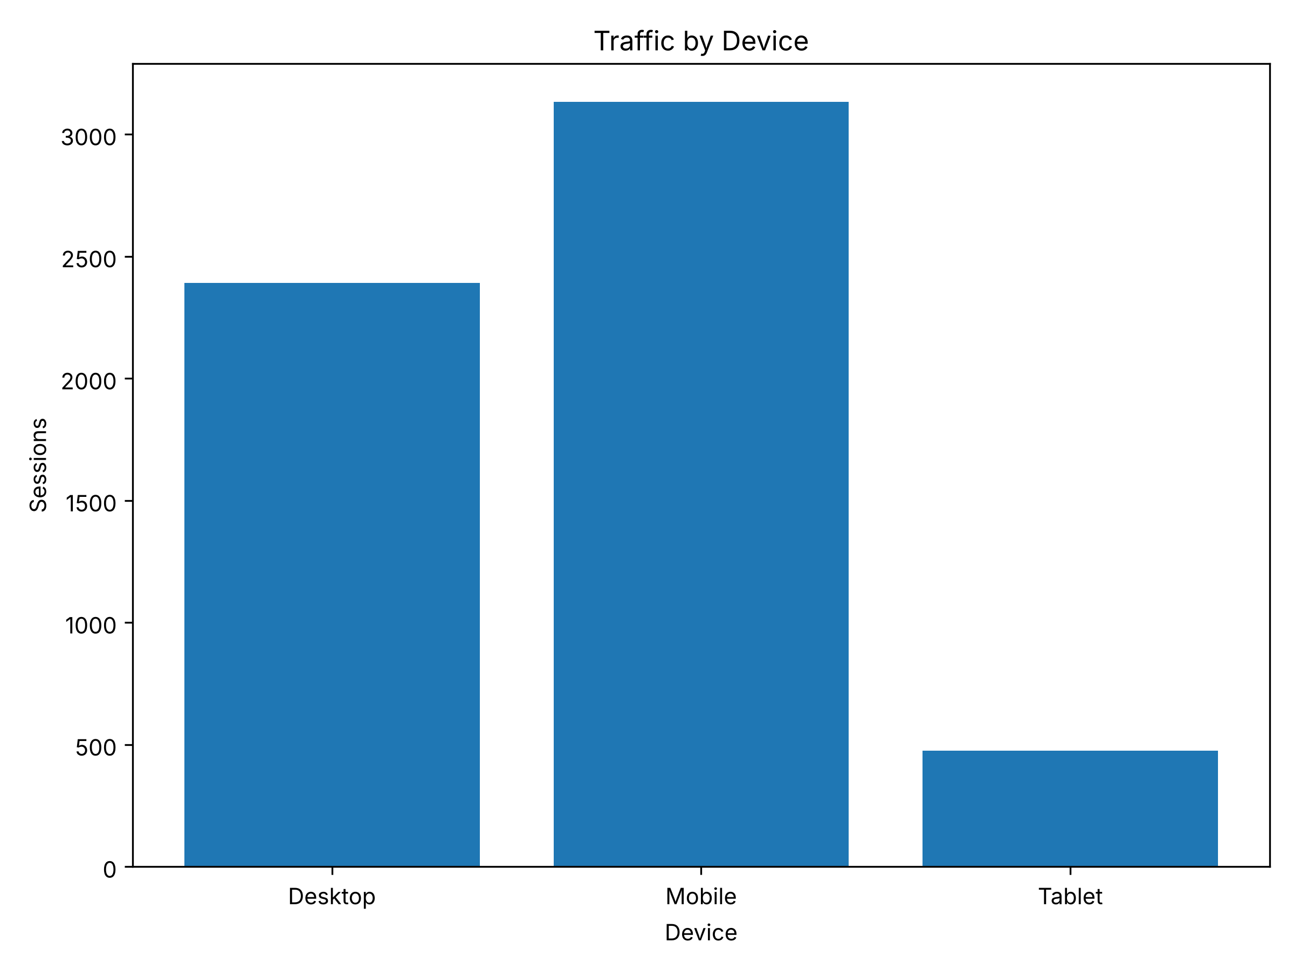
Sessions by device

5. Time-based Traffic Patterns
The busiest hour is 19:00 with 496 sessions.
The busiest month is 2026-03 with 2,117 sessions.
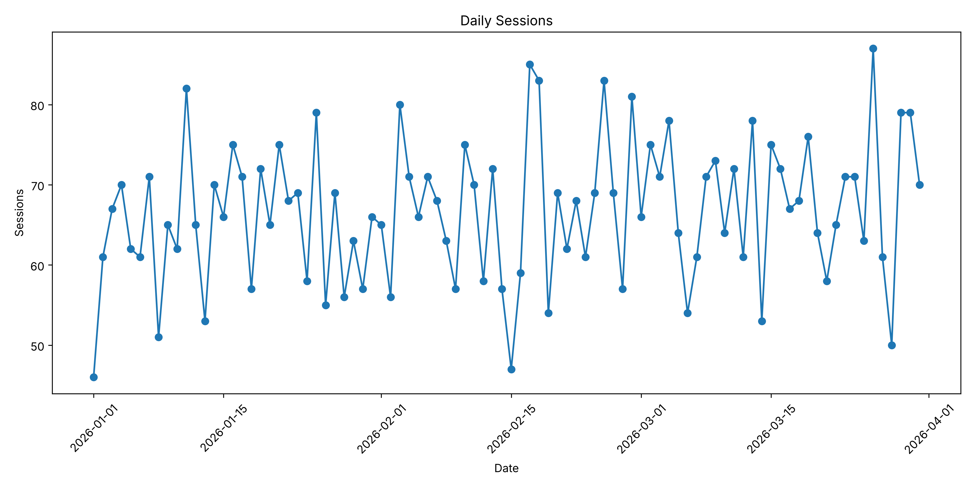
Daily session trend
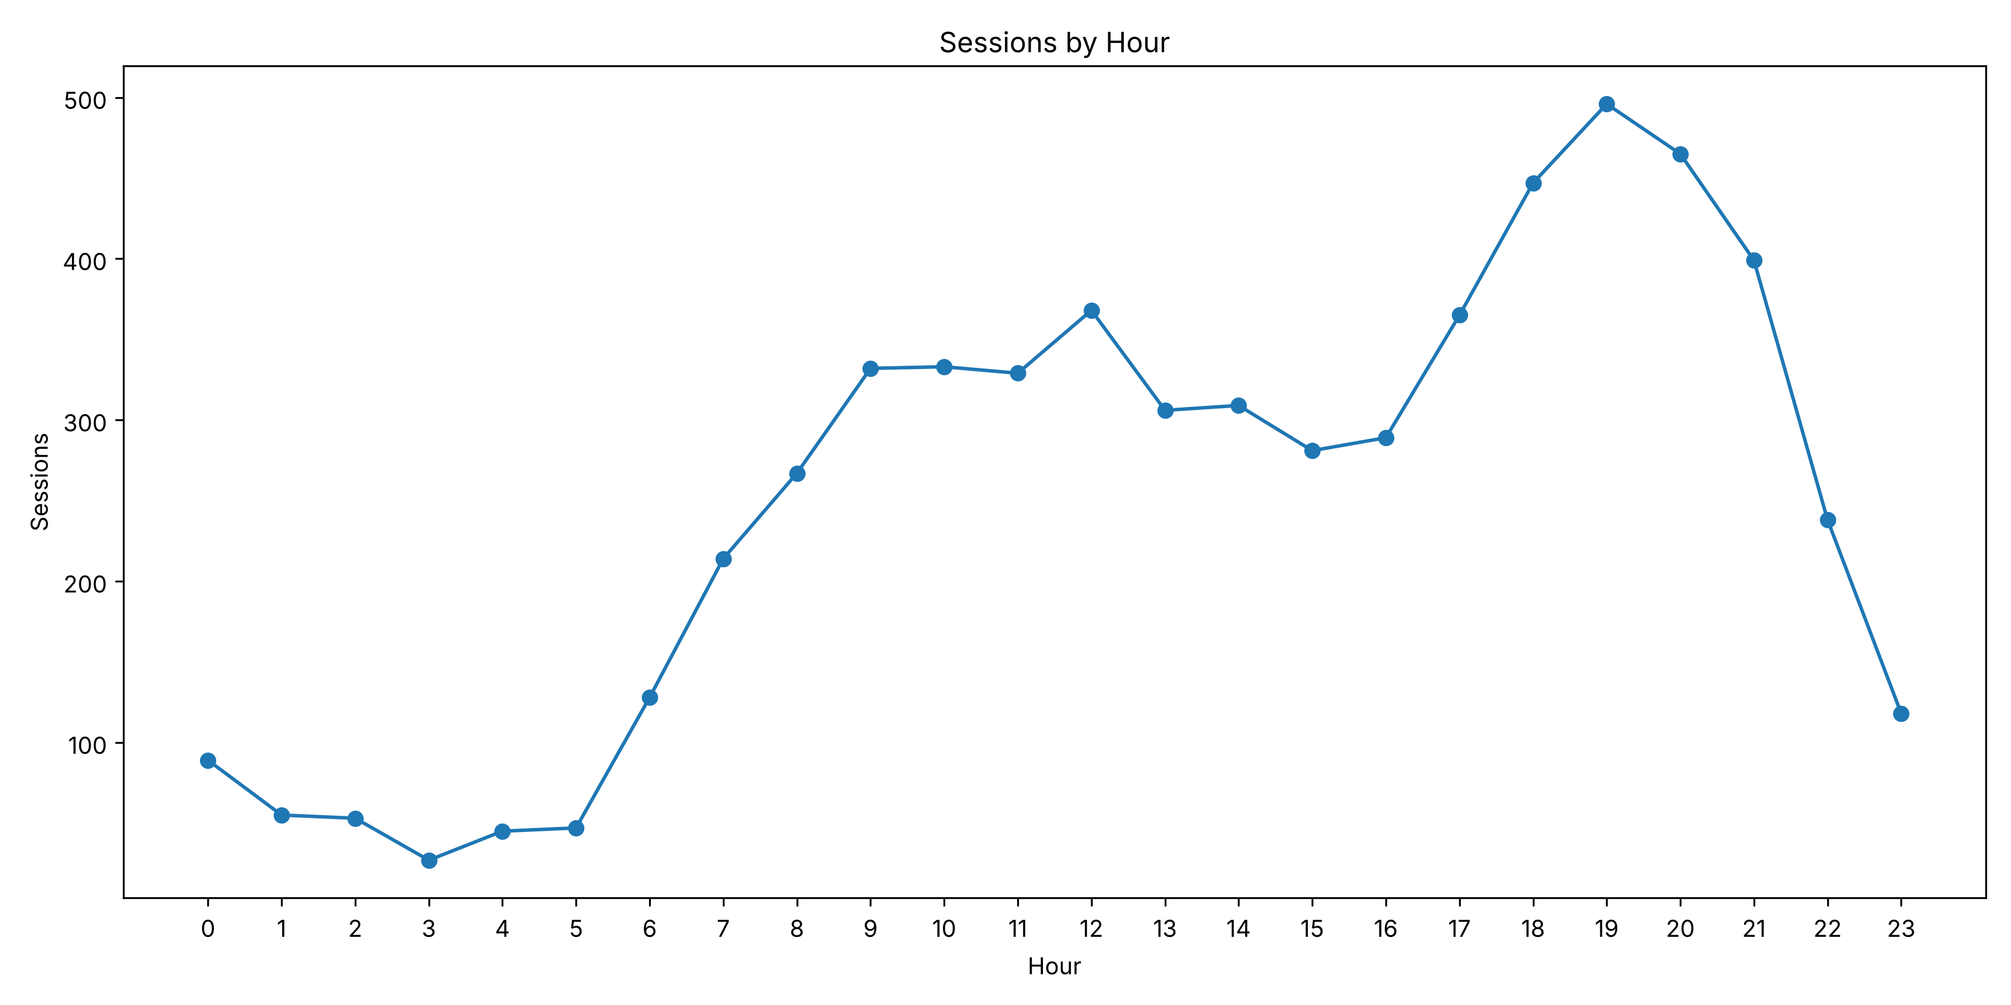
Sessions by hour

6. Business Insights
- 1. Highest traffic source: Google (1920 sessions)
- 2. Highest conversion-rate source: Email (9.27%)
- 3. Highest traffic device: Mobile (3132 sessions)
- 4. Most pages per session: Desktop (3.76)
- 5. Peak traffic hour: 19:00 (496 sessions)
- 6. Highest conversion-rate hour: 14:00 (8.41%)
- 7. Highest traffic day: 2026-03-26 (87 sessions)
- Note: correlation shows association and does not prove causation.

7. Recommendations
Prioritize acquisition channels with strong conversion performance, investigate high-bounce segments, and review device-specific user journeys. Validate any proposed campaign changes with controlled experiments before reallocating significant budget.
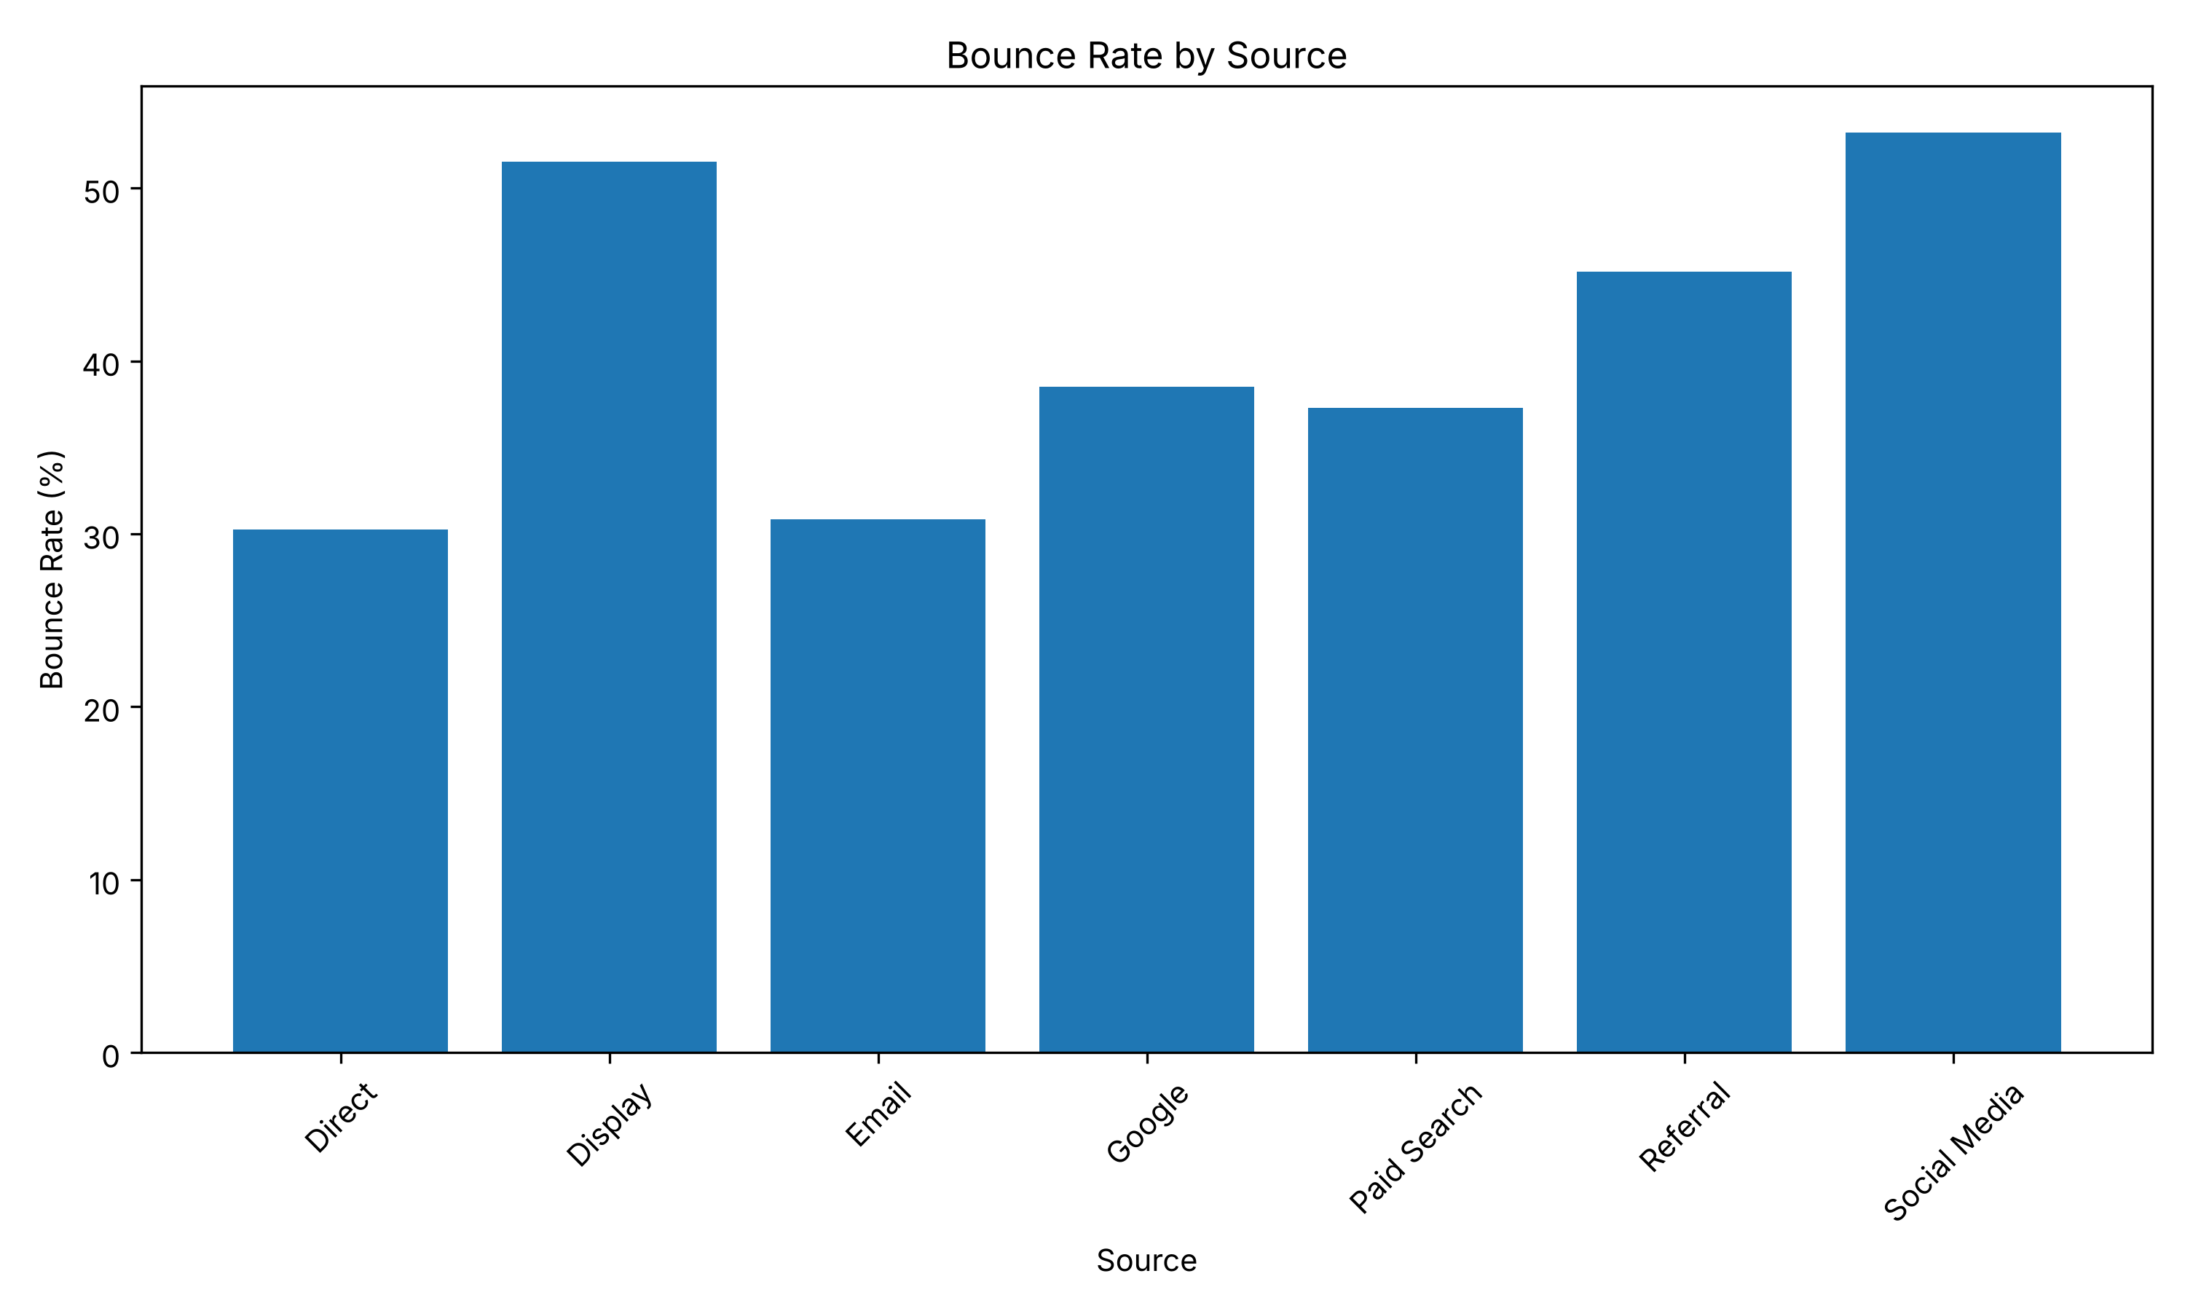
Bounce rate by acquisition source
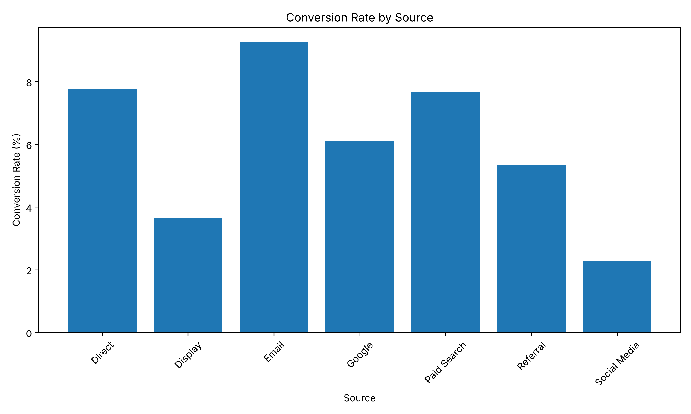
Conversion rate by acquisition source
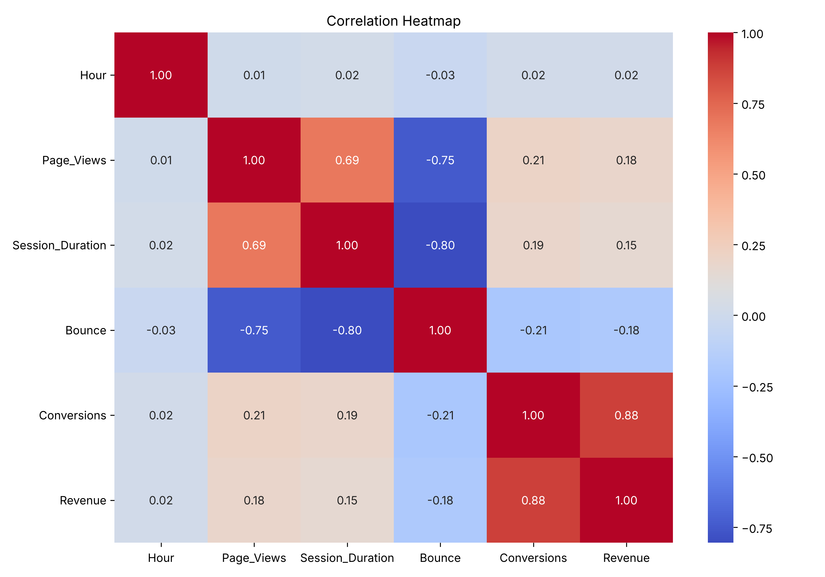
Correlation matrix; association does not imply causation

