{ClientName}
Level 2 Energy Audit
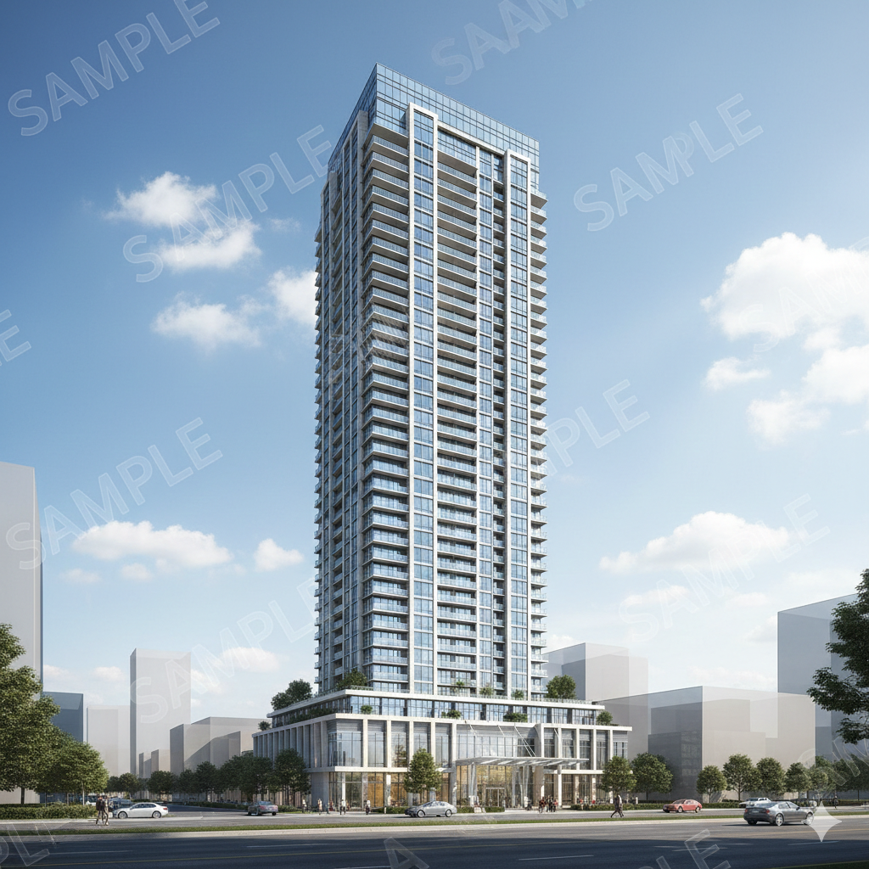
{Property Address1},
{City}, {Province Abbreviation} {Post Code}
{DateDocument}
Prepared by:
Mann Engineering
1110 FINCH AVENUE W, SUITE 706
TORONTO, ON M3J 2T2
Web: Mann Engineering
Phone: 416 201 9109
Fax: 416 201 8050

TABLE OF CONTENTS
List of Tables 4
List of Abbreviations 5
1. Executive Summary 6
2. Description of this Study 8
3. Facility and Systems Description 9
3.1 General Facility Overview 9
3.2 Building Mechanical Systems Overview 9
3.2.1 Central Heating/Cooling Systems 9
3.2.2 Central Ventilation System 10
3.2.3 DHW System 11
3.2.4 Miscellaneous 12
4. Utility History 13
4.1 Utility Data Summary 13
4.2 Gas Consumption Breakdown 14
4.3 Gas Consumption Breakdown (By Source) 15
4.4 Electrical Consumption Breakdown 16
4.5 Electrical Consumption Breakdown (By Source) 17
4.6 Water Consumption Breakdown 20
5. Energy Conservation Measures 22
5.1 Measures 1 – New BAS (Building Automation System) 22
5.2 Measure 2 – VFD Retrofits 24
5.3 Measure 3 – Hydronic Distribution System Balancing Review (Heating & DHW) 26
5.4 Measure 4 – Fuel Switching (DHW Electric to Gas) 27
5.5 Measure 5 – Condensing Boiler retrofit + Primary and Secondary Piping 29
5.6 Measure 6 – Long Term WSHP Conversion Strategy 31
6. Building Upgrades 33
6.1 Upgrade Measure 1 – Electric Vehicle Charging Stations 33
7. Measures Considered but not Included 34
8. Energy Savings 35
9. Cash Flow 36
10. Equipment Schedules 40
APPENDICIES 41
Appendix A – Utility Bills Summary 41
Appendix B – Comprehensive Energy Management Measures 43
Appendix C – Canada's Greenhouse Gas Emissions 44
Appendix D – Ontario Power Authority: Save On Energy Retrofit Program 46
Appendix E – Enbridge Incentive Programs 48
Appendix F – Energy Efficiency Measures Checklist 55
Appendix G – Site Pictures 62
Appendix H – Other Services Available from Mann Engineering 65

List of Tables
Table 1: Recommended Energy Management Measures 7
Table 2: Utilities Use Breakdown 10
Table 3: Natural Gas Consumption Summary in Comparison with Benchmarking for Multi Residential Buildings 11
Table 4: Gas consumption by Source 12
Table 5: Electricity Consumption Summary in Comparison with Benchmarking for Multi Residential Buildings 13
Table 6: Electrical consumption by Source 13
Table 7: Water Consumption Summary in Comparison with Benchmarking for Multi Residential Building 15
Table 8: Cost and Payback Summary with 6% Utility Cost Escalation per Year 26
Table 9: Cash Flow Analysis Calculations 27
Table 10: Cash Flow Profile for 4 Year Lease 27
Table 11: Cash Flow Profile for 5 Year Lease 28
Table 12: Cash Flow Profile for 6 Year Lease 28
Table 13: Natural Gas Consumption by Month 31
Table 14: Electricity Consumption by Month 31
Table 15: Water Consumption by Month 32
Table 16: Energy Management Measures 33

List of Abbreviations
Btu British Thermal Units
CFL Compact Fluorescent Lamp
Cfm Cubic Feet per Minute
CO2 Carbon Dioxide
DHW Domestic Hot Water
ekWh Equivalent Kilo Watt Hours
° F Degree Fahrenheit
fc Foot candle
GJ Giga Joules, Unit for Measuring Heat Content
HP Horse Power
HWS Hot Water Supply
HVAC Heating, Ventilation, and Air Conditioning
ID Equipment Identification Tag
BAS Building Automation System
LB Pound
LED Light Emitting Diode
kW Kilo Watt, a Measure of Electric Demand
kWh Kilo Watt hours, a Measure of Electricity Usage
m3 Cubic Meter
Max Maximum
MBH 1,000 Btu per hour
MH Metal Halide Min Minimum
MMBtu / hr Million Btu per hour
NA Not Available or not applicable
NRCAN Natural Resources Canada
OAT Outside Air Temperature
O & M Operations and Maintenance
DDC Direct Digital Controls
VFD Variable Frequency Drive
VAV Variable Air Volume

Executive Summary
Mann Engineering performed an ASHRAE Level 2 Energy Audit at {Property Address1}, {District}, in {City}, {Province}. The structure is a {Number of Floors} multi residential building with {Level of Garage} underground parking garage comprising {Number of Suites} residential units constructed in {Date Constructed}. Overall, the building envelope is in good condition, with no significant air leakage or moisture issues reported by operators or observed during the site visit.
{Executive Summary Block}
It was determined based on the results from the analysis and our observations from the site visit, a series of building improvement measures were formulated. In this audit, Mann Engineering quantified savings through standard engineering calculations and evaluated the practical and economic feasibility of the implementations
The proposed energy management measures, costs, incentives and simple payback periods are summarized in comprehensive table on Appendix B of our report. This list of energy management measures is comprehensive and we have identified the measures that we recommend as the best business case for this facility.
This Audit has identified several potential energy conservation measures that could be implemented to reduce the utility costs in the building.


Table 1: Recommended Energy Management Measures

Comments:
Recommended Measures were chosen under the following criteria:
- Favorable payback for individual measure
- Equipment which will have to be replaced regardless due to approaching or being beyond expected service life. In these cases, the measure was compared to base case Re Re replacement.

Description of this Study
Mann Engineering was selected to investigate the options for reducing the operating and maintenance costs of the mechanical system and building automation system design at Building Address A, in Toronto, Ontario. The energy audit can be broken down into three phases which are described as follows:
Site Visit
The audit began with an overall understanding of the building operation within the context of electricity, natural gas, and water utilization. Visual inspection and data collection of all HVAC equipment, building envelope, lighting and control system were compiled for subsequent analysis. Through discussions with cooperative on site staff, we attained an understanding of the operational characteristics of the facility.
Audit Preparation
Mann reviewed the existing 12 month utility bills, building envelope and the historical logs and created a breakdown of energy usage. Through computer simulations and benchmarking, classified various energy usages and quantities.
Mann reviewed the existing HVAC system drawings. Through our conceptual design and system analysis, we identified the possible system conversion for better performance and enhanced space comfort level.
This Audit has identified several potential energy conservation measures that could be implemented to reduce the utility costs in the building.

Facility and Systems Description

General Facility Overview
A detailed energy audit was performed at Building Address A. The structure is a High-Rise multi residential building with 5 level underground parking garage constructed in 20xx. It has a mixture of 3 bedroom, 2 bedroom, 1 bedroom, and studio for a total of xxx units. The architectural condition of the building is in good condition. The building has a mixture of uses including Lobby, Game Room, Gym, Guest suite, Meeting Room, Management office and rental units. The site visit included a comprehensive walk through, review of all mechanical rooms and equipment and an interview with the building operator.

Building Mechanical Systems Overview

Central Heating/Cooling Systems
{Central Heating Systems block}
{Central Cooling Systems block}

Central Ventilation System
{Central Ventilation System Block}

DHW System
{DHW System Block}

Miscellaneous
{Miscellaneous Block}

Utility History
This section analyzes the utility usage and cost, determines the efficiency of energy usage, and compares this facility’s performance with the mean performance of other multi residential buildings in Ontario. Also, it establishes the base year for energy usage so that future energy performance can be tracked and estimated savings can be verified. All benchmarks for this building are based on the National Energy Use Database 2000-2022, published by Natural Resources Canada.

Utility Data Summary
Table 2: Utilities Use Breakdown
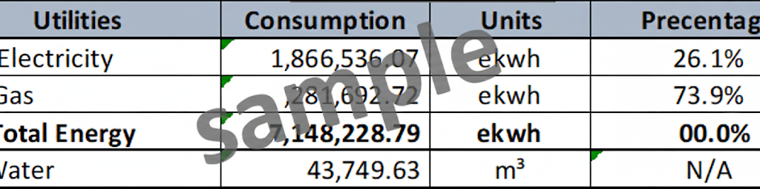
Comments
The energy consumption (lighting, plug loads, cooling and heating) is included in the above utility data. All figures and graphs in the report include the entire building unless otherwise noted.
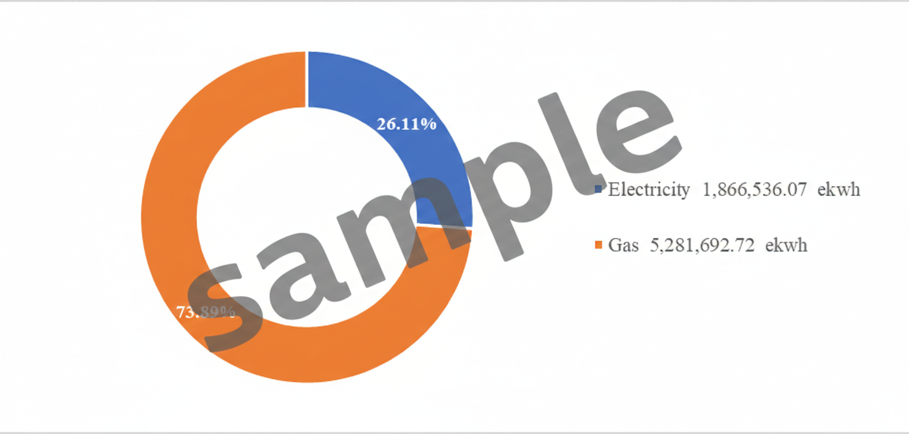
Figure 4.1.1: Annual Total Energy Breakdown with Gas Energy Conversion in ekWh

Comments
From the energy breakdown above, it can be concluded that the biggest energy consumption source is natural gas. Natural gas is used for space and suite heating, DHW and MUA units. Whereas, the electrical energy is used for cooling, lighting, fans pumps and building base loads. From Mann’s database of previous energy audits, natural gas consumption usually accounts for 55 to 60% of total energy consumption.

Gas Consumption Breakdown
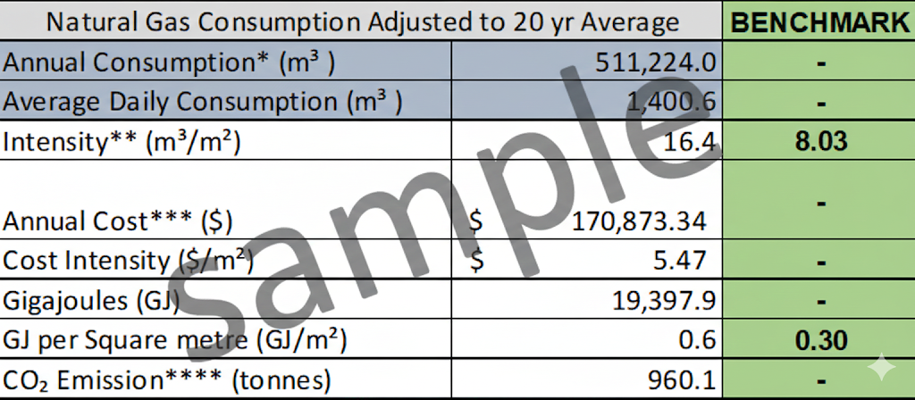
Table 3: Natural Gas Consumption Summary in Comparison with Benchmarking for Multi Residential Buildings
1 Based on year 2024~2025 bill.
2 Based on estimated building area of xxxxx ft²
3 Based on average $0.31 per m³
4 CO2 Emission Sources: Average Provincial Emission Factors (Ontario)
5 Based a combination of NRCan data and a database of 50+ buildings in Ontario collected by Mann.
Comments
The building’s natural gas intensity is significantly above the benchmark. This is likely attributable to the operation of the boiler plant and lack of BAS. This indicates excessive gas consumption, nearly double the efficient benchmark level. Focus should be given to investigate the reasons behind this high usage, identifying potential inefficiencies or areas for improvement. Addressing these issues could lead to substantial energy savings and reduced costs.

Gas Consumption Breakdown (By Source)
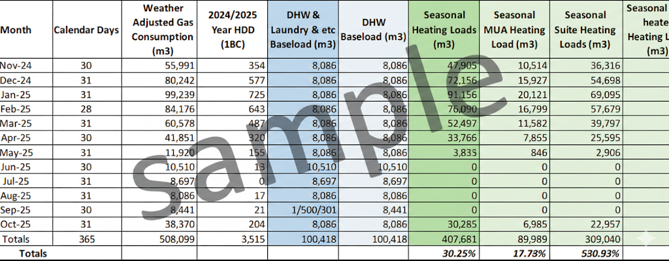
Table 4: Gas consumption by Source
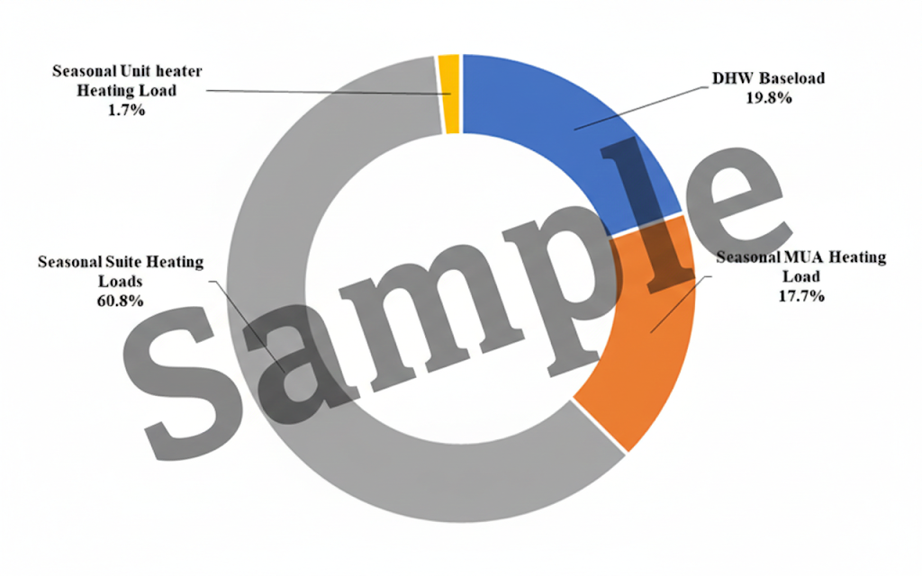
Figure 4.3.1: Natural Gas Consumption Breakdown by Source
Comments
Seasonal heating demand drives the highest natural gas consumption, comprising 80% of annual usage.
Within seasonal heating, 17.7% is attributed to MUA heating, while 60.8% is attributed to the space heating loads; the remaining 1.7% is associated with unit heaters / ancillary heating loads.
Domestic hot water (DHW) represents 20% annual consumption; Mann's audit database typically shows DHW at approximately 25% 30% of total gas use, indicating below typical performance.
Elevated seasonal consumption may be partially attributable to ventilation runtime, limited scheduling/modulation, and/or envelope infiltration heat loss.

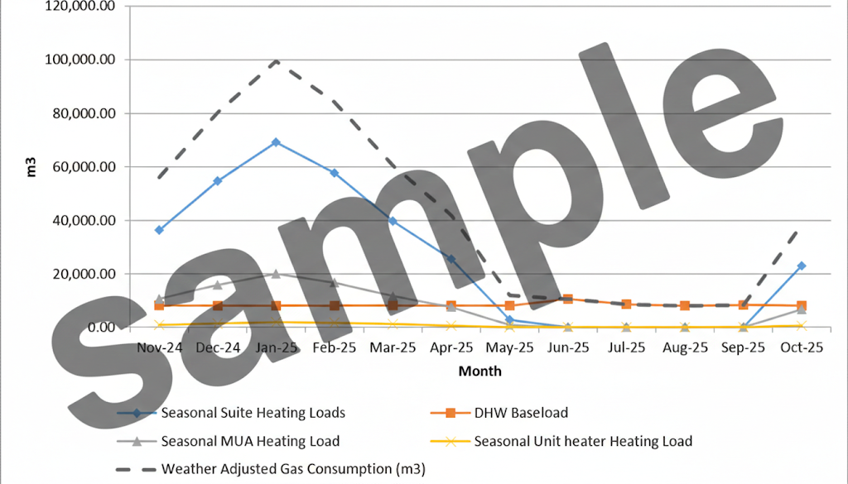
Figure 4.3.2: Annual Gas Consumption with Weather Adjusted Gas Consumption

Electrical Consumption Breakdown
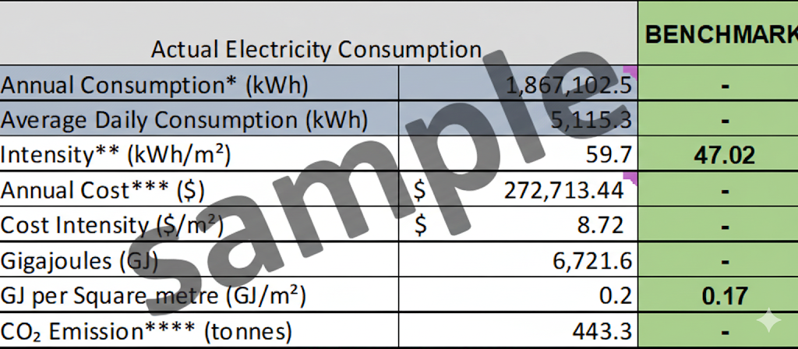
Table 5: Electricity Consumption Summary in Comparison with Benchmarking for Multi Residential Buildings
1 Based on year 2024~2025 bill.
2 Based on estimated building common area of xxxxx ft²
3 Based on average $0.15 per kWh
4 CO2 Emission Sources: Average Provincial Emission Factors (Ontario)
5 Based a combination of NRCan data and a database of 50+ buildings in Ontario collected by Mann.

Comments
The electric consumption intensity for the building is observed to be significantly higher than the benchmark. Overall, the building’s elevated electrical consumption appears to be driven primarily by operational and control related factors rather than widespread equipment deficiencies. Control based optimization measures—particularly BAS integration, improved scheduling, and monitoring—are expected to provide the most effective opportunities for reducing electrical energy use.

Electrical Consumption Breakdown (By Source)

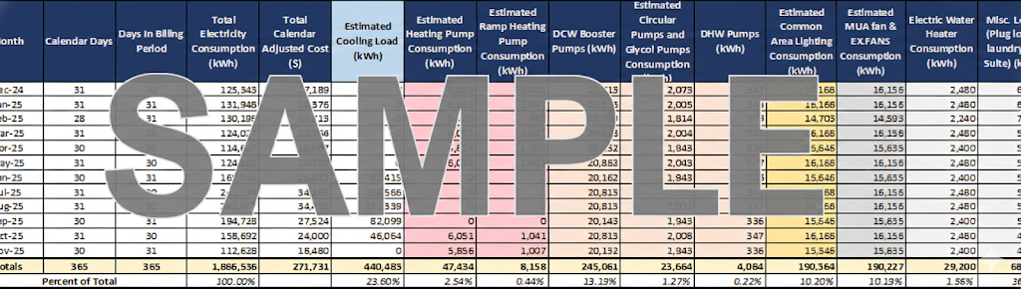
Table 6: Electrical consumption by Source
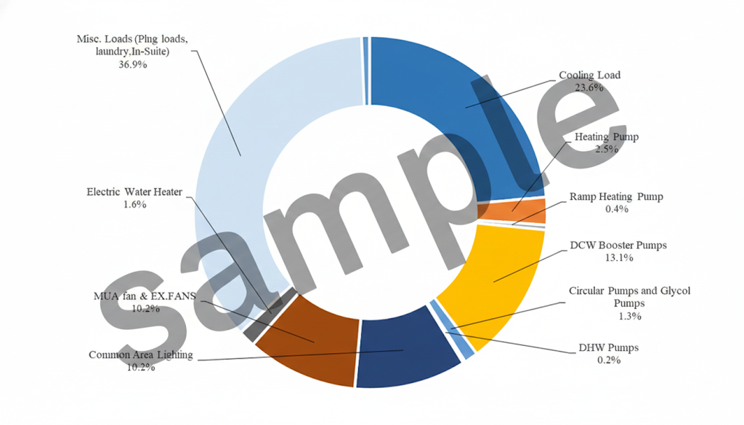
Figure 4.5.1: Annual Electrical Consumption Breakdown Pie Chart

Comments
Miscellaneous loads account for approximately 37% of total annual consumption.
Cooling loads represent a major electrical end use, accounting for approximately 24% of total consumption. This suggests that cooling system runtime and control strategy play a meaningful role in overall electrical performance.
Mechanical pumping systems and electric space heating loads account for 18% and 3% of total consumption, respectively. Continuous pump operation is common in this building vintage; however, significant savings can often be achieved by retrofitting Constant Volume (CV) pumps with Variable Frequency Drives (VFDs).
Electric water heaters, accounting for 2% of consumption, are utilized specifically for domestic hot water (DHW) recirculation reheating. These units are configured to operate primarily during off peak (nighttime) hours to maintain loop temperatures, effectively decoupling this thermal load from the building's peak electrical demand profile.
Lighting and ventilation fan loads account for approximately 10% and 10%, respectively. While these loads are relatively modest, incremental savings may be achieved through BAS controls strategy.
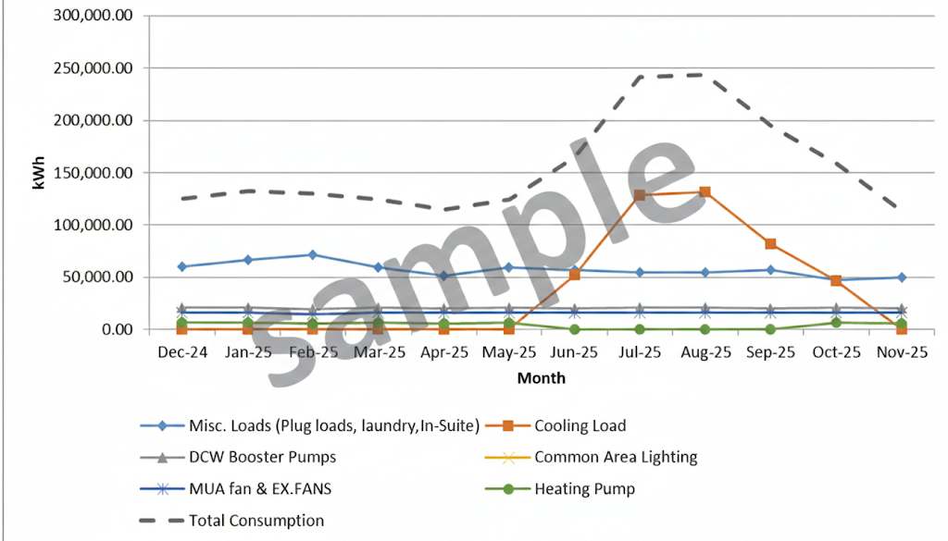
Figure 4.5.2: Annual Electrical Consumption Breakdown Line Chart
Comments
Based on site observations and operational feedback, the cooling system currently lacks centralized BAS driven optimization. Chilled water and condenser water temperatures appear to be maintained conservatively, limiting opportunities to maximize chiller coefficient of performance (COP) under part load and shoulder season conditions.
In addition, the condenser water pumping system includes large constant speed pumps, which may contribute to elevated electrical consumption during cooling operation. Without centralized monitoring, scheduling, and temperature reset, the cooling plant is unable to dynamically respond to actual building load, outdoor conditions, or occupancy patterns.
As a result, cooling efficiency is constrained primarily by control strategy rather than by the underlying condition of the chiller or cooling tower equipment

Water Consumption Breakdown
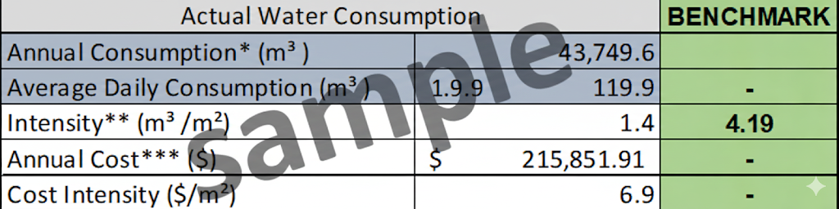
Table 7: Water Consumption Summary in Comparison with Benchmarking for Multi Residential Building
1 Based on year 2025 bill.
2 Based on estimated building area of xxxxx ft2
3 Based on average $4.76 per m3
4 CO2 Emission Sources: Average Provincial Emission Factors (Ontario)
5 Based a combination of NRCan data and a database of 50+ buildings in Ontario collected by Mann.

Comments
The water consumption is seen to be significantly lower than the benchmark. This may be due low occupant density. This may also be due to low amounts of irrigation required for this site. Water consumption can be reduced further through the installation of low flow fixtures.

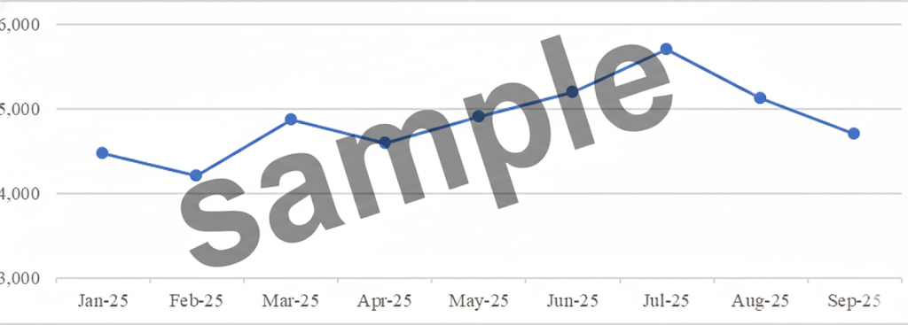
Figure 4.6.1 Annual Water Consumption Chart

Comments
The water meter indicates relatively stable consumption during the shoulder months, followed by a steady increase into the summer period, with peak water use occurring in July 2025 at approximately 5,700 m³. Water consumption then declines gradually from August through September as seasonal demand decreases. Opportunities exist to reduce overall water consumption through upgrades to in suite plumbing fixtures and improved water use efficiency.

Energy Conservation Measures
{MEASURE_BLOCK}
Saving calculation


Building Upgrades

Upgrade Measure 1 – Electric Vehicle Charging Stations
If the electric vehicle (EV) sector continues to grow as projected, nearly half the vehicles sold in Canada in 2030 will be electric. Th at is the outlook according to a new report from Clean Energy Canada, in partnership with Navius Research. The study, “The Fast Lane: Tracking the Energy Revolution 2019,” lays out a road map of Canada’s clean energy future and its role in the economy.
Natural Resources Canada (NRCan) will be rolling out the much needed Zero Emission Vehicle Infrastructure (ZEVI) incentive program this year. It is sponsored by NRCan and aims to cover 50% of the cost of Electric Vehicle (EV) charging stations for workplaces (commercial or industrial buildings), multiresidential buildings, public places, and many others. We will be working with our clients to help them provide this important service for their customers and utilize the incentive program with peace of mind. To find out more about the incentives and the services we are offering, please visit: www.mannenergysolutions.com/services/ev charging solutions.

Measures Considered but not Included
The following are measures that were not applicable to this report and the justifications on why they were not included.
- Installing High Efficiency Motors and Drives: Extensive engineering would be required to see if installing higher efficient motors and drives will generate modest savings. This should be included in a condition assessment but is not included in the scope of an energy audit.
- Supplement Domestic Hot Water with Solar Thermal Collectors: Switching from electric to gas is economically better at this time. In the future if gas prices increase several fold solar thermal can still be added.
- The insulation of all piping for heating, floors over unheated spaces and walls during repairs is a relatively inexpensive mean of energy conservation.
- Upgrade the roof to higher R Value roof if a roof renovation is applied.
- All defective taps should be repaired or replaced with “washer less” fixtures.
- Equipment efficiency should be checked and maintained on regular basis in accordance with manufacturer’s specifications. Combustion air flow should not be obstructed by equipment in the boiler room

Energy Savings

SAMPLE

SAMPLE
Table 8: Cost and Payback Summary with 4.5% Utility Cost Escalation per Year
Comments
The estimated annual energy and cost savings presented above reflect the combined impact of the following recommended measures:
Number | Description of Measure | Estimated Utility / Cost Savings
 | {MEASURE_SUMMARY_ROW}

Recommended measures were selected based on the following criteria:
- Measures demonstrating a favourable simple payback on an individual basis;
- Equipment upgrades that are required regardless of payback due to systems being beyond their expected service life or approaching end of life.

Cash Flow

SAMPLE
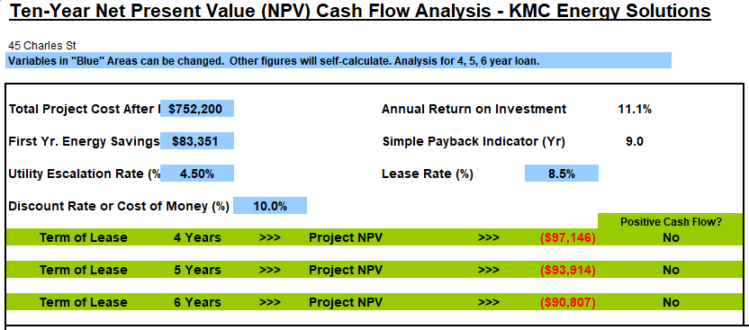
Table 9: Cash Flow Analysis Calculations

SAMPLE

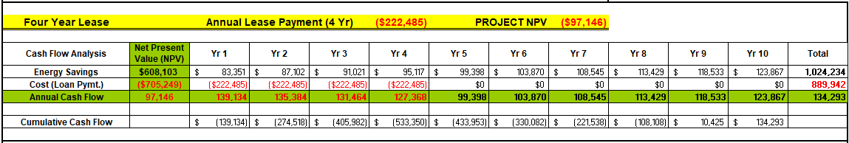
Table 10: Cash Flow Profile for 4 Year Lease

SAMPLE

SAMPLE
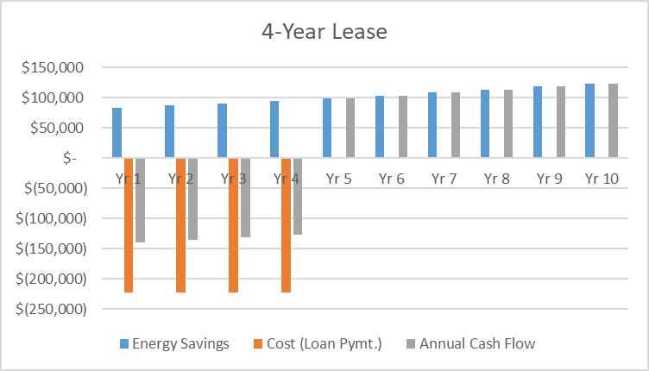
Figure 9.1 Annual Cash Flow Diagram for 4 Year Lease
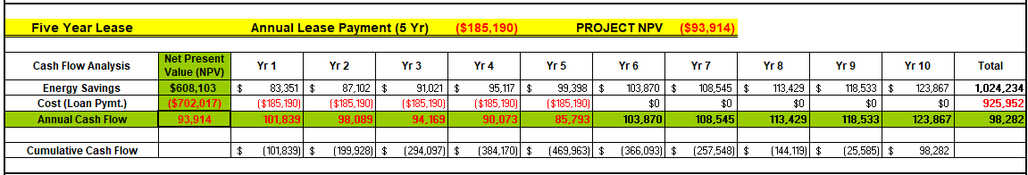
Table 11: Cash Flow Profile for 5 Year Lease

SAMPLE

SAMPLE
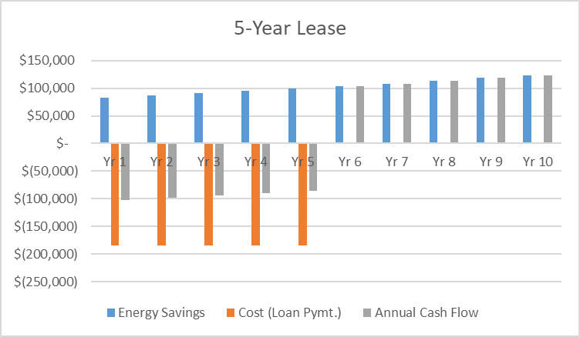
Figure 9.2 Annual Cash Flow Diagram for 5 Year Lease
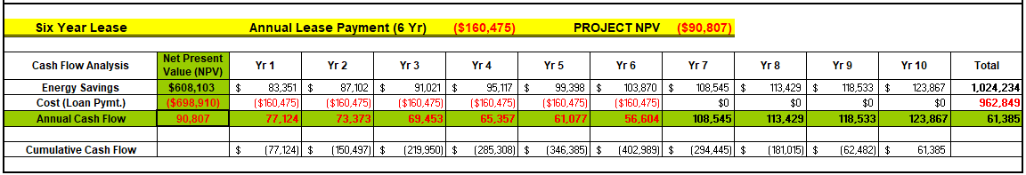
Table 12: Cash Flow Profile for 6 Year Lease

SAMPLE
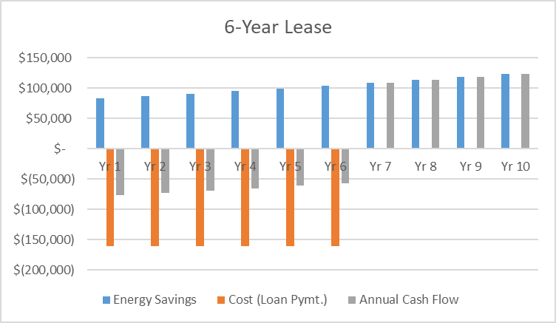
Figure 9.3 Annual Cash Flow Diagram for 6 Year Lease

Equipment Schedules
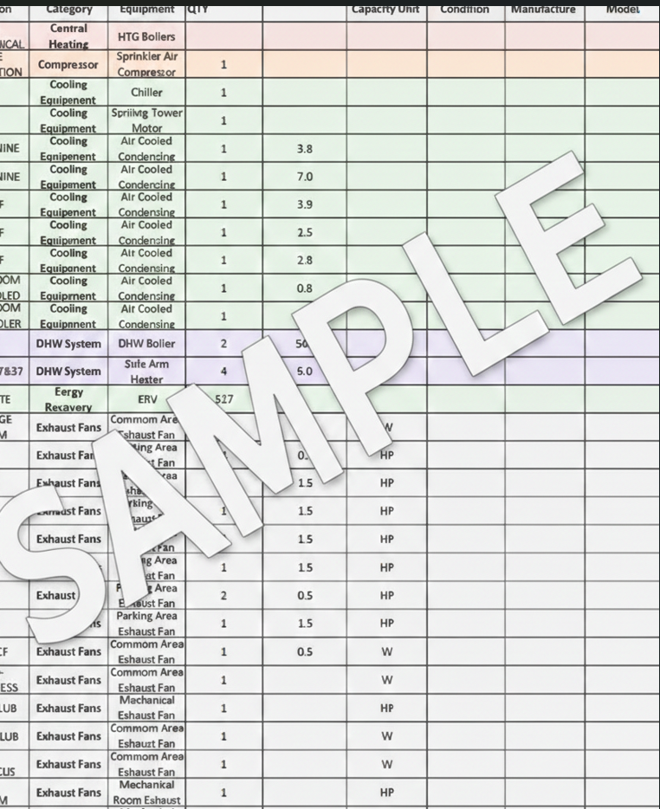

APPENDICIES

Appendix A – Utility Bills Summary

SAMPLE

SAMPLE
Table 13: Natural Gas Consumption by Month
Table 14: Electricity Consumption by Month

SAMPLE
Table 15: Water Consumption by Month

Appendix B – Comprehensive Energy Management Measures

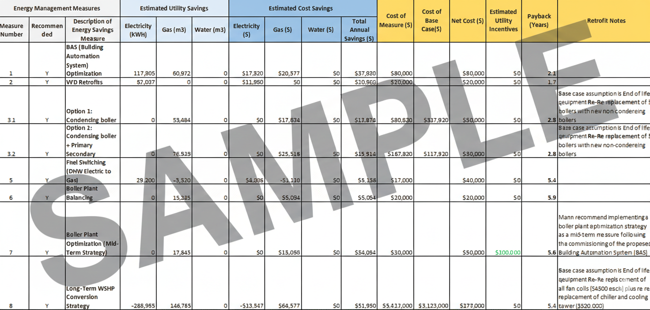
Table 16: Energy Management Measures

Appendix C – Canada's Greenhouse Gas Emissions

Canadians have a huge appetite for energy. Ironically, citizens of developing countries where climate change will take its greatest toll produce only a fraction of the greenhouse gas of Canadians.

By the numbers:
- Canada is one of the greatest consumers of energy per capita, burning the equivalent of roughly 7,700 liters of oil per person each year. This is roughly 50 times the consumption rate of Bangladesh, a country that stands to be largely eliminated by climate change induced sea level rise.
- Canadians use more energy than all of the 760 million inhabitants of Africa.
- Canada makes up less than one half of one percent of the world's population, but is the world's eighth largest producer of carbon dioxide.
- Canadians spend about $75 billion annually 10 percent of our GDP on energy to heat homes and offices, and to operate cars, factories and appliances. This is equivalent to $2,500 per person.
Canada Country Analysis
Canada's greenhouse gas emissions are increasing. Energy consumption grew about 13 per cent between 1990 and 1998, while emissions rose at a rate of 1.5 per cent annually, 17 per cent since 1990. Rising emissions trigger more rapid climate change and worsen air pollution with serious health consequences.
On a sectoral basis, the energy industry and the transportation sector contribute the greatest share of emissions. For individual Canadians, transportation accounts for almost half of greenhouse gas emissions, primarily due to automobile use. Energy use in the home accounts for the other half of greenhouse gas emissions produced by individual Canadians.
Despite our high consumption, research shows that Canadians are eager to adopt clean, renewable energy technologies. The good news is that these technologies are available now, and are becoming more affordable each year. Many Canadians also realizing that cutting energy use can mean substantial savings.
The federal government has announced Billions of dollars in incentives and programs targeted to meet the Kyoto Protocol. Two such programs are attached in the Appendix under NRCAN and Enbridge.

Appendix D – Ontario Power Authority: Save On Energy Retrofit Program



In the Retrofit program you can receive incentives for a variety of energy efficient measures available under three streams: Lighting, HVAC, and Manufacturing and other equipment. To participate, your project must be pre approved with a minimum incentive of $500.

Eligibility

Retrofit incentives are available to owners or lessees* of:
• Commercial spaces or buildings, such as offices, retail and grocery stores, restaurants, hotels, and warehouses
• Industrial facilities in sectors such as food and beverage, automotive, plastics, steel, mining, paper, and chemical industries
• Institutional buildings, including hospitals, universities, municipal facilities
• Multi family buildings, such as apartments (including social housing) or condominiums
• Agricultural facilities, including dairy, swine and poultry farms, greenhouses, and nurseries.

*If you lease, you must have the owner’s consent or authorization to participate.

What types of projects are eligible?

Projects eligible for the Retrofit program are generally those that provide sustainable, measurable, and verifiable reductions in peak electricity demand and electricity consumption. Examples of eligible projects include:
• Lighting retrofits • Lighting controls
• HVAC redesign • Chiller replacement
• Variable speed drive installations

Incentives are available for a variety of products and technologies to continue to help businesses save on energy costs and increase their competitiveness.

Retrofit program measures and incentives

The Retrofit program will release semi annual updates each spring and fall in the 2021 2024 period. As part of these updates, new measures and incentives are being added to the Retrofit program to enable businesses to continue to save on energy costs and to take advantage of a variety of technologies and products to help improve the overall operations of buildings and facilities.

Below is the list of measures and incentives currently available under the Retrofit program.

The incentives listed below are the maximum amounts offered. The actual amounts paid will depend on specific program requirements, including equipment size and eligible cost caps.

Note: This list has been updated to reflect changes made to the Retrofit program effective October 12, 2022

Appendix E – Enbridge Incentive Programs

Enbridge offers many incentives for gas saving measures. The following is not a comprehensive list of all programs and their details, but are the most applicable for this building and the proposed measures:

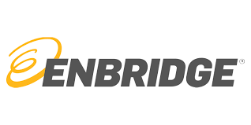
Retrofits & Custom

Get paid for energy efficient upgrades.

Saving energy is good for business. Investing in retrofits that make your building or facility more energy efficient can reduce operating costs, improve profitability, create a more comfortable environment and reduce greenhouse gas (GHG) emissions.

We offer a range of programs and incentives for retrofit projects that deliver energy savings—from straightforward upgrades to custom projects in commercial, multi residential, affordable multi family housing and industrial buildings.

What’s in it for you?
• One on one expertise, at no cost to you.
• Help to identify and prioritize energy efficiency projects.
• Help to translate opportunities into measurable savings.
• Incentives that cover up to 50 percent of project costs.

Contact an Energy Solutions Advisor

Types of retrofit projects

• Boiler Upgrades
• Water heating systems
• Building and Process Controls
• Heat recovery
• Steam & hot water systems
• Air Balance

What are the incentives?

Custom retrofit incentives
Custom engineering project incentives | Incentive
Custom projects reduce natural gas consumption in your building. Examples include insulation upgrades, heat recovery, boiler and related controls, control systems and building automation systems.  Get up 50 percent of the energy efficiency upgrades costs up to maximum of $200,000. | $1.00/annual m3 of natural gas saved

Is your project eligible?

• Commercial building.
• Located in the Enbridge Gas service area, including areas previously served by Union Gas.
• Project eligibility must first be confirmed by an Enbridge Gas Energy Solutions Advisor.

Enbridge Fixed Incentive Program

Speed up payback on equipment upgrades

Whether you’re replacing end of life equipment or planning to buy new, the Fixed Incentive Program makes it easy to offset the cost of upgrading to energy efficient natural gas technology.
Contact an Energy Solutions Advisor for help to find the right equipment for your business.

A fast and effective way to save energy

• Reduce energy and operating costs.
• Boost energy performance.
• Improve comfort in your building or facility.
• Reduce greenhouse gas (GHG) emissions.

Contact an Energy Solution Advisor

How the program works

1. Work with an Energy Solutions Advisor to identify energy efficient upgrades suited to your facility.
Or, take an online energy assessment.
2. Once eligibility is confirmed, make arrangements to purchase and install your energy efficient
equipment.
3. Work with your business partner or Energy Solutions Advisor to complete the application form and
submit all supporting documents needed.
4. Upon receipt of your completed application, we will process your application and you will receive
your incentive by mail in 10 – 12 weeks.

Condensing make up air (MUA)

For buildings with greater ventilation requirements, condensing MUAs can improve air quality, provide greater comfort and create a healthier environment. Learn how condensing MUAs work.

Condensing MUA incentives
 | Incentive
Constant speed | $0.60/CFM
2 speed or VFD | $1.10/CFM

Condensing Water heater incentives
 | Incentive
Storage water heaters > 75 kBTU/hr | $0.80/annual m3 of natural gas saved
Instantaneous (tankless) water heaters ≥ 75 kBTU/hr | $1.00/annual m3 of natural gas saved

Heat recovery ventilators (HRV) and energy recovery ventilator (ERV)
Save energy by keeping the heat in while moving stale air out. Learn how ERVs and HRVs work.

HRV incentives
 | Incentives
No existing HRV and not required by code
≥ 55% to ≤ 64% sensible heat recovery effectiveness | $2.15/CFM
≥ 65% to ≤ 74% sensible heat recovery effectiveness | $2.50/CFM
≥ 75% to ≤ 84% sensible heat recovery effectiveness | $2.90/CFM
≥ 85% sensible heat recovery effectiveness | $3.30/CFM
Improved effectiveness
≥ 65% to ≤ 74% sensible heat recovery effectiveness | $0.75/CFM
≥ 75% to ≤ 84% sensible heat recovery effectiveness | $1.10/CFM
≥ 85% sensible heat recovery effectiveness | $1.50/CFM
ERV incentives
 | Incentive
No existing ERV and not required by code
≥ 55% to ≤ 64% sensible heat recovery effectiveness | $2.75/CFM
≥ 65% to ≤ 74% sensible heat recovery effectiveness | $3.30/CFM
≥ 75% to ≤ 84% sensible heat recovery effectiveness | $3.75/CFM
≥ 85% sensible heat recovery effectiveness | $4.00/CFM
Improved effectiveness
≥ 65% to ≤ 74% sensible heat recovery effectiveness | $1.00/CFM
≥ 75% to ≤ 84% sensible heat recovery effectiveness | $1.25/CFM
≥ 85% sensible heat recovery effectiveness | $1.50/CFM
Business partner incentive | $100 per unit
Distributor incentive | $50 per unit

Equipment Eligibility

Eligible equipment is ERV/HRV with a minimum sensible effectiveness of 55 percent at 32 F for spaces with no ERV/HRV or for spaces were ERV/HRV is not required by code (OBC, SB 10, SB 12) and ERV/HRV with a minimum sensible effectiveness of 65 percent at 32 F for spaces were ERV/HRV is required by code.

Incentive paid is based on the operating CFM of the ERV/HRV and to qualify for an incentive, the sensible effectiveness used to validate the above criteria must be at the operating CFM level.

This offer is not eligible in areas where: the operating CFM sensible effectiveness level is below the minimum requirements above; systems where DCV or scheduled setbacks are used during operated hours; spaces where 100% of the exhaust air must be evacuated from the building in order to avoid cross contamination (100% fresh air is required such as described in OBC section 1.1.1.4. spaces where no recirculation is allowed by codes or standards, for instance, any limitations as per CSA Z317.2_10 Special Requirements for Heating, Ventilation, and Air Conditioning (HVAC) Systems in Health Care Facilities); and areas where contaminants (gases and vapors) may be present and the ERV/HRV may bring them back into the breathing zone.

In suite installations may be eligible at a different incentive level.

Appendix F – Energy Efficiency Measures Checklist

Building Envelope

Windows

• Install double pane windows
• Add tinted/reflective coating to window surface.
• Add exterior shading device.
• Attach storm glazing to moveable sash of operable windows.
• Reduce glass area (wall up/close off).

Doors

• Install insulated doors.
• Add vestibule entry.
• Resize exterior doors (make delivery doors smaller to reduce excessive infiltration).
• Install windscreens in areas with constant strong winds to protect exterior doors from direct blast of prevailing winds.
• Install a switch on overhead doors that prevents activation of heating and cooling units when doors are open.
• Install self closing doors on openings to unconditioned spaces.

Insulation/Infiltration

• Insulate roof (rigid).
• Insulate ceiling (batt/blow).
• Insulate wall.
• Insulate floor.
• Insulate between heated/cooled spaces and unconditioned or outside areas such as parking garages, porticos, storage, basements, and attics.

Cooling

• Install indirect and/or direct evaporative cooling.
• Install an economizer cycle with enthalpy or dry bulb temperature control to optimize use of outside air for “free” cooling.

Chiller/AC Equipment

• Upgrade inefficient chillers.
• Add floating head pressure controls.
• Install variable speed chiller compressor motor.
• Replace air cooled condensers with cooling towers.
• Install two speed or ASD on condenser fan motor.
• Install air to air evaporative pre cooling

Distribution System

• Install strainer cycle to chillers.
• Rebalance water system(s).
• Install ASD on pump motor.

Heating

• Replace inefficient older Boiler
• Match building heating loads by installing modular boilers.
• Install modulating burner controls or controls with 10:1 (or better) turn down ratio.
• Purchase and install automatic staging controls.
• Install electronic ignition to fire boiler.
• Install time clock w/ low temp override.

Heat Recovery Options
• Capture waste heat from flue gas to preheat combustion air and/or heat feed water
• Capture waste heat from continuous blowdown to preheat combustion air and/or heat feed water.

Distribution System
• Insulate piping and auxiliary equipment.
• Repair/replace condensate system leaks.
• Install thermostatic control valves on radiators.
• Replace/ repair steam traps.
• Rebalance water system(s).
• Install VFD on pump motor on hydronic systems.

Other Heating Options
• Install radiant heating.

Lighting

Lamp Modification

• Change mercury vapor (MV) to metal halide (MH)/ high pressure sodium (HPS).
• Install efficient ballasts with T8 or T5 lamps.
• Retrofit/replace exit signs with LED exit signs.
• Replace incandescent with compact fluorescent lamps (CFL).

Fixture Modification
• Change indoor incandescent to T8 or T5 four foot fluorescent or HIDs.
• Replace exterior incandescent lamps with more efficient types such as HPS or MH.
• Reconfigure and reduce the number of light fixtures.

Controls
• Install local switches.
• Install occupancy sensors and dimmers.
• Install photocells on exterior lighting.
• Install daylighting controls (with dimming ballasts).
• Provide timer switches in remote or seldom used areas where there will be brief occupancy periods.

Ventilation/Distribution

• Convert constant air volume (CAV) systems to variable air volume (VAV) systems.
• Replace variable inlet vane dampers with VFD motor drive.
• Install filter pressure drop gauges.
• Reduce air stratification.

Distribution Issues
• Properly adjust and balance air systems.
• Seal ducts to prevent air leakage.
• Replace failed dampers with new low leakage models.
• Insulate ducts.

Controls
• Avoid simultaneously heating and cooling air (note: it may be cooled at the air handling unit and warmed at the classrooms and/or offices).
• Install controls that will automatically close dampers during unoccupied periods.
• Install controlled or gravity dampers on all exhaust ducts to close ducts when fan is not operating.
• Install time clocks or other controls to shutoff exhaust system when not needed.
• Modulate exhaust fan speed to reduce exhausting conditioned air.
• Implement full Building Automation System (BAS)

Heat Recovery Options

• Install air to air heat recovery system in ventilation system

Domestic Hot Water
• Install flow restrictors.
• Install auto off faucets.
• Decentralize hot water heating (go to point of use water heating).
• Lower central water loop temperature and install booster heaters.
• Insulate piping and tank.
• Add hot water preheat from waste heat sources (e.g., from chiller and/or refrigeration compressor waste heat).
• Replace oversized water heaters with smaller heaters.
• Install summer heater to avoid larger heater usage.
• Install instant DHW heaters.
• Install 90 percent plus condensing heater.
• Install DHW pump/tank timers.

Controls
• Install a BAS/DDC system.
• Install time clocks on all boilers, chillers, and fan units.
• Replace existing room thermostats with programmable thermostats.
• Install system controls to limit electrical demand (e.g., increase cooling set point).
• Install system controls to reduce heating/cooling of unoccupied spaces.
• Lock out boiler in summer and chiller in winter.

Fans
• Install CO2 sensors for OSA control (referred to as CO2 demand controlled ventilation).
• Install occupancy sensors to modify room temperature set points and air flow rates.
• Install programmable controls on exhaust fans.
• Optimize controls loop by tuning PID coefficients.
• Install optimum stop/start devices

Lighting
• Install daylighting controls.
• Install lighting sweep controls.

Temperature Control
• Install discharge air temperature reset devices.
• Install hot and chilled water supply temperature reset control.
• Install night setback control.

Electrical Equipment

• Upgrade to energy efficient motors.
• Convert to efficient motors when existing motors fail.
• Install variable speed motors.
• Replace oversized motors.
• Purchase energy efficient equipment (e.g., computers).

Kitchen System

• Use evaporative cooling for make up air cooling.
• Install smoke activated hood ventilator.
• Install heat recovery system (use compressor waste heat to pre heat dishwasher water).

Renewable

• Install solar hot water systems.
• Install photovoltaic solar panels.
• Utilize geothermal heat pumps.

Appendix G – Site Pictures
 | 
Heating Boilers | DHW Boilers
 | 
Chiller | Cooling Tower
 | 
MUA 1 | MUA 2
 | 
Generator | Electric Room
 | 
Mixing Valve | Secondary Heating/Cooling Pump
 | 
Garage Ex Fan | EV Charger

Appendix H – Other Services Available from Mann Engineering

1. IR Scans of electrical systems – Determine if any critical electrical systems are on the verge of failure.
2. Indoor Air Quality measurements – We can take measurements of the CO, CO2, NO2, refrigerant and other gases that occupants are breathing in and compare to safe levels.
3. Utility Consumption Investigations – Not sure who’s meter is paying for what? Want to know why one area of the building is consuming more utilities than another? We can help.
4. Feasibility Studies – If you are thinking about a significant project, you should get a professional engineer to review the site in detail before you spend any money on design or construction.
5. Peer Reviews – Want a second set of eyes to review your engineering drawings before you make a significant capital expenditure? As we say in the industry, measure twice, cut once!
6. Harmonic Analysis – Power quality issues are very common these days. Let us review your power in detail and provide recommendations for lowering your power factor (which saves you money!) and improving the power quality (which will increase the life of your electrical system).
7. Code Compliance – Get one of our experienced engineers to review systems that have been red tagged, shut off or do not comply with current code.
8. Suite conversions or expansion – Mann has assisted several clients convert unused parking garage space or laundry rooms to fully functional, highly rentable suites.
9. BOMA, LEED, EnergyStar – Building values can increase and operating costs can decrease by meeting BOMA, LEED or EnergyStar certifications. Mann has experience submitting the applications and evaluating the work required to meet your targeted certification level.
10. Renewable Energy – Interested in reducing your building environmental footprint? Geothermal, solar and co generation are all great ways to take you off the grid!
11. Riser Pipe Replacements – Mann has teamed up with some of the most experienced pipe replacement solution providers to develop a low cost, reduced downtime solution to replacing your risers.
12. Mold assessments – Mold grows very quickly and affects building construction and occupant health. Mann can review and test for mold to prevent/correct the problem before it grows.
13. Fan coil replacements and servicing – Regularly cleaning your fan coil unit (or radiators) can reduce fan power, improve indoor air quality, and prevent mold.

