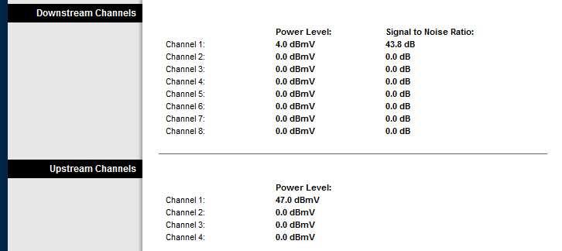

<http://www.dslreports.com/faq/3412>

Downstream Power: (-5 dBmV to 5 dBmV)

You generally want between -12db and +12db. Most modems are rated from -15 to +15. Anything less or more than that and you may have quality issues.

I personally prefer to not have less than -7db. If you want to raise your signal level a bit, check my troubleshooting and splitter section.

Downstream SNR: (32 dB - 50 dB)

This number is best over 30, but you may not have any problems with down to 25. Anything less and you will probably have slow transfers, dropped connections, etc.

See my "Downstream SNR" definition for more information on this.

Upstream Power: (32 dBmV - 50 dBmV)

The lower this number is, the better. If it is above 55, you may want to see if you can reconfigure your splitters. Anything above 57 is not good and should be fixed ASAP. (This is getting pretty close to not being able to connect.)

Upstream SNR:

Anything above 29 is considered good. The higher this number is, the better. If this number is below 25 and 29, you have a minute amount of noise leaking in somewhere. If it's anything less than 25, you want to get it fixed as you may have a lot of packet loss or slow transfer rates.

See my "Upstream SNR" definition for more info.