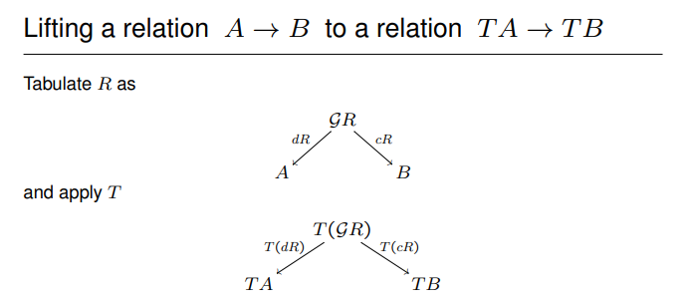

(citation: Relation Lifting, Alexander Kurz, University of Leicester, 2014-04-30)

In category theory, a branch of mathematics, given a morphism f: X → Y and a morphism g: Z → Y, a lift or lifting of f to Z is a morphism h: X → Z such that f = g∘h. We say that f factors through h.