Quantum Optimization Showdown: DQI vs QAOA on Trapped-Ion Hardware
|Y>Quantum 2026 Challenge Sponsors: Travelers Insurance + Quantinuum + LTM

The Challenge
Two fundamentally different quantum optimization algorithms. One trapped-ion quantum computer. One real-world insurance problem. Which scales better?
Your mission: benchmark Decoded Quantum Interferometry (DQI) against the Quantum Approximate Optimization Algorithm (QAOA) on P&C insurance product bundling optimization instances of increasing size, running on Quantinuum’s trapped-ion platform using the Guppy language and Selene emulator.

Background
The insurance and financial services industry faces combinatorial optimization problems that grow exponentially in complexity – portfolio optimization, risk modeling, claims processing, and product bundling all reduce to NP-hard integer programs. Quantum computing promises speedups for these problems, but which quantum algorithm is the right tool?
QAOA (Farhi et al., 2014) is the established variational approach: a parameterized quantum circuit whose angles are tuned by a classical optimizer. It’s well-studied but faces known barriers at low circuit depth.
DQI (Jordan et al., 2024) is a fundamentally different paradigm: instead of variational tuning, it uses quantum interference and syndrome decoding to amplify high-quality solutions. No classical optimization loop – just quantum mechanics and coding theory.
Both algorithms can solve the same class of problems. But how do they compare as problem size grows on a real insurance use case? That’s what you’ll find out.

The Use Case: P&C Insurance Product Bundling

The Business Problem
A property & casualty (P&C) insurer sells individual coverage options – auto liability, collision, comprehensive, roadside assistance, home dwelling, renters, umbrella, and more – each priced separately. The goal is to decide which coverages to bundle into discount packages to maximize total contribution margin (profit).
Bundling creates a tradeoff: the discount makes the package cheaper, lowering per-unit revenue, but increases the take rate (more customers buy the bundle), potentially increasing overall profit.

Canonical Problem Reference
The full business problem, parameter definitions, constraints, reference instance, and approved scaling sizes are defined in LTM/YQH26.pdf.

What You Must Deliver

1. Implement Both Algorithms
QAOA Implementation: - The native ZZPhase gate directly implements ZZ interactions in the cost Hamiltonian, so QAOA cost-layer couplings can be mapped naturally to Quantinuum hardware.
DQI Implementation: - Convert the insurance ILP to a max-XORSAT instance (parity check matrix B, constraint vector v) using the provided ilp_to_maxxorsat module - Build the DQI circuit: Dicke state preparation, phase encoding, syndrome encoding, decoder, Hadamard transform - Target Quantinuum’s native gate set - Test with and without BP1 decoding

2. Benchmark Across Problem Sizes
For each algorithm and each problem described in LTM/YQH26.pdf
Metric | Description
Quality of Solution | Best objective value found vs. classical optimum (or best classical bound). Report the approximation ratio.
Time to Solution | Proxy metrics that mimic wall-clock time and/or number of circuit evaluations to reach a target solution quality.
Also record: - Circuit depth (in native gates) - Two-qubit gate count - Number of qubits used - Number of shots / circuit evaluations - Feasibility rate (fraction of measurements yielding constraint-satisfying solutions)

3. Analysis and Presentation
- Scaling plots: How do quality and resource-based time-to-solution proxies scale with n for each algorithm?
- Resource comparison: Gate counts, circuit depth, qubit requirements
- Constraint handling: How do the algorithms handle the structured insurance constraints differently? Does DQI’s max-XORSAT encoding or QAOA’s penalty approach work better?
- Insights: At what problem size does one algorithm start to outperform the other? Why?
- Bonus: Can you improve either algorithm’s performance? (Custom decoders, parameter initialization strategies, circuit optimizations, constraint-aware mixers, hybrid approaches)

Platform: Quantinuum Helios
You will have access to Quantinuum’s trapped-ion systems via the Guppy language and Selene emulator.

Why Trapped Ions?
Feature | Advantage
All-to-all connectivity | No SWAP overhead – every qubit talks to every qubit
Native ZZPhase gate | Directly implements QAOA cost-layer interactions in one gate
High gate fidelity | 99.9%+ two-qubit gate fidelity
Mid-circuit measurement | Enables advanced techniques like qubit reuse and error detection
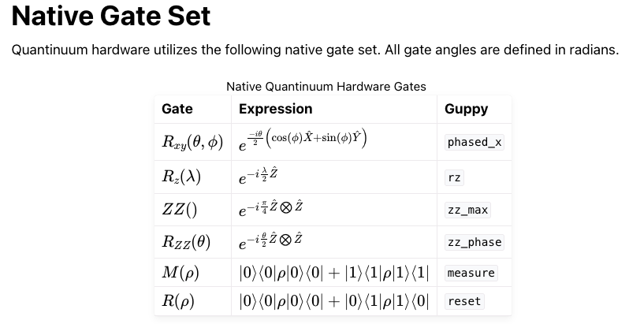
More details about Helios operations can be found here: https://docs.quantinuum.com/systems/user_guide/hardware_user_guide/helios.html

Language: Quantinuum Guppy
Guppy is installed as the guppylang Python package.
pip install guppylang
Guppy can be used with Python versions 3.10, 3.11, 3.12, 3.13 and 3.14. The MacOS, Linux and Windows operating systems are supported.
The source code for Guppy can be found in a public repository on GitHub. If you have a feature request or think you have found a bug, feel free to raise a GitHub issue.
Guppy programs can be executed on the Selene emulator. As of the v0.21 release, Selene is now included with guppylang and powers the guppylang.emulator module under the hood.
Detailed instructions: https://docs.quantinuum.com/guppy/getting_started.html
Guppy Examples: https://docs.quantinuum.com/guppy/examples_index.html
Detailed setup instructions and Quantinuum account credentials will be provided at the hackathon.
DQI Recommended reading:
https://pennylane.ai/qml/demos/tutorial_dqi
https://arxiv.org/pdf/2509.08328 and the related GitHub repo https://bcg-x-official.github.io/dqi/
QAOA Recommended reading and implementation references:
Older but useful QAOA implementation reference (pytket): https://github.com/Quantinuum/pytket-docs/blob/89fc450f1a2ad9fc68b8e860e83be6dc58d77df2/docs/examples/algorithms_and_protocols/pytket_qaoa_maxcut_example.ipynb
https://journals.aps.org/prresearch/abstract/10.1103/24gg-7p8z and related code: https://github.com/jpmorganchase/End-to-End_Protocol_for_High-Quality_QAOA_Parameters and related data repo: https://zenodo.org/records/12209739
https://arxiv.org/abs/2210.05526
https://arxiv.org/abs/2409.12104 and related data repo: https://zenodo.org/records/15231805

Evaluation Criteria
Your submission will be judged on:
Criterion | Weight | Description
Quality of Solution | 30% | How close are your solutions to the classical optimum across all problem sizes?
Time to Solution Proxies | 25% | How efficiently does each algorithm find good solutions?
Scaling Analysis | 20% | Rigor and insight in your comparative scaling analysis
Technical Implementation | 15% | Code quality, use of Quantinuum’s native capabilities, circuit optimization
Presentation | 10% | Clarity of results, visualizations, and conclusions

Tips for Success

Start small: Get both algorithms working on the n=10 instance (5 coverages, 2 packages) before scaling up

Classical baselines first: Solve each instance with PuLP (provided in starter code) so you know the optimum

Exploit the structure: The QUBO is block-diagonal across packages -- decompose it

ZZPhase is your friend: Each ZZ penalty term is one native Quantinuum gate -- no decomposition needed

DQI needs max-XORSAT: The ILP-to-max-XORSAT conversion is the critical pipeline step. Understand the gadgets.

Tune lambda carefully: Too large a penalty makes the landscape flat; too small permits infeasible solutions. Start with lambda = 3 * max(c_{i,m}) and adjust.

Mandatory choice matters: Which coverage you pick from a mandatory family opens/closes different optional coverages via dependencies. This interaction creates the problem's complexity.

Read the references: further_reading.docx has implementation tricks and theoretical insights

Classical Context: Why This Matters
Let's be upfront about the classical landscape. General integer linear programming is NP-hard (Karp, 1972), but modern solvers are extraordinarily effective in practice. Commercial solvers like Gurobi and CPLEX, along with open-source alternatives like CBC/COIN-OR and HiGHS, leverage decades of algorithmic refinement in branch-and-cut methods -- combining branch-and-bound search, cutting planes, and sophisticated presolve techniques. Since 1989, solver performance has improved by roughly 20 billion times, driven by a factor of approximately 5 million from algorithmic advances and approximately 4,000 from hardware improvements. For our insurance bundling ILP at n=200 with its block-diagonal structure (10 independent sub-problems of 20 variables each), classical solvers find proven optima in milliseconds. That is the honest baseline.
So why spend a weekend running quantum circuits that won't beat a laptop running CBC? Because the point isn't to beat Gurobi today -- it's to understand quantum scaling behavior on structured, real-world problem formulations. How do approximation ratios, gate counts, and circuit depths change as n grows from 10 to 50 to 200? Most quantum optimization benchmarks use random instances, but the behavior of quantum algorithms on structured industry problems with dependencies, incompatibilities, and block-diagonal cost matrices remains an open research question. Sabater et al. found that quantum resources scale sublinearly with problem size -- so is there a crossover point where quantum becomes competitive, and if so, at what n? These are frontier questions in quantum optimization, and the scaling analysis you produce this weekend is a genuine contribution to answering them.
One practical note: PuLP with the CBC solver is included in the starter code as your classical baseline. Always solve each instance classically first. Knowing the proven optimum lets you compute meaningful approximation ratios for your quantum results -- without it, you're flying blind.

Challenge designed by Travelers Insurance, Quantinuum, and LTM for |Y>Quantum 2026. For questions during the hackathon, visit the sponsor table or ask a mentor.

Q-Net Community
We encourage you to join our Quantinuum Network (Q‑Net) . Q‑Net offers year‑round resources to keep you up to date on all things related to Quantinuum, including developer tools, documentation, trainings, webinars, events, and more.

