***RMS Account Management Service***

Author: Tien Nguyen

Date: 31/07/2020

# Introduction Account Management Service:

## Overview:

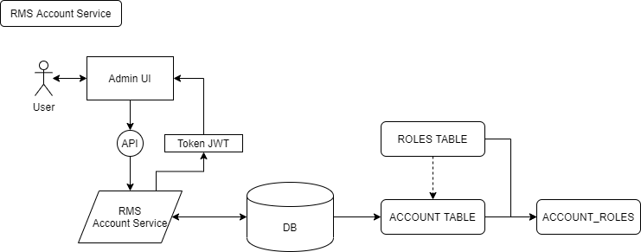

## Business/Requirement Of Account Management:

### Requirements:

Language: Java using Spring Boot + Restful APIs + Security with Json WebToken (HS512)

Database: PostgreSQL

Require APIs:

Api/account/login

Api/account/modifyPassword

Api/account/listAllAccount – **Admin or High level only (almost is IT Roles)**

Api/account/find - **Admin or High level only (almost is IT Roles)**

### Business:

RMS Account System will handle management account all employees and roles, also It will be the brigde to connect the rest services in system through Token. All websites before to call services will call account service as highest priority.

System Account will be generate token (Id, Username, Role) and return to UI. After that UI will take token of that user and call to another service with API

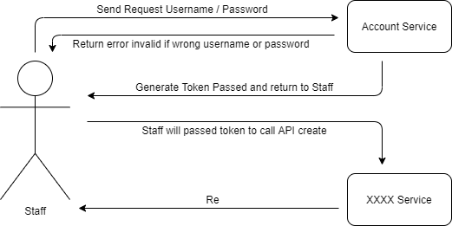

For generate token will build in account service, **another services** need to call into each and cache token of that user logged account.

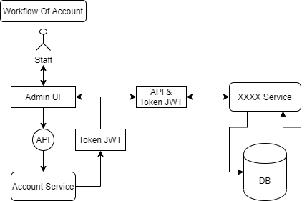

**Account Name**: will take **first letter of first name and merge with last name**, to **avoid duplicate account** system will add latest number (**using ID**) in last of account which created in Profile Service

**Password**: will be encode password.

First account created will be require newbie (new staff) change password at first time. To know which account is new create and old created that will have the flag “**N**” for new account and empty for old account,

When new staff first login, will be show up message please change password at your first time login. Confirm yes the system will link to page change password.

After changed password, the system will auto login with input that username and new password to authenticate and generate password (this step will auto go to main page of RMS).

**New Request:** when validate login account, check expiration password:

If password date > 3 months, will be move to directly link change password

If password date < 3 moths, ignore.

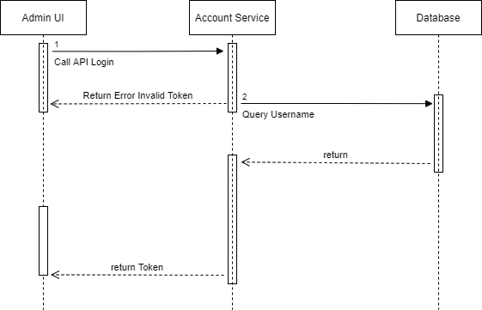

### Validation:

*Case 1*

*Account Name* should not empty: error will handle from website UI and throw error message: “***Please input username!***”

*Password* should not empty: error will handle from website UI and throw error message: ”***Please input password!***”

*Case 2*

*Account Name not existed*: when user try to input account not exist into website UI, the system will handle for website UI that query username and return message back to UI: “***Username not existed!!***”

*Case 3*

*Account Name or Password invalid:*

Error will handle by The System back-end side. The flow is when user input password, system will matches between password was stored in database and password was input from user. If it error, token won’t generate (it will return null).

Website UI will take null token and throw error for user “***Invalid Username or Password****”*

*Case 4*

***Advance Security block account if wrong 5 times: (New Request)***

This point only work after all requirements above completed.

When user forget password and trying to input 5 times, the system will auto setting status active in database to blocked account. When user input any password again, UI will throw error message: “***Your Account has been blocked, Please send contact to administratior***”

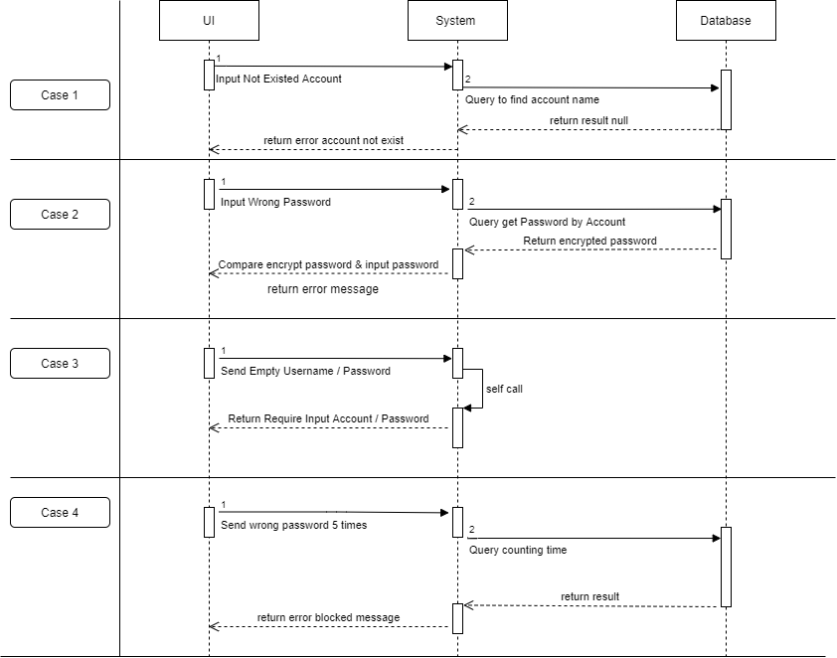

# UI/UX requirement: