***RMS Profile Management Service***

Author: Tien Nguyen

Date: 12/08/2020

# Introduction Account Management Service:

## Overview:

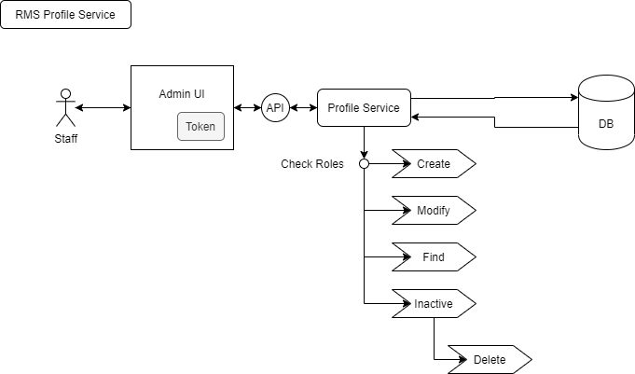

## Business/Requirement Of Account Management:

### Requirements:

Language: Java using Spring Boot + Restful APIs + JPA

Database: PostgreSQL

Require APIs:

Api/account/create

Api/account/modify

Api/account/listAllProfiles – **Admin or High level only**

Api/account/find

Api/account/inactive

Api/account/delete – **Admin or High level only If**

Api/account/refreshData

Api/account/checkInvalidProfiles

### Business:

RMS Profile Service will take care about management detail profiles of employees, also system will let employee can find another employee but will be limited info of that employee who will be search.

With RMS not only store data of all employees but also will help you export into file PDF about your information (personal info, experience, goals, skills, position,….).

**Create New Profile:**

As RMS System, new comer won’t have allow to access system, Staff or HR will do it, they will add new information of new comer.

Profile Service will store all data into database and return account / password (not encode) but in database password will be encrypted by security. Staff or HR will send account and password to new comer.

**Modify Profile and Update Skill:**

Each Employee updated the skill and information as your experience (Strong/weakness skills,…) will push notify into manager (if already going to any departments or any projects (if it is IT department), if you are newbie and not have manager yet, the system will push details into HR, they will find manager and send it into new manager.

**Inactive profile and delete:**

For Inactive profile and inactive account to log in into RMS system that employee won’t have allow to access RMS system, this case only for any employees who want to resign out company or for probation employees (2 months) if they don’t passed and will have valid on 6 months.

For delete profile and account, RMS System won’t delete totally all data of that employee, it will delete some data unnecessary only, so their main infor (like address, email, phone, ID, Employee ID,…) still cache into database. After 6 months, the RMS system will scan all profiles and all accounts which is already inactived.

But some cases, like sell information any projects or information of any employees will be inactive and delete some data immediately and effect pernamently.

### Validation: