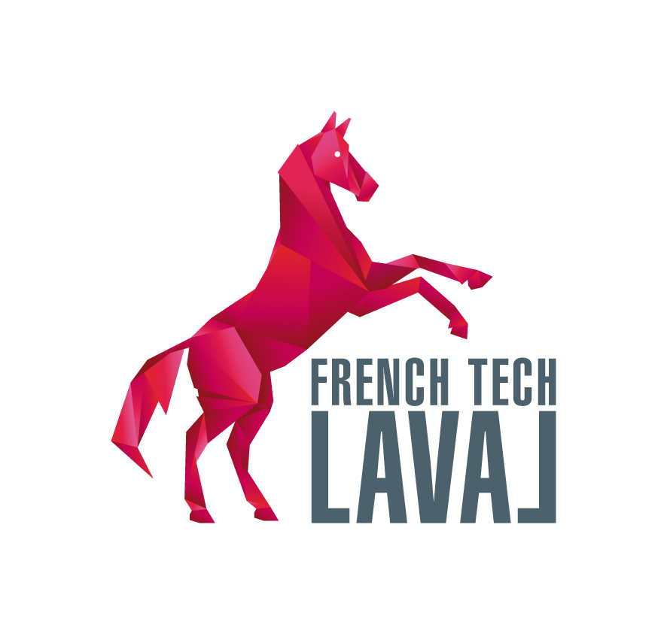
Your logo or header here



Mr Laurent Chrétien,
Laval French Tech Technical Referent
Maison de la Technopole
6 rue Léonard de Vinci
CS 20119
53001 LAVAL, FRANCE

DATE

Dear Sir,

For almost 20 years, Laval has contributed to the emergence of virtual and augmented reality technologies. From a pioneering position, Laval has become the European Capital of Virtual Reality particularly owing to the Laval Virtual international trade show. Beyond this key event, a whole ecosystem contributes to our local economy and territorial attractiveness.

I am convinced that the French Tech labelling is a significant boost to the national and cross-border development and recognition of technology companies and startups.

Besides, Laval expertise in the field of virtual and augmented reality as well as the setting up of a thematic network on this issue will represent a major asset for the French Tech network.

That is why I hereby would like to give Laval application my support and Company name ‘s support for its labelling and for the setting up of a virtual reality/augmented reality thematic network within the French Tech.

Let me assure you of our strong support in this process.

First Name Last Name signature

