**Battleship**

**Description:**

Write a program that will allow someone to play the game Battleship. The program will create a random configuration of ships for the computer and allow the player place his/her ships. The player and computer will then alternate shots, attempting to sink all of the enemy ships. Review the rules for Battleship for additional information.

**Suggestion for Adding Graphics:**

Save the Battleship.mat file to your current MATLAB folder (the folder in which you will write your game program). Try out the following commands in the command window to understand how they work. Then incorporate them into your game program.

Load Graphics Data:

load Battleship % Loads the player (Player\_Board) and computer (Opponent\_Board) boards (10x10 cell arrays) along with a number of different image, shown below.

|  |  |  |  |  |  |
| --- | --- | --- | --- | --- | --- |
| C:\Users\bucksgy\Dropbox\University_of_Cincinnati\Teaching\2012_Fall\ENED_1090\Project\Battleship_Images\Battleship_Boat_Front_bot.bmp | C:\Users\bucksgy\Dropbox\University_of_Cincinnati\Teaching\2012_Fall\ENED_1090\Project\Battleship_Images\Battleship_Boat_Front_bot_hit.bmp | C:\Users\bucksgy\Dropbox\University_of_Cincinnati\Teaching\2012_Fall\ENED_1090\Project\Battleship_Images\Battleship_Boat_Front_top.bmp | C:\Users\bucksgy\Dropbox\University_of_Cincinnati\Teaching\2012_Fall\ENED_1090\Project\Battleship_Images\Battleship_Boat_Front_top_hit.bmp | C:\Users\bucksgy\Dropbox\University_of_Cincinnati\Teaching\2012_Fall\ENED_1090\Project\Battleship_Images\Battleship_Boat_Front_left.bmp | C:\Users\bucksgy\Dropbox\University_of_Cincinnati\Teaching\2012_Fall\ENED_1090\Project\Battleship_Images\Battleship_Boat_Front_left_hit.bmp |
| Boat\_FrontBack\_1 | Boat\_FrontBack\_1\_hit | Boat\_FrontBack\_2 | Boat\_FrontBack\_2\_hit | Boat\_FrontBack\_3 | Boat\_FrontBack\_3\_hit |
|  |  |  |  |  |  |
| C:\Users\bucksgy\Dropbox\University_of_Cincinnati\Teaching\2012_Fall\ENED_1090\Project\Battleship_Images\Battleship_Boat_Front_right.bmp | C:\Users\bucksgy\Dropbox\University_of_Cincinnati\Teaching\2012_Fall\ENED_1090\Project\Battleship_Images\Battleship_Boat_Front_right_hit.bmp | C:\Users\bucksgy\Dropbox\University_of_Cincinnati\Teaching\2012_Fall\ENED_1090\Project\Battleship_Images\Battleship_Boat_mid_hor.bmp | C:\Users\bucksgy\Dropbox\University_of_Cincinnati\Teaching\2012_Fall\ENED_1090\Project\Battleship_Images\Battleship_Boat_mid_hor_hit.bmp | C:\Users\bucksgy\Dropbox\University_of_Cincinnati\Teaching\2012_Fall\ENED_1090\Project\Battleship_Images\Battleship_Boat_mid_vert.bmp | C:\Users\bucksgy\Dropbox\University_of_Cincinnati\Teaching\2012_Fall\ENED_1090\Project\Battleship_Images\Battleship_Boat_mid_vert_hit.bmp |
| Boat\_FrontBack\_4 | Boat\_FrontBack\_4\_hit | Boat\_Mid\_hor | Boat\_Mid\_hor\_hit | Boat\_Mid\_vert | Boat\_Mid\_vert\_hit |
|  |  |  |  |  |  |
| C:\Users\bucksgy\Dropbox\University_of_Cincinnati\Teaching\2012_Fall\ENED_1090\Project\Battleship_Images\Battleship_hit.bmp | C:\Users\bucksgy\Dropbox\University_of_Cincinnati\Teaching\2012_Fall\ENED_1090\Project\Battleship_Images\Battleship_miss.bmp | C:\Users\bucksgy\Dropbox\University_of_Cincinnati\Teaching\2012_Fall\ENED_1090\Project\Battleship_Images\Battleship_open_water.bmp |  |  |  |
| Hit | Miss | Open\_Water |  |  |  |

Display Gameboards:

subplot(2,1,1); imshow([Opponent\_Board{1,:};Opponent\_Board{2,:};Opponent\_Board{3,:};

Opponent\_Board{4,:};Opponent\_Board{5,:};Opponent\_Board{6,:};  
Opponent\_Board{7,:};Opponent\_Board{8,:};Opponent\_Board{9,:};  
Opponent\_Board{10,:}]);

subplot(2,1,2); imshow([Player\_Board{1,:};Player\_Board{2,:};Player\_Board{3,:};  
Player\_Board{4,:};Player\_Board{5,:};Player\_Board{6,:};Player\_Board{7,:};  
Player\_Board{8,:};Player\_Board{9,:};Player\_Board{10,:}]);

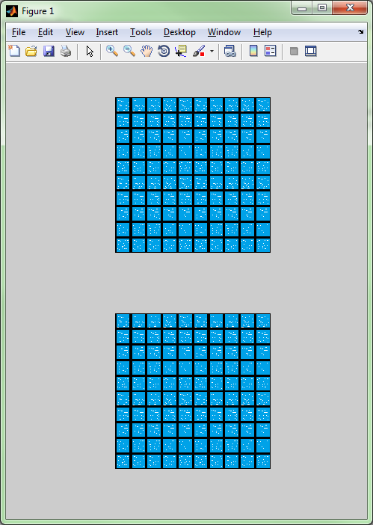

Note: If you dock the figure by clicking on the arrow, it will stay on the screen the entire time for viewing.

Displaying Boat Images on the Game Board:

* Suppose the player wishes to place his or her Aircraft Carrier (5 spaces long) on the board horizontally starting from position (2,3)

% Place the left pointing end of the boat at position (2,3)

Player\_Board{2,3} = Boat\_FrontBack\_3;

% Place the middle sections of the boat at positions (2,4-6)

Player\_Board{2,4} = Boat\_Mid\_hor;

Player\_Board{2,5} = Boat\_Mid\_hor;

Player\_Board{2,6} = Boat\_Mid\_hor;

% Place the right pointing end of the boat at position (2,3)

Player\_Board{2,7} = Boat\_FrontBack\_4;



Displaying Hits and Misses

* Suppose you fire a shot at location (5,5) and miss
* Suppose the computer fires a shot at location (2,5) and hits your Aircraft Carrier
* Suppose you fire a shot at location (8,7) and hit the submarine

% Display miss for shot at (5,5)

Opponent\_Board{5,5} = Miss;

% Display hit for shot at (2,5)

Player\_Board{2,5} = Boat\_Mid\_hor\_hit;

% Display hit for shot at (8,7)

Opponent\_Board{8,7} = Hit;



Other Notes:

* Use the “warning” command to suppress warnings when displaying images (you should place this at the beginning of your program)

warning('off','all'); % turns off all warning messages

* You will likely need to maintain two sets of arrays: the two graphic game boards (loaded when you load Battleship.mat) and two simple numeric arrays that contain the locations of the boats, hits, and misses as it will be difficult to do comparisons with the graphics arrays
* Use the provided function Setup.m in order to help randomly position the computer’s ships  
    
  % run the setup function  
  Locations = Setup();  
    
  Setup will return a 5x4 array with the following formatting:
  + Column 1 indicates the ship (1 = Aircraft Carrier, 2 = Battleship, 3 = Submarine,   
    4 = Cruiser, 5 = PT Boat)
  + Column 2 indicates whether the ship is horizontal (2) or vertical (1) on the board
  + Column 3 indicates the row of the left most (horizontal) or top most (vertical) end of the ship
  + Column 4 indicates the column of the left most (horizontal) or top most (vertical) end of the ship

For example, Setup may return the following:

Location =

1 2 9 6

2 2 10 4

3 1 3 6

4 1 8 2

5 1 1 9

This would result in:

* The Aircraft Carrier being placed horizontally starting at location (9,6)
* The Battleship being placed horizontally starting at location (10,4)
* The Submarine being placed vertically starting at location (3,6)
* The Cruiser being placed vertically starting at location (8,2)
* The PT Boart being placed vertically starting at location (1,9)

